CHEMICAL ENGINEERING TRANSACTIONS  VOL., 2023 | A publication of
The Italian Association
of Chemical Engineering
Online at www.cetjournal.it
Guest Editors: Sabrina Copelli, Richard Siwek
Copyright © 2023, AIDIC Servizi S.r.l.
ISBN ; ISSN 2283-9216

Predictive Models for the Estimation of the Minimum Ignition Energy of Polydisperse Organic Dusts
Linda Vitaloniª, Alessandra Melchioreª, Martina S. Scottonª, Marco Barozziª, Valentina Busini^{b}, Sabrina Copelli^{a,}*
ªUniversità degli Studi dell’Insubria, Department of Science and High Technology, Via Valleggio 9, 22100, Como, Italy
^{b}Politecnico di Milano - Department of Chemistry, Materials and Chemical Engineering “Giulio Natta”, Via Mancinelli 7, 20131, Milano, Italy
*sabrina.copelli@uninsubria.it
The process industry is a sector characterized by the sale of 50 % of its products in the form of powder and in which 80 % of the goods generated are made through a production system that involves the use of a powder. This sector massively employs solid materials and, using operations such as material transport, crushing, screening, sanding, trimming, feeding tanks and bins, storage of granular materials and many other activities, is very often characterized by the collateral emission of dusts. A similar scenario makes the risk of a dust explosion one of the major concerns of the process industry. In this context, to ensure the safety of people and infrastructures, it is crucial to obtain the parameters that characterize the explosiveness of the dust. Actually, these parameters are all determined experimentally, involving large economic costs, technical difficulties, and long dead times. This work focused on the estimation of one of these parameters, the Minimum Ignition Energy (MIE), which is considered to be one of the most important to assess the probability of having a dust explosion. Therefore, starting from the experimental test within a 1.2 L Hartmann tube, two new versions of a mathematical model capable of predicting the MIE for an organic powder were proposed. The models characterize the powder analysed through its particle size distribution and a few chemical-physical characteristics obtained from literature. Six organic powders were selected to validate the model (aspirin, cork, corn starch, sugar d₅₀=135 µm, sugar d₅₀=34 µm and wheat flour), with the intention of comparing the theoretical data obtained with literature experimental ones.
  - Introduction
The Minimum Ignition Energy (MIE) is the smallest thermal energy which, released in a point of a dust cloud suspended in the air, could trigger a combustion. Its value is usually reported in millijoules [mJ] and can vary greatly depending on the chemical nature of the powder, its physical characteristics, and the conditions in which the powder is present. The value of the MIE is involved in the design of numerous parts of the plant, such as electrical components, mechanical and process equipment, and in operations to remove unwanted dusts. MIE is also used in the layout of the production line. In fact, the Minimum Ignition Energy value is influenced by process parameters and, by modifying them, it is possible to obtain higher, and therefore less dangerous, MIE values.
Currently, regulations (such as ASTM E2019-03) require that the determination of the Minimum Ignition Energy value of a dust is carried out through laboratory tests. The test for the evaluation of the MIE is conducted by suspending a dust cloud in a closed container, to recreate confinement, and then starting an electric discharge of different known values (Ogle, 2016).
There are several models capable of obtaining the MIE value according to current regulations. Now, the most used devices are the Hartmann tube and the MIKE-3 tube. The tests differ in the dimensions of the cylinder (diameter 71 mm and height 420 mm for Hartmann tube; diameter 68.5 mm and height 315 mm for MIKE-3 tube), the powder suspension mode (Hartmann tube uses two successive air jets, respectively at 450 mbar for pre-suspension and 500 mbar for dispersion; MIKE-3 tube uses a single jet at 7 bar), the possibility of adjusting the inductance (only for MIKE-3 tube) and other adjustments relating to electrodes, such as the ability to choose different ignition energies and adjust the distance between the electrodes (Janes et al., 2008).
The experimental tests are currently the only methodology recognized by the standards defining MIE. However, the experimental methods exhibit many limitations, in particular: 1) the need to conduct several experimental tests for each dust sample to determine the MIE value; 2) in many cases, the tested powders are dangerous, both for their explosive potential and for the toxic products that they can release during combustion; 3) the procedure requires long times and high economic costs.
There are few researches aimed at describing the explosive behaviour of a dust as a function its thermochemical properties. Hosseinzadeh et al. (2019) proposed a theoretical model to correlate MIE with MIT (Minimum Ignition Temperature). Ren et al. (2009) proposed a mathematical model that related the MIE to dust parameters (dust particle size, dust concentration, turbulence, spark energy density and spark discharge time). In the literature, papers investigating the mathematical relationship between the MIE and particle size are fewer. The most recent study has been conducted by Copelli et al. (2021) but it describes the influence of a mean diameter of the dust on the MIE without considering the complete Particle Size Distribution (PSD). The present work was based on the work of Copelli et al. (2021) but it introduced the influence of PSD on MIE value.
The mathematical model developed, if compared to the experimental method, presented some important advantages, in particular: 1) it does not depend on equipment uncertainties or human errors (therefore ensuring the repeatability of the calculations); 2) it is both money and time saving because the procedure requires only the execution of a Thermogravimetric test (TG) and the determination of the particle size distribution of the dust sample; 3) the use of powders, the risk of explosions, and the exposure of the laboratory staff is reduced; 4) it is possible to analyse all the industrial conditions at which the dust is handled and/or used also taking into account the influence of granulometric changes.
  - Methods and Mathematical Models
In this work, two mathematical models were developed and then implemented into a MATLAB® code; particularly six organic powders were simulated: aspirin, cork, corn starch, sugar d₅₀=135 µm, sugar d₅₀=34 µm and wheat flour.
The mathematical models simulated the pyrolysis and combustion dynamics of complex polydisperse dusts inside a Hartmann tube when the spark is generated, and it interacts with the dust. The work of Copelli et al. (2021) on monodisperse dusts was used as a base for the development of two new models.
First of all, it was necessary to collect data available in the scientific literature for the chemical-physical and kinetic characterization of the samples (Copelli et al., 2021), that is: the particle size distributions and the experimental value of MIE (Beck et al., 1997; Eckhoff, 2003; Babrauskas, 2003; Addai and Krause, 2016). However, for greater reliability of the results, most of the values necessary for the codes are easily obtainable from a single experimental test, with Thermogravimetric Analysis (TGA) and Differential Scanning Calorimetry (DSC).
Then, the first simplified model was developed. This model had a simple structure to obtain a higher computational speed. The simplified method analysed each sample diameter and evaluated the results in relation to the particle size powder distribution.
The procedure was started using the necessary data from the scientific literature. The characteristic particle size powder distribution was divided into seven diameter classes: 375 μm, 187.5 μm, 98 μm, 67 μm, 47.5 μm, 26 μm, 10 μm. For each of these classes, the massive percentage of that diameter was provided. The model proceeded progressively, and, for each diameter, five different sample masses were analysed, respectively: 1500 mg, 1200 mg, 900 mg, 600 mg and 300 mg (selected according to the ISO/IEC 80079-20-2:2016 standards, 2016). For each sample mass, seven spark energies were tested, respectively: 1 mJ, 3 mJ, 10 mJ, 30 mJ, 100 mJ, 300 mJ, 1000 mJ.
Selected a diameter, and a mass of sample, knowing the energy of the spark, it was necessary to estimate the equivalent diameter of the spark influence zone (which can be referred to as the volume of air where the heat coming from the spark is distributed).
For the development of both models, a relationship between the energy of the spark, the temperature, and the extension of its influence area was determined. It had been assumed that the influence area of the spark was at 0 ms. Starting from this assumption, it was possible to determine the equivalent diameter of the spark influence zone in relation to the ignition energy used. The data used for this operation were taken and processed from the Bu et al. (2019) work, in which, with a high-frequency thermal imaging camera, the evolution of the high-temperature zone of the spark was photographed at different times. The tests were carried out inside a Hartmann tube with samples of cornstarch, wood dust and polymethyl methacrylate with different ignition energies. All obtained parameters are reported in Table 1.
Table 1: Dust ignition energy and equivalent spark diameters taken from the article by Bu et al. (2019)
Dust samples | Ignition energy [mJ] | Equivalent diameter [mm]
Polymethyl methacrylate | 3 | 3.41
Wood dust | 50 | 6.10
Cornstarch | 100 | 8.24
From the data collected in Table 1, using an exponential regression to interpolate them, it was possible to develop Eq. (1) which correlates the energy of the spark to the equivalent diameter of its influence zone:
$$D_{HC}=2.0933∙E_{S}^{0.2871}$$ | (1)
where D_{HC} is the equivalent diameter of the spark influence zone in mm and E_{S} is the spark energy in mJ.
Then, it was necessary to calculate the air temperature in the influence zone (T_{air}). If all the energy possessed by the electric discharge goes to increase the enthalpy of the air in the influence zone, the air temperature can be obtained from Eq. (2):
$$m∙ C_{P}∙ \left(T_{air}- T_{amb}\right)=E_{S}$$ | (2)
where C_{P} is the specific heat of air, T_{amb} is the ambient air temperature and m is the air mass in the influence zone, calculated according to Eq. (3).
$$m=\left(\frac{πD_{HC}^{3}}{6}\right) {∙ρ}_{air}$$ | (3)
T_{air} was calculated as:
$$T_{air}=T_{amb}+\frac{E_{S}}{\left(\frac{πD_{HC}^{3}}{6}\right){∙ρ}_{air}∙C_{P}}$$ | (4)
A total integration time equal to 100 ms was assumed to simulate both the heating of the dust mass in the affected area and the successive pyrolysis/combustion phenomena.
The mathematical model described by Copelli et al. (2019) was used to represent the pyrolysis phenomenon of organic powders. The material and energy balances included within this model were based on the following hypotheses: 1) dust particles has spherical symmetry; 2) resistance to mass transfer and diffusive versus convective flow in the gaseous phase are negligible; 3) secondary reactions between volatile compounds and pyrolysis products are absent; 4) there is local thermal equilibrium between solids and volatiles; 5) specific heat of the solid phase is constant and higher than specific heat of the gaseous phase; 6) air temperature in the influence zone (T_{air}) and the volume of the particles (V_{t}) are constant; 7) the state of the gaseous phase is pseudo-stationary.
The material balance of the solid phase was written considering only the solid mass involved in the devolatilization process, and it can be expressed according to Eq. (5):
$$\left\{\begin{aligned}\frac{∂c_{S}}{∂t}=-k∙{ρ_{S,r,0}}^{n-1}∙{c_{S}}^{n} \\ I.C.: c_{S}(t=0)=1 \end{aligned}\right.$$ | (5)
where c_{s} is the dimensionless density of the dust particle, ρ_{S,r,0} is the reactant mass for unit volume of particle at instant 0, and k is the devolatilization kinetic constant.
The material balance equation of the volatile compounds is reported in Eq. (6), considering the pseudo-stationary state and dimensionless variable V as the ratio between massive flow rate of the volatile gases leaving the surface of the single particle per unit area ($v$) and ρ_{S,r,0}:
$$V=\frac{v}{ρ_{S,r,0}}$$  $$\left\{\begin{aligned}\frac{∂V}{∂r}=-\frac{2}{r}∙V+k∙{{ρ_{S,r,0}}^{n-1}∙c_{S}}^{n} \\ B.C.: V( r=0)=0 \end{aligned}\right.$$ | (6)
Considering the hypothesis according to which: i) the specific heat of the solid phase is constant and higher than the specific heat of the volatiles, ii) ρ_{S,eff} is the effective density of the particle, iii) h is the enthalpy of volatiles for unit volume, iv) $\vec{q}$is the flow of heat that occurs by conduction, v) $\overline{λ}$is the effective thermal conductivity and vi) ${∆H}_{pyr}$is the enthalpy of the endothermic reaction of pyrolysis, the energy balance on the particle can be expressed as Eq. (7):
$$ρ_{S, eff}∙c_{p,S}∙\frac{∂T}{∂t}=-∇×\left(h∙\vec{v}+ \vec{q}\right)-{∆H}_{pyr}∙k∙{ρ_{S,r}}^{n}$$ | (7)
where:
$$ρ_{S, eff}=ρ_{S}∙\left(1-\overline{ε}\right); \overline{ε}=0.5; h=ρ_{V, app}∙c_{p,V}∙T; \vec{q}=-\overline{λ}∙∇T; \overline{λ}=λ∙\left(1-\overline{ε}\right)$$ | (8)
Substituting these definitions into Eq. (7), it is possible to obtain Eq. (9):
$$\left\{\begin{aligned}ρ_{S}∙\left(1-\overline{ε}\right)∙c_{p,S}∙\frac{∂T}{∂t}=\overline{λ}∙\frac{∂^{2}T}{{∂r}^{2}}+\frac{2}{r}∙\overline{λ}∙\frac{∂T}{∂r}-c_{p,V}∙\left[\frac{∂}{∂r}\left(v∙T\right)+\frac{2}{r}∙\left(v∙T\right)\right]-{∆H}_{pyr}∙k∙{ρ_{S,r}}^{n} \\ I.C.: T(t=0)=T_{0} \\ B.C.:\left\{\begin{aligned} \overline{λ} ∙{\left.\frac{∂T}{∂r}\right|}_{r=0}=0 \\ \overline{λ} ∙{\left.\frac{∂T}{∂r}\right|}_{r=R}=-h_{c}∙\left({\left.T\right|}_{r=R}-T_{air}\right)-ε_{em}∙σ∙\left( {\left.T\right|}_{r=R}^{4}- T_{air}^{4}\right)\end{aligned}\right.\end{aligned}\right.$$ | (9)
To determine whether the concentration of flammable gaseous compounds in the zone of influence is high enough to reach or exceed the Lower Flammability Limit (LFL), a material balance must be written. The total mass of flammable volatile compounds entering the influence zone can be expressed as in Eq. (10):
$$\left\{\begin{aligned}\frac{dρ_{V}}{dt}=\frac{ρ_{S,r,0}∙V(r=R,t)∙π∙D_{p}^{2}∙N_{p}}{V_{HC}} \\ I.C.: ρ_{V}(t=0)=0 \end{aligned}\right.$$ | (10)
where ρ_{v} is the concentration of volatile compounds, D_{p} is the mean diameter of the particles, N_{p} is the number of solid particles present in influence area and V_{HC} is the volume of influence area.
For the development of mathematical models, it is necessary to define the flammability range of the powders. The main problem is that the type and quantity of flammable gases/vapours are characterized by the chemical composition of the powder and the temperature at which pyrolysis takes place. For this reason, it has been approximated that the only product generated by the pyrolysis of an organic powder is methane, characterized by Lower Flammability Limit (LFL) = 4.95 % v/v at ambient temperature and Upper Flammability Limit (UFL) = 15 % v/v.
The elaboration of the concentration value of flammable volatiles resulting at the end of the spark (ρ_{v}) is obtained through the integration on the heating time of the Eq. (5), (6), (9) and (10). If the ρ_{v} obtained at the end of the process, expressed in % v/v, is above the LFL, the model records in an "Ignition Energy/Sample Mass" matrix whether ignition occurred (I) or not (NI). Obtained the MIE values for all five sample masses of a given diameter, the representative MIE of the single diameter is calculated with Eq. (11):
$$MIE={10}^{\left(\log_{10}{(E2)}-\frac{I\left(E2\right)}{\left[NI+I\right]\left(E2\right)+1}∙\left(\log_{10}{(E2)}-\log_{10}{(E1)}\right)\right)}$$ | (11)
where E2 is the minimum energy at which at least one of the five dust masses is ignited, E1 is the maximum energy value at which powder ignition fails for each of the five masses, I(E2) is the number of dust masses that ignited at energy E2 and [NI+I](E2) is the total number of masses tested at energy E2.
After all the diameters were tested, a weighted average of MIE values on the massive percentages provides the MIE value, for that specific powder and particle size distribution.
The second model developed is the complete model, in which the estimation procedure more accurately approximates the chemical-physical dynamics involved in the test. The complete model simulates the simultaneous heating of all particle size classes present in the sample, extrapolating the concentration of flammable gaseous compounds without the need for a subsequent weighted average. The procedure is the same as for the simplified model, the only difference is that in this case the five sample masses analysed are composed of several diameters of powder at the same time.
Another difference between the two models is the level of accuracy with which the system of Ordinary Differential Equations (ODE) and Partial Differential Equations (PDE), composed by Eq. (5), (6), (9) and (10), are solved: in the simplified model this system provides a single value, representative of the mass of flammable volatiles obtained at the end of the process; in the complete model, the system provides a temporal evolution of the concentration of flammable volatiles during the heating phenomenon.
  - Results and discussion
Table 2 shows the MIE experimental values taken from the scientific literature for the samples analysed, compared with the MIE theoretical results obtained using the simplified and complete mathematical model.
Table 2: MIE values obtained by simplified model and from complete model compared with experimental data
Samples | Experimental values [mJ] | Simplified Model [mJ] | Complete Model [mJ]
Aspirin | 1 | 1 | 1
Cork | 3 | 5 | 4
Corn starch | 30 | 16 | 17
Sugar d₅₀=135 µm | 55 | 6 | 21
Sugar d₅₀=34 µm | 20 | 9 | 5
Wheat flour | 30 | 14 | 25

Respectively, Figure 1a and Figure 1b show the results obtained with the simplified and complete method compared with the MIE experimental data in a graph.
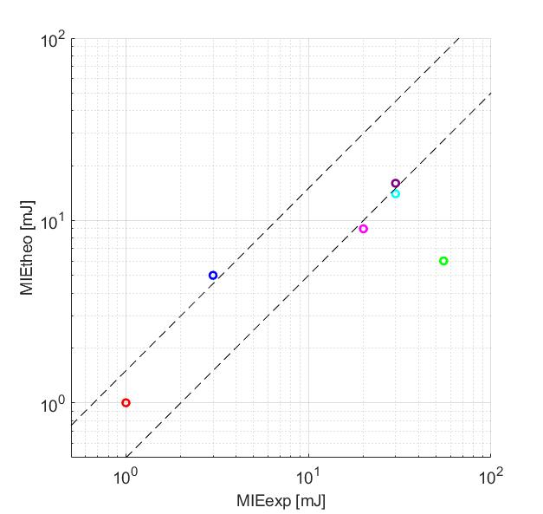a) | 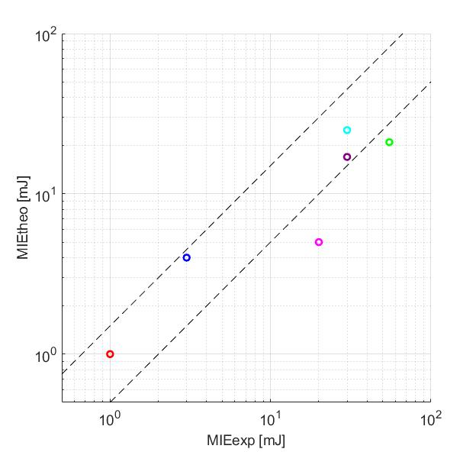b)
Wheat flour
Corn starch
Sugar (d₅₀=34 µm)
Sugar (d₅₀=135 µm)
Cork
Aspirin
Figure 1: a) Graph of the simplified model results; b) Graph of the complete model results
The area comprised between the dotted lines indicates the agreement between the experimental data and those predicted by the model; it also encompasses a range of ±50 % at the bisector. It is possible to notice that in both cases most of the values fell inside or close to this zone.
The complete model shows less difference between experimental and theoretical results. This is translated into the graph as a less scatter of all data from the bisector and its confidence intervals represented by the dashed lines.
Finally, the simplified model showed an average bias of 52 % and four samples having a bias greater than 50 %. The complete model showed an average bias of 38 % and two samples having a bias greater than 50 %.
Therefore, it is possible to appreciate an improvement in accuracy of the complete model compared to the simplified one.
  - Conclusions
The aim of this work was to develop two different mathematical models, able to predict the Minimum Ignition Energy (MIE) value of a polydisperse powder sample, avoiding the execution of dedicated set of experimental tests in the Hartmann tube (only TGA and PSD data are necessary to implement the MIE calculation).
The models were validated using literature MIE values for six samples: aspirin, cork, corn starch, sugar d₅₀=135 µm, sugar d₅₀=34 µm and wheat flour. Furthermore, the mathematical models were developed basing essentially on pre-existing studies and photographs of the dust ignition phenomenon in a 1.2 L Hartmann tube.
Unfortunately, for small variations of some kinetic parameters, considerable variations in the MIE values are obtained, highlighting the importance of conducting thermogravimetric tests directly on the dust samples to be analysed.
Furthermore, the need to use the particle size distribution values, the experimental MIE values, the chemical-physical and kinetic data from different sources, exposes to the risk that these data are not compatible because they are not taken from the same powder sample under the same conditions.
To minimize this risk, it was necessary to carefully select the data, in particular the MIE values associated with the distributions used for the validation. Only in this way, it possible to obtain reasonably reliable data for comparison with the values produced by the mathematical models.
However, the limitations faced by this research work have not prevented the obtaining of consistent and encouraging data which allow to plan future implementations and improvements, easily achievable with a further laboratory study of the analysed samples and the pyrolysis phenomenon connected to them. In fact, the results obtained are encouraging, mainly within the range of acceptability, and are reasonably in line with the experimental results.
The improvement of the two mathematical models in accuracy and a validation on a greater number of samples, using different granulometric distributions, could lead to a speeding up, simplification and reduction in terms of costs and time of the risk estimation procedure.
References
Addai E.K., Krause U., 2016, Investigation of explosion characteristics of multiphase fuel mixtures with air. Western Engineering, Inc, Powell, Wyoming.
Babrauskas V., 2003, Ignition Handbook: Principles and Applications to Fire Safety Engineering, Fire Investigation, Risk Management and Forensic Science, Books Alumni.
Beck H., Glienke N., Mohlmann C., 1997, BIA-Report 13/97, Combustion and explosion characteristics of dusts, Hauph/erband der gewerblichen Berufsgenossenschaften, HVBG, Sankt Augustin, Germany.
Bu Y., Yuan C., Amyotte P., Li C., Cai J., Li G., 2019, Ignition hazard of non-metallic dust clouds exposed to hotspots versus electrical sparks, J. Hazard. Mater., 365, 895–904.
Copelli S., Barozzi M., Scotton M.S., Fumagalli A., Derudi M., Rota R., 2019, A predictive model for the estimation of the deflagration index of organic dusts, Process Saf. Environ. Prot., 126, 329–338.
Copelli S., Scotton M.S., Barozzi M., Derudi M., Rota R., 2021, A practical tool for predicting the Minimum Ignition Energy of organic dusts, Ind. Eng. Chem. Res., 60, 10807−10813.
Eckhoff R.K., 2003, Dust Explosions in the Process Industries: Identification, Assessment and Control of Dust Hazards, Elsevier.
Hosseinzadeh S., Berghmans J., Degreve J., Verplaetsen F., 2019, A model for the Minimum Ignition Energy of dust clouds, Process Saf. Environ. Prot., 121, 43–49.
Janes A., Chaineaux J., Carson D., Le Lore P.A., 2008, MIKE 3 versus HARTMANN apparatus: Comparison of measured Minimum Ignition Energy (MIE), J. Hazard. Mater., 152, 32–39.
Ogle R.A., 2016, Dust Explosion Dynamics, 1st edition, Butterworth-Heinemann (Ed.).
Ren C.L., Li X.G., Wang F.L., Radandt S., 2009, Mathematical model for minimum ignition energy of dust clouds, Dongbei Daxue Xuebao Journal Northeast. Univ., 30, 1702–1705.

