CHEMICAL ENGINEERING TRANSACTIONS  VOL., 2023 | A publication of
The Italian Association
of Chemical Engineering
Online at www.cetjournal.it
Guest Editors: Sabrina Copelli, Richard Siwek
Copyright © 2023, AIDIC Servizi S.r.l.
ISBN ; ISSN 2283-9216

Study of the interaction between a high-pressure jet and
horizontal tanks using CFD
Giovanni Romanoª, Carlo Maria Marzorati^{b}, Paolo Tombiniª, Marco Barozzi^{c}, Sabrina Copelli^{c}, Valentina Busini^{d}
ªRomano Safety Management S.t.P., Via Saore 25, 24046, Osio Sotto, Bergamo, Italy
^{b}Tecnologia Ricerca Rischi S.r.l, Via Saore 25, 24046, Osio Sotto, Bergamo, Italy
^{c}Università degli Studi dell’Insubria, Department of Science and High Technology, Como, Italy
^{d}Politecnico di Milano - Department of Chemistry, Materials and Chemical Engineering “Giulio Natta”, Via Mancinelli 7, 20131, Milano, Italy
valentina.busini@polimi.it

Accidental high-pressure flammable gas releases are among the most relevant hazards in the process safety, and consequences could be severe. In the recent decades, there have been numerous efforts to study high-pressure jets in open field (i.e., free jets). Easy-to-use mathematical models have been developed, to rapidly assess the main physical variables involved in safety evaluations. However, in a realistic scenario, the accidental leak may involve either the ground or a piece of equipment. As demonstrated by recent works, when a jet interacts with an obstacle, its behavior can significantly change. Therefore, the mathematical models extrapolated for the free jet scenario could be a source of incorrect predictions. Focusing on the scenario of an accidental high-pressure unignited flammable jet, this work shows how the presence of one or two obstacles, placed at a different distance from the source of the leak, can influence the lower flammability limit cloud extent of methane. Varying the height of the source term, the effect of the interaction among the jet, both the obstacles, and the ground was systematically studied through a Computational Fluid Dynamics analysis.
  - Introduction
In industrial plants, jets are one of the most common incident scenarios, as up to 50% of industrial accidents are related to mechanical failure of tanks or flanges (Crowl and Louvar, 2012): if a small break appears in the wall of equipment, where a high-pressure flammable gas is stored, then it exits in the form of jet. The extent of this jet depends entirely on the chemical and physical characteristics of the material released in the atmosphere, the storage pressure and temperature, the atmospheric turbulence, and the eventual presence of obstacles nearby. One of the most important characteristics associated to the release of a high-pressure jet is the considerable distance that it could reach, making this incidental scenario capable of triggering domino effects, which could involve other equipment that were not directly involved in the primary event (Casal, 2017).
When an obstacle is impacted by a flammable gas release, the behavior of the jet and the extent of the potentially damaged areas are modified by its presence, as it is known from both literature and recent works (Bénard et al., 2016, Colombini and Busini, 2019, Colombini et al., 2020a, Colombini et al., 2020b, Colombini et al., 2021, Colombini et al., 2022a, Colombini et al., 2022b). This assumes particular importance in industrial and process safety, since consequences are proportional to the extent of the flammable mixture.
These aspects are not particularly investigated in literature, because the modeling of such scenarios is not easy: simpler models, like gaussian or integral models, do not consider adequately the presence of obstacles, resulting in outcomes far from the reality. Therefore, Computational Fluid Dynamic models (CFD) are needed to properly assess the accidental scenarios, although their use comes with a noticeable cost in terms of time and skills. Hence, it is necessary to find the ideal balance between finding rigorous and precise results for industrial applications and the amount of time needed to solve the CFD simulation of an incidental scenario.
This work focuses on the interaction between a high-pressure flammable gaseous jet and cylindrical horizontal tanks. When there is more than one tank, a series arrangement is used, with a fixed distance between the center of the tanks. The effects of a jet impacting against obstacles were studied through CFD, and the following parameters were modified in the simulations carried out: the height of the release point of the jet and the distance between the first obstacle and the release point of the jet.
Moreover, the storage pressure and the rupture hole size were varied, to obtain an engineering correlation that could allow predicting the area threatened by the jet that impacts against multiple obstacles.
Finally, the results were investigated to verify if a simplification of the industrial scenario is possible, without losing the significance of the results.
  - Materials and methods
For all the simulations, an upstream pressure greater than the critical threshold to achieve chocked conditions is used. This is a computationally expensive problem to face, due to the modeling of complex phenomena, such as shock waves formation and Mach disk establishment downstream to the jet orifice (Franquet et al., 2015). Since the main aim of the present work is the far-field zone of the jet, a way to overcome these problems is to model them through analytical correlations, such as the widely adopted model of Birch et al. (1984). This model introduces a pseudo-source, whose size depends on the size of the hole and the storage conditions, defined in such a way that it is crossed by the same mass flow coming out of the hole, but under conditions of pressure and ambient temperature.
Given the outdoor location of the accidental scenario, atmospheric conditions and a velocity profile, in accordance with the atmospheric class 5D of the Pasquill’s categories, were used. To perform the CFD analysis, Ansys Workbench 19.1 was used and CFX was deployed to numerically solve the flow governing equations with the Reynolds’s Average of the governing equations (i.e., the RANS approach). The k-ω SST turbulence model was chosen because it is the best solution for managing the calculations needed for high pressure jets.
  - Results and discussion

As it was pointed out in the introduction, a generic scenario of a leak from a storage tank (or a pipeline) was simulated in this work; the leakage was considered to be constant in time (i.e., steady state condition). The details of the source term (i.e., storage pressure, mass flowrate, and real hole diameter) together with the correspondent equivalent source diameter computed with the Birch et al. (1984) method are reported in Table 1. The ground was modeled as an adiabatic wall surface, with a roughness height equal to 0.01 m, simulating a concrete forecourt. For the environmental air inlet, the lateral and top boundaries a “inlet” boundary type was chosen to provide realistic wind conditions. An environmental temperature equal to 300 K was considered. Computational domain dimensions were properly sized to avoid any interference by the boundaries but, at the same time, avoiding a waste of computational resources (Franke, 2007).

Table 1: Methane release specifications.
 | Set 1 | Set 2 | Set 3
Real Hole Diameter [mm] | 25,4 | 25,4 | 50,8
Storage pressure [bar] | 65 | 130 | 65
Equivalent Diameter [mm] | 146 | 206 | 292
Mass flowrate [kg/s] | 5,18 | 10,36 | 20,72

To this aim, the work of Hourri et al. (2009) was taken as reference. A rectangular box of 105x32.2x35 m was built for each of the simulations performed. A vertical planar symmetry in correspondence of the jet axis was introduced, further reducing the pointless calculation time associated to the simulation. The calculation grid was made thicker near the point of release and coarser away from it, both for the diameter of the cell and for the growth rate of the cell itself. Moreover, the grid independence was positively achieved.
Tank sizes used in the simulations can be displayed in the following Table 2 and Figure 1.
The height of the release point of the jet (H) was varied within the same operating conditions and set; in particular, it was assumed initially a height of the release point of 1,5m, equal to the height of the centre line of the cylindrical tank. Then, a ± 25% variation was applied.
In this work, the position (d) of the first obstacle was varied along the axis of release, in such a way as to check whether there is a change in the behaviour of the jet when the impact with the obstacle occurs at a distance less than or greater than half of ME_NO, where ME_NO is the maximum distance reached by a jet that interacts with the ground in the absence of obstacles.
Table 2: Tank dimensions  D [m] D_{g} [m] R[m] P [m] V [m]  2 0,25 1 2 3 | 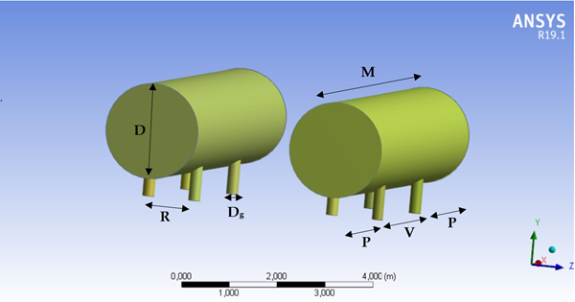 Figure 1: Tank geometry: height from ground = 0,5 m, M = 7m

Specifically, the following cases were analysed for each release set:
- d/ME_NO = 0,75;
- d/ME_NO = 0,5;
- d/ME_NO = 0,25;
- d/ME_NO = 0,125.
The analysis of the results focused mainly on two parameters: influence on distance to LFL (Lower Flammability Limit) and generation of vortices. The former is used to evaluate the maximum extent (ME) reached by the flammable cloud following its interaction with ground/obstacles.
The latter serves to further assess the role played by obstacles in influencing the behaviour of the jet, in particular the turbulence associated with the post-impact phases leading to a dilution of the methane concentration, reducing the extent of the jet.
Within this work, therefore, 72 simulations were carried out, of which 36 with a single tank and 36 with a pair of tanks; the overall geometry used for the simulations is shown in Table 3.
Table 3: Carried out simulations, cases differ for the height of the release point and release set.
Case | H [m] | d/ME_NO [-] | Release set |  | Case | H [m] | d/ME_NO [-] | Release set
a | 2 | 0,75 | Set 1 |  | f | 1,2 | 0,75 | Set 2
 | 2 | 0,5 | Set 1 |  |  | 1,2 | 0,5 | Set 2
 | 2 | 0,25 | Set 1 |  |  | 1,2 | 0,25 | Set 2
 | 2 | 0,125 | Set 1 |  |  | 1,2 | 0,125 | Set 2
b | 1,5 | 0,75 | Set 1 |  | g | 2 | 0,75 | Set 3
 | 1,5 | 0,5 | Set 1 |  |  | 2 | 0,5 | Set 3
 | 1,5 | 0,25 | Set 1 |  |  | 2 | 0,25 | Set 3
 | 1,5 | 0,125 | Set 1 |  |  | 2 | 0,125 | Set 3
c | 1,2 | 0,75 | Set 1 |  | h | 1,5 | 0,75 | Set 3
 | 1,2 | 0,5 | Set 1 |  |  | 1,5 | 0,5 | Set 3
 | 1,2 | 0,25 | Set 1 |  |  | 1,5 | 0,25 | Set 3
 | 1,2 | 0,125 | Set 1 |  |  | 1,5 | 0,125 | Set 3
d | 2 | 0,75 | Set 2 |  | i | 1,2 | 0,75 | Set 3
 | 2 | 0,5 | Set 2 |  |  | 1,2 | 0,5 | Set 3
 | 2 | 0,25 | Set 2 |  |  | 1,2 | 0,25 | Set 3
 | 2 | 0,125 | Set 2 |  |  | 1,2 | 0,125 | Set 3
e | 1,5 | 0,75 | Set 2
 | 1,5 | 0,5 | Set 2
 | 1,5 | 0,25 | Set 2
 | 1,5 | 0,125 | Set 2
To analyse whether the influence of the ground is predominant, it was decided to normalize the results with the ME_NO. It can be observed that, in the presence of an obstacle, the ME is generally lower or, in some cases, comparable to the ME_NO. The notable exception is Case_a, where there is an increase of up to 40% in the ME. In this case, however, the reference jet has no interaction with the ground. In addition, it can be noted that, as the distance of the obstacle from the point of release increases, the dimensionless ME tends asymptotically to 1.
When the obstacle is in the closest position to the point of release, the maximum extension of the jet is lower, with ME reductions ranging from 15% to 50%. This behaviour occurs due to the effects of impact with the obstacle when the release speed is still high. Among these effects are the formation of vortices downstream of the obstacle, which cause the dilution of the jet itself through the recall of ambient air and the separation of the jet from the ground, such as to limit the contribution of drag of the ground.
The release height greatly affects the behaviour of the jet when the release from the incidental event is lower, that is, in Set 1. There are in fact important variations of the ME, essentially linked to two distinct behaviours: the jet is diverted over the obstacle as a result of the impact, or the jet is channelled under the obstacle.
On the contrary, in the simulations belonging to Set 2 and Set 3, we can observe how the release height gradually loses importance in influencing the maximum extension of the jet.
The general trend of the graphs in Figure 2 reflects what has already been analysed for single obstacles. The ME is lower than the ME_NO, except in special cases such as Case_a, with reductions up to 50% depending on the distance of the pair of obstacles to the point of release.
The maximum extension of the jet increases with the distance of the pair of obstacles from the point of release, as the dilution of the jet linked to the turbulence, generated by the impact, occurs when the ground has already affected the jet behaviour significantly; conversely, turbulence is critical in reducing the ME when the pair of obstacles is near the jet release point. The height of the release point greatly affects the behaviour of the jet in Set 1, while in Set 2 and Set 3 its contribution is progressively smaller.

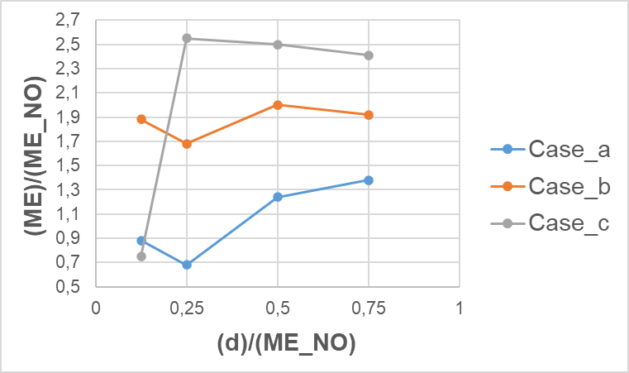  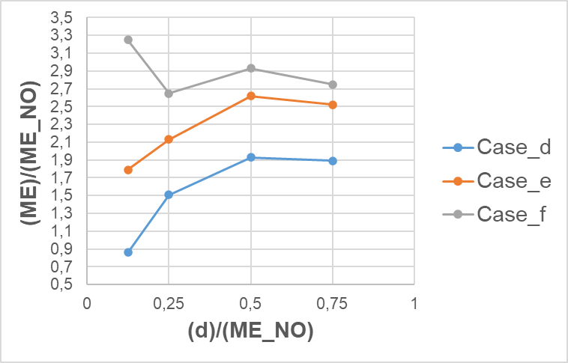  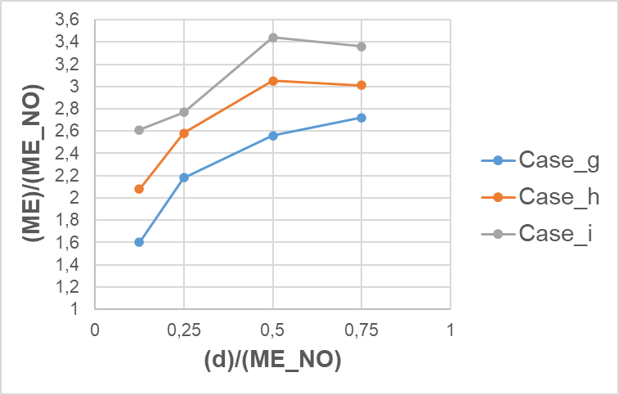 | 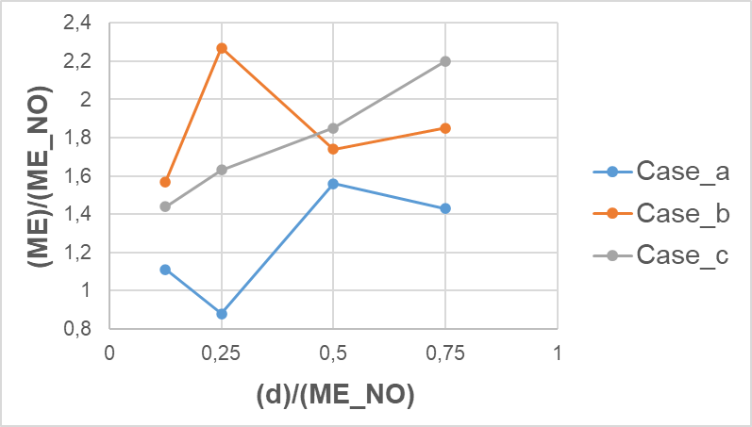  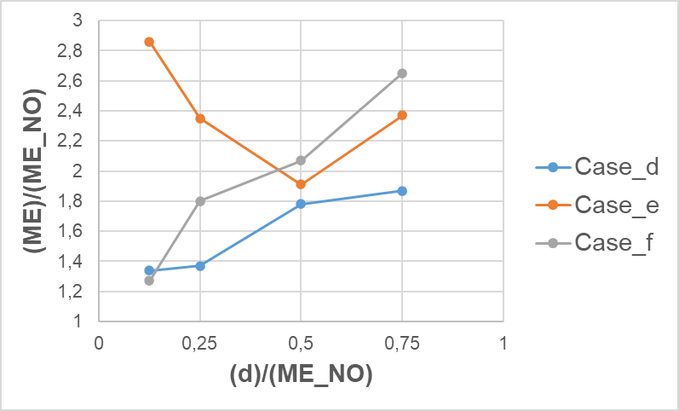  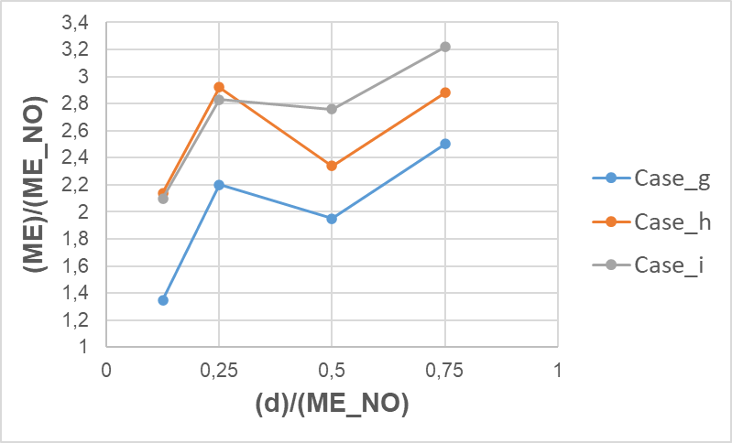
Figure 2: Dimensionless ME for each set for a single tank (left) and pair of tanks (right).
To observe more immediately the effect of the second obstacle on the behaviour of the jet, it was decided to divide the maximum extensions of the pair of obstacles jets (ME_pair) by those relating to the respective single cases (ME_single) depending on the distance of the first obstacle from the point of release. It is also recalled that the distance between the two obstacles is fixed and equal to s/D = 2. There is great variance in the results when the pair of obstacles is in a very close position at the point of release. When, on the other hand, the pair of obstacles is in the position equivalent to d/ME_NO = 0,5, a general decrease of between 5% and 25% of the dimensionless ME can be observed, confirming what had already been achieved in a previous work (Romano et al., 2022) for an s/D = 2 ratio.
Thus, it can be noted how the influence of turbulence and the dilution of the jet contribute to create the greatest differences between single obstacle and pair of obstacles in this area. Finally, the dimensionless ME tends to converge towards a unit value if the obstacles are at the maximum distance, between the simulated ones, from the point of release; this indicates a progressive loss of influence of the second obstacle on the extension of the jet.
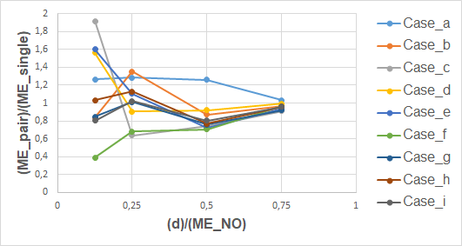
Figure 3: Comparison between dimensionless ME for each release set.

The analysis of the interaction between the jet and the obstacle was based on the study of the streamlines, which allow observing the speed gradients and the path followed by the jet during the release. At close range, the kinetic energy associated with the release of the jet is still very high; for this reason, the impact with the obstacle generates a very high level of turbulence. Since turbulence is associated with the formation of vortices that cause the entrainment of ambient air, the result is the dilution of the concentration of gas, which limits the maximum extension of the jet as the value of the LFL is reached at shorter distances. For this reason, up to 50% reductions in ME were obtained at the closest distance compared to ME_NO.
At a great distance, the speed gradients are reduced and, for this reason, the turbulence generated by the impact modestly modify the ME, which is instead influenced mainly by the ground, in a similar way to what happens for NO jets.
An example of streamlines trend is shown in Figure 4, both for close range impact and impact at a great distance.
As already pointed out above, when there are two obstacles in series, the ME is reduced both compared to the NO jet and to the case in presence of a single obstacle. The presence of the second obstacle represents, in fact, an additional source of turbulence along the path of the jet, favouring the recall of atmospheric air and decreasing the kinetic energy of the jet following a second impact, as well as its circulation within the gap between the two obstacles. In addition, the turbulence generated downstream of the second obstacle helps to limit even more the dragging effect of the ground, for example by causing the jet to detach from the ground.

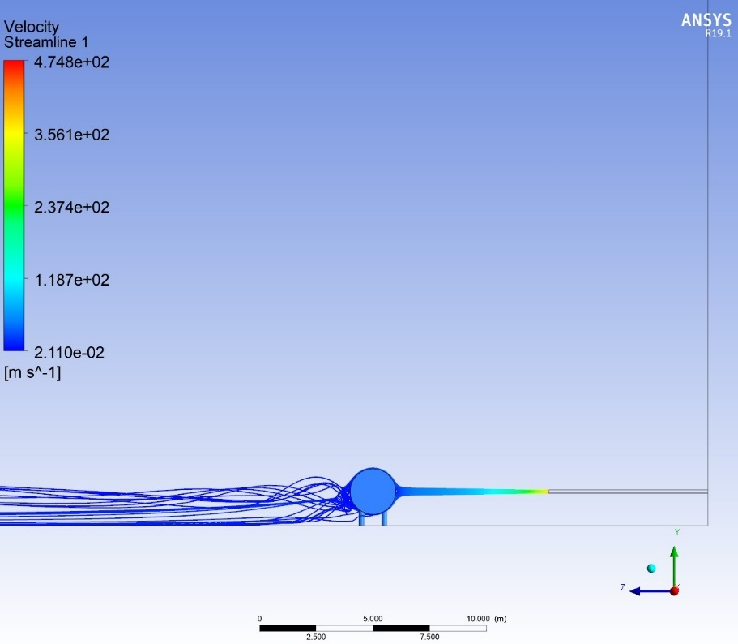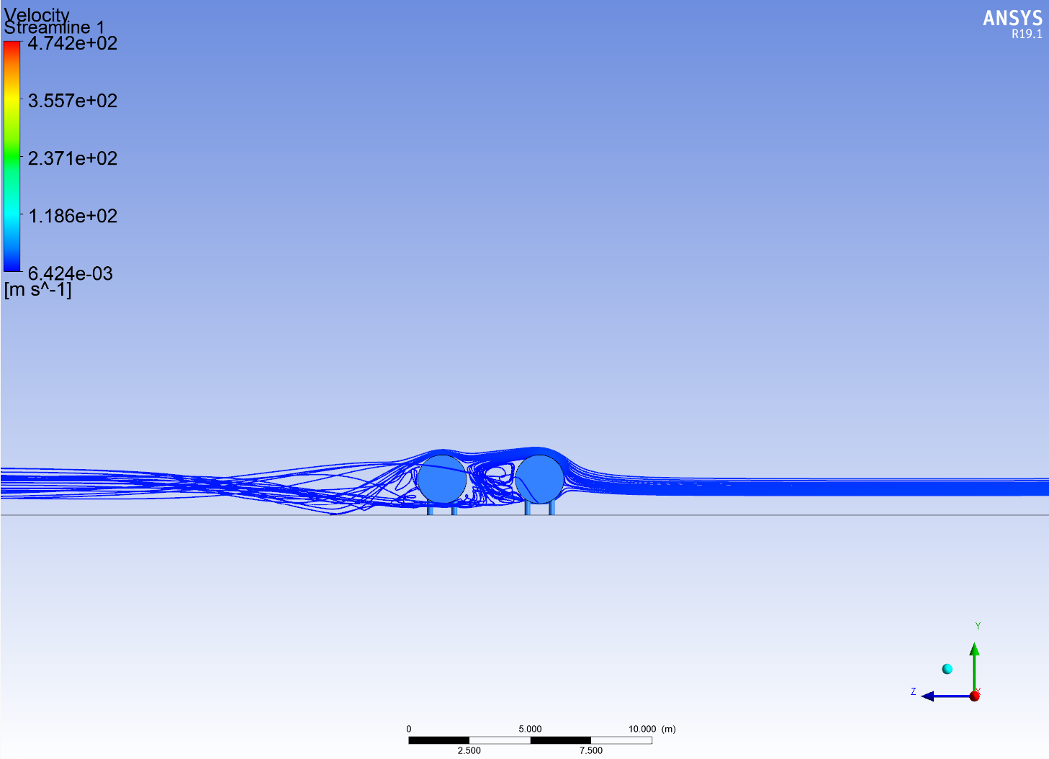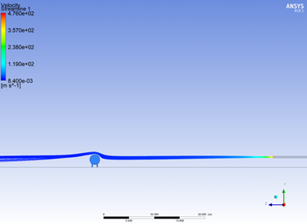
Figure 4: Streamlines trend for close range impact and impact at a great distance.
  - Conclusions
In this work, the scenario of a methane high-pressure jet parallel to the ground, interacting both with it and a single tank or a couple of tanks, was investigated. Varying the height of the source above the ground, the influence that such kind of obstacles has on the jet was analyzed.
With regards to the preliminary results shown, it is possible to conclude (see Figure 5) that:
- For cases with a single obstacle, a simplification of the simulation geometry is possible only if d/ME_NO > 0,5; in this case, it is possible to assume that the influence of the obstacle is negligible compared to the influence of the ground, therefore the results obtained by Colombini (2022b) can be used;
- For cases with a pair of obstacles, a simplification of the geometry of the simulation is possible only if d/ME_NO > 0,75; in this case, the influence of the second obstacle is negligible and it is possible to simulate the scenario which presents only one obstacle.
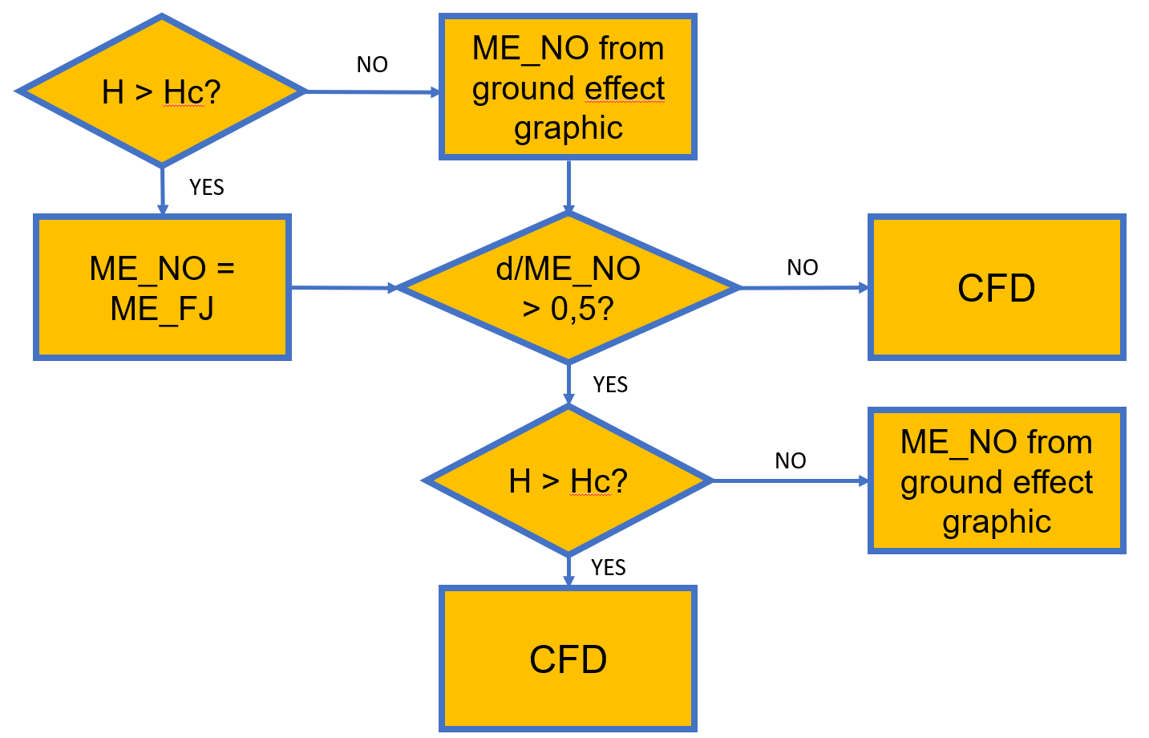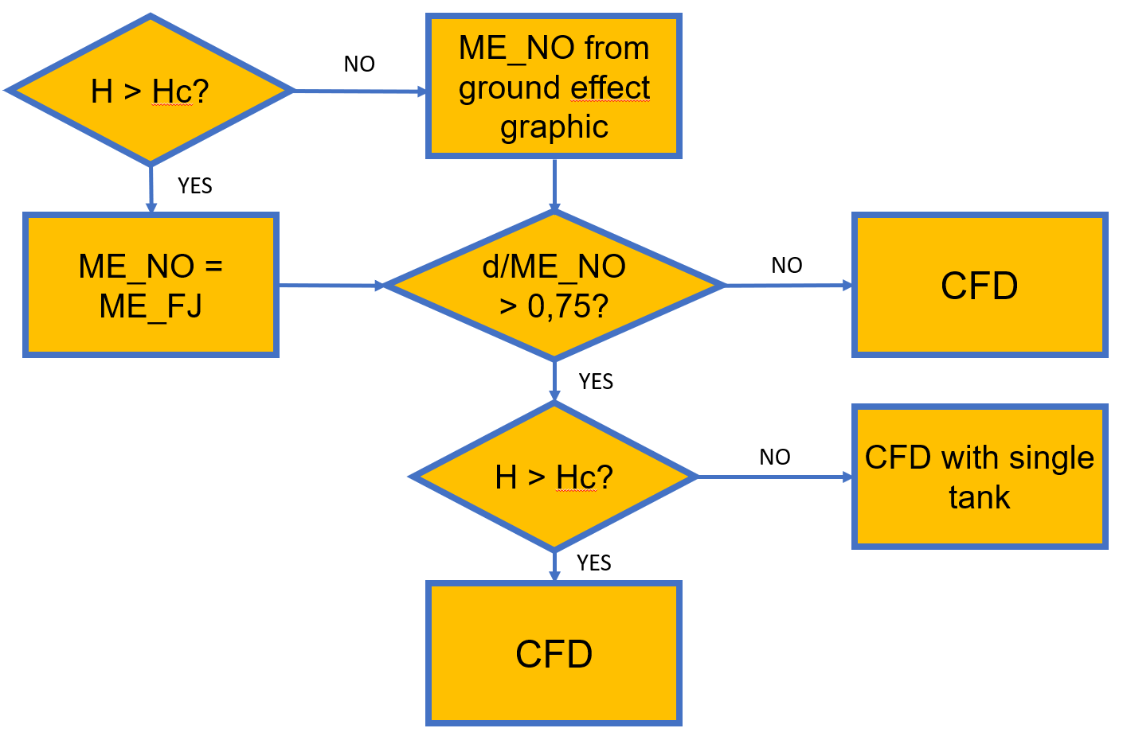
Figure 5: Outline of the conclusions for single tank cases (left) and pair of tanks cases (right). ME_FJ is the maximum extent of the LFL of a jet which has no interaction with the ground and the obstacles.

References

Bénard P., Hourri A., Angers B., Tchouvelev A., 2016, Adjacent Surface Effect on the Flammable Cloud of
Hydrogen and Methane Jets: Numerical Investigation and Engineering Correlations, International Journal
of Hydrogen Energy, 41, 18654-662.
Birch, A., Brown, D. R., Dodson, M. G., and Swaeld, F., “The structure and concentration decay of high-pressure jets of natural gas”, 1984, Combustion Science and Technology.
Casal, J., Gómez-Mares, M., Muñoz, M., Palacios, A., Jet fires: A ‘minor’ fire hazard? Chem. Eng. Trans. 26, 13–20. DOI: 10.3303/CET1226003, 2012.
Colombini, C., Busini, V., "Obstacle influence on high pressure jets based on computational fluid dynamics simulations," Chemical Engineering Transactions, 77, 2019.
Colombini, C., Carlini, L., Rota, R., and Busini, V., "Ground Influence on High-Pressure Methane Jets: Effect on Different Substances," Chemical Engineering Transactions, 82, 2020a.
Colombini, C., Martani, A., Rota, R., and Busini, V., "Ground influence on high-pressure methane jets: practical tools for risk assessment", Journal of Loss Prevention in the Process Industries, 67, 2020b.
Colombini, C., Maugeri, G., Zanon, G., Rota, R., Busini, V., “Unignited High-Pressure Methane Jet Impinging a Pipe Rack: Practical Tools for Risk Assessment”, Journal of Loss Prevention in the Process Industries 69, 2021
Colombini, C., Carminati, E., Parisi, A., Rota, R., Busini, V., “Safety evaluations on unignited high-pressure methane jets impacting a spherical obstacle”, Journal of Loss Prevention in the Process Industries, 74, 2022a
Colombini, C., Iannantuoni, C., Rota, R., Busini, V., “Unignited high-pressure methane jet impacting a cylindrical obstacle: An assessment tool for consequences analysis”, Journal of Loss Prevention in the Process Industries, 76, 2022b.
Crowl, D. A., Louvar, J. F., Chemical Process Safety: Fundamentals with Applications, Pearson, 2012.
Franke, J., "Best practice guideline for the CFD simulation of ows in the urban environment," Meteorological Institute, 2007.
Franquet, E., Perrier, V., Gibout, S., Bruel, P., 2015, Free underexpanded jets in a quiescent medium: A
review. Prog. Aerosp. Sci. 77, 25–53. DOI: 10.1016/j.paerosci.2015.06.006.
Hourri A., Angers B., Bénard P., 2009, Surface Effects on Flammable Extent of Hydrogen and Methane Jets,
International Journal of Hydrogen Energy, 34, 1569-1577.
Pontiggia, M., Busini, V., Ronzoni, M., Uguccioni, G. and Rota, R., "Effect of large obstacles on high momentum jet dispersion," Chemical Engineering Transactions, 2014.
Romano, G., Tombini, P., Ferrario, F., Mormile, A., "High-pressure jet and cylindrical obstacles in series: a CFD study," European Safety and Reliability Conference, 2022.

