CHEMICAL ENGINEERING TRANSACTIONS  VOL., 2023 | A publication of
The Italian Association
of Chemical Engineering
Online at www.cetjournal.it
Guest Editors: Sabrina Copelli, Richard Siwek
Copyright © 2023, AIDIC Servizi S.r.l.
ISBN ; ISSN 2283-9216

MIT of hybrid Mixtures – why no new standard?
Dieter Gabel*ª, Joshua Hütherª
ªOtto-von-Guericke University (Magdeburg, Germany)
gabel@ovgu.de
The Nex-Hys Project, funded by the German Federal Ministry of Economy as part of the WIPANO frame program, aimed to develop standards for safety characteristics of hybrid mixtures. These should be designed in a way that the standards are extended and the existing values in the experimental setup still hold true.
As part of the project, the Otto-von-Guericke University focused on the Minimum Ignition Temperature. Starting from a comparison of apparatuses for liquids (EN 14522) and dusts (IEC 80079-20-2) the decision to use the Godbert Greenwald Oven was made, as only there the possibility to introduce substances in gaseous and solid phase is given in principle.
The standardized setup was extended by a heated chamber to evaporate the liquids to be tested. Burnable gases were introduced into the system by means of mixing according to the partial pressure method in the pressurized air chamber or the evaporation chamber. Thus, it was possible to determine the MIT of the pure gases and vapors in the GG oven. Series of test for different substances under variation of the concentration show comparable values to the standard methods and to values found in literature. A trend to slightly higher temperatures (for gases and vapors) with a deviation close to the measurement uncertainty can be found. All in all, the deviation by different operators seems to be in the same range and cannot be neglected.
Following various combinations of dust, vapors and gases were tested. Up to now, no combinatory effect was detected. This seems to be in contradiction to former own publications, but there the setup was different. This could be an explanation for these nonreproducible result.
In all combinations, the MIT of the substances that has the lower MIT is dominating the final value. The setup-up generally proved to be able to test for the MIT of hybrid mixtures without violating existing values.
Part of the tests were made in a GG oven of double length showing a clear influence on the MIT for some substances, due to the longer residence time.
Apart from some rather practical weaknesses of the standardized setup there are general disadvantages that limit its use for a further development. First there is the totally unknow concentration and distribution of fuels in this open setup. Secondly, the subjective detection of the ignition by the operator. Third, the temperature distribution and heat transfer conditions that are not well defined.
The original intention behind the experiment is not in line with the scientific intention to create a versatile instrument to determine the ignition temperature for all phases and their mixtures. Therefore, a completely new approach would be necessary. The existing MIT standards for dust and vapor/gases can further exist unchanged and fulfil their purpose.
  - Introduction
The Minimum Ignition Temperature is one of the safety relevant units describing the ignition sensitivity. The MIT is separately defined for liquids/gases (EN 14522) and dusts (IEC 80079-20-2). For decades this was sufficient to ensure safety in handling and processing different types of combustible materials. Within the Nex-Hys project the potential need for implementing new standards for safety relevant units of hybrid mixtures were researched. Hybrid mixtures are compositions of combustible materials in different phases – practically the combination of a dust (solid) and gas or vapor (gas phase). Liquid phases, like spray of fog, have not been regarded. This lag is addressed in detail by other researchers [El-Zahlanieh et al., 2022] and needs to be included in further discussions.
As result of the Nex-Hys project, that ended in spring 2022, a working group of the German standardization committee (NA 095-02-09-01 AK) was established to introduce procedures for the determination of the maximum explosions pressure and the explosion pressure rise velocity separately for dust/gas [Spitzer et al., 2023] and dust/vapor [Heilmann et al., 2023]) hybrid mixtures. These procedures could be extended for LEL and LOC as soon as the experimental validation is available. The confirmation of both procedures is achieved by separate round robin test.
For the MIT of hybrid mixtures, no new standard was initiated. Following, the findings of the project that lead to this decision are summarized and discussed. A classical literature review on the topic is omitted, as these are already published by the author [Gabel et al., 2022].

  - MIT of hybrid mixtures

The MIT is the lowest temperature of a surface to ignite a combustible substance. In all cases this is achieved under variation of the concentration of the substance. Stating a MIT, generally the concentration is not mentioned but only the final temperature value is given as result. The formation of the mixture and the surface relevant for the ignition differ significantly in the two mentioned standards. According to EN 14522 an Erlenmeyer glass flask heated in an oven is used, whereas for dusts two totally different apparatuses are standardized: the BAM oven and the Godbert-Greenwald (GG) oven. Also due to the different physical behavior, the mixture generation needs to be different. For the dust apparatuses pressurized air is needed to distribute the solid material to be tested. Liquids are to be evaporated by the heat of the system first before they mix with the surrounding gas phase (air). The driving force to form the mixture is diffusion as well as the low momentum by the injection, both for the vapor as well as for the gas directly introduce into the flask. These descriptions should make clear that it was necessary to first define a new apparatus to test hybrid mixtures. Second, it becomes obvious that a “concertation” should not be stated as the situations in the experimental setups do not qualify to ensure an ideal mixture. Third, the Ignition Temperature of a hybrid mixture will be a function of two parameters, the amount of dust and the amount of the gas/vapor, thus the number of necessary tests to get a hybrid MIT will significantly increase. These thoughts let to the setup and procedure that were finally applied.
    - Setup and procedure
In preparation and in the first phase of the project different configurations of the experimental setup were tested. First, the decision to use the GG oven as the basis was made. The flask method for liquids has the clear disadvantage that no possibility the remove the dust after each experiment is given. The BAM oven has no clearly defined air reservoir (volume and pressure) used in the distribution system and cleaning issues, too. Second, preference was given to the parallel injection system. The serial approach first tested had clear disadvantages. When arranging the solvent reservoir before the dusts chamber the moisture lead to agglomeration effects and sticking. The other way around was practically not possible, as the dust could not be blow into the tube through the solvent reservoir. In both cases the mixing quality is questionable with a serial approach. Finally, the setup as display in Figure 1 was qualified and used for further research.
Main modification of the displayed setup is the heated evaporation chamber that is connected to the oven tube in parallel to the dust injection system. The two solenoid valves are electrically in parallel, too.
The important advantage of this setup is, that the only deviation from the standard oven is the top where the substance to be tested enter the tube. There is only a minor influence on the dust distribution in the tube. This was visually proven by high speed video recording in an unheated transparent tube and practically by measuring MITs in the original and modified setup for pure dust.
To limit the number of necessary experiments the same pressure is used in both reservoirs. In general, the overpressure is varied between 0.1 bar and 1.0 bar. Taking different pressures in both chambers would lead to a number 100 possible combinations. Multiplied with the number of combinations for the amounts of combustible materials in the same range results in an unacceptable high effort. Additionally, it can be assumed that an equal pressure leads to an even distribution of the dust and gas in the tube with the same forced downward velocity. Here too, various combinations were tested to justify this decision.
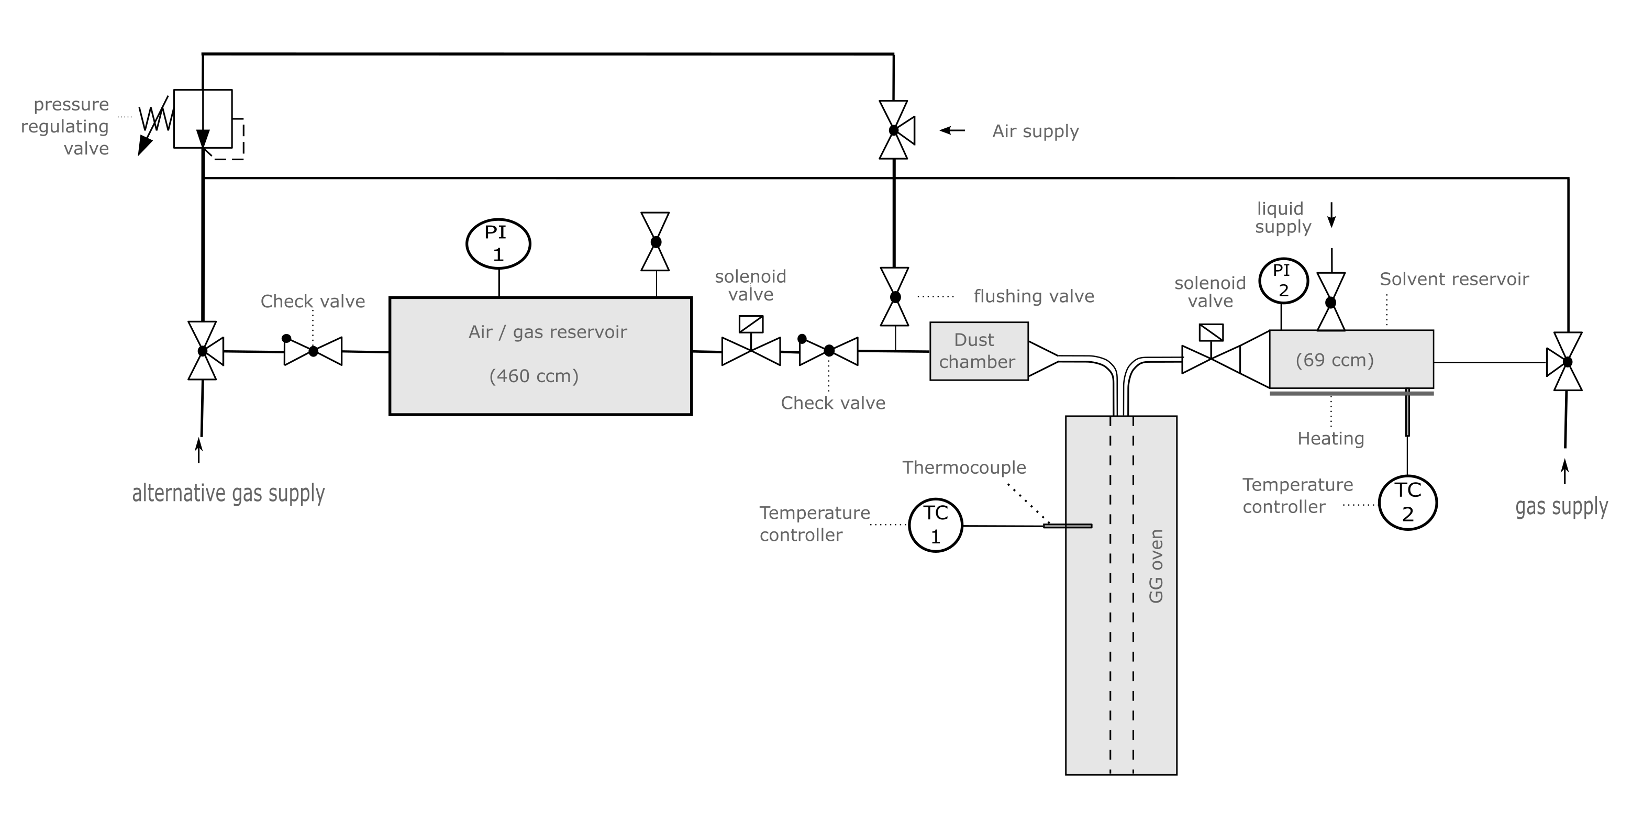
Figure 1: modified GG oven for hybrid MIT testing

The solvent reservoir is used to supply the gas phase to the oven. In case of gases the reservoir is first pressurized to the wanted pressure with the gas to be tested according to the partial pressure law. Then it is filled with pressurized air to the chosen system pressure. To achieve higher gas concentrations, it was necessary to overpressure the system first. The chamber was filled to the required pressure to reach the right gas mixture and following the mixture was released until the wanted system pressure was achieved. For liquids the solvent chamber was first heated to a temperature 20 K above the boiling point. Then the selected amount of liquid was introduced and a time of 30 seconds to evaporate given before pressurizing to the system pressure and conducting the experiment.
Additionally, instead of the standard oven an oven of double length was used for a series of experiments.
The overall procedure mainly follows the standard. First the MIT of the pure substance (under variation of the amounts) is to be determined. As starting point for the gas phase, the stochiometric mixture in the chamber is chosen. Knowing the MIT of the pure substance the influence of the admixture of the second phase is tested. From the point of view of safety, it only would be interesting whether the MIT of the lower igniting substance could be further decreased. Within the project always both influences were tested.

    - Experimental results

Experiments were carried out in combination of the oven length and materials listed in Table 1.
Corn starch was used in the Nex-Hys project as standard, and the same sample is used by all partners for all experiments. Additionally, Lycopodium was chosen, as it serves as common dust in dust explosion testing. [Geoerg et al., 2022] The gases and vapors are standard laboratory grade chemicals.
Table 1: Experimental combination matrix
Oven length | Dusts | Gases / Vapors
Single | Starch | Methane
 |  | Hydrogen
Double | Lycopodium | Heptane

The summarized results are presented in Figure 2. The length of the oven is disregarded in this diagram but will be discussed separately. The different markers and colors refer to different students Bachelor Thesis (BT) and Master Thesis (MT) (the theses are not listed as literature but gratitude to the students’ work should be given by mentioning their names) and data from former researchers at our university [Addai et al., 2017]. The diagram is divided into three parts, from left to right pure substance, hybrid mixtures with vapors and hybrid mixtures with gases.
As mentioned before the final MIT is a single point Temperature to be stated. Please be aware that each of these single points is derived from up to several hundred single experiments. Throughout the project generally more repetition and variations were undertaken then required by the standard.

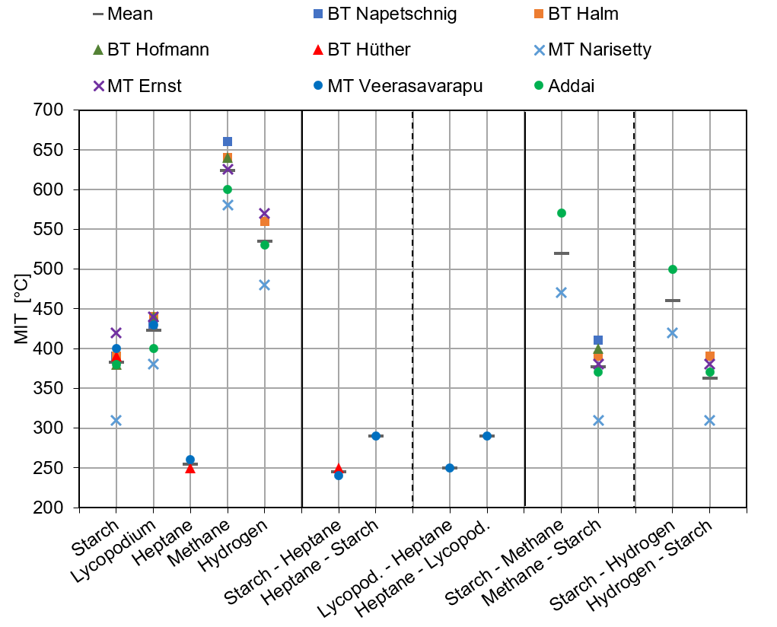
Figure 2: Summarized results of standard and hybrid MIT tests
    - Discussion
Looking in detail to the results presented in Figure 2 different findings can be highlighted. The variation within the results is rather big. The deviation from the mean value can reach more then 50 K. This is only partially correct, as the influence of the longer oven needs to be considered separately. All experiments in the longer oven lead to lower values. The reduction varies between 20 K and 50 K depending on the substances and the operator. The biggest influence can be seen for methane, where the standard oven leads to an MIT of 650 °C and the double length oven to 580 °C. The latter value is already below the standard MIT for gases listed in the CHEMSAFE database. The same holds true for Hydrogen with a standard value of 560 °C in the database and the short oven but 480 °C in the long GG oven. Nonetheless the variation of the MIT for the same setup is considered to be at least ± 15 K for the same operator and slightly bigger for different operators.
For Heptane only values in the short oven are available and the measured values lie 30 K above the standard value measured according to EN 14522. A reduction as described above can be expected for a longer tube as well.
First of all, the values for hybrid mixtures show that none of the hybrid MITs lies below the value of the lower igniting single substance. There is an influence but no combinatory effect.
Adding small amounts of Starch to an ignitable concentration of Heptane does not influence the MIT. On the other hand, the MIT of starch is lowered by 120 K due to the admixture of Heptane. The system Lycopodium and Heptane behaves similarly. The influence of Heptane on the MIT of Lycopodium is stronger (∆_{MIT}=140 K) as the differences in the MITs of the single substances is bigger (170 K to 150 K).
The data for hybrid mixtures with gases shows that here the general situation is the other way around as the MITs of the dusts are well below the MITs of the gases. The general outcome of the hybrid MIT experiments is equivalent as described before. There is almost no effect by mixing the higher igniting gas to the dust. The admixture of dust lowers the MITs of the gases. As long as the added amount of dust is not ignitable itself the hybrid MITs are still considerable above the MITs of the pure dust. But even smallest amounts of dust – way below the MEC – may be able to lower the MIT of the gas phase.
  - Conclusions

Within the research project setup and procedure were developed to measure MITs of hybrid mixtures. Extensive experimental work proofed the applicability and reliability. No relevant deviation from the measurements following the standards procedure and setup could be found. The general behavior of hybrid mixtures is noncritical. The component with the lower MIT dominates the hybrid behavior. There is no experimental evidence that a mixture of two components ignites below the MIT of the lower igniting substance. This is in line with theoretical expectations – no combinatory effect is to be expected. Repeatability for the same operator and different operators is given within a margin of ± 20 K at best.
The influence of the oven length did become obvious during the project. In all experiments that were conducted in both tube furnaces always a lower MIT could be found in the longer oven. Up to a certain degree the Ignition Temperature of the substances seems to be dependent on the length of the oven or the time the substance is subjected to the heat – resistance time. Besides this dependency there is a second apparatus standardizes that is giving different values, too. Thus, the questions must be asked, why the standard was originally not designed in a way to lead to a (practically) real minimum value. Looking back into the historical development of the Godbert Greenwald oven makes it obvious that this never was the original intention. [Eckhoff, 2019]
On the other hand, the MITs of gases and liquids measured in the double length oven is astonishing closed to the values according to the specific standard. This result must be taken with care, as it is well known that the MIT of gases and liquids is volume dependent, too. The bigger the test volume the lower the MIT. [Brandes et al., 2018]
All in all, the researchers themselves do not promote a further development of the existing standards to qualify for testing of hybrid mixtures. The obvious reason is that there is no critical behavior of hybrid mixtures as could be shown by the experimental data presented here. A more detail look at the experiment reveals the general weaknesses of the setup. As mentioned in the beginning no concentration can be given. Only the amount of substance introduced into the experiment can be determined. In fact, it is not known how much of the dust really goes into the oven. Separate experiments with different dust chambers showed considerable leftovers. Dependencies of the dispersion pressure and the kind of dust are obvious. On the other hand, there is no evidence that all of the liquid put into the evaporation chamber really is turned into gas. These thoughts include the fact that the distribution within the tube is unknown. Even if the video recording suggest that the dust is well distributed into the tube and having enough contact to hot wall the mixing with the second phase was not researched at all.
Next fact to be considered is the uneven temperature distribution in the tube. There is a clear temperature profile not only at the colder open end but within the oven due to the nonuniform application of the heating wire around the tube. The questions how and where the temperature is measured in the experiment becomes crucial.
A final weakness is the ignition detection. According to the standard the operator has to visually decide whether there was an ignition. The criterion – flame leaves the tube – does not work at all for the double length oven. Testing vapors and gases leads to the same problem with flame formation at the top of the tube that is hard to detect. Besides the results presented here systems for ignition detection were researched. A simple thin thermocouple proofed to be a reliable detection method. Besides the ignition detection measuring the air temperature in the oven seems to be a much more reliable way to define the oven temperature than the measuring the inner wall temperature as applied now (or the temperature at the outside of the Erlenmeyer flask as in EN 14522).
The existing standards to determine the MITs of gases, vapors and dusts fulfill their task, are well established and safety engineers know how to further apply the values. Considering hybrid mixtures, the user is sufficiently safe applying the lowest value of a single substance that can be found in a mixture. No lowest “concentration” value can give below that an influence can be excluded. Accepting this limitation there is no need to changed existing standard to test for hybrid mixtures.
On the other hand, the existing standards are historically developed and have their limitation. From a scientific point of view only a systematical new development would make sense to generally improve the quality of the MIT value. This cannot be done by modifying the apparatuses used so far
Finally, the question raised in the headline should be answered. Why no new standard?
The existing standards are sufficiently good, as long as you know their limitation. Simply modifying an existing standard does not considerably improve the situation. Developing a new standard would be a great effort, if an significant improve is to be made and good scientific work is to applied. Additionally, the new MITs might not be consistent with the exiting MIT values. This could be critical for standards referring to the existing ones and application by the practitioner.

Acknowledgments
Considerable part of this work has been performed within the research program ’Development of standardized determination methods for safety parameters of explosion protection for hybrid mixtures (NEX-HYS)’ funded by the German Federal Ministry of Economic Affairs and Climate Action - BMWi (grant number 03TNH006A).

References
Addai E.K., Addo A., Abbas Z., Krause U., 2017, Investigation of the minimum ignition temperature and lower explosion limit of multi-components hybrid mixtures in the Godbert-Greenwald furnace, Process Safety and Environmental Protection, 111, 785–794.
Brandes E., Hirsch W., 2018, Zündtemperaturen in großen Behältern, Physikalisch-Technische Bundesanstalt (PTB). DOI: doi.org/10.7795/110.20191105A.
CHEMSAFE - Database for Safety Characteristics in Explosion Protection (2022). URL: https://www.chemsafe.ptb.de/. accessed 21.04.2023
Eckhoff R. K., 2019, Origin and development of the Godbert-Greenwald furnace for measuring minimum ignition temperatures of dust clouds. In: Process Safety and Environmental Protection, pp. 17–24. ISSN: 0957-5820. DOI: //doi.org/10.1016/j.psep.2019.06.012.
El-Zahlanieh S., Jean A., Vignes A., Dufaud O., 2022, The role of vapor fraction in hydrocarbon mist explosion, Proceedings of the 14th International Symposium on Hazards, Prevention and Mitigation of Industrial Explosions (ISHPMIE 2022)", Braunschweig, Germany, DOI: 10.7795/810.20221154
Gabel D., Geoerg P., Napetschnig P., Krause U., 2022, Minimum Ignition Temperature of Hybrid Mixtures, Chemical Engineering Transactions, 90, 373-378.
Geoerg P., Spitzer S., Gabel D., Krause U., 2022, Where one plus one equals three: the MIT of hybrid mixtures, Proceedings of the 14th International Symposium on Hazards, Prevention and Mitigation of Industrial Explosions (ISHPMIE 2022)", Braunschweig, Germany, DOI: 10.7795/810.20221154
Heilmann V., Taiwo A., Hirsch W., Großhans H., Zakel S., 2022, Prenormative Study on the Safety Characteristics of Explosion Protection for Hybrid Mixtures of Dusts and Vapours, Proceedings of the 14th International Symposium on Hazards, Prevention and Mitigation of Industrial Explosions (ISHPMIE 2022)", Braunschweig, Germany, DOI: 10.7795/810.20221154
Spitzer S., Askar E., Benke A., Cloney C., D’Hyon S., Dufaud O., Dyduch Z., Gabel D., Geoerg P., Heilmann V., Jankuj V., Jian W., Krause U., Krietsch A., Mynarz M, Norman F., Skrinsky J., Taveau J., Vignes A., Zakel S., Zhong S., 2023, 1st international round robin test on safety characteristics of hybrid mixtures, Journal of Loss Prevention in the Process Industries, Volume 81, ISSN 0950-4230, doi.org/10.1016/j.jlp.2022.104947.

