CHEMICAL ENGINEERING TRANSACTIONS  VOL., 2023 | A publication of
The Italian Association
of Chemical Engineering
Online at www.cetjournal.it
Guest Editors: Sabrina Copelli , Richard Siwek
Copyright © 2023, AIDIC Servizi srl .
isbn ; ISSN 2283-9216

Modeling of the risk of forest fires for the Andean community Picol Orcompugio, Cusco – Peru.
Danny Lizarzaburu-Aguinagaª*, Wendoly Suarez Muñozª, Juan J. Ordoñez Galvezª, Eusterio Acosta Suasnabarª, Carlos A. Castañeda-Oliveraª, Carlos del Valle Jurado^{b}
ªUniversidad César Vallejo, Av. Alfredo Mendiola 6332, Lima 15314, Perú.
^{b}Universidad Nacional Mayor de San Marcos, Lima, Peru
* Corresponding: dlizarzaburu@ucv.edu.pe
In Peru, the risk of forest fires is common in different regions, only in the Cusco region by October 2022 there were 10 active fires (COER, 2022), these disturbances play a role in the dynamics of the ecosystems, decimating the ecosystem services that in turn affect the economy in the area. One of the most common origins of these fires is the use of fire as a tool to clear and prepare the soil; Other origins are weather conditions, due to the effect of global warming, which alters the patterns of rainfall and solar incidence (Armenteras et al., 2020); That is why the need arises to model the risk of forest fires that can break out in the San Gerónimo district, specifically in the Andean community of Picol Orcopungio, due to its low response capacity and level of poverty. The information was collected based on historical forest fires and the analysis of meteorological variability in the previously delimited area, which allowed the development of maps of temperature, humidity, precipitation, and wind speed, as inputs for the modeling of possible forest fires in the area. The results of the investigation showed valuable information on the characteristics of the Andean Community, the mapping of meteorological conditions, and the modeling of fire risk for agricultural areas, forest areas, and community areas. The investigation concludes that the characteristics of the Andean Community and the meteorological conditions of the study area present a high risk and contribute to the formation of forest fires, it also presents a risk model that allows for managing prevention and emergency operations in the Andean community.
  - Introduction
In the years 2019 and 2020, anomalous incendiary activity was recorded, and geographical areas such as the Arctic, Europe, Oceania, and the Amazon have been involved in severe fires, affecting countries such as the United States, Sweden, Norway, Australia, Indonesia, Chile, Peru, and Brazil. The Copernicus Atmospheric Monitoring Service (CAMS) determined that more than 345,940 surface hectares had burned, generating a scenario that aggravates climate change (Angra and Sapountzaki, 2022), due to the millions of tons of CO₂ released (Hernandez, 2020). Similarly, in Peru, there have been nearly 1800 forest fires affecting the high mountain ecosystem (Zubieta et al., 2023). One of these affected regions is Cusco, where the Picol Orcompugio Peasant Community (CC) is located, with an area of 1,510 ha of high Andean grasslands and scrub susceptible to fires (Provincial Municipality of Cusco, 2013). Reporting in 2019 a forest fire of 600 ha of destroyed cover (National Emergency Operations Center, 2019) due to anthropogenic and natural causes, as a result of agricultural activity and the existing meteorological conditions in the area; This situation generates problems such as air pollution (Sahu et al., 2022), soil erosion (Grünig et al., 2022), water pollution (Nam et al., 2023), water disposal for human consumption (Ayra et al., 2021) and affects the health of the population (Moore et al., 2023). The main objective of this research was to develop a map of the potential risk of forest fires in the community of Picol Orcompugio. For this, it was necessary to determine the geographical and meteorological characteristics of the area (Kumar and Kumar, 2022) and to prepare a map of the vulnerable areas of the CC of Picol Orcompugio. The map allows local and regional authorities to make more assertive decisions in the prevention, expansion, and control of forest fires.
  - Methodology
The investigation allowed systematizing the information for the elaboration of a risk map of potential forest fires developed in four stages (see Figure 1), where the area in the Rural Community of Picol - Orcompugio - Cusco - Peru has previously been delimited during 2020, based on information from the San Gerónimo forest fire contingency plan.

Figure 1. Diagram of the development of the investigation procedure
    - Primary data collection.
The compilation began by recognizing the areas affected by forest fires in 2020 (see Table 1) through the reports from the San Jerónimo district fire station and contrasted with the fire alert from the National Forestry and Wildlife Service. (SERFOR), the importance of this information lies in understanding how the area affected by the fires developed to later understand the current forest structure and its ecological processes, which allows better information for the analysis of these events (Boothman and Cardille, 2022); Georeferencing (ArcGIS) of the affected areas made it possible to locate and delineate the forest fires in the area (Chaudhary et al., 2022).
Table 1: Points of forest fires that occurred in CC Picol Orcompugio - 2020
Number | Zones | Number of hectares destroyed (ha) | Date and Time
1 | Picol – Santa Maria  (Ecological Reserve) | 8 | 10/05/2020 / 5:45 p.m.
2 | Cerro Picol – Larapa | 8 | 10/05/2020 / 9:20 p.m.
3 | Santa Maria | 2 | 11/23/2020 / 11:00 a.m.
4 | Picol hill | 20 | 11/23/2020 / 12:20 p.m.

Subsequently, the meteorological stations in the study area were identified through the National Meteorology and Hydrology Service (SENAMHI), to extract the meteorological data from four stations. These stations are shown in Table 2.
Table 2: List of weather stations used in the research
Weather Station | Province | District | Latitude | Length | Altitude
New Pisac | Tracing | Pisac | 13° 25´ 21.50” S | 71° 51´ 13.90” W | 2966
Cay Cay | Quispicanchi | Andahuaylillas | 13° 35´ 59.96” S | 71° 42´ 01.00” W | 3117
Kayra | Cusco | St Geronimo | 13° 33¨ 24.29” S | 71° 52´ 30.61” W | 3214
Colquepata | paucartambo | Colquepata | 13° 21´ 47.27” S | 71° 40´ 24.10” W | 3696
    - Characterization of the peasant community of Picol Orcompugio
Orcompugio was achieved, elaborating the location map of the area with field recognition through the support of Geographic Information Systems (GIS) tools (Figure 2), to identify the factors and most significant elements of the spatial area (forestry, agriculture, and grasslands) that interact with the presence of fires, and the population impacted by the event (see Figure 3).
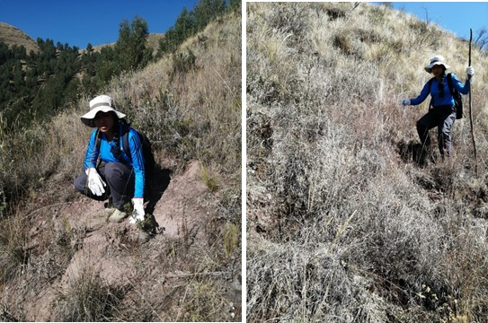 | 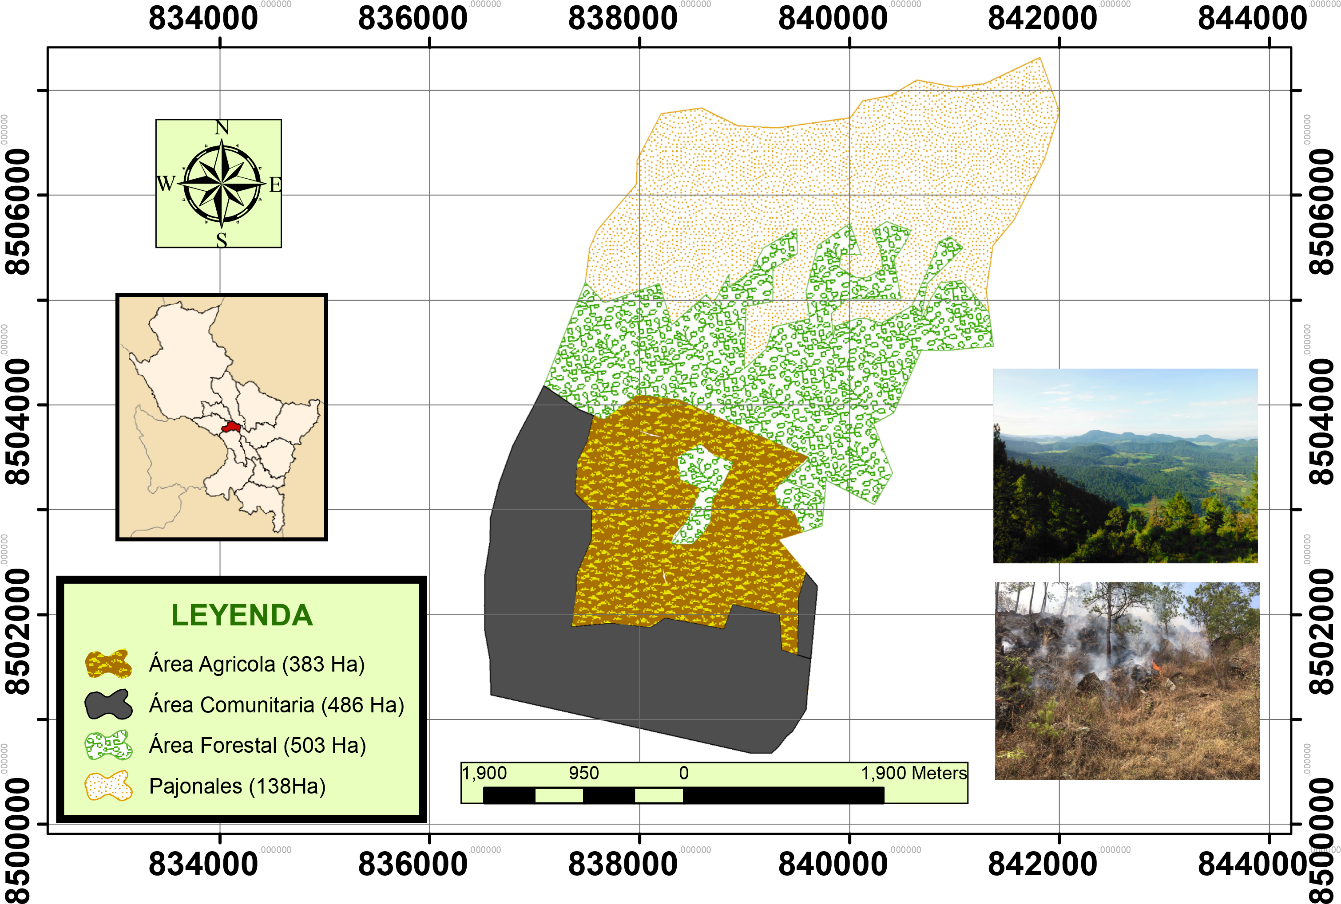
Figure 2. Field recognition in the peasant community of Picol Orcompugio. | Figure 3. Characterization of the spatial elements in the peasant community of Picol - Orcompugio
    - Characterization of meteorological variables.
The meteorological data collected in the SENAMHI database for the Cusco region was processed biweekly, for the period January 2020 to January 2021, and analyzed to guarantee its spatial and temporal representativeness, as well as the determination of the gradients of each variable (Figure 4). Subsequently, georeferenced points were taken in the GIS tool, to obtain fictitious stations (Table 3) to prepare the calculation of climate information.

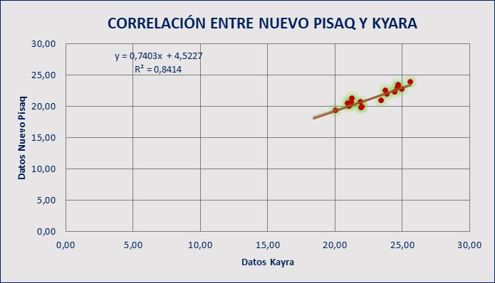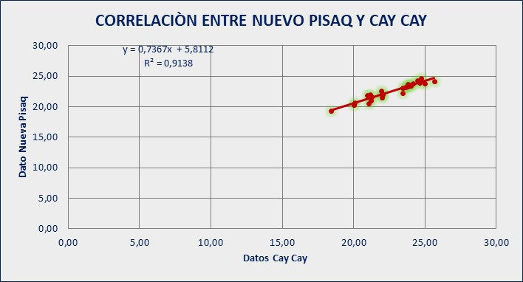
Figure 4. Consistency analysis of meteorological data
Table 3: UTM coordinates for the preparation of the climate map.
Spot | Altitude | Latitude | Length | Spot | Altitude | Latitude | Length
1 | 3973.26 | -13.49 | -71.88 | 11 | 3662.67 | -13.52 | -71.87
2 | 4334.09 | -13.49 | -71.86 | 12 | 3957.75 | -13.52 | -71.86
3 | 4385.37 | -13.48 | -71.84 | 13 | 3717.90 | -13.52 | -71.86
4 | 4154.01 | -13.50 | -71.85 | 14 | 4049.51 | -13.51 | -71.86
5 | 4067.79 | -13.51 | -71.87 | 15 | 4137.81 | -13.51 | -71.86
6 | 4150.15 | -13.51 | -71.88 | 16 | 3474.68 | -13.53 | -71.87
7 | 4287.93 | -13.50 | -71.88 | 17 | 3377.45 | -13.53 | -71.88
8 | 3872.32 | -13.51 | -71.89 | 18 | 3446.92 | -13.53 | -71.86
9 | 3894.63 | -13.51 | -71.88 | 19 | 3625.69 | -13.52 | -71.88
10 | 3840.83 | -13.51 | -71.87

The meteorological maps were used to characterize the study area with the monthly average values of the meteorological variables (temperature, humidity, and precipitation), the relief of the area, and the information on the wind dynamics (wind speed) taken from the meteorological station of Nuevo Pisac (the only station with these data), all this was integrated to later correlate them with the points of historical forest fires (Tian et al., 2022).
  - Results and discussion
Below are the geographical and meteorological analyses contrasted with the historical information on the forest fires that allowed the development of the potential map of fire risks, a tool that allows for improving risk management and decision-making by the authorities (Mishra et al., 2023).
    - Meteorological maps of the CC of Picol Orcompugio.
The different meteorological maps (temperature, heat sources, rainfall, and relative humidity) can be seen in Figures 5a, 5b, 5c, and 5d. These conditions play a preponderant role in the process of the occurrence of forest fires of natural origin; due to the state of humidity of the basin and the conditions of thermal intensity, which makes this area a favorable place for the presence of said event (Yesquen et al., 2021).

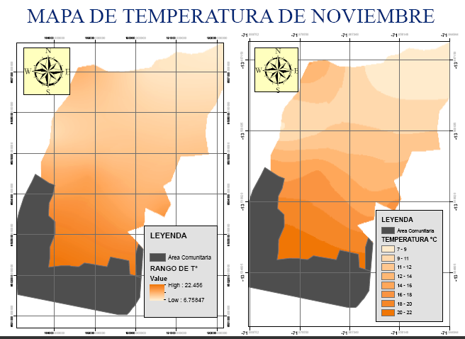 | 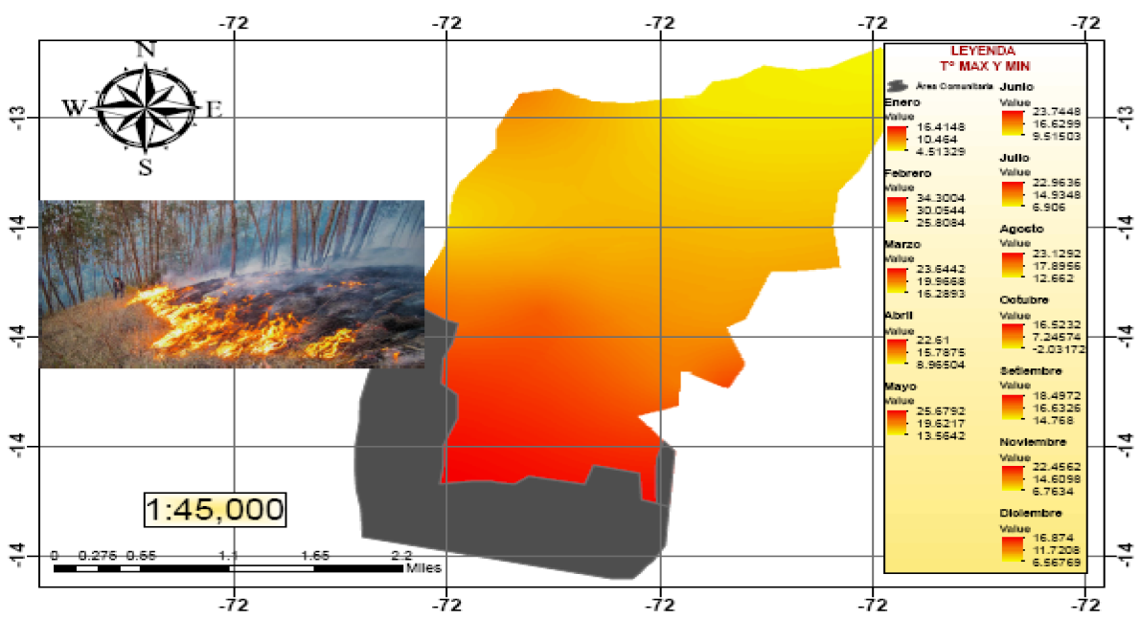
Figure 5a. The temperature gradient of CC Picol - Orcopungio | Figure 5b. Hot spots of the CC de la Picol – Orcopungio
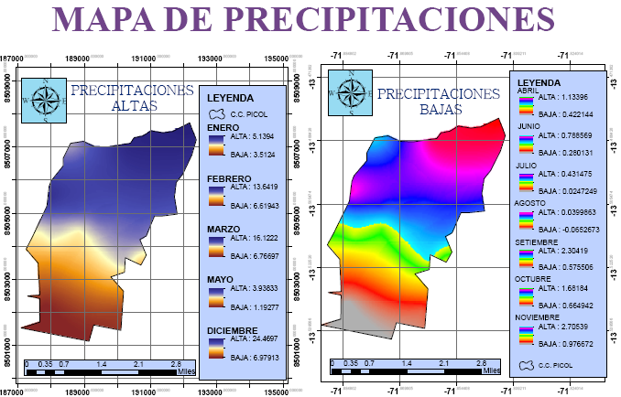 | 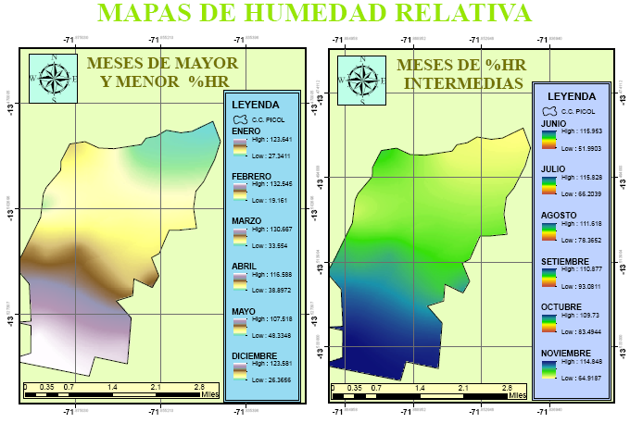
Figure 5c. High and low rainfall of CC Picol - Orcopungio | Figure 5d. Relative humidity of CC Picol – Orcompugio

The temperature of the rural community is variable (Figures 5a and 5b) depending on the time of year, with temperatures from 4.5 °C to 34.4 °C and clear skies at noon in the rainy season and -2.03 °C at 25.7 °C in the dry season. Being the minimum values at dawn. The precipitations are appreciated in Figure 5c on the left side the months with high precipitations that fluctuate between 1.2 mm/ day and 24.5 mm/ day and on the right side the low precipitations that fluctuate between 0.02 mm/ day and 2.7 mm/ day are shown. The data was also analyzed, intercepting high temperatures and low rainfall, identifying that in the months of June to October, greater conditions are generated that favor the ignition of the fire. The relative humidity variable presented mostly close average values (60% - 70%), evidencing that it is not an important factor at the time of a forest fire; however, it must be considered that the environment is being analyzed and not the vegetation cover (Jo et al., 2023).
    - Map of the area affected by fires in the CC of Picol Orcompugio.
In the elaboration of this map, it was necessary to identify the area of the fires with the critical and sensitive points in the proliferation of the fires, for which fieldwork was carried out to help position the areas affected by the fires that occurred in 2020. For this, it was necessary to integrate, through GIS tools, the location map of the study area with its relief characteristics (forest, agricultural, grassland, and peasant community) with the map of the area of forest fires for the period 2020, as shown in Figure 6.
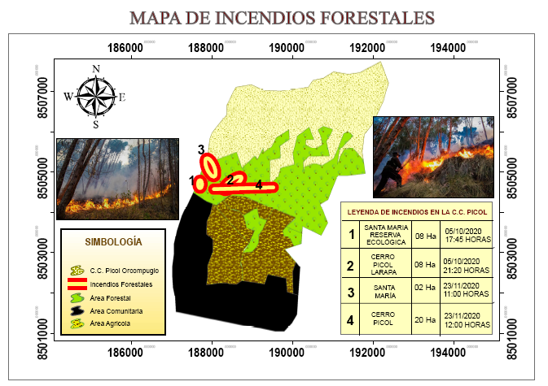
Figure 6. A map identifying the fire points at the Picol- Orcompugio CC
    - Potential fire risk map.
Based on the analyzes developed for each of the variables selected as incidence factors in the occurrence of forest fires in the Picol Rural Community, both from the natural and anthropic points of view, it has allowed them to be integrated and finally obtained the potential map of fire risk (Figure 7), where the areas susceptible and potential to the presence of fires with temperatures ranging between 13 °C and 17 °C can be seen, predominantly in forest and agricultural areas and subject to adverse weather conditions (little precipitation and high heat sources).

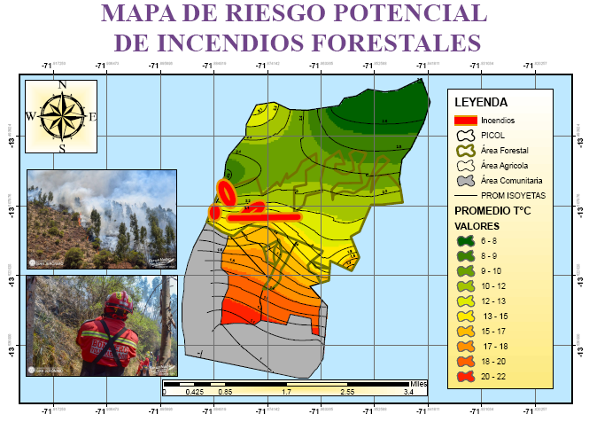
Figure 7. Map of the potential risk of forest fires in the rural community of Picol
  - Conclusion
The geographical conditions of the Picol- Orcopungio CC, slopes and forest area where thorny grasslands and dry scrub predominate increase the risk of ignition and expansion of forest fires, and given that these areas constitute the habitat of different endemic species, it becomes an area highly vulnerable for the forest in the area. The flood or low water conditions characterized in the community by presenting a temperate climate in the lower part of the valley and cold in the upper part (bimodal) throughout the year, coupled with the absence of water in the months of April to October raises the risk of a forest fire. The map of the areas affected by the fires showed an impact of 38 ha of the forest area and, alternatively to the collection of information, some anthropic causes for the occurrence of fires and fires arose (burning of bushes for recreational activities or clearing of agricultural land). Therefore, it is concluded that the elaboration of the map of the potential risk of forest fires shows us the areas of greatest and least risk of the presence of fires, leaving the authorities a management instrument to prevent, manage and control contexts like those presented historically.

Acknowledgments:
The authors of this research thank the Research Group on Environmental Management and Waste Treatment (GIGATRE) of Universidad César Vallejo for their support in the development of this research.
References
Angra D., and Sapountzaki K., 2022, Climate Change Affecting Forest Fire and Flood Risk—Facts, Predictions, and Perceptions in Central and South Greece. Sustainability (Switzerland), 14(20). doi.org/10.3390/su142013395
Armenteras D., González TM, Vargas JO, Meza Elizalde MC, and Oliveras, I., 2020, Fires in northern South American ecosystems: advances in tropical fire ecology in Colombia, Ecuador, and Peru. Caldasia, 42(1), 1–16. doi.org/10.15446/caldasia.v42n1.77353
Ayra HPN, Jordan, MJL, Olivera, CAC, Alfaro, EGB, and Galvez, JJO, 2021, Water sustainability of the Yanacocha lagoon: Future scenarios for the population of carhuamayo, Junin, Peru. Chemical Engineering Transactions, 86(February), 487–492. doi.org/10.3303/CET2186082
Boothman R., and Cardille JA, 2022, New techniques for old fires: Using deep learning to augment fire maps from the early satellite era. Frontiers in Environmental Science, 10(August), 1–15. doi.org/10.3389/fenvs.2022.914493
National Emergency Operations Center. (2019). Forest ^{Fire} in the District of San Jerónimo - Cusco -DE-PICHIRHUA-APURÍMAC.pdf˃ accessed 24.03.2023.
Chaudhary SK, Pandey AC, and Parida, BR, 2022, Forest Fire Characterization Using Landsat-8 Satellite Data in Dalma Wildlife Sanctuary. Remote Sensing in Earth Systems Sciences, 5(4), 230–245. doi.org/10.1007/s41976-022-00076-3
COER., 2022, Cusco Region registers 10 active forest fires. Peruvian State. <www.gob.pe/institucion/regioncusco/noticias/659781-region-cusco-registra-10-incendios-forestales-activos> accessed 10.02.2023.
Grünig M., Seidl R., and Senf C., 2022, Increasing aridity causes larger and more severe forest fires across Europe. Global Change Biology, November 2022, 1648–1659. doi.org/10.1111/gcb.16547
Hernandez, L., 2020, The Planet on Fire. In WWF Spain.
Jo HW, Krasovskiy A., Hong M., Corning S., Kim W., Kraxner F., and Lee WK, 2023, Modeling Historical and Future Forest Fires in South Korea: The FLAM Optimization Approach. Remote Sensing, 15(5). doi.org/10.3390/rs15051446
Kumar S., and Kumar A., 2022, Hotspot and trend analysis of forest fires and its relation to climatic factors in the western Himalayas. Natural Hazards, 114(3), 3529–3544. doi.org/10.1007/s11069-022-05530-5
Mishra B., Panthi S., Poudel S., and Ghimire BR, 2023, Forest fire pattern and vulnerability mapping using deep learning in Nepal. Fire Ecology, 19(1). doi.org/10.1186/s42408-022-00162-3
Moore LE, Oliveira A., Zhang R., Behjat L., and Hicks A., 2023, Impacts of Wildfire Smoke and Air Pollution on a Pediatric Population with Asthma: A Population-Based Study. International Journal of Environmental Research and Public Health, 20(3), 1937. doi.org/10.3390/ijerph20031937
Provincial Municipality of Cusco. (2013). Cusco Urban Development Plan by 2023.
Nam S., Yang H., Lim H., Kim J., Li Q., Moon H., and Choi HT, 2023, Short-Term Effects of Forest Fire on Water Quality along a Headwater Stream in the Immediate Post-Fire Period. Water (Switzerland), 15(1). doi.org/10.3390/w15010131
Sahu RK, Hari M., and Tyagi B., 2022, Forest Fire Induced Air Pollution over Eastern India during March 2021. Aerosol and Air Quality Research, 22(8), 1–12. doi.org/10.4209/aaqr.220084
Tian Y., Wu Z., Li M., Wang B., and Zhang X., 2022, Forest Fire Spread Monitoring and Vegetation Dynamics Detection Based on Multi-Source Remote Sensing Images. Remote Sensing, 14(18), 1–20. doi.org/10.3390/rs14184431
Yesquen DLN, Ayala KKL, Olivera CAC, Nakayo JLJ, Flores JWV, and Farfán, ERE (2021). Impact of climate variability on the ecological components of a swamp: The case of Pantanos de Villa, Peru. Chemical Engineering Transactions, 86(May), 493–498. doi.org/10.3303/CET2186083
Zubieta R., Ccanchi Y., Martínez A., Saavedra M., Norabuena E., Alvarez S., and Ilbay M., 2023, The role of drought conditions on the recent increase in wildfire occurrence in the high Andean regions of Peru. International Journal of Wildland Fire. doi.org/10.1071/WF21129

