CHEMICAL ENGINEERING TRANSACTIONS  VOL., 2023 | A publication of
The Italian Association
of Chemical Engineering
Online at www.cetjournal.it
Guest Editors: Sabrina Copelli, Richard Siwek
Copyright © 2023, AIDIC Servizi S.r.l.
ISBN ; ISSN 2283-9216

CFD Simulation of Explosions in Fired Combustion Chambers
Vicenç Espejo^{a,b}, Artemis Papadaki^{b}, Joaquim Casal^{b} and Eulàlia Planas^{b*}
ªVysus Consulting Spain, S.L., (VYSUS GROUP Company) Carrer Orient, 78-84, floor 4, Office 16, 08172, Sant Cugat del Vallés, Barcelona, Catalonia, Spain
^{b} Centre for Technological Risk Studies (CERTEC), Barcelona East School of Engineering (EEBE), Universitat Politècnica de Catalunya, Avinguda Eduard Maristany 16, 08019, Barcelona, Catalonia, Spain
*Corresponding auhor: eulalia.planas@upc.edu
A wide range of equipment (boilers, furnaces, reformers, etc.) in industrial processes use fired combustion chambers to retrieve heat from a fuel. Although these systems have been used since long time and their safety has been significantly improved, explosions related with disturbances in the firing chamber still occur with certain frequency. The experimental testing of these explosions is challenging due to the complex design and large volume of combustion equipment, along with the presence of internal elements (heating tubes, burners, ignitors) and explosion relief panels. Moreover, empirical explosion evaluation methods may lack accuracy by not considering overpressure reflections and the effects of internal elements. Computational Fluid Dynamics (CFD) models are becoming nowadays accessible and runnable with ordinary desktop computers. In the present work, GEXCON FLACS software has been used to evaluate the effects of explosions inside combustion chambers. The results obtained confirm the potential utility of CFD simulations to analyze this type of explosions.
  - Introduction
Many processes use combustion chambers to generate heat to be used in a process. One of the best-known hazards related to these facilities corresponds to explosions with subsequent damages to people, assets and environment (Mannan and Lees, 2005). These accidents keep occurring nowadays (Espejo et al., 2021). The detailed evaluation of such explosions can be useful in mitigating potential risks and improving the design of systems and associated protective measures.
Typical explosion evaluation methods (such as the TNT equivalency or the Baker-Strehlow-Tang ones) are empirical correlations based on the amount of flammable substance, its characteristics, and correlation factors defined by the methodology (Casal, 2018). These models might not be directly applicable to explosions within combustion chambers, primarily due to their occurrence in congested volumes as pointed out by Edri et al. (2019). Moreover, these models may lack sensitivity to the presence of internal elements, which can induce turbulence and accelerate the flame, as well as the influence of explosion relief panels.
Experimental investigation of this phenomenon can be challenging and expensive due to the high cost of real equipment, However, Computational Fluid Dynamics (CFD) simulators are now readily available and can be run on standard desktop computers using various commercial or open source software solutions. Detailed simulations of the explosion process can overcome potential limitations of empirical explosion modeling tools.
  - Simulation setup
    - Study cases considered
In the current study, two representative simulation cases were examined, each representing distinct combustion chamber designs documented in the existing literature. For the purpose of comparison and to adopt a worst-case scenario, the following conditions were applied: a homogeneous filling of the combustion chamber with a methane-air mixture, where the methane concentration corresponded to an Equivalence Ratio (ER) of 1.081 (see Table 1). The ignition source was positioned in a volume surrounding the furnace burners and ignitors, covering the entirety of the combustion chamber section and extending to a height of 1 m. The details of the simulation cases are described below.

(a) | (b) | (c) | (d)
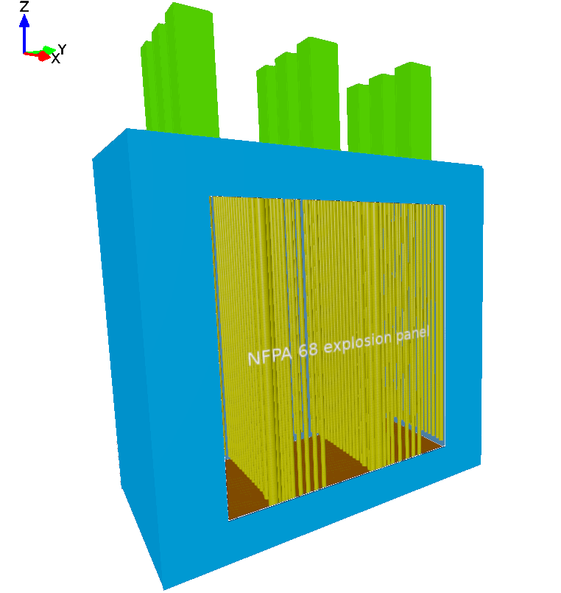 | 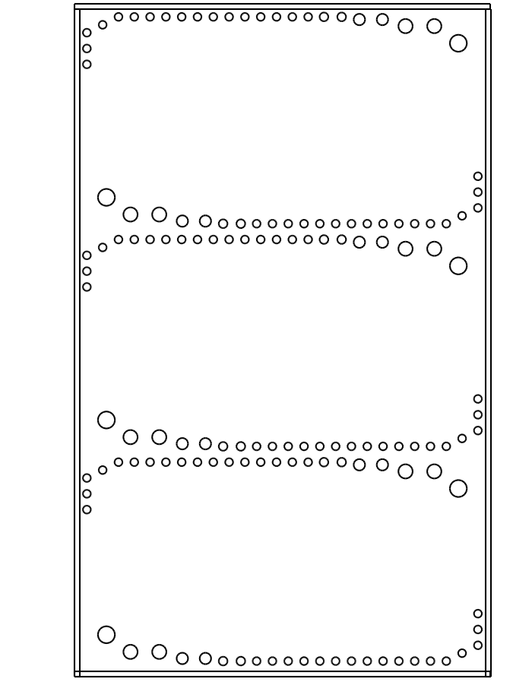 | 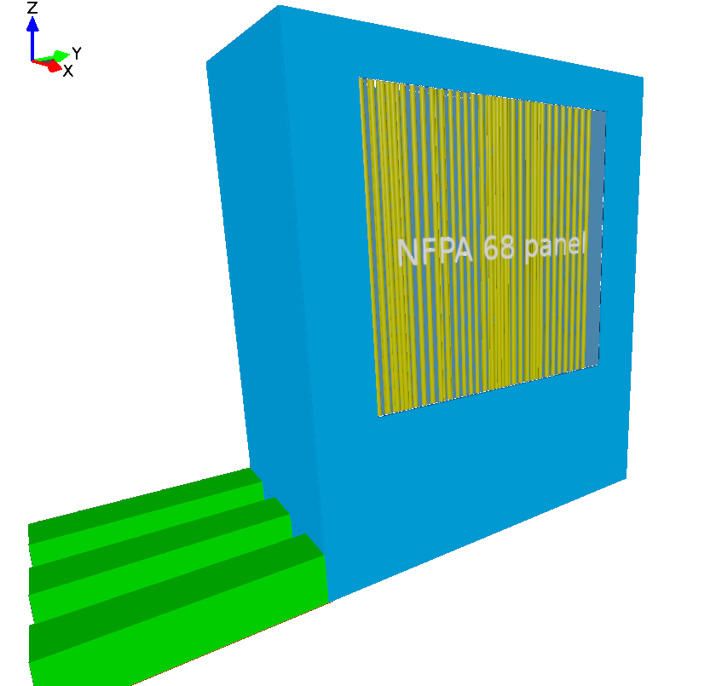 | 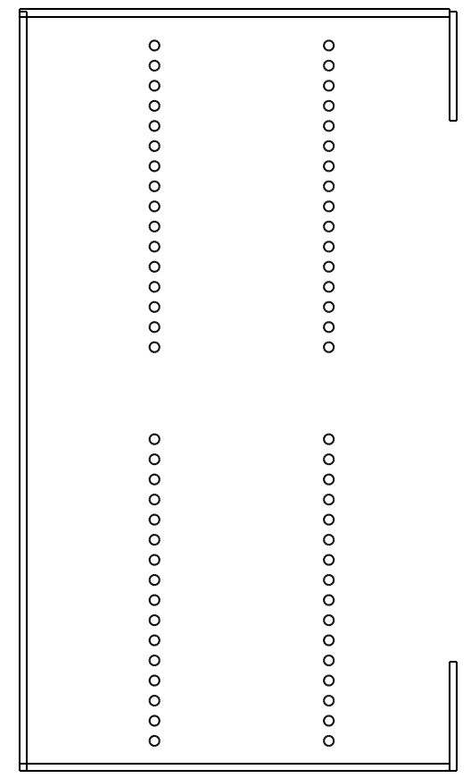
Figure 1: a) General 3D view of the vacuum furnace (Case 1). Smoke ducts are represented in green, combustion chamber in blue and the reforming tubes in yellow, lateral explosion panel is semi-transparent. b) Horizontal 2D (XY) view of the vacuum furnace with details of tubes distribution and diameters. c) General 3D view of the steam methane reformer (Case 2). Flue gases ducts are represented in green, combustion chamber in blue and the reforming tubes in yellow; explosion panel is semi-transparent. d) Horizontal (XY) 2D cut of the steam methane reformer with details of tubes distribution and diameters.
CASE 1: Vacuum furnace 20 MW
First simulation case corresponds to a vacuum furnace (VF) described by Li et al. (2015). The ANSYS CFX simulation suite was used in the cited article to model the flue gas flow through the combustion chamber and to assess the efficiency of the burners in relation to the position of the internal tubes. The furnace geometry is a rectangular box with dimensions (7.9 x 4.2 x 13.1) m³ (L x W x H), where the burners are located on the floor in three rows. Each row is surrounded by a set of tubes whose diameter varies depending on the content being heated. Three smoke ducts per row are located opposite the burners to connect the chamber with the convective area and the flue gas treatment process (Figure 1a-b). For calculation and sensitivity purposes, an explosion panel sized according to NFPA 68 (NFPA, 2018) was included to the model.

CASE 2: Steam methane reformer 17 MW
The second case considered is a steam methane reformer (SMR) described by Tutar et al. (2021). This SMR has a capacity of 17 MW and is designed to produce hydrogen from methane using 64 reforming tubes. The original article focused on optimizing the flame and radiation on the reforming tubes to improve the performance of the equipment. The combustion chamber of the SMR is a rectangular prism measuring (9.8 x 5.5 x 11.9) m³. It has 30 burners located on the ceiling arranged in three rows. Between each row, two groups of 16 reforming tubes are located. The flue gases are collected by three channels located on the floor and opposite the burners (Figure 1c-d). In this study, an explosion panel was included in the design, sized according to NFPA 68 standard (NFPA, 2018).
    - Simulation software
GEXCON FLACS v.21 was used for the simulations. FLACS is a CFD software specially designed for the simulation of safety scenarios in industrial environments. The code is based on the finite volume method, and it solves the Reynolds Averaged Navier-Stokes (RANS) transport equations, including mass, momentum, enthalpy, kinetic energy, dissipation, mass-fraction, and mixture, on a structured 3D Cartesian grid (Gexcon AS, 2021). The simulation grid is a rectangular static mesh defined using the concept of porosities, which can integrate complex geometries.
FLACS software was selected for the present work as it has been specially validated for gas explosions applications (Hjertager et al., 1988). Further information on the model or validation works are available in the literature (Hansen et al., 2010).
    - Mesh definition and boundary conditions
A cubic regular mesh was used to define the simulation domain inside the combustion chambers. Each control volume located in the simulation area had a length of 1 cm. This size was defined by the minimum distance between tubes to avoid any non-real obstruction to flow inside the furnace. The simulation domain was extended by at least 1 m from combustion chamber walls outside the equipment, except towards explosion panel opening direction, which was extended to 70 meters to evaluate the relief of pressure wave. To optimize the calculation time, the grid size outside the combustion chamber was increased by a ratio of less than 1.20 in the venting direction, following FLACS best practice guidelines (Gexcon AS, 2021) to avoid calculation instabilities. Apart from the effect of explosion panels, the simulation mesh and geometry were not modified during the simulation.
    - Simulation parameters
The main simulation parameters are included in table 1. In FLACS, the time step criteria for simulations are defined by the CFL (Courant-Friederichs-Levy) numbers. These numbers are time-dependent and based on the grid size. As per best practices for explosion simulations, the CFLC and CFLV numbers should ensure that in each time step, the speed of sound does not propagate more than 5 times the local grid cell and the convective flow is not propagated more than half a grid. It is worth noting that lower CFL numbers require more iterations and increase the calculation time, and higher numbers may lead to underestimated or non-converging results due to numerical instabilities of the model.
Table 1: Simulation parameters
Parameter | Value | Comment
Gas composition | 100 % methane | Natural gas assimilated
Equivalence ratio | 1.081 | Methane-air concentration with higher deflagration index (K_{G})* and lower ignition energy (Faghih et al., 2016).
CFLC / CFLV | 5 / 0.5 | FLACS Best Practice for Explosions and numerical stability.
Time of ignition | 0.5 s | -
DTPLOT | 0.015 | Simulation output parameters are recorded at least every 0.015 s of simulation.
Minimum simulation time | 0.8 s | Assumed enough to handle the explosion and far field effects.
Timestep code | Keep_low | Necessary to maintain CFL numbers low to avoid lower iterations for far field effects (Rosas et al., 2014).
Boundary conditions | Euler | Momentum and continuity equations are solved in the boundary with no flow restrictions.
*K_{G}: Deflagration index, maximum increase of pressure in time, normalized by volume. K_{G} = (dP/dt)_{max} x V^{1/3}
    - Explosion relief panels
FLACS can simulate the effect of explosion relief panels. The explosion panels act as a geometry with a defined porosity which is modified when the net pressure in one side of the panel exceeds the defined opening pressure. The parameters that were considered to include the relief the panels are listed in Table 2.

Table 2: Explosion panels definition
Parameter | Value | Comment
Size | VF 20 MW: 88 m²  SMR 17 MW: 49 m² | According to NFPA 68 (NFPA, 2018).
Type | Popout | --
Opening pressure | 35 mbarg | According to NFPA 86 (NFPA, 2015).  Panel yields when net pressure over the panel exceed the opening pressure.
Initial / final porosity | 0 / 95 % | No mass allowed at initial time, 95% when panel pops out
Weight | 80 kg/m² | Considered for a typical density of steel and 1 cm width.
  - Results and discussion
    - Overpressure inside the furnaces
The ignition of fuel and air mixture causes pressure to build up within the combustion chamber. Maximum overpressures for any control volume inside the combustion chamber, and the time needed from ignition to be achieved were evaluated. Although these maximum overpressures were obtained in very small control volumes (1 cm³), they were considered as a measure of overpressure built up in the simulation for comparison purposes. In order to assess the impact of combustion chamber design on the obtained results, three distinct scenario variations were considered: (1) the furnace in its original configuration, (2) the furnace without internal tubes, and (3) the furnace without an explosion relief panel.
Table 3 provides evidence that the CFD simulator exhibited sensitivity to specific characteristics and designs of the simulated scenarios. It was observed that in both cases, overpressures were marginally lower when internal elements were excluded. The presence of internal elements can induce turbulence during flame propagation, thereby augmenting combustion rates and subsequently resulting in higher overpressures.
Table 3: Maximum overpressure in control volumes within the combustion chamber and time from ignition.
CASE | Furnace in its original configuration |  | Furnace with no internal elements |  | Furnace with no relief panels
 | Max. pressure (barg) | Time  (ms) | Max. pressure (barg) | Time  (ms) | Max. pressure (barg) | Time  (ms)
1. VF 20 MW | 8.3 | 41.5 | 6.4 | 40.7 | 16.4 | 60
2. SMR 17 MW | 12.0 | 61 | 11.4 | 59 | 26.8 | 54

In scenarios where explosion relief panels were not taken into account, the maximum pressures within the combustion chambers exhibited a considerable increase, nearly doubling the values of the maximum overpressure obtained. Despite the presence of explosion panels, the maximum overpressure recorded in the control volumes remained at levels significant enough to pose a potential risk of complete or critical equipment destruction. For detailed analysis of the effect on the furnace structure, the expected overpressures on the combustion chamber walls provided by the CFD simulator are depicted in Figure 3.

(a) | (b) | 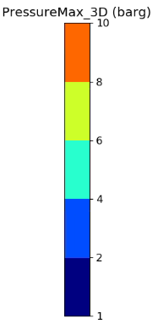
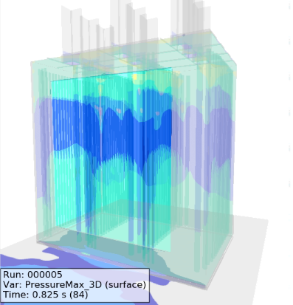 | 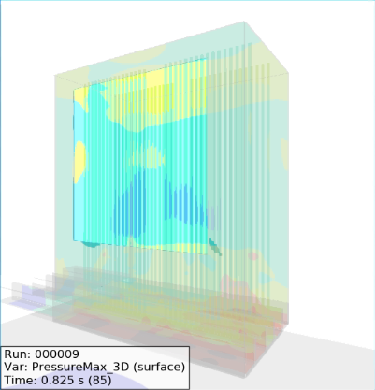
Figure 3: Overpressures applied to the furnace structure. a) Vacuum 20 MW case. b) SMR 17 MW case
Based on the obtained results it is evident that, while the equipment experiences high overpressures during an explosion, the impact on its geometry is non-uniform, with areas experiencing a wide range of pressures from 1 to 6 or 8 barg depending on the case. For VF 20 MW scenario, the combustion chamber walls were subjected to overpressures higher than 6 barg, while in the SMR 17 MW case overpressures to the structure of the combustion chamber exceeded 8 barg. The higher values obtained in the SMR 17 MW case can be attributed to the higher density of internal tubes distribution. In both cases overpressures of 1 barg to the structure were widely exceeded, so the destruction of the equipment could be expected.
Interestingly, both cases exhibited higher overpressures on the side opposite to the ignition point. This behavior can be attributed to the explosion phenomena initiated at the ignition region and accelerated across the equipment during flame propagation.
Upon ignition of the gas, the resultant overpressure remained confined within the combustion chamber until the net pressure on the side of the explosion panels surpassed the defined maximum allowable pressure. Figure 4a illustrates the overpressure development within the VF 20 MW case just prior to the activation of the relief panel, presented in a horizontal (XY) 2D cut at a height of 3.45 meters. In this analysis, pressures exceeding the maximum yield pressure were partially observed on the surface of the panel. However, at a height of 10 meters (Figure 4b), no overpressures were present, indicating that the propagation of the explosion had not yet encompassed the entire surface of the panel.

(a) | (b) | 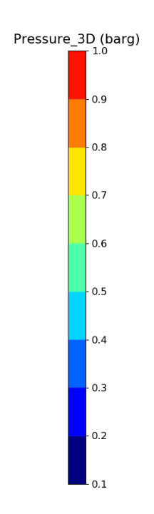
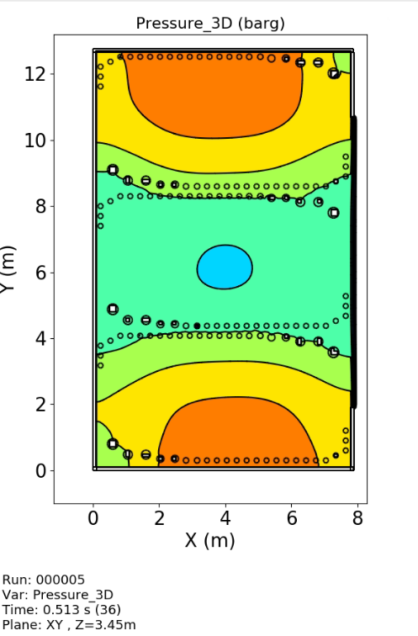 | 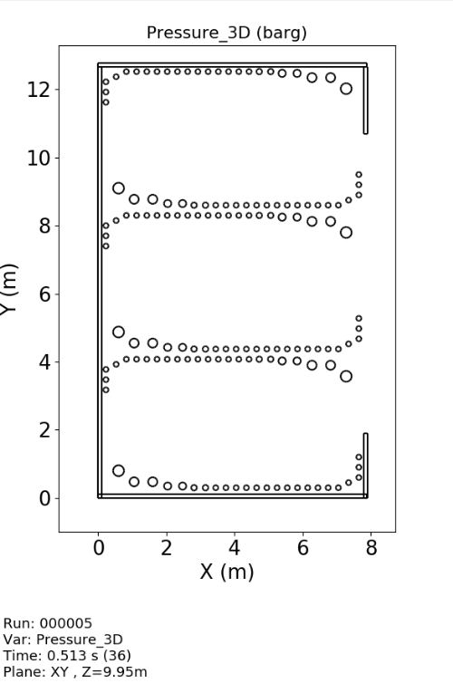
Figure 4: Overpressure in the VF 20 MW prior to relief panel opening. a) At 3.45 m height. b) At 10 m height.
    - Evaluation of detonation probability
The inclusion of tubes in the simulation led to the augmentation of turbulence, resulting in higher overpressure levels. This observation suggests the potential for flame front acceleration and the occurrence of the Deflagration to Detonation Transition (DDT) phenomenon. In cases where detonation is likely, it is essential to adjust simulation control parameters to accommodate higher calculation complexities, ensuring numerical stability and preventing the underestimation of results (Rosas et al., 2014).
FLACS can be used to predict the likelihood of a DDT occurrence. It can be estimated evaluating the parameter DPDX, which is defined as a non-dimensional spatial pressure gradient across the flame front. A DPDX value of 5 or greater indicates that DDT is likely to occur (Rosas et al., 2014). Figure 5a shows the maximum DPDX values obtained for the simulated cases. In both cases, the DPDX values never exceeded a threshold of 5, indicating that the development of detonation phenomena can be deemed improbable under the simulated conditions.
(a) | (b)
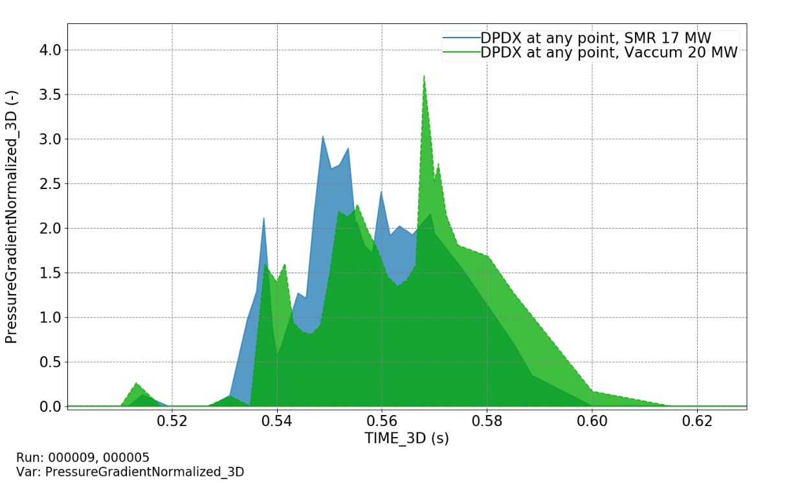 | 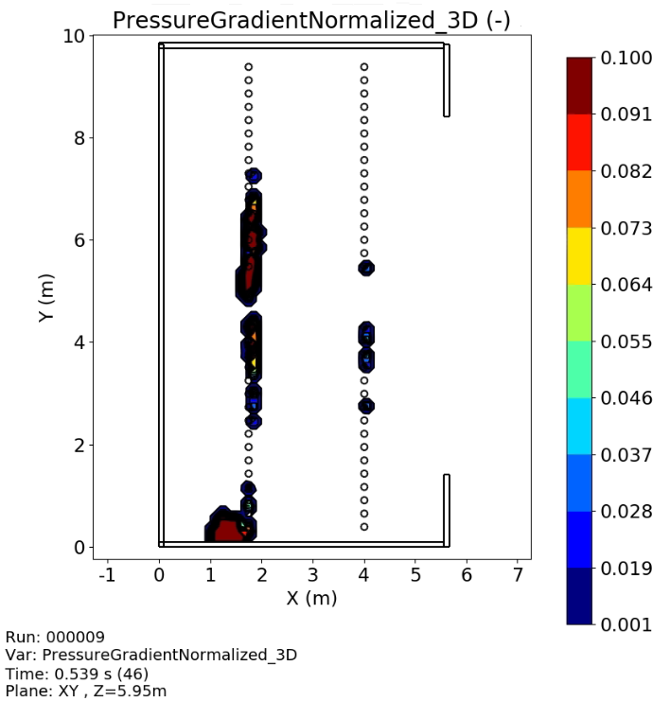
Figure 5: a) DPDX values obtained in the two cases analysed. b) DPDX in SMR 17 MW case presented in a horizontal (XY) 2D cut plane (Z = 5.95 m).
Detailed evaluation of DPDX within the furnace revealed notable pressure gradients around the internal tubes (Figure 5b). This highlights the unique capability of the CFD simulation, in contrast to other simpler models, to unveil the significant influence of internal elements on the obtained results. These pressure gradients can account for the disparities in the maximum achieved pressure between the original design cases and the cases without internal elements, as depicted in Table 3.
One potential reason for the absence of DDT phenomena may be attributed to the reactivity of the chosen fuel. Methane, when mixed with air, exhibits a flammable nature but is characterized by relatively lower deflagration indexes (K_{G}) as compared to other fuels such as propane, butane, or hydrogen (Faghih et al., 2016). Considering alternative fuels with higher reactivity could potentially increase the likelihood of detonation evolution in the simulations.
  - Conclusions
The use of CFD tools for furnace explosion evaluation proves to be a valuable and beneficial approach. The outcomes attained in this study demonstrate a high sensitivity to specific factors that influence explosion effects, such as internal geometry, gas composition, and the presence of explosion relief panels.
In the two presented cases, the maximum achieved pressures were lower when no internal tubes were included. The simulation also considered the effect of explosion relief panels, revealing maximum overpressure values approximately 50% lower compared to cases without relief panels. Despite this reduction, the overpressures exerted on the equipment's structure remained sufficiently high to induce total or critical destruction of the equipment. The simulation cases presented considered a conservative worst-case scenario approach with the combustion chamber totally filled with a homogeneous mixture of fuel and air. In these conditions the relief panels may not be effective enough to protect the structure as supposed to be by design. Relief panels may be more effective in a more realistic scenario that considers a limited gas inlet (such as a burner control valve leak, ignition attempt failure, etc.).
Obtained results have demonstrated that further investigation can be developed considering more realistic fuel leak scenarios or different fuel compositions. Comparison between CFD model results and empirical explosion models can also be carried on in future investigations for the determination of overpressures achieved out of the combustion chambers.
Acknowledgement
This work has been done under Project PID2020-114766RB-100 funded by MCIN/ AEI /10.13039/501100011033. Authors also thanks the support from Generalitat de Catalunya SGR2021-00251.
References
Casal J., 2018, Evaluation of the Effects and Consequences of Major Accidents in Industrial Plants. Secon Edition. Elsevier. ISBN 9780444638830. Amsterdam, The Netherlands.
Edri I.E., Grisaro H.Y., Yankelevsky D.Z., 2019. TNT equivalency in an internal explosion event. J Hazard Mater 374, 248–257.
Espejo V., Vílchez J.A., Casal J., Planas E., 2021, Fired equipment combustion chamber accidents: A historical survey, J Loss Prev Process Ind, 71, 104445.
Faghih M., Gou X., Chen Z., 2016, The explosion characteristics of methane, hydrogen and their mixtures: A computational study, J Loss Prev Process Ind, 40, 131–138.
Gexcon AS, 2021, FLACS-CFD v21.3 User’s Manual.
Hansen O.R., Hinze P., Engel D., Davis S., 2010, Using computational fluid dynamics (CFD) for blast wave predictions, J Loss Prev Process Ind, 23, 885–906.
Hjertager B.H., Fuhre K., Bjørkhaug M., 1988, Gas explosion experiments in 1:33 and 1:5 scale offshore separator and compressor modules using stoichiometric homogeneous fuel/air clouds, J Loss Prev Process Ind, 1, 197–205.
Li Xuegang, Zhang L., Sun Y., Jiang B., Li Xingang, Wang J., 2015, Numerical simulation of the flue gas side of refining vacuum furnace using CFD, Chem Eng Sci, 123, 70–80.
Mannan Sam., Lees F.P., 2005, Lees’ loss prevention in the process industries: hazard identification, assessment, and control, Elsevier Butterworth-Heinemann, Oxford, United Kingdom.
NFPA, 2018, NFPA 68. Standard on Explosion Protection by Deflagration Venting.
NFPA, 2015, NFPA 86: Standard for Ovens and Furnaces.
Rosas C., Davis S., Engel D., Middha P., van Wingerden K., Mannan M.S., 2014, Deflagration to detonation transitions (DDTs): Predicting DDTs in hydrocarbon explosions, J Loss Prev Process Ind, 30, 263–274.
Tutar M., Üstün C.E., Campillo-Robles J.M., Fuente R., Cibrián S., Arzua I., Fernández A., López G.A., 2021, Optimized CFD modelling and validation of radiation section of an industrial top-fired steam methane reforming furnace, Comput Chem Eng, 155, 107504.

