CHEMICAL ENGINEERING TRANSACTIONS  VOL., 2023 | A publication of
The Italian Association
of Chemical Engineering
Online at www.cetjournal.it
Guest Editors: Sabrina Copelli, Richard Siwek
Copyright © 2023, AIDIC Servizi S.r.l.
ISBN ; ISSN 2283-9216

Experimental Observations of the Aluminium Combustion Process during Flame Propagation in a Tube
Clement Chanut*, Fares Saad Al Hadidi, Frederic Heymes
Laboratoire des Sciences des Risques, IMT Mines Alès, Alès, France
clement.chanut@mines-ales.fr
Combustion process during metallic dust flame propagation is still a point of discussion. Heterogeneous combustion (between solid particles and the air) or partial heterogeneous combustion followed by homogeneous combustion (in the gas phase) are two possible metallic combustion processes.
In this work, aluminium flame propagation inside a tube is studied. Some experimental observations of this flame propagation mechanism are presented: as for example, micro-explosions of particles, white tail-like light following particles... These different observations seem to agree with a (partial) homogeneous combustion process in the gas phase.
  - Introduction
Dust explosion is a major risk in industries dealing with a large variety of dusts, as all combustible dusts can cause an explosion. Organic dusts (corn, carbon, sugar, plastics…) and metals (aluminium, iron, magnesium…) are typical combustible dusts. All these industries have to deal with this hazard and thus have to model the consequences of these explosions (overpressure, thermal effect and missile effects). Knowledge about combustion process during flame propagation is mandatory to model the consequences of an accidental explosion.
Goroshin et al. (2022) propose to classify the combustible dusts depending on the type of combustion: heterogenous or homogeneous combustion in the flame. This type of combustion depends on the ability of this condensed fuel to volatilize to form a premixed gaseous mixture before combustion. Plastics and other organic and inorganic dusts are able to volatilize prior to combustion, thus are able to form a premixed gaseous mixture prior to combustion. Models used to predict the consequences of accidental explosions seem adaptable to this kind of dust explosions (Kahlili, 2012).
However, flames in non volatile solid fuel suspensions exhibit an heterogeneous combustion process. In this case, these models for predicting consequences are not accurate enough (Kahlili, 2012). Knowledge about these specific combustion processes and the behavior of the resulting propagating flame is mandatory to elaborate new models. Experimental analysis of flame propagation for these dusts is necessary to study the specificities of such explosions.
Puri (2008) proposes a model of aluminium combustion (Figure 1). From this model, depending on the diameter of the dust, aluminium can exhibit heterogeneous combustion or a partial heterogenous combustion followed by an homogeneous combustion. The transition between heterogeneous and homogeneous combustion occur when the aluminum boiling point is reached. In case of nanoparticles, aluminum dust has totally reacted before reaching this boiling point; thus the reaction occur only in heterogeneous phase. This kind of combustion model concerns an isolated particle and is mainly based on the experimental analysis of the combustion process of one isolated particle. However, the combustion mechanism of aluminum cloud has to be studied to model consequences of accidental explosions.
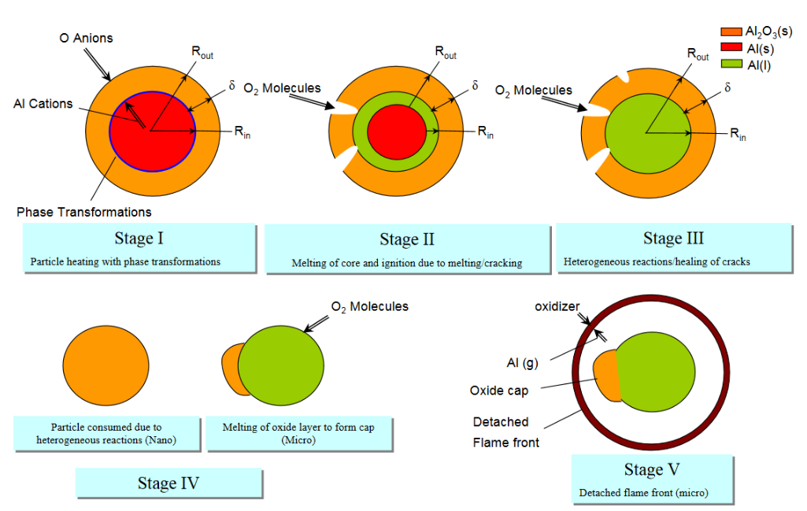
Figure 1. Mechanism of combustion of an isolated aluminium particle (Puri, 2008)
In this work, aluminum dust flame propagation in a tube is studied. Propagation mechanism is visualized by two optical techniques: direct visualization of the light emitted by the flame front and PIV (Particle Image Velocimetry). With PIV technique, the motion of particles just in front of the flame front is deduced. The objective of this work is to observe some experimental characteristics of the type of combustion involved during aluminum flame propagation.
  - Experimental setup
Aluminium dust flame propagation tests are performed inside the prototype presented in Figure 2; this setup has been already described in (Chanut et al., 2022). This prototype is a vertical tube of around 2,5 m height and 150 x 150 mm square cross-section. Aluminium dust is injected by discharge of compressed air vessels. Aluminium dust cloud is ignited by an electric spark located at the bottom of the prototype. The flame propagates from the closed bottom end up to the open upper end of the prototype.
Different optical techniques are used to visualize the propagating flame and the motion of the particles just ahead the flame front. Direct visualization of the light emitted by the flame is performed by using high-speed cameras. Adjusting the lens aperture and the exposure time to this emitted light is important to obtain images not saturated and to distinguish the details of this flame front. On a previous article, Chanut et al. (2018) highlighted the importance of analysing non-saturated images, especially for the determination of the burning velocity by the mainly used “open-tube method”.
TR-PIV (Time-Resolved Particle Image Velocimetry) is used to visualize and determine the motion of the aluminium particles just ahead the flame front. Implementing this TR-PIV technique is challenging due to the specificity of these experiments (high luminosity of the flame, dense cloud attenuating the laser, fast phenomenon…). However, using an energetic pulsed laser, a bandpass filter and limiting the exposure time of the camera with an adapted synchronization between the camera and the laser, TR-PIV measurements have been performed. TR-PIV measurements just in front of the aluminium propagating flame is important to understand the global phenomenon of flame propagation and the motion of the particles; moreover thanks to this measurement of the particle velocity in front of the flame front, the burning velocity (consumption rate of the reactants by the flame front) can be deduced by an innovative method, without an a priori estimation of the flame temperature. Details of the specificities of this TR-PIV setup and about this direct method for the determination of the burning velocity can be found in (Chanut et al., 2022).
The results presented hereafter are observed during the propagation of aluminum with a mean diameter of 6.5 µm, near stochiometric concentrations.

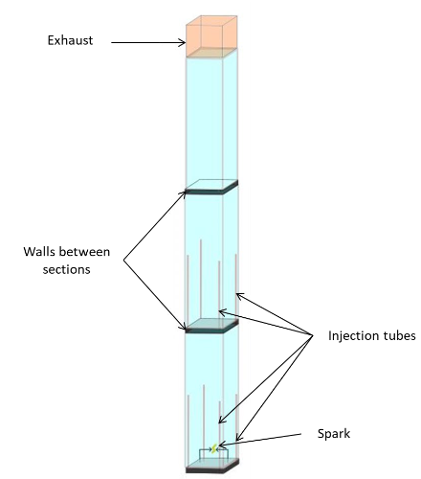
Figure 2. Experimental setup
  - Experimental observations
First of all, granulometric distributions of aluminum powder before and after an explosion test were compared, as exposed on Figure 3. Distribution of initial aluminum powder is mainly centered around the median diameter of 6,7 microns. On the contrary, distribution of the powder collected after a test is polydisperse. Particles with diameter around 6 microns are still present, but an important fraction of nanoparticles is also present with diameter of few hundreds of nanometers. Characteristic diameters generally used to describe a granulometric distribution, corresponding to the powder before and after an explosion test, are detailed on Table 1. Homogeneous combustion between gaseous aluminum and oxygen can be responsible of the presence of nanoparticles. Indeed, after this homogeneous combustion, condensation of the products of this reaction produces alumina nanoparticles.

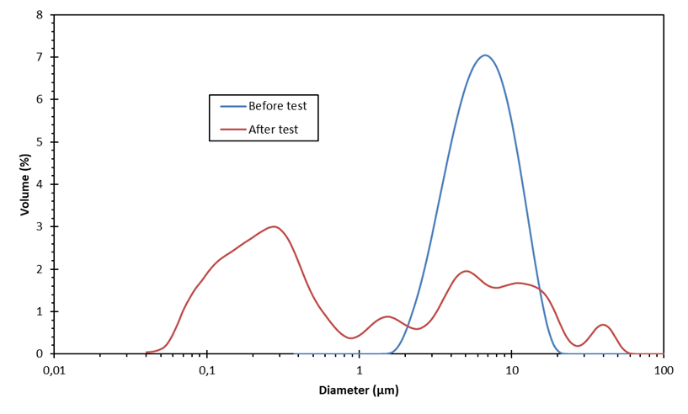
Figure 3: Granulometric distribution of aluminum powder before and after a test
Table 1: Characteristic diameters of the powder before and after an explosion test
Diameter (µm) | d₁₀ | d₅₀ | d₉₀ | D_{3,2}
Powder before test | 3,4 | 6,7 | 12,2 | 5,6
Powder after test | 0,12 | 0,52 | 14,5 | 0,31

Different optical configurations of direct visualization technique were performed to analyze the global flame propagation along all the height of the prototype, but also to observe the local flame propagation during the first steps of flame propagation (flame kernel formation) and at different heights during the upward flame propagation.

The two images on the left of Figure 4 are examples of the first steps of 3D flame propagation around the electrodes; the time below each image correspond to the time from the beginning of the ignition of the suspension. The very luminous sphere on the first image correspond to the electric spark used to ignite the aluminum particles.
The image on the right of this figure represents a zoom of the second image. With this zoom, less luminous “white tail-like light” (as named by Gao et al. (2017)) following very luminous aluminum particles are observed. This phenomena has already been visualized by Gao et al. (2017) studying nano-metals flame propagation in a prototype similar to a Hartmann tube. These previous authors attributed this “white tail-like light” to the homogeneous reaction between aluminium vapour and oxygen. Indeed, the products of the reaction between aluminium vapour and oxygen is condensed alumina.
Reaction between aluminum vapour and oxygen can explain this observation. However, this light could also correspond to the detachment of liquid aluminum at the surface of the particle due to the velocity of the gaseous phase (thermal expansion).

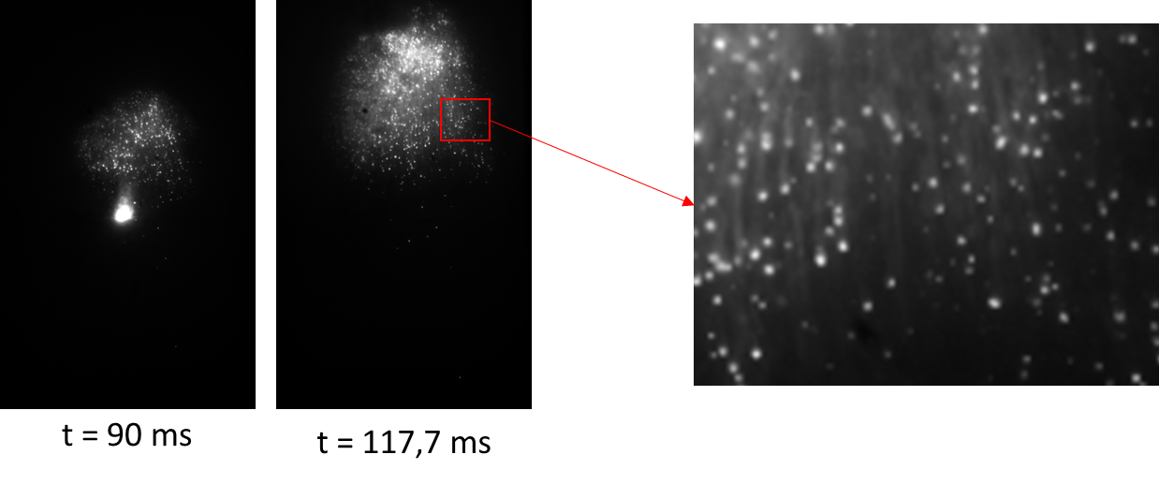
Figure 4: Illustration of "white tail-like light" following particles
Figure 5 exposes an example of images obtained while visualizing a zone of interest of 4,8 cm x 7,7 cm; the images exposed on this figure represent only a zone of 3,4 cm x 2,9 cm. The time between each image exposed is 0,133 ms. On these images, a red circle follows the displacement of one isolated particle in a zone located behind the flame front; i.e. the flame front already crosses this visualization zone. From image a to c, fluctuations of light intensity are observed. Then from image d to e, the local explosion of this isolated particle is observed; indeed this particle is suddenly divided in multiple different particles with different directions of displacement at higher velocity than the initial velocity of the first isolated particle.
Gao et al. (2017) also observed this phenomena of “micro-explosions” in their smaller scale experiments. These previous authors concluded that these “micro-explosions” are caused by an intense vaporization of the aluminum core of the particle.

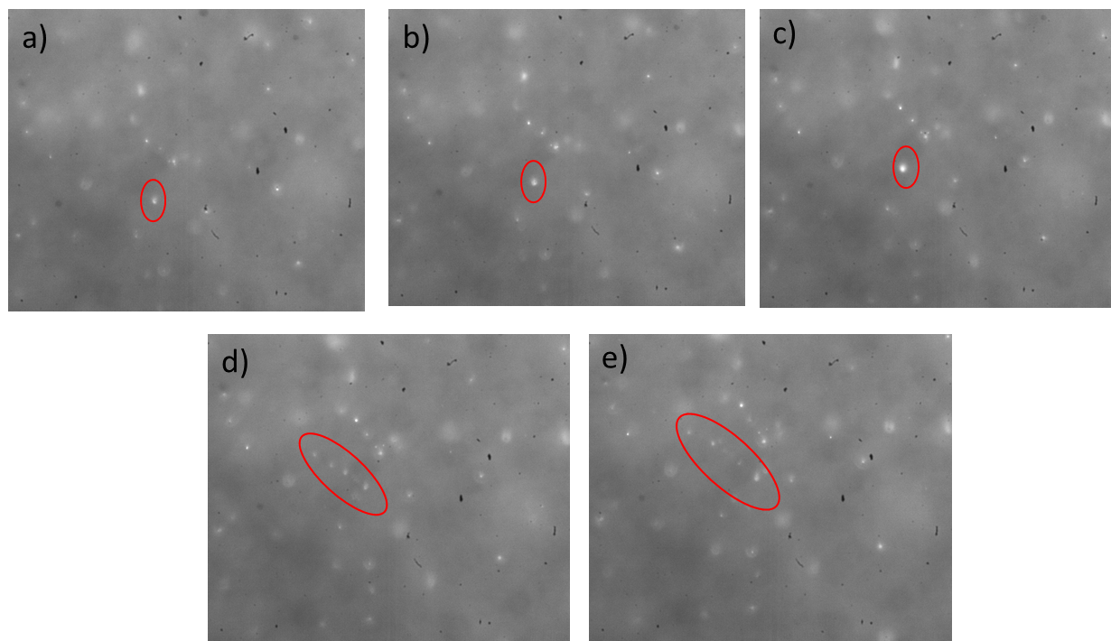
Figure 5: Visualization of local "micro-explosions" of isolated particles
As previously explained, PIV (Particle Image Velocimetry) system is used to observe simultaneously the motion of the flame front and of the particles ahead the flame front. In Figure 6 (left), an example of image obtained by PIV is exposed; for this experiment, aluminium with a mean diameter of 20 µm is studied for display purpose. Indeed, laser light (used to illuminate the aluminium particles) is less attenuated by these particles of bigger diameter; thus, the characteristics of this flow and of this flame are easier to observe on these images.
In Figure 6 (left), we can distinguish the luminous flame and the cloud of aluminium particles ahead the flame front. It is important to note that the light emitted by the flame front is strongly attenuated by the bandpass filter mounted on the high speed camera. Thus the “luminous flame” distinguishable on this image is not due to the combustion or due to hot particles but is due to light scattered by combustion products. Indeed, this “luminous flame” is also less luminous on the left part of the image (laser light attenuated). Moreover, during tests realized without turning on the laser light, the light emitted by the flame was very lightly distinguishable on the images obtained by camera (due to the parameters selected to obtain good quality images of PIV).

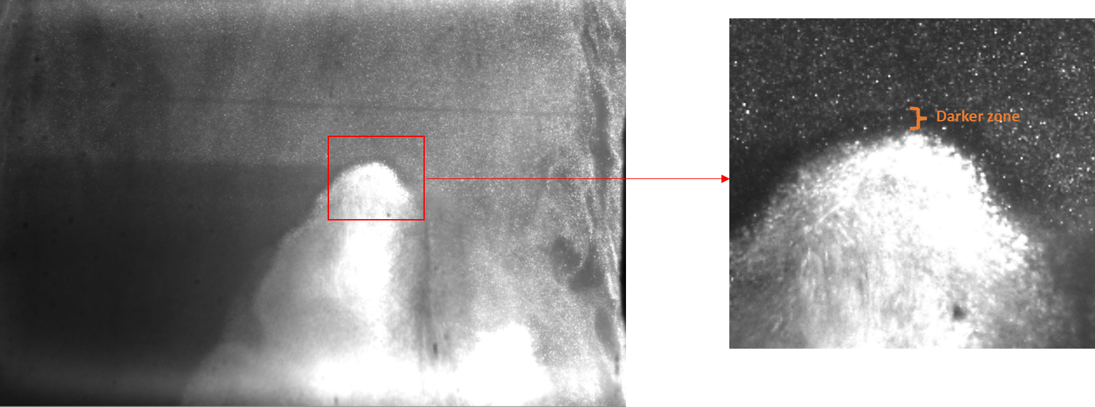
Figure 6: Example of images obtained by PIV (Particle Image Velocimetry)
On this image, the laser light (used to illuminate the aluminium particles) enter in the prototype from the right of this image, cross the particles and the flame front and exit the prototype on the left part of this image. In the upper part of the image, the laser light is lightly attenuated by the aluminium particles. However, in the lower part of the image, the laser light seems strongly attenuated by the combustion products. The presence of an important quantity of alumina nanoparticles can explain this important attenuation of the laser light compared to the initial 20 µm aluminium particles. As previously noted, the presence of nanoparticles of alumina can be a consequence of an homogenous reaction between aluminium vapour and oxygen, forming condensed alumina.
The image on Figure 6 (right) focuses on the top part of the flame front (red square on the left image). A darker zone between the luminous flame and the aluminium particles is distinguishable; this dark zone corresponds to a zone with less particles (less light scattered). Thus, this dark zone could correspond to a zone where aluminium (reactant) is vaporized but where alumina (combustion product) is not yet condensed.
Lomba et al. (2019) studied a stationary flame of aluminum powder (7,1 mean diameter) using a burner. They implemented different optical diagnostics to study this combustion, especially a PIV system. These authors observed a similar dark zone. They attributed this zone to the absence of Mie scattering (drop in particle density) due to the beginning of the preheating zone and the fact that condensed alumina is not yet formed.
  - Conclusions
Combustion process of non-volatiles suspension, as metals, is still a point of discussion. For such suspensions, heterogeneous and homogeneous combustion can occur. Experiments were conducted to study the phenomenon of combustion during aluminium flame propagation in a vertical tube. These experiments are thus complementary of previous study focusing on this combustion phenomenon. Indeed, main previous studies were conducted on smaller scale tube or using burner (studying stabilized flames).
Different interesting characteristics are observed during these experiments: presence of nanoparticles in the combustion products, “white tail-like light” following luminous particles, local micro-explosions of isolated particles, presence of a dark zone in front of the main luminous flame on PIV images… These characteristics were also experimentally observed by Lomba et al. (2019) for stabilized flame or by Gao et al. (2017) for propagating flame in a prototype similar to a Hartmann tube. All these observations are in accordance with the hypothesis of a homogeneous combustion between aluminium vapour and oxygen. This type of combustion is predicted by the combustion mechanism proposed by Puri (2008).
In their detailed review article, Goroshin et al. (2022) highlights the complexity of flames in non-volatile solid fuel suspensions, such as metals, and the importance of research on this field to improve our knowledge on this phenomenon. These authors insist on the discrete behaviour of such flames compared to premixed gaseous flames. They note that even a flame exhibiting a homogenous reaction can present a discrete behavior. Indeed, aluminium vapour reacts quasi immediately with oxygen preventing the formation of a premixed mixture. Thus, characteristics of these aluminium flames have to be analyzed without just classifying it in homogeneous or heterogeneous combustion.
The experimental setup presented in this paper and the innovative PIV system implemented are very useful to improve our knowledge on metal flame propagation. Indeed, this PIV system has already been used to determine the burning velocity (without assumption on flame temperature) and the corresponding simultaneous turbulence intensity just ahead the flame front (Chanut et al., 2022). This direct method for the determination of the burning velocity will be useful to determine the regime of combustion of different suspensions. Indeed, experiments will be performed by substituting nitrogen present in the air with argon and helium. By comparing the burning velocities of these different mixtures, the regime of combustion will be determined.
References
Chanut C., Al Hadidi F.S., Heymes F., Lopez C., 2022, Simultaneous Measurement of Burning Velocity and Turbulence Intensity Ahead of the Flame Front during Aluminium Flame Propagation, Chemical Engineering Transactions, 90, 391–396. https://doi.org/10.3303/CET2290066
Chanut C., Heymes F., Lauret P., Slangen P., 2018, Visualization of aluminum dust flame propagation in a square-section tube, Chemical Engineering Transactions, 67, 7–12. https://doi.org/10.3303/CET1867002
Gao W., Zhang X., Zhang D., Peng Q., Zhang Q., Dobashi R., 2017, Flame propagation behaviours in nano-metal dust explosions, Powder Technology, 321, 154–162. https://doi.org/10.1016/j.powtec.2017.08.013
Goroshin S., Pale J., Bergthorson J.M., 2022, Some fundamental aspects of laminar flames in nonvolatile solid fuel suspensions, Progress in Energy and Combustion Science, 91. https://doi.org/10.1016/j.pecs.2022.100994
Kahlili I., 2012, Sensibilité, sévérité et spécificités des explosions de mélanges hybrides gaz/vapeurs/poussières, PhD Thesis, Université de Lorraine.
Lomba R., Laboureur P., Dumand C., Chauveau C., Halter F., 2019, Determination of aluminum-air burning velocities using PIV and Laser sheet tomography, Proceedings of the Combustion Institute, 37, 3143–3150. https://doi.org/10.1016/j.proci.2018.07.013
Puri P., 2008, Multi scale modeling of ignition and combustion of micro and nano aluminum particles, PhD Thesis, The Pennsylvania State University.

