|  |  |
| --- | --- |
| cetlogo***CHEMICAL ENGINEERINGTRANSACTIONS***  ***VOL., 2023*** | A publication of  aidiclogo_grande |
| The Italian Association  of Chemical Engineering  Online at www.cetjournal.it |
| Guest Editors:Sabrina Copelli, Richard Siwek  Copyright © 2023, AIDIC Servizi S.r.l. **ISBN**;**ISSN** 2283-9216 | |

**Experimental study on different extinguishing agents for fire of Lithium Ion Batteries for Electric Mobility**

D. Palmaa, P. Gentileb, M. Mazzarob, P. Russoa,\*

aSapienza University of Rome, Department of Chemical Engineering Materials Environment, Rome, Italy

bNational Fire Corps, Central Directorate for Prevention and Technical Safety, Rome, Italy;

paola.russo@uniroma1.it

This paper shows the research work based on experimental tests for identifying the most efficient extinguishing agent against LIBs fire. Experimental tests were conducted in cooperation with the National Fire Corps of Rome. For these experimental test LIBs typically used in electric, Hybrid or plug-in Hybrid vehicle have been chosen. The tested cell was placed on a metal grate inserted between two electric plates. The heat generated from the two plates induced the cell to thermal runaway and then to fire. In Total 11 Kokam SPLB pouch cells of 40 Ah and 3.7 V each have been used. Four different extinguishing agents have been tested: Water, F500, Foam and AVD. The results of each experimental tests were analysed in terms of chemical and physical action. An optimization model was developed for identifying the most efficient agent between all those tested. The results obtained from the experimental tests are preliminary results of the research concerning the extinguishing agents for fire of LIBs. The operating conditions chosen for these tests can be defined as ideal: the cell was not hidden by any obstacle (battery module or vehicle compartments).

* 1. Introduction

Electric Vehicles are finding more and more application within the Mobility Sector, especially in the road transport. Lithium-Ion Batteries (LIBs) are becoming an opportunity for a sustainable road mobility. Electric vehicles store their energy in battery modules, each composed by many Lithium Ion cells and they are often placed in the lower part of the vehicle. The more electric mobility will grows the more Lithium Ions Batteries (LIBs) of high capacity will be used. This technology still must reach its maximum technological development in term of construction materials, material recycling and safety. This paper will show the research work based on experimental tests for identifying the most effective extinguishing agent against LIBs fire. A fire from these modules could result very difficult to suppress if the right extinguishing agent is not used. Fire from LIBs may be due to different sources: liquid electrolyte (organic fuel), generated vapours and gas (organic and inorganic fuel) and the cathode chemical components (metal fuel). These diversified fuel sources inside the LIBs lead to different typologies of fire. An extinguisher which may cover a fire from a large part of these fuels is required to ensure an efficient extinction phase. First, all the categories of extinguishing agent were taken into consideration: gas, foam, liquid and powder-based. In the literature Webster (2006) studied the efficiency of Halon 1301 at different concentrations, while Long et al. (2013) and Liu et al. (2018) studied the efficiency of Novec 1230 for LIBs fire. These extinguishing agents act in the gaseous phase and exert their efficiency when supplied in enclosures where it is possible to reach and maintain an optimal concentration of the extinguishing agent. Long et al. (2013) and Ubaldi et al. (2022) showed that CO2 does not appear to be a suitable extinguishing agent for LIB fires. In fact, it acts only by physical mechanism (suffocation and dilution of the fuel) and its heat exchange capacity is much lower than water-based extinguishers. Rao et al. (2015) and Li et al. (2015) showed that ABC powder extinguishing agent is not effective for lithium battery fires. Its extinguishing action is based on the absorption of heat by the decomposition of its molecules for temperatures over 200 °C, as also studied by Su. et al. (2014). Egelhaalf et al. (2013) studied the efficiency of different water-based extinguishing agents: Pure Water, Water + F500 (1%), Water + Firesorb (1.8%), showing higher efficiency for F500 and Firesorb blends in terms of extinction phase duration and agent quantity required. Based on these results, the liquid and foam based extinguishing agents have been tested in this work. These two classes were found to be the most suitable for extinguishing the fire from LIBs.

* 1. Experimental
     1. Materials

Cells used were pouch cell Kokam SPLB 40 Ah (K-SPLB-40), with a total nominal energy of 148 Wh. Cell sizes are 22cmx22cmx1cm. The cathode chemical composition is based on Lithium Cobalt Manganese Nickel (NMC) and the anode is based on Graphite. The electrolyte is a solution of Lithium Hexafluorophosfate in a mixture of Ethylene Carbonate (EC) and Ethylmethyl Carbonate (EMC).

* + 1. Test Apparatus Design

For every test each Kokam cell was placed on a metal grate between two heating plates, each of 1500 W of power. This heating mode has been preferred to allow a slow and controlled heating of the cell.

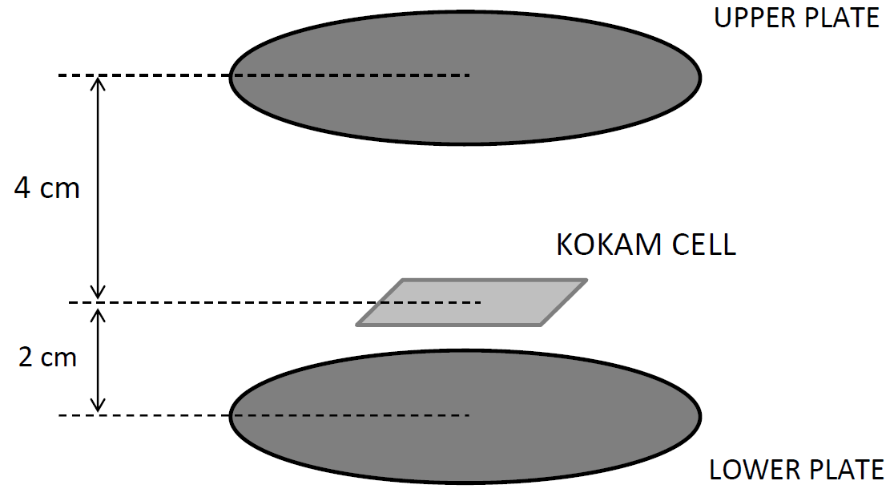 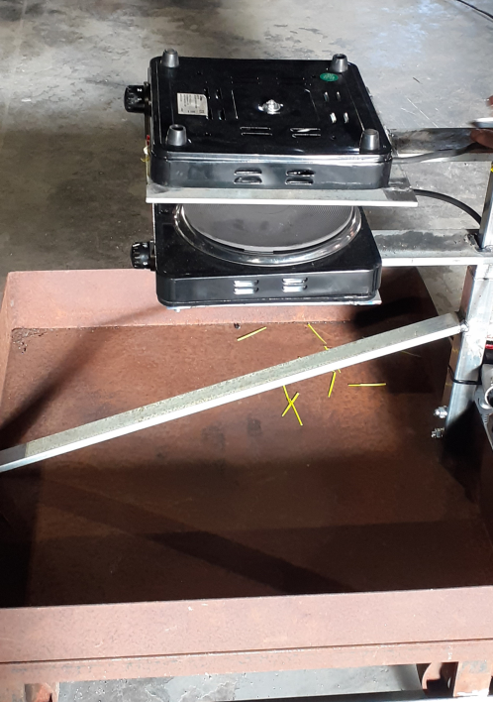

Figure 1a:Design of the heating system Figure 1b: Picture of the heating system

The distance between the two plates was set to 6 cm. Each cell was placed at 2 cm from the lower at 4 cm to the upper plate for ensuring the necessary space for the swelling of the cell. Three thermocouples have been used for recording the surface temperature of the cells. One thermocouple was placed on the lower surface (TC1), two thermocouples on the upper surface (TC3, TC5). The test apparatus is equipped with a hood for the extraction of the gases developed during the fire.

* + 1. Operating conditions

To standardize the extinction tests and guarantee a uniform supply condition of the extinguishing agent, the following conditions have been adopted:

* Start of extinguishing agent supply: for each test the agent was supplied in a temperature range of 390 – 520 °C, depending on the fire conditions and timing of each burning cell. This allowed the agent to be supplied when the flame was vigorous and not in decay phase, so as not to influence the extinguishing action efficiency with the fuel change.
* End of extinguishing agent supply: for each test the supply was interrupted as the flame went out.
* Distance of supply: for each test the extinguishing agent was supplied at less than 1 m (about 50-70 cm) depending on the fire hazard. This choice has been made in order not to disperse the agent, but to concentrate the supply.
* Ambient conditions: each experimental test was made in November 2022. The ambient temperature was about 18 °C. The tests apparatus was located inside a (20mx10mx6m) building with no windows and no sun light.

In total 11 extinction tests were performed of which only the most significant results are discussed in the following. The tests considered are reported in Table 1.

Table 1: List and technical specifications of the experimental tests

|  |  |  |  |  |  |  |
| --- | --- | --- | --- | --- | --- | --- |
| Test  ID Num | Test date | Cell type | Extinguishing agent | Solute Concentration  (%) | Extinguisher Flowrate/Jet  (L/min) | Test Code  (ID-Ext-Supp-%-Jet) |
| 4 | 14/11/22 | K-SPLB-40 | F500 | 2 | 13.2 / Spray | 4-F5-M-2-SP |
| 6  9  10  11  12  13 | 14/11/22  16/11/22  16/11/22  16/11/22  16/11/22  16/11/22 | K-SPLB-40  K-SPLB-40  K-SPLB-40  K-SPLB-40  K-SPLB-40  K-SPLB-40 | Foam  Water  F500  Water  F500  AVD | 2  -  3  -  2  20 | 8.3 / Spray  10.3 / Spray  7.2 / Mist  16.4 / Spray  13.2/ Spray  3.0 / Spray | 6-FO-E-2-SP  9-WA-M-0-SP  10-F5-H-3-MI  11-WA-E-0-SP  12-F5-H-2-SP  13-AV-L-20-SP |

Test Code has been chosen with the following criterion:

Test ID Num - Extinguishing Agent - Extinguisher Supplier - Solute Concentration (%) - Extinguisher Jet

A typical cell temperature profile for test where cooling is obtained by spray jet extinguishing agent is reported in Figure 2.



Figure 2: Cell temperature profile for cooling by spray jet

* 1. Data Analysis, Elaboration and Optimization Model
     1. Definition of the 3 parameters of the efficiency

The data from thermocouples TC1 and TC3/TC5 have been elaborated to calculate 3 parameters with which to describe and evaluate extinguishing efficiency for each test.

These parameters are:

1. Extinguishing Agent Specific Quantity (Φ): it describes the quantity of extinguishing agent used for extinguishing the flame, normalized by the energy of the cell (L/kWh). It shows the extinction efficiency in terms of the quantity of agent required.
2. Temperature Derivative of Extinction phase (Δ): it describes the average temperature derivative (°C/sec) of the cell calculated over the whole range of the agent supply phase and the subsequent decay. It shows the extinction efficiency in terms of cooling.
3. Duration of the Extinction phase (Ω): it describes the Duration of the Extinction phase (sec). It shows the efficiency in terms of timing.

The parameter Φ is calculated as shown in Equation 1:

$Φ=(m_{EXT}^{START}- m_{EXT}^{END})/ρ_{EXT}*\frac{1}{E_{CELL}}$ (1)

Where mEXTSTART and mEXTEND is the extinguisher weight before and after the supply, ρEXT is the density of the extinguishing agent and ECELL is the energy of the cell. The parameter Δ is calculated as the arithmetic average between the average temperature derivative of TC1 and TC3 (or TC5) over the whole test range, according to the following equation 2:

$Δ=(\sum_{k=1}^{k=K}{\left(\frac{{dT}_{k}^{TC1}}{dt}\right)}/K+\sum_{k=1}^{k=K}{(\frac{{dT}_{k}^{TC3}}{dt})/K} )/2$, for each k=sampling time ∈ [tSTART EXT ; tEND 1° DECAY] (2)

Where tEXT is the extinguishing supply start time and tEND 1° DECAY is the 1st° decay end time.

The equation 2 calculates the average between the average temperature derivative between the lower surface and higher surface of the cell. If, as a first approximation, the conduction of heat inside the cell is considered as a linear trend, the equation (2) expresses the average temperature derivative inside the cell. Figure 3 reports the real values (RV) of the 3 parameters (Φ, Δ, Ω) for each extinction test.



Figure 3: Real Values Distribution. RS = Reference System. AV(RV) = Average(Real Values)

* + 1. Optimization Model for the Extinguishing Efficiency

To valuate and compare the efficiency of extinguishing agents an optimization model of the 3 parameters has been proposed. The 3 parameters have different values and unit. For comparing them, it is calculated the normalized value (NV).

This calculation has required:

* To write a formula for the normalization
* To choose a reference system for the normalization

The normalization of the parameter Φ and Ω is based on the following formula:

   

Where NVi(n) is the normalized value of one experimental test (i) of one of the 2 parameters (n=Φ, Ω) showed in Figure 3. So that i=4,6,9,10,11,12,13 and n=Φ,Ω. SR is the Reference System.

The normalization of the parameter Δ is based on the following formula:



Where NVi(Δ) is the normalized value of one experimental test (i) of the parameter (n=Δ) showed in Figure 3. So that i=4;6;9;10;11;12;13. SR is the reference system.

For simplicity, it said that NV(Φ)=φ, NV(Δ)=δ and NV(Ω)=ω.

Equation (3) was written to consider that the higher is Φ or Ω the lower is the efficiency, thus the lower is the normalized value.

Equation (4) was written to consider that the lower is Δ (it is a negative number) the higher is the efficiency, thus the higher is the normalized Value (RS(Δ) < 0).

The Reference System for the normalization was chosen according to the following equation:

${RS}^{(n)}={AV({RV}_{i})}^{(n)}+ {RANGE({RV}_{i})}^{(n)}$ (5)

Where AV(RVi)(n) is the average of the real values showed in Figure 3 for each parameter n=Φ, Δ, Ω, and RANGE(RVi)(n) is the range of the real values showed in Figure 3 for each parameter n=Φ, Δ, Ω.

This formulation for the reference system ensures that:

* it is satisfied the condition |RS(n)| > MAX(|RVi(n)|), i.e.the reference system is outside the range of the real values distribution for each parameter;
* the reference system acts on the real values of each parameter in the same way, as it is calculated starting from the distribution of the real values;
* the normalized values (NV) are dimensionless, positive and it is 0 < NVi(n) < 1.

The RS position is shown in Figure 3.

From the Equations (3), (4) and (5) the normalized values of each test (i) and for each parameter (n) were calculated. Figure 4a shows the NVi(n) distribution for each parameter while Figure 4b shows for each experimental test the distance between the NVi(n) and the AV(NVi)(n) of each parameter and the average distance (AD) as defined in equation 6:

${AD}_{i}=\sum_{n}{({NV}_{i}^{(n)}}-{AV\left(NV\right)}_{i}^{\left(n\right)}) / N$ (6)

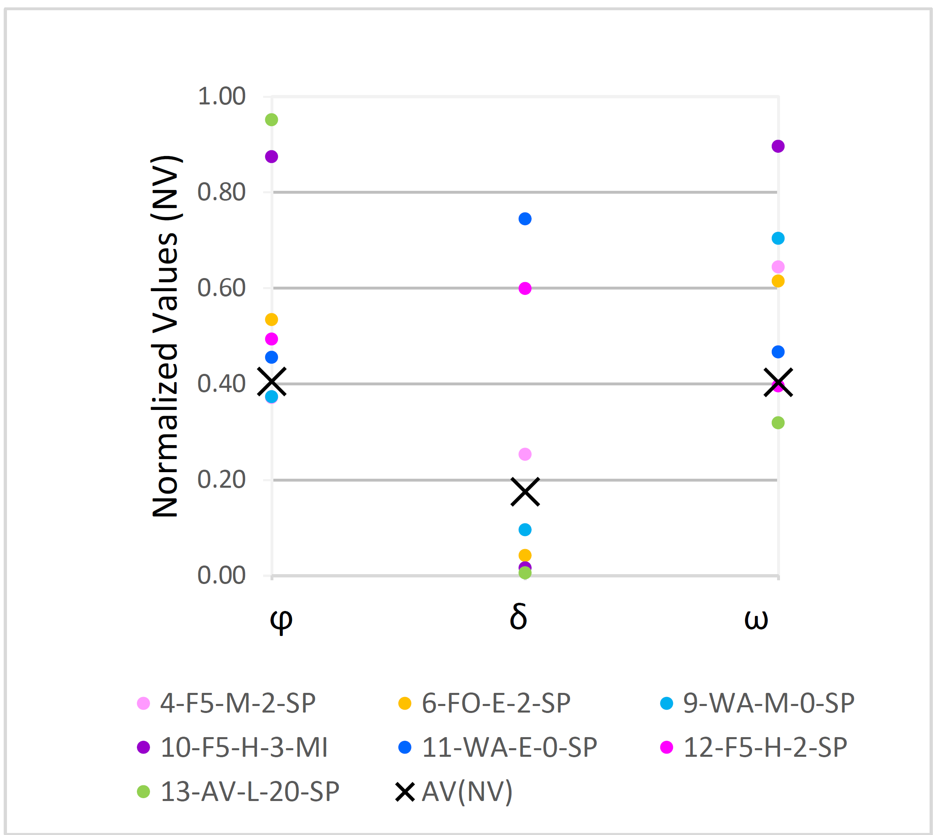 

Figure 4a: NV Distribution Figure 4b: Distance between NV and AV(NV)

 

Figure 5: Radar plot of the NV of the 3 parameters Figure 6: Comparison between the triangles area of the optimized model

The distribution in Figure 4a allows to recognize the efficiency for each extinguishing agent. Furthermore, Figure 3b shows that for test 10, 11, 12 the value of Average Distance (AD) is higher than 0.2 (Eq.6, with i=10,11,12, N=3). The value of AD also provides an indication of the efficiency for each extinguishing agent. Figure 4 shows the NV in a radar plot. Each axis refers to each Parameter. The higher is the NV, the higher is the efficiency.

A comparison of the efficiency of each extinguishing agent is obtained by calculating the areas of the triangles as reported in Figure 5. These areas are the locus of triads of points (φi ; δi ; ωi) that each extinguishing agent is able to ensure for suppressing the fire from the tested cells. Hence the extinguishing agent with the largest triangle area corresponds to the most efficient agent (see Figure 6): the most efficient extinguisher was the pure Water (11-WA-E-0-SP), followed by F500-water spray (12-F5-H-2-SP) and F500-water mist (10-F5-H-3-MI).

* 1. Conclusions

Extinction tests were performed on Li-ions pouch cells of 40 Wh with different extinguishing agents.

In each test the fire was completely extinguished with the first supply of agent.

The maximum flame height was about 1.5 m. No flame reignition occurred after the end of the agent supply.

An optimization model was proposed to compare the efficiency of the extinguishing agents used in the tests.

The three parameters used for the optimization model were chosen for describing and measuring the extinction action during the agent supply and the subsequent cell temperature decay. They allow to understand how each agent acts on fire from Kokam SLPB 40 Ah cell.

From the optimization model it emerges that the most efficient extinguisher was the pure Water (11-WA-E-0-SP), followed by F500-wate spray (12-F5-H-2-SP) and F500-water mist (10-F5-H-3-MI).

For sake of clarity, these results refer to experimental tests in which no obstacle covered the cell (i.e. battery module or vehicle compartments). In this condition the extinguishing jet can reach and wet the surface without any loss, regardless of the fluid dynamic of the jet (mist or spray).

Acknowledgments

The extinction tests were conducted with the support of the National Fire Brigade of Rome, which has provided high professional operators: Alessandro Ilari, Duilio Loi, Ferruccio Esibini, Salvatore Fumaselli.

References

Cai Ting, Tran Vivian, Stefanopoulou Anna G., Siegel Jason B., 2021, Modelling Li-ion Battery First Venting Events Before Thermal Runaway, IFAC PapersOnLine, 54-20, 528–533.

Ditch B., de Vries J., 2013, Flammability Characterization of Lithium-ion Batteries in Bulk Storage, FM Global, Boston, MA.

Egelhaaf M., Kress D., Wolpert D., Lange T., Justen R., Wilstermann H., 2013, Fire Fighting of Li-Ion Traction Batteries, SAE International Journal of Alternative Powertrains, Vol. 2, pp. 37-48.

Hill D., Warner N., Kovacs W., 2017, Considerations for ESS Fire Safety, OAPUS301WIKO(PP151894), Rev. 3, Det Norske Veritas (U.S.A.) Inc.

Kokam, 2006, Material Safety Data Sheet, Kokam, https://it.scribd.com/document/336759788/Kokam-SLPB-MSDS-New-Ficha-Tecnica#.

Larsson F., 2017, Assessment by Abuse Testing, Fluoride Gas Emission and Fire Propagation, 978-91-7597-612-9, Department of Physics Chalmer University of Technology Goteborg, Sweden.

Long Jr R.T., Blum A.F., Bress T.J., Cotts B.R.T, 2013, Best Practices for Emergency Response to Incidents Involving Electric Vehicle Battery Hazards: A Report on Full-Scale Test Result, 1205174.000 F0F0 0613 RTL3, Fire Protection research Foundation, Quincy, Massachusetts, U.S.A.

Liu Yujun, Duan Qiangling, Xu Jiajia, Chen Haodong, Lu Wei, Wang Qingsong, 2018, Experimental study on the efficiency of dodecafluoro-2-methylpentan-3-one on suppressing lithium-ion battery fires, Royal Society of Chemistry, 8, 42223–42232.

Luo W., Zhu S., Gong J., Zhou Z., 2018, Research and Development of Fire Extinguishing Technology for Power Lithium Batteries, Procedia Engineering, 211, pp. 531–537.

Maloney T., 2014, Extinguishment of Lithium-Ion and Lithium-Metal Battery Fires, DOT/FAA/TC-13/53, U.S. Department of Transportation, Federal Aviation Administration, Washington.

Rao H., Huang Z., Zhang H., Xiao S., 2015, Study of fire tests and fire safety measures on lithium-ion battery used in ships, The 3rd International Conference on Transportation Information and Safety, June 25 – 28.

Ubaldi, S., di Bari, C., De Rosa, A., Mazzaro, M., Russo, P. 2022, Investigation on Effective Fighting Technology for LIB Fire, Chemical Engineering Transactions, 91, pp. 505–510

Yuan Shuai, Chang Chongye, Yan Shuaishuai, Zhou Pan, Qian Xinming, Yuan Mengqui, Liu Kai, 2021, A review of fire-extinguishing agent on suppressing lithium-ion batteries fire, Journal of Energy Chemistry, 62, pp. 262–280.

Webster H., 2006, Flammability Assessment of Bulk-Packed, Rechargeable Lithium-Ion Cell in Transport category Aircraft, DOT/FAAAR-06/38, Office of Aviation Research and Development Washington, DC 20591.

Wuang Quingsong, Mao Binbin, Stoliarov Stanislav I., Sun Jinhua, 2019, A review of lithium ion battery failure mechanisms and fire prevention strategies, Progress in Energy and Combustion Science, 73, pp. 95 – 131.

Wang Q, Shao G., Duan Q., Sun J., 2016, The Efficiency of Heptafluoropropane Fire Extinguishing Agent on Suppressing the Lithium Titanate Battery Fire, Fire Technology, 52, pp. 387–396.