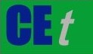 CHEMICAL ENGINEERING TRANSACTIONS  VOL. , 2023 | A publication of
The Italian Association
of Chemical Engineering
Online at www.cetjournal.it

Guest Editors: Sabrina Copelli, Richard Siwek
Copyright © 2023, AIDIC Servizi S.r.l.
ISBN ; ISSN 2283-9216

Study of the Electric Spark and Combustion Characteristic Times in a MIKE 3 Apparatus
Sieni Elisabettaª, Barozzi Marco^{b}, Scotton Martina^{b}, Sundararajan Rajeswari^{c}, Lamberti Patrizia^{d}, Copelli Sabrina^{b,*}
ªUniversità degli Studi dell’Insubria, Department of Theoretical and Applied Science, via Dunant 3, 21100, Varese, Italy
^{b}Università degli Studi dell’Insubria, Department of Science and High Technology, via Valleggio 9, 22100, Como, Italy
^{c}Purdue University, 610 Purdue Mall, IN 47907, West Lafayette, USA
^{d}Università degli Studi di Salerno, Department of Information Engineering, Electrical Engineering and Applied Mathematic, Via Giovanni Paolo II 132, 84084, Fisciano, Italy
sabrina.copelli@uninsubria.it

Understanding how dust can ignite and explode in an industrial contest is an important and complex task, and much of the work around this is mainly performed via experimental measurements, in accordance to specific standards. However, those same properties are straightforwardly closely related to the nature of the experimental tests. Among these, the Minimum Ignition Energy (MIE) of a dust cloud, that is usually measured in a MIKE 3 apparatus, can be affected by several factors, as: delay time of the electric spark with respect to the dust-air dispersion formation inside the apparatus, dust concentration, humidity content, dust granulometry, etc. The delay time is one of the worst parameters to adjust, because the fluid-dynamics of the dust-air mixture inside the tube is not easily predictable. Within this work, a study on the characteristic times of all the relevant phenomena occurring within a MIKE 3 apparatus was done by means of slow-motion videos of the tests. Particularly, three different characteristic times were compared referring to a given sample of niacin dust: dust lifting and settling times, effective spark delay time (that is, the time at which the spark is visible) and combustion time (that is, the time at which the flame is visible). According to the results, the effective delay time is almost always quite different with respect to the theoretical one, influencing the effective concentration of dust between the electrodes and, finally, the possibility to have a flame ignition or not within the apparatus. This means that the value of the MIE parameter can be profoundly influenced by the effective delay.

Keywords: Process Safety; Dust Explosions; Minimum Ignition Energy; Spark Delay Time
  - Introduction
Dust explosions are among the most severe accidents that may impact chemical industries (Cloney, 2021). Several motivations lie under this statement. At first, today still too often the threat posed by combustible dust is ignored by companies and operators (Abbasi and Abbasi, 2007). This leads to unawareness of the danger represented by an improper handling and storage of dust, resulting in unwanted, severe accidents. According to many Chemical Safety Board analyses, it was found that almost every accident where combustible dust is involved, can be related to a general lack of knowledge of the threats represented by combustible dust (CSB, 2006). Also, dust explosion is a very complex phenomenon (Eckhoff, 2003), which includes many subjects: dust lifting requires fluid-dynamic modelling of discontinuous media, dust ignition requires a proper combustion model, including every possible ignition source (which can be energy in form of heat, mechanical or electrical sparks), kinetics and turbulence, dust explosion require proper deflagration/detonation/deflagration to detonation model (Barozzi et al., 2020). Due to this complexity, most of the work required for ensuring safety in processes that involves dust is carried out with direct experimental testing. Usually, performing a risk assessment of a chemical process that involves combustible dust requires the determination of a certain set of well-known parameters: Minimum Explosive Concentration (MEC), Minimum Ignition Energy (MIE) (Copelli et al., 2021), Limiting Oxygen Concentration (LOC), deflagration index (K_{st}), Maximum Pressure (P_{MAX}), Detonation test (BAM Hammer test). Each one of these parameters is found according to specific standards and proper instruments (EN, ASTM or NFPA standards, depending on the country). It is straightforward than understanding the amount of duty required from industries to properly assess the explosivity of dust, considering the high number of parameters and verification to be estimated. Among these, the MIE is an energy, usually found in the range of 3-1000 mJ for dust, required to ensure the generation a stable flame in a dust cloud. The most common way to find this is the Hartmann tube or a MIKE device (Eckhoff, 2003), which consist of an opened tube, where dust is loaded, dispersed, and then ignited by providing a fixed amount of energy. While the Hartmann tube is more of a historical device, and it is used today as a screening tool, the MIKE (mainly in the version 3), is the most common device used to find the MIE. Reproducibility is a crucial issue in this type of test. Indeed, many experiments are required to find the MIE (Copelli et al., 2021). However, the test is focused on finding whether the dust cloud ignites, without considering other aspects. According to the literature, the whole spark developed in such a test is completely developed in 1 ms, with the arc lasting for about 100 μs (Sankhé et al., 2019), and its extinguishing phase is characterized by an almost spherical distribution of the plasma around the electrodes. These times are way larger than the typical, characteristic time of pyrolosis, which is about 5-10 ms (Copelli et al., 2021), and for this reason, the spark is usually intended as a local source of heat. However, the development of an arc discharge in e heterogenous environment such as an air-dust mixture is a very complex phenomenon, and it may impact how the spark is generated. The scope of this work is to propose a set of experimental evidence that highlight the fact that it may be necessary to furtherly investigate the interactions between the spark developed in the MIE and the dust cloud. A set of experiments with and without dust was carried out then to study the characteristics times such as: dust lifting, air-dust mixture breakdown initiation, and ignition.
  - Case study and methods
    - MIKE 3
The experiments have been carried out in a MIKE 3 apparatus, provided by Cesana AG (visible in Figure 1). This instrument is recommended for the determination of the Minimum Ignition Energy according to several international standards, including EN 13821 (Determination of minimum ignition energy of dust/air mixtures), ASTM E2019 (Standard Test Method for Minimum Ignition Energy of a Dust Cloud in Air), EC 61241-2-3 (replaced by ISO/IEC 80079-20-2:2016), ISO/IEC 80079-20-2:2016 (Explosive atmospheres. Material characteristics. Combustible dusts test methods).
The device is structured in the following way: the ignition is triggered by an air breakdown generated between the tips of two needle electrodes inside the tube. A capacitive circuit is loaded at the very beginning of the test, with a corresponding energy of the spark that is selected by the operator (the range is usually 3-1000 mJ). The device is structured to develop up to 15 kV between the electrodes, which are distant about 6 mm. This ensures the generation of the arc, causing dielectric breakdown (with an electric field intensity up to 2.5 MV/m). The dust cake loaded at the beginning is lifted thanks to an air jet of 10 bar installed at the bottom of the tube. The operator can also choose the delay between the jet and the ignition, to ensure optimal dispersion. Typical delay times are 60,120 and 180 ms. It is also possible to include an inductance up to 1 mH in the circuit: the presence of an inductor allows for a prolonged spark, maximizing the likelihood of occurrence of an eventual ignition.
10 bar air jet
Electrodes
Figure 1: MIKE 3.0 apparatus picture, electrodes and air jet pipe are highlighted

Every test was performed according to the following scheme:
- Preparation of the dust cake on a plate and loading inside the tube
- Set up of ignition energy and delay time
- Blow-up of the air jet to
- Electric circuit closure (to develop air breakdown between the two electrodes)
- Air breakdown
- (eventual) Ignition

A whole set of measurement was performed and analyzed in this work. At first, tests without dust have been conducted with all energies available (3-10-30-100-300-1000 mJ), with and without the 1 mH inductance, for a total of 12 tests. In addition, traditional ignition tests have been conducted using niacin. Dust mass loaded ranges between 750 and 3000 mg, along with energies between 3-1000 mJ. Niacin was chosen as target dust since it is a common standard dust for explosivity testing. The niacin used in this test is the same used for the Calibration-Round-Robin (CaRo20). These niacin samples are milled and analyzed. The sample used, tested with a Malvern Mastersizer 3000™, have a d₁₀ of 4.0 µm, a d₅₀ of 19.2 µm, and a d₉₀ of 75.0 µm. Table 1 resumes all the ignition tests performed, with a total of 64 experiments. Due to the amount of dust available, it was possible to perform only a single test for each condition. This at least ensures the homogeneity of the niacin used, at the cost of repeatability.
Table 1: Scheme of Niacin tests carried out. Every test was conducted with an inductance of 1 mH
# of total tests | Loaded mass | Delay time | Energy
16 | 750 mg | 60-120-180 ms | 3(only with 120 ms)-10-30-100-300-1000 mJ
16 | 1200 mg | 60-120-180 ms | 3(only with 120 ms)-10-30-100-300-1000 mJ
16 | 2000 mg | 60-120-180 ms | 3(only with 120 ms)-10-30-100-300-1000 mJ
16 | 3000 mg | 60-120-180 ms | 3(only with 120 ms)-10-30-100-300-1000 mJ

    - Movies and frames elaboration
Movies of each event have been recorded with an iPhone 13 Pro Max, using Slow-Mo option at 240 fps with High Definition (1080p). Each record was then analysed with a freeware app, Frame Wrapper (APPCANO LLC), to extract the frames and allows for the determination of specific time steps. The software, depending on the movie, can automatically decompose it into 240, 60, or 30 fps sequences. The software elaborates the clip automatically at the highest frame rate possible.
  - Results
For what concerns empty tube results, spark was always generated and captured in the movies. Figure 2 represents the test carried out with the maximum energy (1000 mJ), with the inductance of 1mH.
Figure 2: Spark generation with an empty, 1mH inductance test, 1000 mJ. From left to right: moving electrode stopped, electrodes starts to close, with an early generation of the arc, full arc development.
This is the only test in the whole campaign where the spark was visible in two consecutive frames, within a time of step 17 ms. In all other tests, the spark (when captured) was visible in a single frame only. Without dust, the delay time is always respected: if 60, 120 or 180 ms are given, the arc occurs at this time. This means that the device is reliable and the electrical circuit is calibrated correctly.
For what concerns niacin tests, it got ignited under all conditions. This is typical of niacin, which is a highly explosive dust. Figures 3, 4 and 5 reports frames of some test. Figure 3 reports a low mass test, with minimum energy and average delay time, Figure 4 reports a test with 2000 mg loaded, 30 mJ spark and low delay time, and Figure 5 reports a high dust loaded, delay time, and energy test.
a | b | c | d | e
Figure 3: 750 mg, 3 mJ, 120 ms. From a to e: start of experiment, dust lifting, arc trigger, combustion trigger, flame propagation
a | b | c | d | e
Figure 4: 2000 mg, 30 mJ, 60 ms. From a to e: start of experiment, dust lifting, arc trigger, combustion trigger, flame propagation
a | b | c | d | e
Figure 5: 3000 mg, 1000 mJ, 180 ms. From a to e: start of experiment, dust lifting, arc trigger, combustion trigger, flame propagation

Each test was analysed with the scope of finding the characteristic times of those specific events:
- Visible lifted dust (t₀)
- Spark release (t₁)
- Spark end (t₂)
- Combustion trigger (t₃)
- End of combustion (no visible flame) (t₄)
From those times, those significative time steps were identified and analysed:
- The effective delay time t_{del}, which is the difference between t₁ and t₀, this time should be equal to the delay time given to the MIKE 3
- The combustion trigger time t_{ign}, that is the difference between t₃ and t₂.
For what concerns the identification of the spark, only in 5 over 64 movies it was not possible to detect a visible air breakdown, which occurred nonetheless, since the ignition was triggered. This means that in 92.1% of experiments, the camera can capture the spark within a framerate of 240 fps (that is, a frame every 4 ms). Also considering the empty tube experiments, the percentage of positively captured sparks raises to 93.4%. This is very interesting, considering that the length of a spark it is supposed to last for hundreds of microseconds. This is due to the presence of inductance in the circuit, which develops a longer spark. However, in every frame analysed, the spark never lasted for more than one frame in every test performed. This means that the duration of the same should be lesser than 4 ms. Unfortunately, with the instruments used in this test, no more specific information can be inferred.

    - Delay time analysis
In this part, the distribution of the delay time is reported and commented. Figure 6 e reports the distributions found. It can be noticed that, in most of the cases, the time between the formation of the dust cloud and the spark is usually greater than the theoretical delay time. This means that, despite the presence of a very intense electric field between the electrodes, the air and dust mixture require more time to become conductive, closing the circuit and developing the arc discharge. Our claim is that the presence of dust between the electrodes changes the dielectric properties of the medium, that is not simple air, but air mixed with solid particles. Particles dielectric properties (which should be studied and analysed), may impact the occurrence of air breakdown. However, this aspect is extremely complex to be studied, because the dust is not fixed, but it is continuously rising and settling inside the tube.
a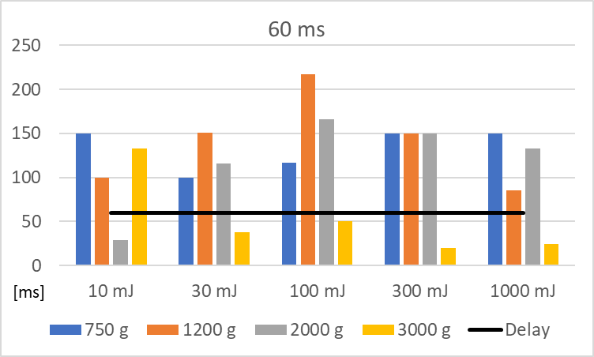 | b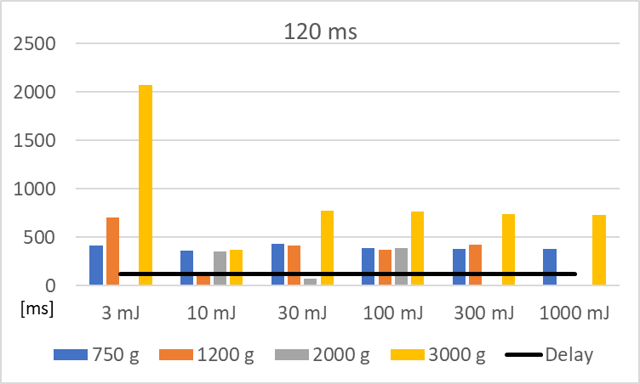 | c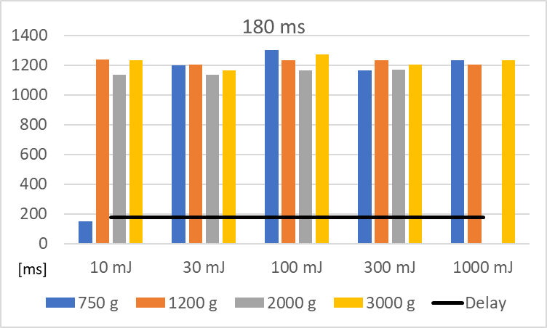
Figure 6: Distribution of effective delay time t_{del} under different conditions. a) Delay time 60 ms; b) Delay time 120 ms, c) Delay time 180 ms

For what concerns the dependence of t_{del} from energy, input delay time, and loaded mass, it appears that the delay time given by the operator is by far the most important factor. As it can see in Figures 6 a, b, and c, t_{del} tends to increase significantly with the delay time itself. With 180 ms, t_{del} distribution is more stable, with times between 1100 and 1300 ms. The only exception was the 10 mJ case, with a very early spark. It also interesting to observe very different behaviours with high loads of niacin: when 3000 mg of dust is loaded, t_{del} is usually lower than the delay time for 60 ms, and greater with 120 and 180 ms. When t_{del} is lower than the delay time, electrical breakdown occurs at a lower electric field. It could be that, with a high amount of dust and a low delay time, there is a significant amount of dust between the electrodes (the dust is still rising in the bottom part of the tube), developing a completely different environment, closer to a solid layer of dust, which requires a lower electric field (that is developing in the meanwhile) for a dielectric breakdown. The energy of the spark does not seem to affect in a particular way the effective delay time.
Finally, the study a little bit more in detail the dependence from the delay time, the delay ratio was calculated, that is, according to Eq 1.
$$r=\frac{t_{del}}{delay time}$$ | (1)

a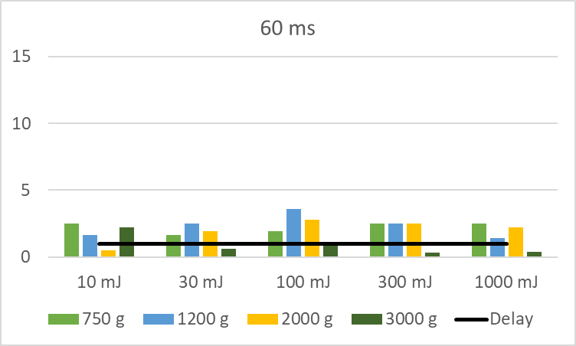 | b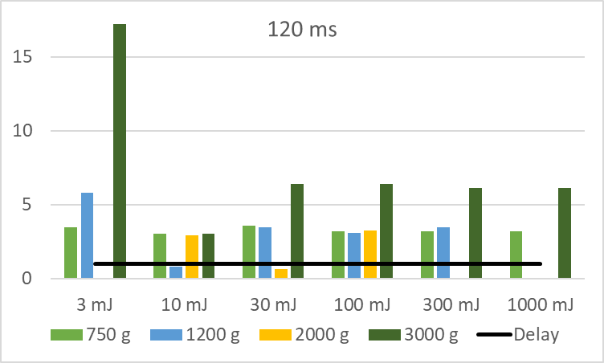 | c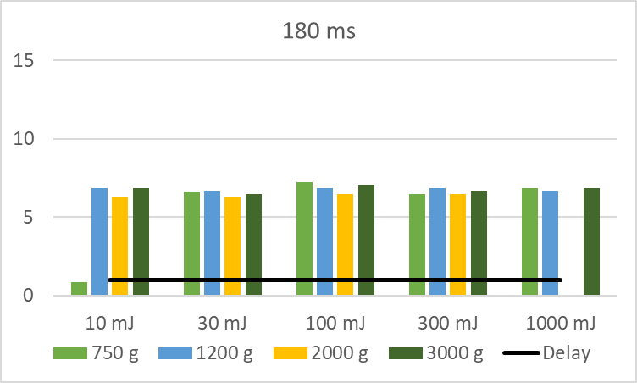
Figure 7: Distribution of delay ratio under different conditions. Delay time: a) 60 ms; b) 120 ms, c) 180 ms

From Figure 7, it can be noticed that, increasing the delay time, higher ratios are developed: average r is equal to 1.85 for 60 ms, 4.4 for 120 ms and 6.1 for 180 ms, showing a mild proportional dependance of the ratio from the delay times, according to the observed data.
    - Ignition trigger analysis
Figure 7 reports the distribution of t_{ign} under different test conditions. The time is picked at frame that may coincide or be after the expiring of the spark. So, when this time is equal to 0, an ignition is detected at frame right after the spark is found. From results, it shown that, in most cases, the ignition is very close to the spark, which mean that there is an average distance of about 4 ms between spark and combustion. This is in accordance with the specific time of pyrolysis of 5-10 ms (Copelli et al., 2021), which is the limiting factor when igniting a fine particle like the one proposed in this study. However, in many cases this condition is not respected: sometimes it is necessary to wait hundreds of milliseconds before the ignition is triggered.
a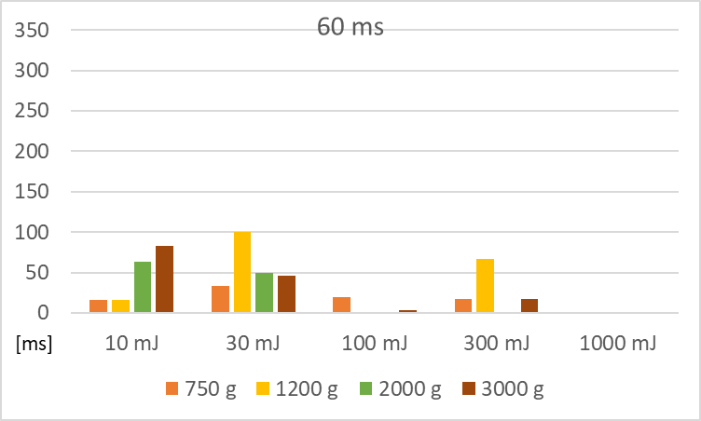 | b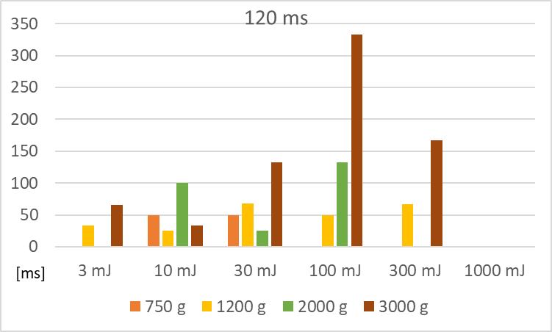 | c  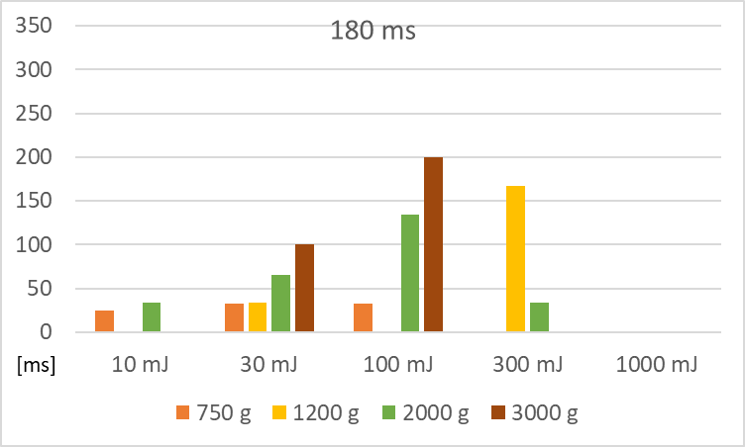
Figure 7: Distribution of t_{ign} under different conditions. Delay time: a) 60 ms; b) 120 ms, c) 180 ms

In some case, flame propagation does not occur instantly, but it requires some time. This can be due to an excessive local concentration of dust, which doesn’t allow combustion to self-sustaining locally in the surrounding gas phase.
  - Conclusions
Despite being a well-known and standardized process, the determination of the MIE by using electric sparks is based upon extremely complex physical and chemical phenomena: arc, air and heterogeneous mixtures breakdown, pyrolysis, combustion, turbulence and thermal radiation, involved in a highly time-dependant environment. The scope of this work is to highlight the possible interactions among combustion and electrostatic effects that require more detailed and focused studies. From the results achieved in this work, it was shown that, the presence of dust in the tube deeply affects the development of the electric breakdown.
Acknowledgements
Thanks to TÜV SÜD GmbH (Basel, Switzerland) for the availability of dust and MIKE 3
References
Abbasi, T., Abbasi, S.A., 2007. Dust explosions–Cases, causes, consequences, and control. Journal of Hazardous Materials 140, 7–44. https://doi.org/10.1016/j.jhazmat.2006.11.007
Barozzi, M., Copelli, S., Scotton, M.S., Torretta, V., 2020. Application of an Enhanced Version of Recursive Operability Analysis for Combustible Dusts Risk Assessment. International Journal of Environmental Research and Public Health 17. https://doi.org/10.3390/ijerph17093078
Cloney, C., 2021. “2021 Mid-Year Combustible Dust Incident Report - Version #1.
Copelli, S., Scotton, M.S., Barozzi, M., Derudi, M., Rota, R., 2021. A Practical Tool for Predicting the Minimum Ignition Energy of Organic Dusts. Ind. Eng. Chem. Res. 60, 10807–10813. https://doi.org/10.1021/acs.iecr.1c00309
CSB, 2006. Combustible Dust Hazard Study.
Eckhoff, R.K., 2003. Dust Explosions in the Process Industries: Identification, Assessment and Control of Dust Hazards. Elsevier Science.
Sankhé, M., Bernard, S., Wartel, M., Pellerin, S., Gillard, P., 2019. Characterization of a spark discharge for dust cloud ignition. Contributions to Plasma Physics 59, 326–339. https://doi.org/10.1002/ctpp.201800090

