CHEMICAL ENGINEERING TRANSACTIONS
VOL. , 2023

A publication of

The Italian Association of Chemical Engineering Online at www.cetjournal.it

Guest Editors: Sauro Pierucci, Jiří Jaromír Klemeš Copyright © 2023, AIDIC Servizi S.r.l.
ISBN 978-88-95608-98-3; ISSN 2283-9216

Integrated Risk Assessment of a Dangerous Goods Container Terminal. A Bow-Tie Approach
Evgeniia Taubert*, Tomaso Vairo, Margherita Pettinato, Bruno Fabiano
DICCA - Department of Civil Chemical and Environmental Engineering - University of Genoa, Via Opera Pia 15 - 16145,
Genoa, Italy taueugen11@gmail.com

Global trade continues to grow, with an increasing movement of dangerous goods in the supply chain, causing safety concerns. As a significant hub for dangerous goods transport in the Mediterranean region, Genoa Port possibly will develop new container terminals to accommodate the growing load. The proximity of the port to residential areas to the highway and the airport imposes a significant responsibility to assess operational risks and mitigate potential catastrophic events. This study focused on preliminary operational risk assessment using statistical analysis and the Bow-Tie method, which involved analysing the IMO classes to be handled in the terminal as well as accident scenarios based on the most hazardous materials associated with the IMO classes. Due to the increasing effects of climate changes, digitalization and energy transition, potentially adding further hazards during operations, a benchmark needs to be developed, also in view of future applications relying on additional smart and data-driven tools/technologies and statistically significant dataset. The findings of this study can be beneficial for the designing stage of the container terminal, regulatory authorities, stakeholders involved in the transportation and HazMat storage.

Introduction
With the increasing demand for goods and services across the globe, the transportation and storage of hazardous materials (explosive, flammable and toxic) has become a critical concern (Nguyen et al., 2018). Container shipping companies face a wide range of complex operational risks at different management levels (e.g., the NotPetya cyber-attack, Tianjin port explosion, Maersk Honam fire). The management of those risks requires consequence mitigation and preventive measures that depend heavily on effective, informative, holistic risk analyses and quantitative risk analysis (QRA) (Nguyen et al., 2021), even though they do not fall under the provisions of Seveso framework (Laurent et al., 2022). The operational risk level has a higher frequency and a shorter cycle from direct causal factors to consequences, i.e., operational hazardous events and their damages are immediately observable in the same operation (Kuo et al., 2017). Organisational and human factors play an important role and the challenge is to correctly identify relevant items in the HSE management system and the most effective layers of protection, both mitigating and preventing the risk (Fabiano et al., 2022). Inherently, container operational risks are characterised by the multiplicity and dynamicity of influencing factors that affect the potential events (e.g., likelihood, consequences, and detectability) (Goerlandt and Montewka, 2015). The objective of this paper is to discuss the various aspects of qualitative and quantitative risk assessment for a hazardous goods container terminal possibly in an urban port, including the hazards, risk identification, risk analysis, risk evaluation, and risk mitigation strategies (Pastorino et al., 2014). Containers 20" and 40" will be handled, and classified as dangerous, in accordance with the International Maritime Dangerous Goods Code (IMO, 2007) of the International Maritime Organisation (IMO) recommendations. The code also defines the classes of materials that are incompatible with each other. By implementing effective risk assessment practices, a dangerous goods container terminal can enhance safety for workers and citizens and protect the environment.

The paper represents the first step towards layout optimization and design of new levels of automation in the process and smart container data collection, aiming at reducing possible environmental impact of port activities and achieving efficiency, safety, and security.

Methods and case-study definition
According to IMO classification scheme, the inventory of dangerous goods, which theoretically might be stared and handled in an industrial port are presented in Table 1. The case study considered as pilot application, 182 ground slots for the storage of a total of 806 containers (up to the fifth throw). No processing operations (containers filling/refilling, packing etc.) will take place in the area, apart from transhipment operations to or from vessels and loading-unloading of road transport vehicles. Loading-unloading operations will be carried out using shore container quay cranes, transtainer cranes, mobile cranes, reach stackers, port fifth-wheel tractors, trailers, roll trailers, and road transport vehicles. Regarding the handled and stored substances, starting from 2021 collected data in the pilot area, Table 1 summarizes the total number of containers for each IMO Class (IMO, 2007), indicating the most common substance as well, harmonized with United Nations (UN) number.

Table 1: Handled (HCN) / stored (SCN) dangerous good with key reference substance.

IMO Cl. | № UN | Reference article or substance | HCN | SCN
2.1 flammable gases | 1950 | aerosols | 203 | 106
2.2 non-flammable, non-toxic gases | 2857 | refrigeration machines | 72 | 21
2.3 toxic gases | 1040 | ethylene oxide | 9 | 2
3 flammable liquids | 1173 | ethyl acetate | 903 | 163
4.1 flammable solids | 1350 | sulphur | 17 | 7
4.2 substances liable to spontaneous | 1362 | activated carbon | 25 | 10
combustion
4.3 substances which, in contact with | 1408 | ferrosilicon | 16 | 15
water, emit flammable gas
5.1 oxidising substances | 1492 | potassium persulphate | 209 | 64
5.2 organic peroxides | 3108 | solid organic peroxide | 32 | 17
6.1 toxic substances | 1593 | methylene chloride | 117 | 32
6.2 infectious substances | 2874 | furfuryl alcohol | 1 | 1
8 corrosive substances | 2921 | corrosive solids | 612 | 121
9 mixtures of hazardous substances not | 3082 | environmentally hazardous liquid | 280 | 124
covered by other IMO classes |  | substances
The conceived assessment involved the HazId, risk analysis, consequence evaluation, and risk mitigation. The Bow-Tie method was used to map out the potential hazards and their associated risks. This method visualises the relationship between the hazardous event (the top event), its causes, safety barriers, and its potential consequences due to a combination of fault and event trees. The Fault Tree Analysis (FTA) was used to identify the root causes of the hazardous events, e.g., equipment failures, human errors, and external factors as the main contributors to hazardous events in the terminal. The Event Tree Analysis (ETA) was used to evaluate the likelihoods of the consequences of the hazardous events. Finally, the consequences evaluation was conducted to assess the potential impacts of hazardous events on the terminal, workers, and the environment.

Results and discussion
The development of accident scenarios was analysed using the Bow-Tie methodology, which is similar for all types of hazardous substances. Figure 1 shows diagram for container operations centred on the top event loss of containment due to different causes of collisions and container failures. The second step is risk analysis, in terms of probability and estimation of consequences, which is developed for each type of substance.
The probabilities of reasonably credible events were classified according to the semi-quantitative ranking: 1E-03 occurrences per year represent events with a high occurrence probability;
1E-05 occurrences per year represent events with a medium occurrence probability; 1E-07 occurrences per year represent events with a low occurrence probability.

Based on the historical accident events in Genoa port and considering the annual container flow (data by Port Authority), accident probability was estimated in the low probability range. On this basis, the unit accident frequency (i.e., barrier failure) was set at a representative value of 1E-07 occ./year. Nevertheless, new factors could concur in the next future to increase the estimated frequency values, especially considering the vulnerability of the port area to extreme weather conditions, whose occurrence is rising over the years, with a direct effects on operations and barriers integrity. As shown in Figure 1, barrier failure can lead to a loss of

containment of hazardous substances due to collisions between means of transport and fixed obstacles, or containers falling in the different handling phases (in the staging area/transfer between ship and shore/loading- unloading of means of transport).
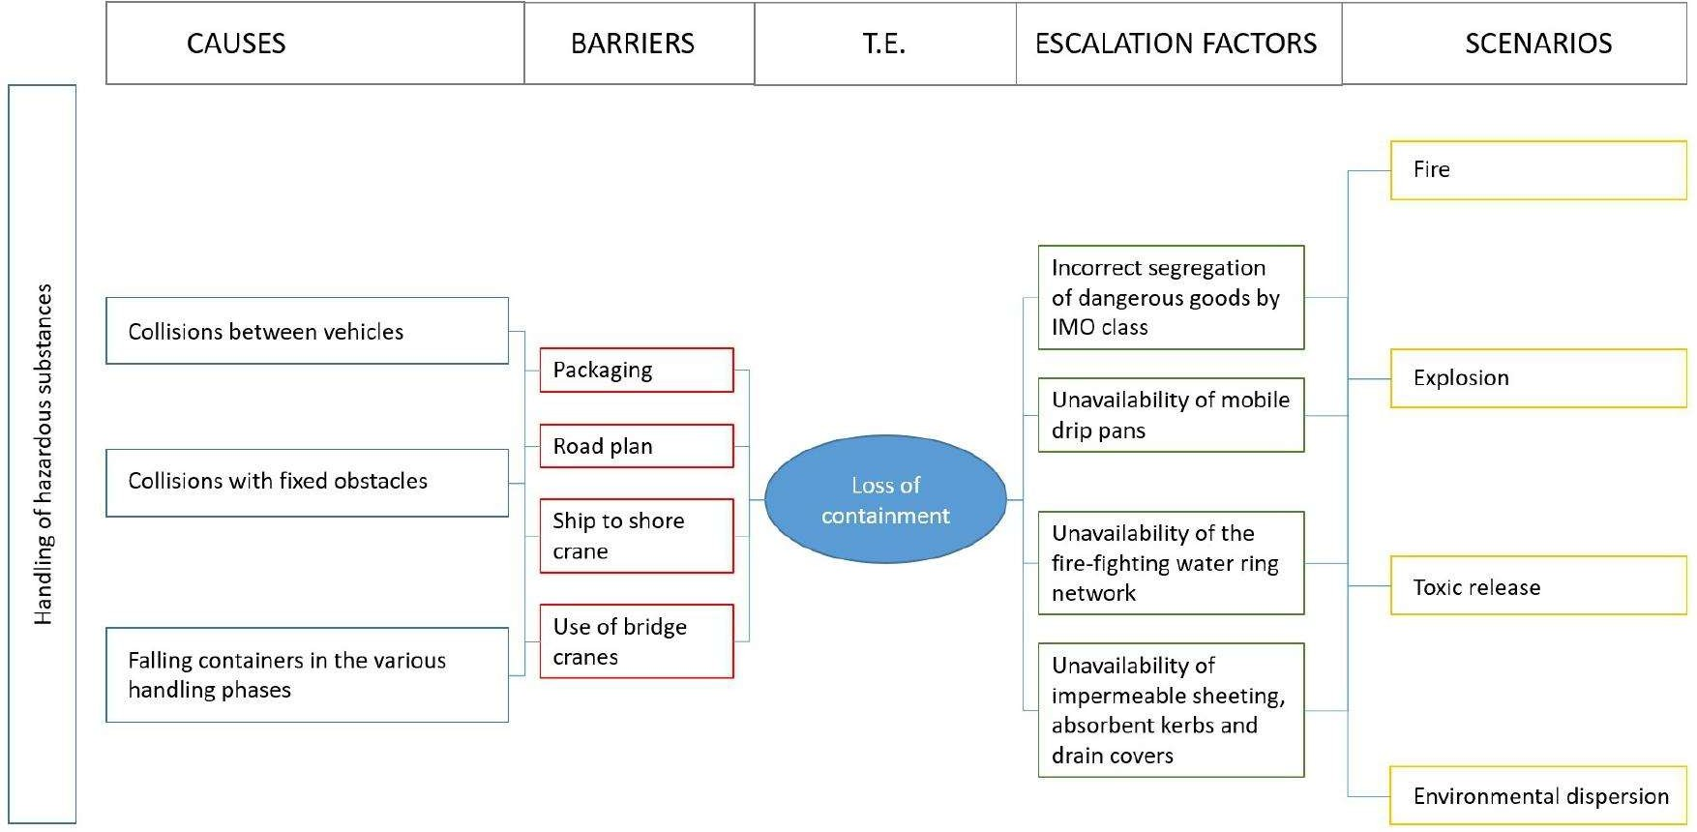

Figure 1: Bow-Tie for dangerous good terminal operations.

Main limitations arise from the evidence that Bow-tie models are not easy to modify once established, limiting their flexibility for dynamic risk environments. Additionally, selected events are often influenced by the analyst's personal point of view, experiences and biases, and relationships between events may not be fully identified.

3. 1 Frequency evaluation
Based on the information obtained according to the Bow-Tie analysis, a fault tree (Figure 2) was developed for determining the probability of loss of containment of hazardous substances. The unit probability of containment loss (TE), resulting from the development of the FT, is equal to 1,2 E-09 occurrences/year per container. The frequencies result from an analysis of the accidents that occurred, carried out by the Genoa port authority.
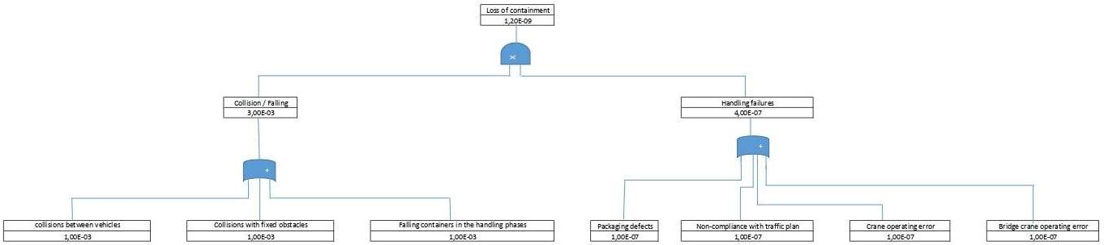

Figure 2: FT loss of containment of dangerous goods.

To estimate the overall frequency, the probability of the top event occurring must be multiplied by the number of handled containers (Table 1) over the covered time span. Container operations (filling/emptying of containers, packing, etc.) are not performed within the case. The reasonably credible Top Events mainly refer to the IMO classes shown in Table 2 in conjunction with their expected frequencies. To estimate the overall frequency, the probability of the top event occurring must be multiplied by the number of handled containers (Table 1) over the covered time span. Specific container operations (e.g., filling/emptying of containers, packaging, etc.) are not performed within the explored application., even though they could be accounted where needed. Analogously, accidents possibly connected to extreme weather conditions induced by climate change can be implemented as additional items.

Table 2: Top Event for IMO classes and calculated frequencies.
Top Event (TE) Involved IMO class Frequencies of TE, occ/y

Release of flammable / explosive
substances
2.1; 3; 4.1; 4.2; 4.3; 5.1; 5.2 5.62 E-04

Release of toxic substances 2.3; 6.1; 6.2 5.08 E-05
Release of polluting substances 9 1.12 E-04

According to the outlined approach, the reasonably credible Top Events mainly refer to the IMO classes shown in Table 2 in conjunction with their expected frequencies.

2 Consequence evaluation
From the identified top events, with their expected frequency, the determination of consequences is carried out by means of the ET technique, through the evaluation of the probability of occurrence of the escalation factors. The release of flammable or explosive substances could lead to the following scenarios: flash fire/explosion, pool fire, dispersion and no consequences which are represented on Figure 3. The same principle is applied in developing two additional ETs, respectively addressing flammable and toxic hazards which are depicted in Figs 4 and 5.

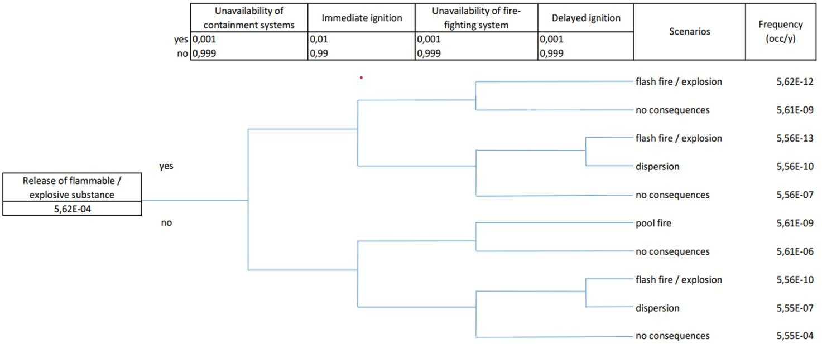

Figure 3: Accidental scenarios for flammable / explosive substances.

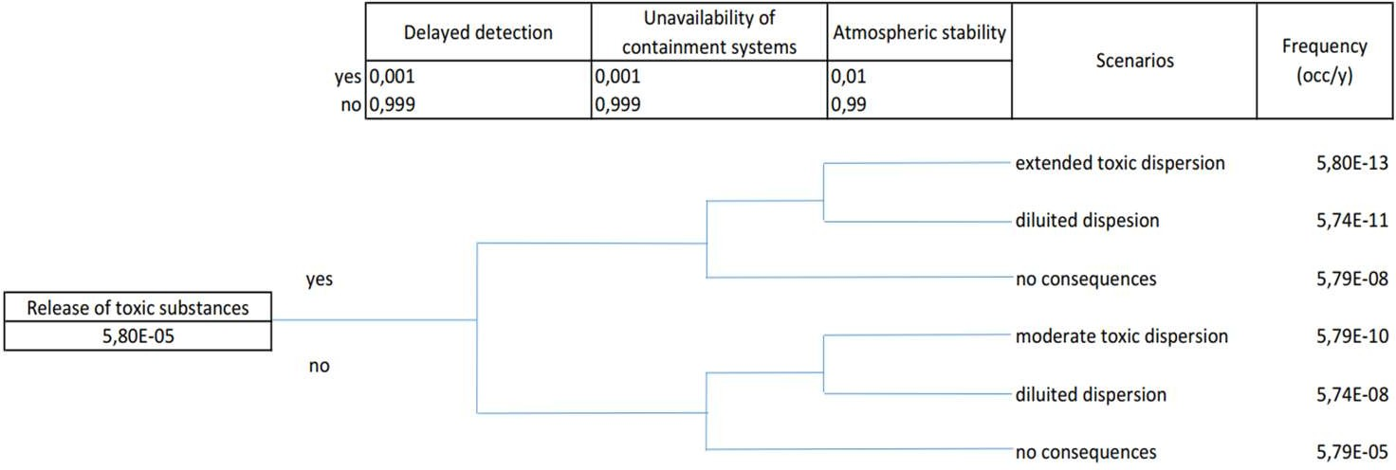
Figure 4: Accidental scenarios for toxic substances.

The summary of the frequency results of the ET analysis accidental scenarios is shown in Table 3. All accident scenarios with significant consequences for humans, or the environment have a frequency that makes them not credible (frequency under the 1 E-07 occ/y). For the consequence estimation, the most represented substances of the same class (Table 1), or the most dangerous representative of that class (depending on the accident scenario), were chosen as the key substance, obtaining the results summarised in Table 4.

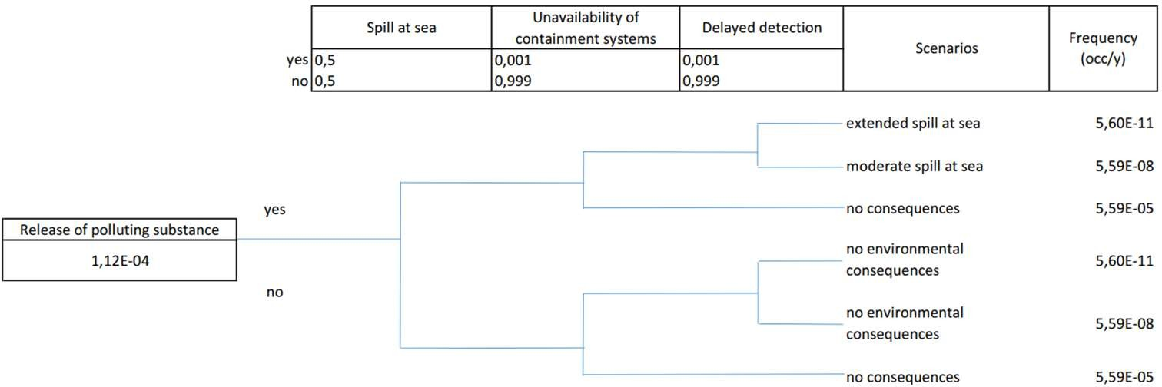

Figure 5: Accidental scenarios for polluting substances.

Additionally, accident scenario consequences were evaluated by accurately implementing well-established integral models for the estimation of physical effects (Van Den Bosch and Weterings, 2005).

Table 3: Accidental scenarios and frequency evaluation.
Release of flammable / explosive substance | Flash fire / explosion | 5.62 E-10
 | Pool fire | 5.61 E-09
 | Dispersion | 5.56 E-07
 | Negligible consequences | 5.61 E-04
Release of toxic substance | Extended toxic dispersion | 5.80 E-13
 | Moderate toxic dispersion | 5.79 E-10
 | Diluted dispersion | 5.74 E-08
 | Negligible consequences | 5.79 E-05
Release of polluting substance | Extended spill at sea | 5.60 E-11
 | Moderate spill at sea | 5.59 E-08
 | Negligible consequences | 1.12 E-04

Top Event Scenario Frequency (occ/y)

A complete range of evolving scenarios was analysed, i.e., toxic release dispersion, pool and flash fires, and vapour cloud explosions (VCE), the latter being included considering the actual presence of potentially congested areas in the given urban industrial port, interconnected with passenger traffic and nearby highway and airport. Results will be used to optimise the layout, considering as well different container handling equipment (CHE), thus helping decision-makers to attain a safer design of the container storage yards.

Table 4: Accidental scenarios modelling.
Release conditions Scenario Substance Evolving scenario and output

Wind: 2 m/s at 3 m
Air Temperature: 20° C Stability Class: F Inversion Height: None Relative Humidity: 50%
Flash fire ethyl acetate (CAS
141-78-6)

Pool fire isoprene (CAS 78- 79-5)

Explosion propane (CAS 74-
98-6)

Toxic release ethylene oxide
(CAS 75-21-8)
Thermal radiation from flash fire. Amount: 1
container equal to a volume 28 m3, 14,650 kg. Burn Duration: 3 s. Flame Length: 91 m (12.5 kW/m2: 83 m; 7 kW/m2: 112 m; 3
kW/m2: 168 m)
Thermal radiation from pool fire. Amount: 1 container equal to a volume 28 m3, 21,007 kg. Max Flame Length: 12 m. Max Burn Rate: 84.4 kg/min. Puddle diameter: 4.1 m (12.5 kW/m2: 11 m; 7 kW/m2: 15 m; 3
kW/m2: 23 m)
Overpressure (blast force) from vapour cloud explosion. Internal pressure: 6 bar. Release duration: 5 min. Amount Released: 391 kg (8.7 psi: never exceeded; 4.35 psi:
28 m; 1 psi: 51 m)
Heavy gas atmospheric dispersion. Amount: 1 container equal to 28 m3, 19,583 kg.
Release duration: 50 min. A stationary cloud or 'mist pool' will result
Amount Released: 1,797 kg (LC50: 24 m; IDLH:93 m)

Conclusions
The risk assessment carried out at the design stage allows identifying preventive and protective barriers that could reduce the escalation factors. Preventive and mitigating barriers are preliminarily identified as follows.
Preventive barriers
- process automation in container terminal (enhanced precision and resource optimisation, monitoring and precursor detection);
- traffic plan with one-way roadways to prevent vehicle collisions in the operational areas;
- ship-to-shore crane unloading and embarkation operations for reducing container positioning errors;
- road vehicles unloading/loading, loading/unloading of railway wagons exclusively by means of bridge cranes, which significantly reduces errors in the picking and positioning of containers;
- containers handling within the dangerous goods staging area.
- Protective barriers
- strict adherence to the rules on the separation of dangerous goods of different IMO criteria classification;
- mobile sealed leakage collection tanks of suitable capacity, against the spread of puddles of corrosive, flammable or toxic liquids, for prompt intervention on damaged containers in every area of the terminal;
- fire-fighting water ring network to protect the dangerous goods parking area;
- impermeable tarpaulins, absorbent kerbs and drain covers for intervention on product spills.
Following risk identification and prioritisation, it is possible to set-up risk mitigation strategies for Genoa terminal operators, regulatory authorities, and other stakeholders. As a practical follow-up, the risk-based framework can help the Port Maritime Authority to enforce, for each dangerous good container terminal, a systematic quantitative procedure to prevent event adverse scenarios and enhance response capabilities, while evaluating the best location or planning. A further step, representing a notable contribution for safety studies, includes reframing the bow-tie model as a dynamic one updating system probability distribution with real time predictions during container operations. The process can be continuously improved and updated based on the changing regulations, technologies (Vairo et al., 2023) operational conditions, trends in terms of transition towards novel materials and novel AI-related approaches to operations and management, as well as to consider climate change effects escalation, to improve safety and sustainability of the terminal operations.

Acknowledgments

This research was funded within the framework of INAIL call BRIC/2021/ID3 (Project DRIVERS- Approccio combinato data‐driven ed experience‐driven all’analisi del rischio sistemico) and the program RAISE (Robotics and AI for Socio-economic empowerment) of PNRR MUR – M4C2 Investment 1.5).

References
Fabiano, B., Pettinato, M., Currò, F., Reverberi, A.P., 2022, A field study on human factor and safety performances in a downstream oil industry, Safety Science, 153, 105795.
IMO, 2007, Revised Recommendations on the Safe Transport of Dangerous Cargoes and Related Activities in Port Areas (IB290E), International Maritime Organization Publisher, London, UK.
Goerlandt, F., Montewka, J., 2015, Maritime transportation risk analysis: review and analysis in light of some foundational issues, Reliab. Eng. Syst. Saf., 138, 115-134.
Kuo, S.Y., Lin, P.C., Lu, C.S. The effects of dynamic capabilities, service capabilities, competitive advantage, and organizational performance in container shipping, Transp. Res. A: Policy Pract., 95, 2017, 356-371.
Laurent, A., Pey, A., Gurtel, P., Fabiano, B., 2021, A critical perspective on the implementation of the EU Council Seveso Directives in France, Germany, Italy and Spain, Process Saf. Environ. Prot., 148, 47–74.
Lee, C.Y., Song, D.P. Ocean container transport in global supply chains: Overview and research opportunities, Transportation Research Part B: Methodological, 95, 2017, 442-474.
Nguyen, S., Wang, H. Prioritizing operational risks in container shipping systems by using cognitive assessment technique, Maritime Business Review, 3, 2018, 185-206.
Nguyen, S., Shu-Ling Chen, P., Du, Y., Thai, V.V. 2021, An operational risk analysis model for container shipping systems considering uncertainty quantification, Reliab. Eng. Syst. Saf., 209, 107362.
Pastorino, R., Vairo, T., Benvenuto, A., Fabiano, B. 2014, Area risk analysis in an urban port: personnel and major accident risk issues, Chemical Engineering Transactions, 36, 343-348.
Vairo, T., Pettinato, M., Reverberi, A.P., Milazzo, M.F., Fabiano, B., 2023, An approach towards the implementation of a reliable resilience model based on machine learning, Process Safety and Environmental Protection, 172, 632-641.
Van den Bosch, C.J.H., Weterings, R.A.P., 2005, Methods for the calculation of physical effects (Yellow Book), Committee for the Prevention of Disasters, The Hague, the Netherlands.

