|  |  |
| --- | --- |
| cetlogo ***CHEMICAL ENGINEERING TRANSACTIONS***  ***VOL., 2023*** | A publication of  aidiclogo_grande |
| The Italian Association  of Chemical Engineering  Online at www.cetjournal.it |
| Guest Editors: Sabrina Copelli, Richard Siwek  Copyright © 2023, AIDIC Servizi S.r.l. **ISBN** ; **ISSN** 2283-9216 | |

‘Self-heating is in the air’: the role of oxygen diffusion on the thermal stability of biomass piles

Rémi Demola, Agnès Janèsa,b, Aimeric Lacourta, Anthony Dufoura, Olivier Dufauda,\*

aUniversité de Lorraine, CNRS, LRGP, F-54000 Nancy, France

bDirection Régionale des Risques Professionnels de la Caisse Régionale d’Assurance Maladie d’Ile-de-France, 75019, Paris, France

olivier.dufaud@univ-lorraine.fr

This study aims to investigate the thermal stability of biomass piles through a combination of experimental and numerical approaches and explore the impact of particle size and oxygen diffusion. Isothermal basket tests were carried out according to EN-15188:2020 on raw and grinded pellets and sieved dust samples. The progression of the thermal wave inside the baskets was particularly studied by positioning thermocouples at different depths of the pile. The role of oxygen diffusion in the pile was examined by varying the basket size, by modifying the particle size distribution and by partially wrapping the baskets in a protective film. The self-heating behaviour of these piles was also assessed by using the crossing point method. The time evolution of the gases generated was analysed by micro-gas chromatography, especially around the cross-point.

In parallel, a three-dimensional model was developed to simulate the thermal behaviour of a quarter cube. The model includes energy balance, considering conductive, convective and radiative heat transfers and a heat-source term. Mass balances for particle size and each species are also considered through consumption and diffusion terms. Shrinking core models were implemented to represent the consumption of reactants. Moreover, thermogravimetric analyses were performed to identify the various reaction stages and determine the activation energy by using Flynn-Wall-Ozawa, Friedman and Kissinger’s methods.

This study demonstrates the significant influence of bed permeability, especially related to oxygen accessibility, on the thermal stability of storage facilities. Finally, the predictive model developed could be used to explore the efficiency of safety measures and technological solutions (compaction, storage size reduction, bagging...).

* 1. Introduction

In the context of energy savings and limitations of fossil fuels, biomass is increasingly used as an energy carrier. Various sources of biomass can be exploited, including wood, herbaceous plants, algae or, increasingly, solid recovered fuels (SRF). Like coal, whose self-heating phenomena have been studied extensively, biomass is also subjected to this type of accident (Restuccia et al., 2019). Moreover, raw materials are found in different forms, e.g., fine dust, sawdust, shells, chips or fibres, which influence their thermal stability. For ease of transport and energy density reasons, it can also be put in the form of pellets of variable size. These changes in shape and size can lead to significant variations in the self-heating behaviour of piles of such materials (Villacorta et al., 2021), due to heat and mass transfer modifications.

More generally, is it possible to predict the effect of variations in the porosity and permeability of biomass piles, caused by their compaction or their fragmentation, on their thermal stability? The answer to this question is far from obvious because the effects of porosity and oxygen diffusion can be counterintuitive and antagonist. Several aspects can indeed be affected by a porosity increase, some positively, others negatively: on the one hand, i) the convection within the pile can be enhanced, ii) the particle-particle distance will be increased, iii) the energy density could be reduced; on the other hand, iv) the oxygen accessibility will be improved and v) the water vapour will be removed more easily. Furthermore, particle size distribution and porosity can evolve in case of long-term storage due to the mechanical degradation of the pellets or their structural integrity loss as their moisture content increases.

This study aims to highlight the cross-influences of particle size and oxygen accessibility on the thermal stability of biomass, more specifically pellets piles. Several experimental approaches were explored in order to modify the oxygen diffusion in the biomass pile was examined in several ways: i) by varying the basket size, ii) by modifying the particle size distribution, iii) by partially wrapping the pellets in a protective film, iv) by varying the porosity by compaction of the bed, or v) by reducing the oxygen concentration in the atmosphere (Schmidt et al., 2003). Only the first three will be presented in this article. The design of experiments was used to highlight the impact of selected factors. In parallel to the experimental approach, a model was developed to represent the thermal behaviour of a quarter cube. In addition to mass and heat transfer terms, a shrinking core model was implemented to represent the consumption of reactants, based on thermogravimetric analyses. Experiments will also be used to validate the heat transfer modes implemented in the model.

* 1. Materials and experimental methods
     1. Pellets and powders preparation

Miscanthus pellets with 6 mm diameter and 10 to 30 mm length were used as raw materials. Their moisture content ranges between 8 and 15 wt% and they are composed of approximately 45, 30 and 25 % of cellulose, hemicellulose and lignin, respectively.

To study the influence of the particle size distribution of biomass on its thermal stability, the pellets were used in various forms. In addition to the tests performed on a) raw pellets, a few tests were performed on b) the longest pellets, selected by sieving and then sorted manually; pellets were also grinded and sieved to select c) only pieces between 1.19 and 4 mm or d) fine powder with a diameter lower than 1.19 mm; e) a 50/50 mixture of fine powder and raw pellets (called medium) was also used after mixing in a 3D shaker mixer (Turbula).

* + 1. Thermogravimetric analyses

Preliminary thermogravimetric analyses (TGA) were conducted under air on Miscanthus pellets and their powder in a TGA STARe System (Mettler Toledo). Pellets were broken into small pieces in order to fill the alumina crucible with 10 to 20 mg of biomass. Samples were subjected to constant temperature ramps (β) of 5, 10, 15 and 20 °C/min. Mass variation was recorded as a function of time/temperature from 30°C to 800°C.

Both integral (Flynn-Ozawa-Wall FWO) and differential methods (Friedman and Kissinger) were applied to study the combustion kinetics of biomass and determine the activation energy. Kinetic constants are assumed to follow an Arrhenius law. FWO method consists in representing ln(β) versus 1/T at given conversion rates (𝛼). Friedman method consists in plotting $ln⁡(β.\frac{dα}{dt} )$ as a function of 1/T, whereas Kissinger analysis is based not on direct analysis of the time-evolution of the conversion, but on its derivative. The degradation peak is then reached for a temperature noted Tp and the activation energy is obtained by representing $ln⁡(\frac{β}{T_{p}^{2}} )$ as a function of 1/Tp. Onset temperatures were also determined.

* + 1. Thermal stability

The self-heating properties of the biomass samples were studied using basket tests as described by ISO/TS 20049-2 (2020) standard. Figure 1a shows an instance of a cubical basket filled with fine powder (< 1.19 mm), placed in an isothermal oven (the spacing of the thermocouples is kept constant by a perforated metal bar).

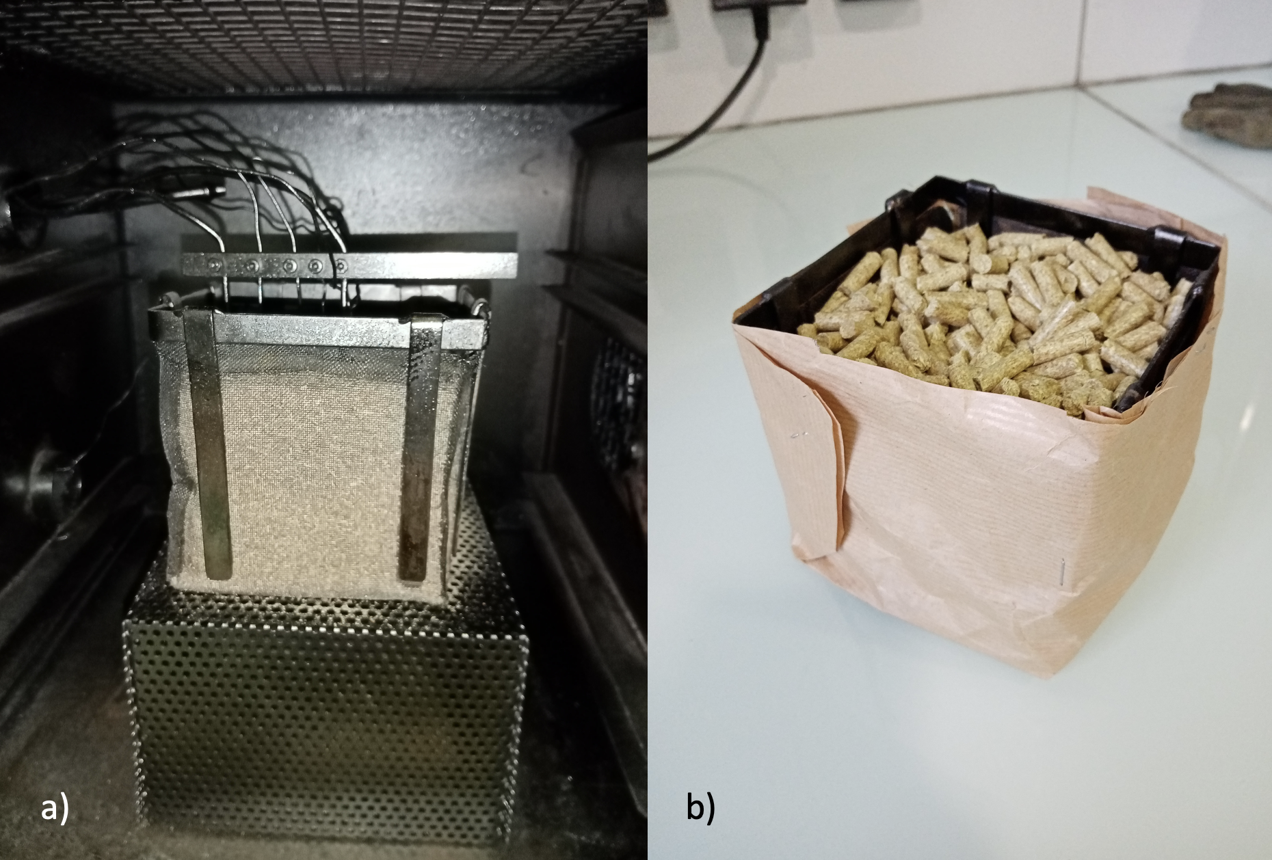

Figure 1: a) Instance of basket test with fine powder, b) wire-basket filled with pellets and wrapped with paper

Heating tests were mainly performed with three different basket sizes of 125, 1000 and 3375 cm3 (Figure 2), following two methods: isoperibolic tests (Dufaud, 2022) and crossing-point method. A 15.6 cm3 basket was occasionally used. In the first approach, ignition criteria are defined by a sample temperature exceeding the oven temperature by 60 K or by the presence of an inflexion point at temperatures higher than the set temperature. Tests were performed by changing the basket sizes and the set temperatures until the critical temperatures are determined for each basket size. The self-heating behaviour can be modelled using the Frank-Kamenetskii theory (Janès et al., 2019). In the crossing-point method, the criterion for validating self-heating is defined by the time tcp at which the temperature at the sample centre is higher than the other temperatures measured.

In order to verify the criterion defined by the previous method and to visualize the propagation of thermal waves within the samples, several thermocouples were placed in them, their positions varying according to the basket size (Figure 2). Tests to be carried out were chosen using the design of experiments methodology, either with full factorial design or with response surface modelling (Doehlert).

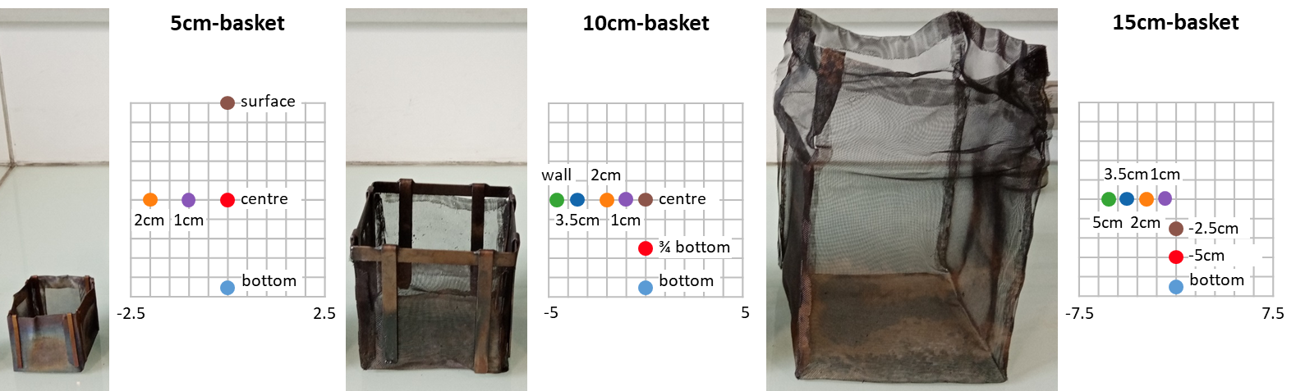

Figure 2: Spatial distribution of thermocouples for the three basket sizes

The flue gases were collected with a sampling tube placed above the basket at different times: before the crossing point, around tcp and after this specific time. They were analysed by micro-gas chromatography (SRA 3000, Agilent). A few tests were also performed by wrapping the basket with paper in order to limit oxygen accessibility. It should be noted that this envelope degrades and ignites spontaneously above 220-230 °C.

* 1. Results and discussion
     1. Thermogravimetric analyses - combustion kinetics

Analyses carried out by TGA show three to four steps: water loss up to 100 °C, hemicellulose reaction below 250 °C, and, above 320 °C cellulose and lignin reactions (non-dissociable at high heating rates).

By applying Flynn-Ozawa-Wall method for conversion rates ranging between 15 and 95%, linear relationships are obtained (Figure 3), which confirms the assumption of an Arrhenius law and allows the determination of mean activation energies for both hemicellulose and cellulose/lignin combustion reactions: 50.6 (with a maximum value of 53.1 kJ/mol) and 45.2 kJ/mol, respectively. As a comparison, Friedman method leads to activation energies of 49 kJ/mol for the first reaction, whereas 47 kJ/mol is obtained by using Kissinger approach. Although slightly lower than most values of biomass combustion activation energies observed in the literature, these results are consistent with those quoted by Gupta et al. (2021) for Areca, pine bark, sal and pine woods (i.e., from 48 to 53 kJ/mol). By using isothermal calorimetry on wood pellets, Guo et al. (2014) measured activation energies ranging from 55 to 58 kJ/mol, which confirms the order of magnitude of our results. They will be used as inputs in the numerical model.

* + 1. Thermal stability: results and evolution of internal temperatures

The first tests that were carried out were aimed at estimating the repeatability of the tests carried out in a basket oven. Three tests performed at 300 °C, in a 10 cm side basket with a medium sample (50/50) lead to a mean crossing point of 67 ± 3 min, which corresponds to a satisfactory repeatability even after mechanical mixing. Some of the results obtained by testing the thermal stability of biomass samples are shown in Table 1; when tests were subjected to a design of experiments, coded variables are given. Conversion from real variables Ai and coded variables xi correspond to $\frac{A_{i}-\overline{A}}{A_{max}-A_{min}}$.

During each test, the time evolution of the temperature at various locations in the basket was recorded. Figure 4 shows that the first signs of self-ignition are not necessarily detected at the centre of the basket and that, due to convection movement within the pile, the propagation of the thermal wave is not symmetrical between the vertical and horizontal axes. Calculation of Rayleigh Ra and critical Rayleigh Rac numbers shows that internal convection cannot be neglected as Ra/Rac = 12.6 for such pile, which is not the case for 1.19-4 mm biomass sample as Ra/Rac decreases down to 0.04. It should also be noted that the first areas where the temperature exceeds the oven temperature are located at 3.5 cm and 2 cm (not shown here) and their crossing point difference is about 10 min between these zones and the centre.

Combustion gases were analysed during several tests: it appears that CO/CO2 ratio remains lower than 0.1 before the crossing point is reached, as it increases to 0.12 and up to 0.3 a few minutes after that point. These experiments demonstrate that it is certainly possible to use such criteria to identify the early occurrence of self-heating of biomass piles.

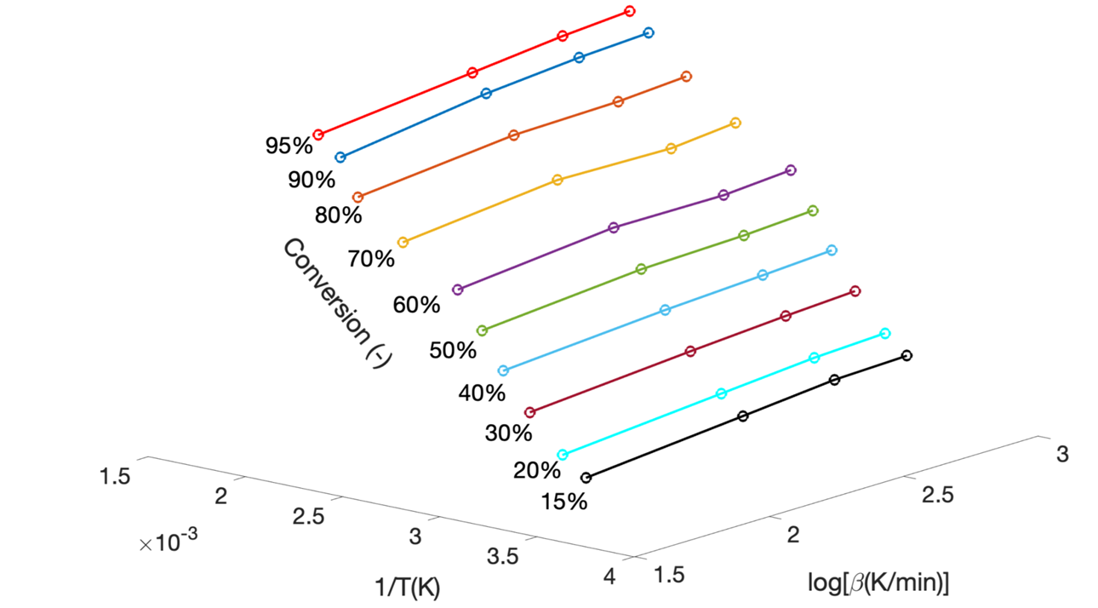

Figure 3: Determination of the activation energy according to Flynn-Ozawa-Wall method

Table 1: Results of thermal stability tests; coded variables

|  |  |  |  |  |  |  |  |
| --- | --- | --- | --- | --- | --- | --- | --- |
| Test | Coded variables | | | Real variables | | | Results |
| Number | x1 | x2 | x3 | Fuel size (mm) | T(°C) | Bask. size(cm) | Ignit. / tcp (min) |
| 1 | 0 | 0 | 0 | Medium (5) | 300 | 10 | 68.7 |
| 2 | 0 | 0 | 0 | Medium (5) | 300 | 10 | 62.5 |
| 3 | 0 | 0 | 0 | Medium (5) | 300 | 10 | 70.4 |
| 4 | 0.5 | 0.866 | 0 | Raw (7) | 400 | 10 | 93.2 |
| 5 | 1 | 0 | 0 | Large (9) | 300 | 10 | 10.8 |
| 6 | -1 | 0 | 0 | Fine (1) | 300 | 10 | 14.3 |
| 7 | -0.5 | -0.866 | 0 | 1.19-4 (3) | 200 | 10 | 108.3 |
| 8 | 0.5 | 0.289 | 0.816 | Raw (7) | 333 | 15 | 48.0 |
| 9 | -0.5 | -0.289 | -0.816 | 1.19-4 (3) | 266 | 5 | 10.7 |
| 10 | 0.5 | -0.866 | 0 | Raw (7) | 200 | 10 | 103.8 |
| 11 | 0.5 | -0.289 | -0.816 | Raw (7) | 266 | 5 | 14.3 |
| 12 | 0 | 0.577 | -0.816 | Medium (5) | 366 | 5 | 5.6 |
| 13 | -0.5 | 0.866 | 0 | 1.19-4 (3) | 400 | 10 | 9.6 |
| 14 | -0.5 | 0.289 | 0.816 | 1.19-4 (3) | 333 | 15 | 54.8 |
| 15 | 0 | -0.577 | 0.816 | Medium (5) | 233 | 15 | 60.5 |
| 16 | - | - | - | Raw (7) | 200 | 5 | Ignition |
| 17 | - | - | - | Raw (7) | 190 | 5 | No ignition |
| 18 | - | - | - | Raw (7) | 180 | 10 | Ignition |
| 19 | - | - | - | Raw (7) | 170 | 10 | No ignition |
| 20 | - | - | - | Raw (7) | 220 | 2.5 | Ignition |
| 21 | - | - | - | Raw (7) | 210 | 2.5 | No ignition |
| 22 | - | - | - | Raw (7) | 170 | 15 | Ignition |

* + 1. Thermal stability: influences of biomass size, temperature and basket size

Preliminary tests to identify cross-influences of powder/pellets size, temperature and basket size on the thermal stability of biomass storage facilities were first performed by introducing the samples into the cold oven. A full factorial 23 design was developed and residual analysis clearly shows a parabolic repartition of the

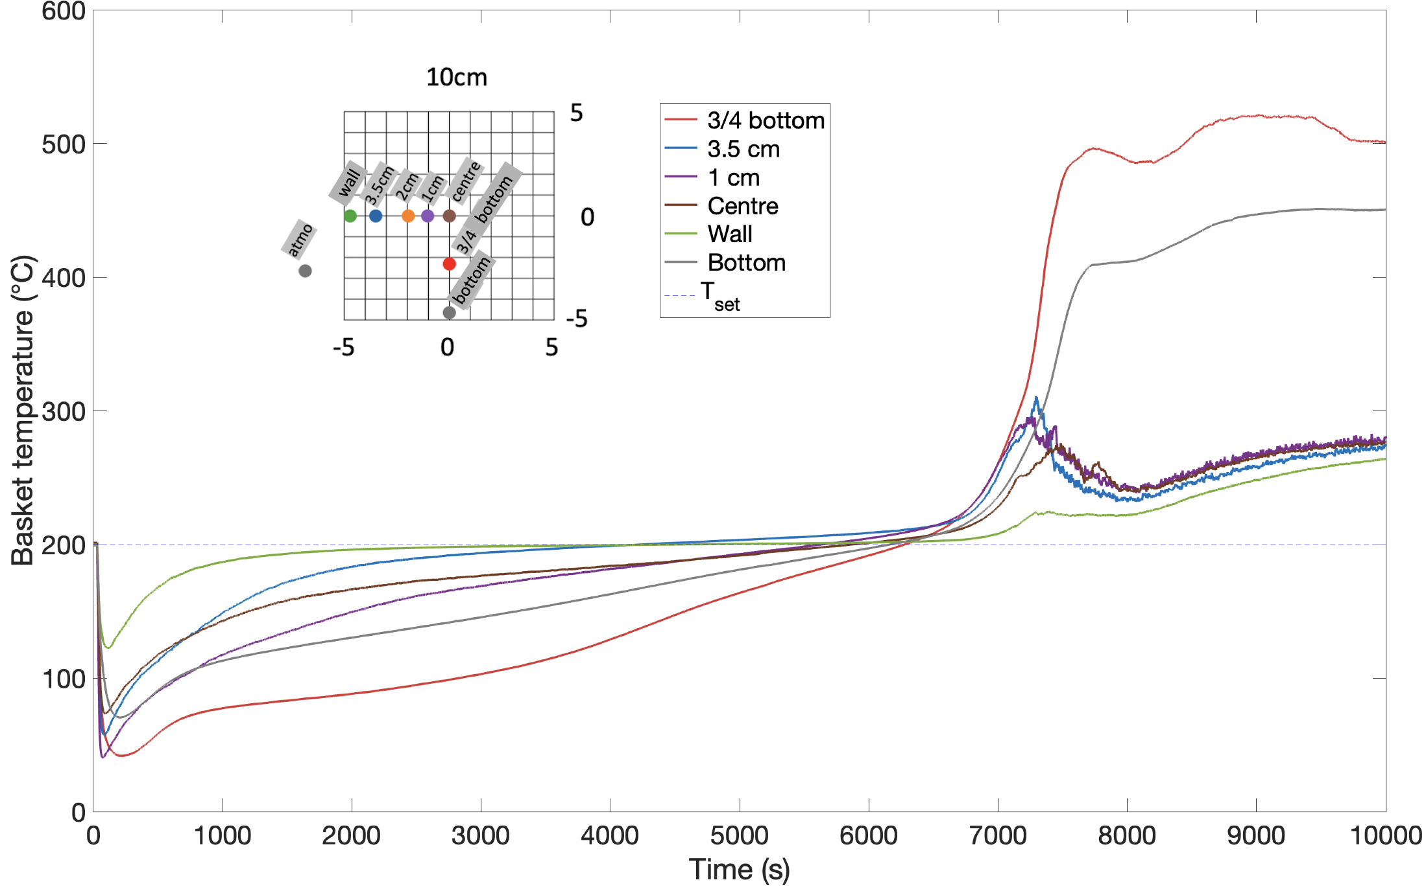

Figure 4: Self-ignition test performed on raw Miscanthus pellets in 10 cm side basket at 200 °C



Figure 5: Cross-influences of the temperature, biomass size and basket size on the thermal stability

errors, which implies that the trends are not linear and that the use of a surface response design is mandatory. Experiments #1-15 (Table 1) were done according to a Doehlert design; results are presented in Figure 5.

Figure 5 confirms the non-linear behavior predicted from the factorial design: there is an optimal biomass size for which the storage is more stable. It demonstrates the significant impact of bed permeability (Yazdanpanah et al., 2010) and oxygen accessibility on the thermal stability of biomass piles: for pellets, the convection within the pile cannot be neglected but the energy density is maximum; whereas for powders, the air diffusion towards the pile centre is limited.

* + 1. Thermal stab: influence of wrap

For 10 cm side basket, bagging increases their thermal stability, but only for temperatures lower than 220 °C. By limiting the access of oxygen, the crossing point time can be increased by almost 60% (pellets at 180 °C).

* + 1. 3D-model

The previous results were used as a basis to develop a 3D model for a quarter basket (10 x 5 x 5 cm3) with 63 cells. A finite volume method was implemented in MATLAB® to solve mass and energy balances, including conductive, convective and radiative heat transfers. The main equations and hypothesis of this model can be found in Bideau et al. (2011). A particle size distribution ranging between 10 µm to 2.5 cm was considered and the consumption of reactants was represented by a shrinking core model, whose activation energy was determined by TGA. It should be stressed that heat release kinetics seems to be a crucial parameter (Schwarzer et al., 2021). Pellets conductivity and heat capacity were taken from Gupta et al. (2021). Experiments allowed to validate the heat transfer within the biomass piles (Figure 6). To predict self-heating satisfactorily, considering the porosity variation during the first reaction phases is still to be developed.

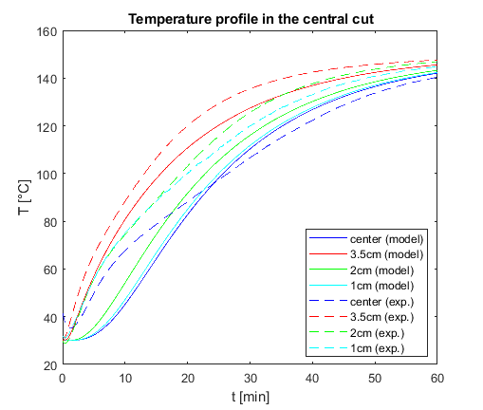

Figure 6: Time-evolution of the temperature in the central cut section of the pile: model and experiments

* 1. Conclusions

The influence of the size of the pellets or biomass powders on the thermal stability of stockpiles is far from being monotonous. Such behaviour is due to changes in pile permeability and especially to a competition between oxygen accessibility and energy density. Experiments, notably the determination of activation energy by TGA, allow both the development of a 3D model and can guide the choice of efficient and practical technological solutions based on e.g., storage size reduction, pellet size selection, bagging or compaction.

References

Bideau D., Dufaud O., Le Guyadec F., Perrin L., Genin X., Corriou J.-P., Caleyron A., 2011, Self-ignition of layers of powder mixture: Effect of solid inertants, Powder Technology, 209, 81-91

Dufaud O., Janès A., Henrion J., Sigot L., Laubie B., Simonnot M.-O., 2022, Ignition and Self-heating Risk Assessment of Hydrocarbon Polluted Soils, Chemical Engineering Transactions, 90, 73-78

Gupta A., Siddiqui H., Rathi S., Mahajani S., 2021, Intra-pellet transport limitations in the pyrolysis of raintree leaves litter, Energy, 216, 119267.

Guo W., Trischuk K., Bi X., Lim C.J., Sokhansanj S., 2014, Measurements of wood pellets self-heating kinetic parameters using isothermal calorimetry, Biomass and Bioenergy, 63, 1-9.

ISO/TS 20049-2, 2020, Solid biofuels - Determination of self-heating of pelletized biofuels - Part 2: Basket heating tests, International Organization for Standardization.

Janès, A., Vignes, A., Dufaud, O., 2019, Ignition temperatures of dust layers and bulk storages in hot environments, Journal of Loss Prevention in the Process Industries, 59, 106-117.

Restuccia F., Fernandez-Anez N., Rein G., 2019, Experimental measurement of particle size effects on the self-heating ignition of biomass piles: Homogeneous samples of dust and pellets, Fuel, 256, 115838.

Schmidt M., Lohrer C., Krause U., 2003, Self-ignition of dust at reduced volume fractions of ambient oxygen Journal of Loss Prevention in the Process Industries, 16 (2), 141-147.

Schwarzer L., Jensen P.A., Wedel S., Glarborg P., Karlström O., Holm J.K., Dam-Johansen, K., 2021, Self-heating and thermal runaway of biomass – Lab-scale experiments and modeling for conditions resembling power plant mills, Fuel, 294, 120281.

Villacorta E., Haraldseid I., Mikalsen R.F., Hagen B.C., Erland S., Kleppe G., Krause U., Frette V., 2021, Onset of smoldering fires in storage silos: Susceptibility to design, scenario, and material parameters, Fuel, 284, 118964.

Yazdanpanah, F., Sokhansanj, S., Lau, A.K., Lim, C.J., Bi, X., Melin, S., Afzal, M., 2010, Permeability of wood pellets in the presence of fines, Bioresource Technology, 101 (14), 5565-5570.