CHEMICAL ENGINEERING TRANSACTIONS  VOL., 2023 | A publication of
The Italian Association
of Chemical Engineering
Online at www.cetjournal.it
Guest Editors: Sabrina Copelli, Richard Siwek
Copyright © 2023, AIDIC Servizi S.r.l.
ISBN ; ISSN 2283-9216

Effect of particle size distribution and inerting mechanism on explosion severity of organic/mineral mixtures
José Serrano^{a,b}, Alexandre Nowicki^{b}, Laurent Perrinª, Olivier Dufaud^{a,}*
ª Université de Lorraine, CNRS, LRGP, F-54000 Nancy, France
^{b}Tecaliman, 44323 Nantes, France
olivier.dufaud@univ-lorraine.fr
The animal feed industry mixes cereals, vitamins, amino acids, and mineral powders to produce a solid mixture called “Premix”. The mitigation of premix explosions is challenging due to the diversity of composition, particle size, and nature of the mixed products. Therefore, determining their explosion safety parameters requires many standardised tests and a time-consuming process. However, it is possible to reduce the extensive use of experimental characterisation by better understanding the physicochemical mechanisms involved. In this context, this project aims to study the influence of Particle Size Distribution (PSD) and the mineral chemical nature on the explosion severity of organic and mineral powder mixtures commonly used for premix manufacturing. Cornflour was mixed with four minerals (sodium chloride, sodium bicarbonate, calcium carbonate, and magnesium oxide) chosen based on their industrial applications and inerting mechanisms (scavenging of radicals, inert gas generation, and heat sink). The powders were sieved to obtain samples with distinct particle size ranges. PSD was analysed ex-situ and in-situ to study the fragmentation behaviour of the products. The explosion tests method was based on the standard ISO/IEC 80079-20-2 using the 20L sphere. The results indicated that due to physical and chemical effects, NaHCO₃ is the most efficient inerting agent. Moreover, its initial PSD did not affect the inhibition performance due to its brittleness and the explosibility test pressure gradient, leading to possible inerting overestimation. NaCl reduced the deflagration index (K_{St}) less efficiently due to the incomplete decomposition into scavenging agents of free radicals, essential for flame propagation. The unsuitable addition of purely thermal inhibitors (CaCO₃, MgO) could increase the mixture’s K_{St} due to a dispersibility improvement, dust cloud PSD reduction and radiation effects. The mineral nature selection during product design could then significantly impact the inherent safety in the premix industry.
  - Introduction
A “premix” is a compound feed not intended for feeding animals directly. Premix manufacturers blend cereals, vitamins, amino acids and mineral products to cover nutritional needs by managing complex formulations. Therefore, applying process safety measures is challenging because of the mixed powders’ multiple physical and chemical properties. Nevertheless, it is possible to assume, in a first approach, that the frequent incorporation of inert materials allows the inhibition of dust explosion by applying the moderation principle of inherent safety (Amyotte et al., 2007). However, the inhibition efficiency depends on many variables, such as the fuel composition and non-combustible nature. For instance, Reding & Shiflett (2019) characterised the inhibition efficiency of five suppressant agents mixed with organic and metallic fuels using thermal analysis and showed that similar decomposition temperature ranges for the fuel and inert increase the inhibition effect of physical and chemical mechanisms. Y. Liu et al. (2022) proposed a NaHCO₃ inerting mechanism and highlighted the influence of sodium-containing species that scavenge the free radicals in oil shale explosions. However, Chen et al. (2022) compared its inerting effects with the corresponding solid product (Na₂CO₃) and discovered that the physical effects are predominant when the inert material proportion increases. Similarly, J. Liu et al. (2022) investigated the efficiency of adding CaCO₃ to inhibit titanium explosions, in which its thermal stability and purely thermal absorption action reduced the inerting capacity. However, few studies have aimed at inerting organic combustible products. One of them was conducted by Yang et al. (2022), in which they compared the inerting efficiency of NaCl and NaHCO₃ on flour explosion at different mineral concentrations. On the other hand, it is well known that the dust cloud PSD also modifies the explosion performance. Jiang et al. (2018) determined the Minimum Inerting Concentration (MIC) of aluminium/NaHCO₃ mixtures with different PSD. The authors found that the MIC was nearly independent of the NaHCO₃ PSD due to the ratio between the reaction time of the aluminium (d₅₀ = 5 µm) according to its combustion regime (Serrano et al., 2021) and NaHCO₃ heating time. Moreover, Bu et al. (2021) researched the suppressant-enhanced explosion phenomenon in aluminium dust flame propagation by adding alumina and improving the dispersibility of the dust cloud by reducing the effective dust cloud PSD, as reported by Bagaria et al. (2019). Nevertheless, this research area has focused mainly on metallic powders, lower PSD (<100 µm) and not considered the combined effects of more than two variables, which reduce their application to protection and mitigation safety measures in the premix industry. Therefore, this study addresses the influence of the inert mechanism and organic/mineral products’ PSD on the explosibility of simplified mixtures commonly used in premix manufacturing to contribute to applying the inherent safety approach and suitable protection measures.
  - Materials and methods
The mineral powders (NaCl, NaHCO₃, CaCO₃ and MgO) were selected according to their relevance in the premix’s formulation and their different main inerting mechanisms (scavenging of radicals, CO₂ generation and heat sink). Cornflour was chosen as the organic fraction of the binary mixtures due to its wide industrial use and suitable explosion parameters. The PSD of the samples was modified using a vibrating sieve shaker according to relevant industrial PSD ranges. It was measured ex-situ using the Mastersizer 3000 Particle Size Analyser (Malvern Instruments) equipped with the Aero S dry dispersion unit. Table 1 shows the characteristic diameters of the powder samples (PSD₀), including the Sauter mean diameter (d_{3,2})
Table 1: Characteristic diameters and temperatures of the powders before dispersion in the 20L sphere
Powder | d₁₀ [µm] | d₅₀ [µm] | d₉₀ [µm] | d_{3,2} [µm] | Temperature [°C]
NaCl | 196 | 280 | 394 | 269 | 800 – 970 (melting)
CaCO₃ | 27 | 241 | 350 | 36 | 700 – 800 (decomposition)
NaHCO₃₋#1 | 9 | 30 | 60 | 17
NaHCO₃₋#2 | 193 | 291 | 434 | 278 | 120 – 190 (decomposition)
NaHCO₃₋#3 | 299 | 422 | 589 | 407
MgO-#1 | 10 | 50 | 126 | 14
MgO-#2 | 167 | 252 | 373 | 239 | 2850 (melting)
MgO-#3 | 462 | 638 | 871 | 621
Cornflour-#1 | 18 | 65 | 134 | 42
Cornflour-#2 | 165 | 240 | 347 | 229 | 300 (decomposition)
Cornflour-#3 | 461 | 635 | 865 | 615
    - Particle size distribution in-situ measurement
The dust cloud generation based on ISO/IEC 80079-20-2 requires a high-pressure injection, leading to significant differences between the samples’ PSD before and after dispersion due to particle fragmentation. The dust cloud PSD (PSD_{d}) was measured in situ using a HELOS/KR (Sympatec GmbH) laser diffraction sensor equipped with R3 and R5 lenses capable of measuring particle sizes between 0.5 – 175 and 4.5 – 875 µm, respectively. The dispersion chamber is similar to the 20L sphere with visualisation windows that promote optical measurements and allow the granulometric analysis under similar conditions to the standard method. The PSD_{d} was assessed each 5 ms and averaged around the standard ignition delay time (60±10 ms).
    - Explosion severity
According to ISO/IEC 80079-20-2, a standard 20L spherical vessel equipped with a rebound nozzle was used for the explosion tests. The dust container pressure was slightly adjusted for large-volume samples to consider the air volume reduction and to pursue the 1 bar pressure at ignition. The binary mixtures P_{max} and (dP/dt)_{max} were obtained between (1000 – 1200 g/m³) based on the P_{max} and (dP/dt)_{max} of the pure cornflour samples. The samples’ mixing process was done in a 3D mixer (Turbula), allowing a high mixing efficiency and reproducibility.
  - Results and discussion
Firstly, the influence of each mineral product and its inerting mechanism will be discussed, followed by the effect of the mineral particle size on the inerting efficiency. Finally, the combined effects of fuel concentration and particle sizes of organic and mineral products over binary mixture explosibility will be introduced.
    - Inert mechanisms efficiencies
The cornflour sample (Cornflour-#1) was mixed at three mass proportions (40%, 60%, 80%) with four mineral samples (NaCl, CaCO₃, NaHCO₃-#2, MgO-#2) with comparable PSD to study the influence of the mineral nature on the maximum explosion overpressure P_{max}, (Figure 1a) and maximum rate of pressure rise (dP/dt)_{max}, (Figure 1b). The experimental data was fitted to a polynomial regression and projected by a dotted line until the pure Cornflour-#1 values. The P_{max} of the mixtures began to decrease significantly after adding 60% of mineral powder. The mixtures with NaCl, CaCO₃ and MgO-#2 led to a similar quasi-linear P_{max} drop, as shown in Figure 1a, demonstrating that the mineral concentration to inhibit the explosion is much higher than 60%. Moreover, their inerting effect had a similar thermodynamic influence on the explosion performance considering their heat capacities (864, 834 and 918 J/kg*K, respectively) and thermal stability (Table 1) (J. Liu et al., 2022; Yang et al., 2022). On the other hand, the P_{max} of mixtures with NaHCO₃-#2 significantly decreased after adding more than 40%, in agreement with (Y. Liu et al., 2022). The 60% NaHCO₃-#2 mixture achieved 60% of the P_{max} obtained with the other mineral products, as seen in Figure 1a. This behaviour was consistent with the low decomposition temperature (T_{decomp}) of NaHCO₃ (Table 1) (Chen et al., 2022), which strongly suggests that the particles decomposed completely through an endothermic process and efficiently removed the heat from the flame front required for the cornflour combustion.

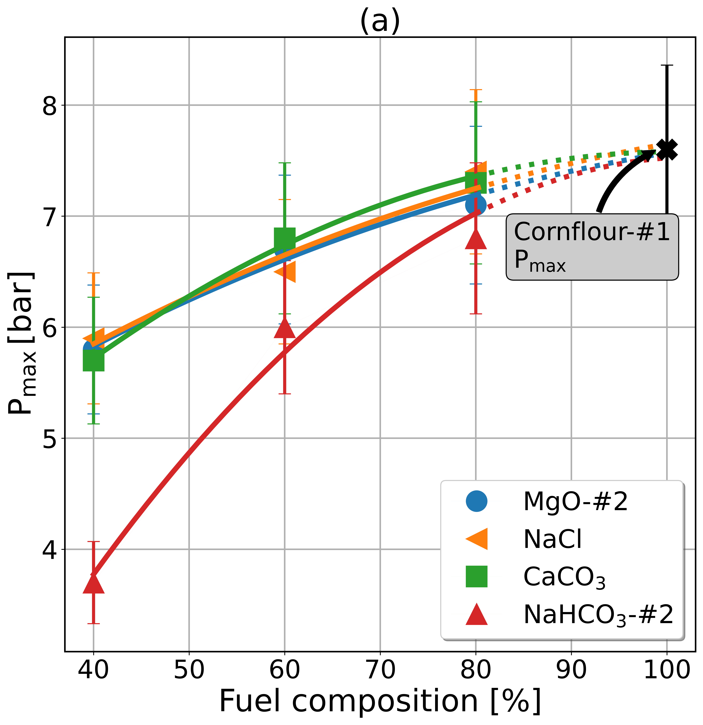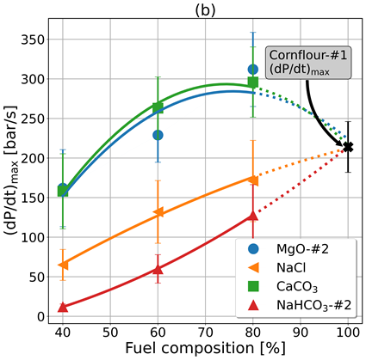
Figure 1: Evolution of explosibility data of cornflour #1 and mineral compounds mixtures at different organic mass concentrations. (a) Maximum explosion overpressure, (b) Maximum explosion pressure rise.
In addition, the Cornflour-#1 mixture needed at least the addition of 20% of NaHCO₃-#2, 40% of NaCl and more than 60% of CaCO₃ or MgO-#2 to significantly decreased its (dP/dt)_{max}, as seen in Figure 1b. The inerting effect by adding NaCl and NaHCO₃-#2 followed a quasi-linear trend over the concentration range studied. On the other hand, the mixtures with CaCO₃ and MgO-#2 achieved an unusual non-linear behaviour as the organic composition decreased and even a (dP/dt)_{max} promoting effect by adding 20% of mineral. The improved dispersibility of the cornflour caused this effect due to the disrupted inter-particle contacts and decreased agglomeration trend induced by the mineral particles over their inerting mechanisms, which led to a PSD_{d} reduction (Bu et al., 2021). In addition, the MgO and CaCO₃ particles remaining at the flame front (delayed thermal degradation – Table 1) might boost the heat radiation transfer afterwards. Furthermore, the other mixtures did not evidence that behaviour due to a complete thermal decomposition (NaHCO₃) and free radicals scavenging mechanism (NaHCO₃/NaCl) ahead from the flame front.

Similarly, the particular inerting mechanism of the mineral products can be seen more clearly in Figure 2 for each binary mixture with an organic composition of 40% and the corresponding Cornflour-#1 curve. As previously discussed, the MgO and CaCO₃ samples led to a similar P_{max} evolution, demonstrating that the thermal sink corresponds to their primary inerting mechanism. Moreover, the CaCO₃ mixture reached a slightly lower P_{max} caused by its delayed thermal decomposition (Table 1), in which a small fraction is converted into CO₂ (J. Liu et al., 2022). Nevertheless, the K_{St} parameter of these mixtures was not significantly different from the pure organic product, illustrating that the application of mitigation safety measures should be equivalent to them. Furthermore, the characteristic temperatures of CaCO₃ and NaCl being close, the inerting method of NaCl is different. Indeed, NaCl acts mainly through a chemical effect caused by the Na⁺ and Cl⁻ ions generated from its thermal decomposition, which “flatten” the overpressure curve, as shown in Figure 2. However, the mixture achieved a comparable P_{max} to the previous mineral samples, suggesting that thermal absorption was the primary explosion moderation (Reding & Shiflett, 2019) because of a lack of Na⁺ radicals to inhibit the explosion considering its T_{decomp} (Table 1) (Yang et al., 2022). Moreover, the inerting effect of the NaHCO₃ sample was the most effective because of its combined effect of the endothermic thermal decomposition at low temperature (Table 1), O₂ dilution and the generation of sodium-containing reactive products within the flame front, which can scavenge the radical species of O⁻ and OH⁻ and modify the propagation phenomenon (Yang et al., 2022). Then, it should be stressed that the physical effects of NaHCO₃ play a significant role from the early stages of the explosion and correspond to the main difference with the similar chemical inhibition mechanism of NaCl (Chen et al., 2022).

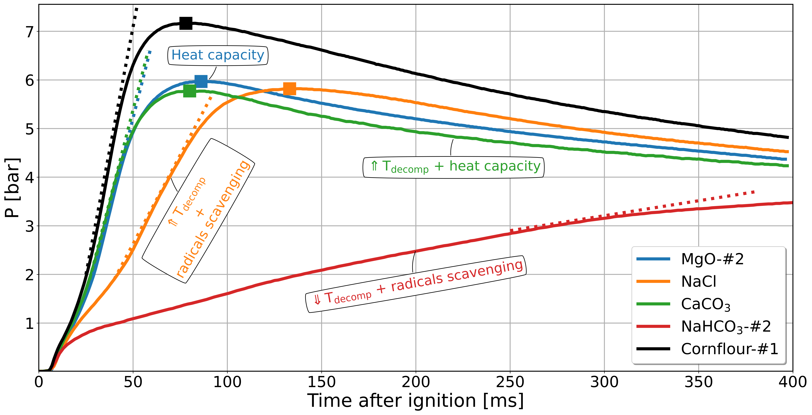
Figure 2: Pressure evolution of 40% Cornflour-#1 and minerals compounds mixtures.
    - Particle Size Distribution (PSD) effect on the inerting efficiency
The mineral product to study the influence of the PSD₀ on the explosion inhibition was NaHCO₃ due to its inerting efficiency. The mixtures comprised Cornflour-#1 and two NaHCO₃ samples (Table 2) with different PSD₀ (Table 1). Both mixtures’ explosibility data ((dP/dt)_{max} and P_{max}) were identical, as seen in the table added to Figure 3. Thus, NaHCO₃ PSD₀ did not affect the inerting efficiency of cornflour explosion, suggesting that the process safety mitigation measures could be applied regardless of their PSD₀. Nevertheless, Amyotte et al. (2007) found that the mineral PSD affects inhibition performance. Therefore, the PSD of the mixtures was measured in situ after dispersion (PSD_{d}) to highlight a potential PSD modification due to powder fragmentation (Figure 3).
Table 2: Binary mixtures of cornflour with different PSD₀ of NaHCO₃
Binary mixture | Organic sample | Organic [%] | Mineral sample
Mixture#1 | Cornflour-#1 | 60 | NaHCO₃-#3
Mixture#2 |  |  | NaHCO₃-#1

When considering the PSD₀ of Mixture#1, both components could be clearly distinguished due to their distinctive particle size range (Table 1): particles with diameters lower than d₆₀ characterise Cornflour#1 sample, whereas the coarsest particles correspond to the NaHCO₃-#3 sample (Table 2). Such analysis could not be applied to Mixture#2 because of the similarities between each component (Table 1), setting up a unimodal distribution with considerably smaller particle size. However, Figure 3 shows that the PSD_{d} of both mixtures were indistinguishable, suggesting an intense particle fragmentation with the same threshold regardless of the NaHCO₃ PSD₀. In this scenario, the high brittleness of NaHCO₃ caused its fragmentation under the energetic pressure gradient and shear stress during an explosion severity test (Bagaria et al., 2019). Therefore, these NaHCO₃ samples underwent the same complete thermal decomposition and gas-phase chemical interaction with the flame (Chen et al., 2022). Similar results were obtained by Jiang et al. (2018) when testing Al/NaHCO₃ mixtures in the 20L sphere, suggesting that although the conditions of the standard explosibility method estimate most traditional scenarios conservatively, it could lead to overestimating the inerting efficiency of a premix with mineral products and thus miscalculating the safety mitigation measures.

Figure 3: Particle Size Distribution (PSD) of Cornflour-#1 and NaHCO₃ (#1 and #3) mixtures measured ex-situ (PSD₀) and in-situ (PSD_{d}). Explosibility data is shown in the table included.
    - Combined effect of PSD and organic fraction
The study of the combined effects of the PSD₀ of both Cornflour and MgO (Table 1) at different fuel proportions (Φ) followed a Box-Behnken experimental design (Figure 4). The mixture explosion was inhibited only with the Cornflour-#3 sample (d₅₀ = 635 µm) and at the lowest fuel concentration (Φ = 40%), corresponding to the expected most favourable scenario for explosion inerting, highlighting the low explosion inhibition efficiency of MgO powder again.

Figure 4: Contours of (dP/dt)_{max} evolution of Cornflour/MgO mixtures versus Φ, organic and mineral d₅₀.
Furthermore, the fuel proportion and cornflour PSD₀ were the most significant factors for the mixture’s explosibility. The reduction of organic PSD₀ showed a non-linear effect over the mixtures (dP/dt)_{max,} and its influence increased with the fuel proportion, as illustrated by Figure 4. In addition, the MgO PSD₀ did not show a significant effect at low fuel concentration (Φ = 40%) or when the cornflour PSD₀ had a d₅₀ ≥ 240 µm (Cornflour-#2 and Cornflour-#3). However, this factor substantially impacted the mixture’s explosibility when the Φ ≥ 60% and the cornflour d₅₀ = 65 µm (Cornflour-#1). In this scenario, MgO particles improved the dispersibility of cornflour more than they inhibited its combustion inhibition, as highlighted in Section 3.1. Therefore, under such conditions, the (dP/dt)_{max} values were even higher than those of the pure cornflour, as presented in Figures 1 and 4, which illustrated the explosion inerting/promotion duality of a mainly “thermal-action” mineral product concerning its mass proportion. However, physical interactions between mineral and organic compounds might follow different trends according to the PSD_{mineral}/PSD_{organic} ratio (Bu et al., 2021) and effective PSD_{d} (Bagaria et al., 2019). Therefore, according to ISO/IEC 80079-20-2, the cornflour PSD₀ was the only parameter significantly influencing the MgO mass required to inert the explosion.
  - Conclusions
Estimating the explosion severity and ignition sensitivity of premixtures used in the animal feed industry is challenging due to the variability of the nature, particle size and composition of their components. Using binary versions of those products and modifying selected factors (fuel concentration, PSD₀ and inert nature) contributes to a better understanding of the explosion severity of premix compounds. This study established that NaHCO₃ is the most efficient inerting agent, with both physical and chemical effects. In addition, the PSD₀ of this mineral did not significantly affect the inerting efficiency because of its fragmentation during the explosibility standard test. Therefore, if the standard procedure can be considered a conservative approach when determining pure combustible powders, because of the increase of the particle surface area by fragmentation, it is no longer so when brittle non-combustible powders are added. Indeed, their fragmentation increases the inhibiting action of minerals and is potentially inadequate concerning the industry reality. Furthermore, the inhibition performance of inert materials with a decomposition temperature higher than fuel pyrolysis seems inadequate (NaCl, MgO, CaCO₃) due to a scarcity of more efficient inerting agents (Na⁺, CO₂) in the reactive flow. On the other hand, adding minerals without a chemical mechanism (MgO and CaCO₃) below 40% could even increase the mixture K_{St} due to dust cloud dispersibility and radiative transfer improvement. For that reason, the mineral nature selection step of the product design could significantly impact the inherent safety in the premix industry. Further research is aimed at characterising the ignition sensitivity of organic/mineral mixtures.
Acknowledgements
The authors would like to acknowledge the support of the EMIX Club members.
References
Amyotte, P. R., Pegg, M. J., Khan, F. I., Nifuku, M., & Yingxin, T. (2007). Moderation of dust explosions. Journal of Loss Prevention in the Process Industries, 20(4–6), 675–687.
Bagaria, P., Li, Q., Dastidar, A., & Mashuga, C. (2019). Classification of particle breakage due to dust dispersion. Powder Technology, 342, 204–213.
Bu, Y., Amyotte, P., Li, C., Yuan, W., Yuan, C., & Li, G. (2021). Effects of dust dispersibility on the suppressant enhanced explosion parameter (SEEP) in flame propagation of Al dust clouds. Journal of Hazardous Materials, 404, 124119.
Chen, X., Lu, K., Xiao, Y., Su, B., Wang, Y., & Zhao, T. (2022). Investigation on the inhibition of aluminium dust explosion by sodium bicarbonate and its solid product sodium carbonate. ACS Omega, 7(1), 617-628.
Jiang, H., Bi, M., Gao, W., Gan, B., Zhang, D., & Zhang, Q. (2018). Inhibition of aluminium dust explosion by NaHCO3 with different particle size distributions. Journal of Hazardous Materials, 344, 902–912.
Liu, J., Meng, X., Yan, K., Wang, Z., Dai, W., Wang, Z., Li, F., Yang, P., & Liu, Y. (2022). Study on the effect and mechanism of Ca(H₂PO₄)₂ and CaCO₃ powders on inhibiting the explosion of titanium powder. Powder Technology, 395, 158–167.
Liu, Y., Zhang, Y., Meng, X., Yan, K., Wang, Z., Liu, J., Wang, Z., Yang, P., Dai, W., & Li, F. (2022). Research on flame propagation and explosion overpressure of oil shale dust explosion suppression by NaHCO₃. Fuel, 314, 122778.
Reding, N. S., & Shiflett, M. B. (2019). Characterisation of thermal stability and heat absorption for suppressant agent/combustible dust mixtures via thermogravimetric analysis/differential scanning calorimetry. Industrial & Engineering Chemistry Research, 58(11), 4674–4687.
Serrano, J., Ratkovich, N., Muñoz, F., & Dufaud, O. (2021). Explosion severity behaviour of micro/nano-sized aluminium dust in the 20L sphere: Influence of the particle size distribution (PSD) and nozzle geometry. Process Safety and Environmental Protection, 152, 1–13.
Yang, P. P., Meng, X., Zhang, Y., Liu, J. Q., Yan, K., Li, F., Wang, Z., Liu, Y., Dai, W. J., & Wang, Z. (2022). Experimental study and mechanism analysis on the suppression of flour explosion by NaCl and NaHCO₃. Combustion Science and Technology, 1–16.

