Combustion of a biomass-derived syngas to decarbonize a tissue paper plant: impact of the turbulence-chemistry interaction treatment on numerical simulations

Chiara Galletti^{1*}, Lorenzo Giuntini¹, Luca Linari², Pietro Saccomano², Davide Mainardi³, Leonardo Tognotti¹, Rachele Lamioni¹
1 Dipartimento di Ingegneria Civile e Industriale, Università di Pisa, 56126 Pisa, Italy;
2 ANDRITZ Novimpianti S.r.l, Capannori (Lucca) – Italy
3 SOFIDEL S.p.A, Porcari (Lucca) - Italy
*Corresponding author E-Mail: chiara.galletti@unipi.it

1.Introduction
In the papermaking industry is responsible of about 7% of the global industrial energy consumption mostly based on fossil fuels as natural gas and liquid petroleum gas, (LPG) with adverse effects on climate changes. The “Fit for 55” and “REpowEU” EU actions aimed at, respectively, 55% reduction of greenhouse gas emissions with respect to 1990 levels by 2030 and diversification of energy sources to reduce our dependence on suppliers of fossil fuels, both ask for a decarbonization of all industrial sectors, including the papermaking one. Here, the tissue paper constitutes one of the main products with a global average consumption per person of about 55 kg/year.
The tissue industry is very-energy demanding with a carbon footprint of around 0.6 kg eq. CO₂ per kg tissue paper [1]; this is mostly related to the thermal energy required for the drying process that in modern paper mills involves a steam-heated cylinder and two hot air hoods. The latter must supply hot air at about 500-600 °C to dry the surface of the tissue paper. These high temperatures are provided by burning fossil fuels.
Very recently, Frigo et al. [2] investigate the technical and economical possibility of feeding the combustion chamber located upstream of the hood for the tissue-paper drying, with a biomass-derived syngas, instead of LPG, to reduce the carbon footprint of the process.
However, further analysis is needed to elucidate how the switching to syngas may impact on the combustion process. Indeed, syngas is a mixture of hydrogen, carbon monoxide, nitrogen, carbon dioxide and therefore its combustion characteristics differ strongly from LPG [3]. The presence of H₂ which is characterized by laminar velocity and adiabatic flame temperature which are significantly higher than natural gas, can produce faster combustion rates [4] and generate higher temperatures which can augment NO_{x} emissions. The presence of inert gases, such as N₂, H₂O and CO₂, on the other hand, can naturally dilute the fuel and therefore produce flames with lower characteristic temperatures, which may help limiting NOx emissions, but may lead to difficulties in the completion of the combustion process. All these differences due to the change of fuel must be analyzed in terms of the combustion system design, as the strategies used to handle fossil fuels could be ineffective or even worsen when using syngas.
This work, we intend to analyze the impact of replacing LPG with a biomass-derived syngas on the combustion process for tissue paper drying in a plant located in Sweden. The syngas is obtained from gasification in a fluidized bed of locally produced wooden pellets. To this purpose, the 2.4 MW burners are of dual-fuel type, to maintain the possibility of being able to use both fuels, i.e., LPG and syngas. The goal is to ensure stable combustion with low CO and NO emissions; besides, the drying requires an even distribution of the flow and temperature on the paper surface, which must be ensured. To this end, advanced numerical simulations, based on computational fluid dynamics, are performed to obtain detailed information on the flow and thermo-chemical fields in the combustion chamber and hood.
2.Methods
Error! Reference source not found. shows the reference geometry of the combustion system, consisting of a horizontal cylindrical combustion chamber and a hood collecting the exhaust stream towards the tissue paper to be dried. The chamber is equipped with a 2.4 MW dual-fuel swirled burner and a flame tube, confining the reaction zone.
Figure 1. Sketch of the combustion system.
The syngas, whose composition is given in Table 1. Syngas composition., is fed through a swirled annular duct with a velocity of 20 m/s and a temperature of 323 K. The combustion air excess is 50%, with the total air being equally split into primary and secondary air. A large amount, i.e. about 14 times that of the combustion air, of humid (i.e., 28.61% by molar fraction of water vapor) recirculation air is also fed externally to the flame tube, to ensure its cooling. Such a recirculation air merges with the exhaust gases just upstream of a deflector cone, which protects the hood from flame radiation. In addition, a static mixer improves the temperature uniformity of the flow. A little amount of recirculation air is allowed to be entrained in the reaction region through an existing gap in the flame tube very close to the burner; this gas is crucial to dilute the flame to limit NO formation via the thermal route in case of LPG.

Table 1. Syngas composition.
Species | N₂ | CO | CO₂ | H₂ | H₂O | CH₄ | C₂H₄ | C₆H₆
Mole fraction [%] | 46.0 | 17.6 | 10.6 | 9.7 | 12.0 | 2.6 | 1.3 | 0.2

3-D numerical simulations are performed by solving the steady-state Favre-averaged Navier-Stokes equations for continuity, momentum, transport/reaction of chemical species and energy with the commercial code ANSYS Fluent v21 based on finite volume methods. Reynolds stresses are closed with the Realizable k-ε turbulence model with standard wall functions, while the turbulent transport of chemical species and heat respectively, are modeled through a gradient transport hypothesis with turbulent Schmidt and Prandtl numbers of 0.7 and 0.85, respectively.
For the closure of the mean reaction source terms two different approaches are compared, i.e.:
- the Eddy Dissipation Model (EDM) [5], based on an infinitely fast chemistry assumption is used with global kinetic scheme, where CH₄ is oxidized to CO, and CO to CO₂ [6] and H₂ is oxidized to H₂O with single step [7];
- the Eddy Dissipation Concept (EDC) [8], based on finite-rate assumption is used with the kinetic mechanism KEE58 [9], consisting of 17 chemical species and 58 reversible reactions.
Indeed, the purpose is to analyze the impact of chemistry on the numerical predictions; in fact, the global scheme ensures a much lower computational requirements, that make it interesting for practical applications.
Radiation is considered by employing the P1 model with the Weighted-Sum-of-Gray-Gases model to estimate the spectral properties of the medium. As for NO_{x} formation, the thermal, prompt and N₂O-intermediate paths are considered, by including the effect of turbulence through a probability density function.
Velocity, temperature, and composition were set as boundary conditions at the inlets of the combustion system, while a pressure outlet condition was set at the exit. The fuel, primary and secondary air were fed with specific swirl angles.
A grid independence study was carried out by performing reactive numerical simulations, to verify that the flame front could be well captured by the mesh size. The chosen grid has 2.4M cells and is polyhedral with prism layers at the walls, ensuring an average value of Y⁺ of 80, enabling a correct implementation of standard wall functions.
The set of equations was solved with a coupled solver and using a second-order upwind interpolation method with the PRESTO! algorithm for the pressure. Convergence was assessed by monitoring physical quantities at specified locations in the combustion chamber as well as by checking the normalized residuals, they are being always below 10⁻⁶.

3. Results and discussion
Figure 2. Velocity-magnitude distribution obtained with EDC and KEE58 mechanism: 3D views on the (a) vertical and (b) horizontal planes. shows the flow field trough the contours of the velocity magnitude in vertical and horizontal planes of the combustion system as predicted by the EDC model and KEE58 kinetic scheme. The highest velocities can be found between the flame tube and the external case, thus allowing an effective cooling of the flame tube wall with the recirculation air. Inside the flame tube we can observe a low-velocity region along the burner axis, while higher velocities can be found near the walls, especially in the upper part. It is worth noting that here the flow field is not axisymmetric, due to a certain amount of recirculation air which unevenly enters the reaction zone, passing through an existing gap in the wall.

Figure 2. Velocity-magnitude distribution obtained with EDC and KEE58 mechanism: 3D views on the (a) vertical and (b) horizontal planes.

The thermal fields on the vertical and horizontal planes obtained with different combustion models and kinetic schemes are compared in Fig 3. The EDM and global kinetics (see left panels) predicts a flame, which is attached to the burner. This happens because the infinitely fast chemistry hypothesis, proper of EDM, along with a strong turbulent mixing at the inlets, make the syngas ignite as soon as it enters the computational domain. Conversely, the EDC, based on finite-rate, with KEE58 kinetic mechanisms, shows a lifted syngas flame (see right panels).
The carbon monoxide emissions are evaluated at the outlet of the hood, to appreciate the capability of the original combustion system to effectively deal with syngas. The EDM model with global kinetics predicts zero CO emissions; this behavior is imputed to the intrinsic hypothesis of the model, i.e., infinitely fast chemistry which leads to a complete combustion. Instead, EDC with a detailed oxidation scheme estimates rather high CO emissions, i.e., of approximately 400 ppm. Indeed, we can observe from Fig. 3 that the flame appears rather long and extends towards the static mixer: this indicates that in case of syngas the combustion process cannot complete within the flame tube upstream of the deflector. As for NO_{x} emissions, they are below 1 ppm in all cases. This is because the syngas is mostly composed of inert gases, i.e., N₂, H₂O and CO₂, which keep the maximum flame temperature below 1700 K, thus avoiding the thermal mechanism of NO formation.

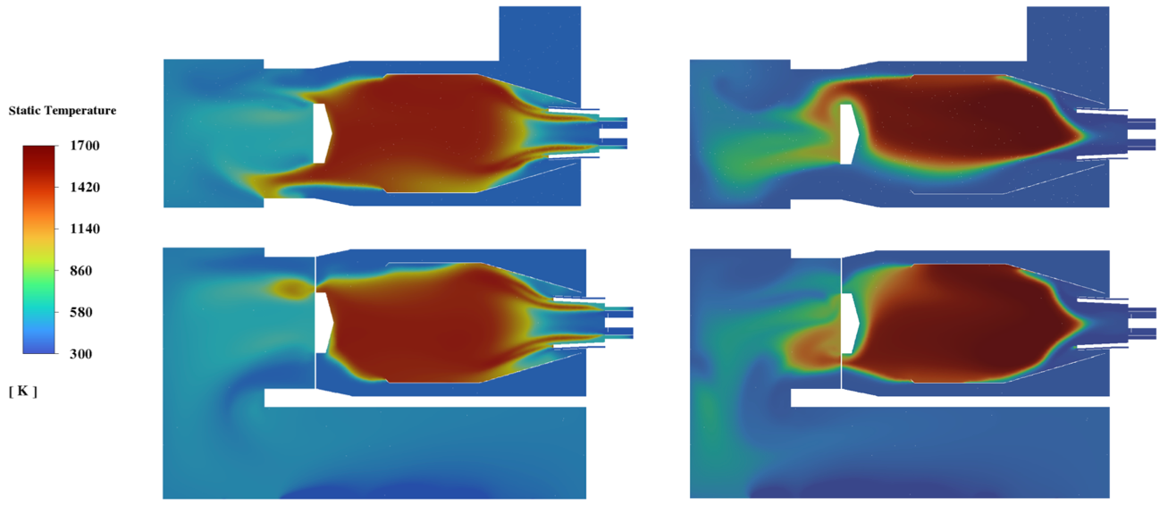
Figure 3. Temperature distribution on z = 0 (top) and y = 0 (bottom) plane. Global (left) and detailed (right) kinetic mechanism.
4. Conclusions
Numerical simulations were carried out of the combustion chamber equipped with an industrial hood used in the paper drying process and fed with a biomass-derived syngas. The study has shown how global oxidation schemes and a fast-chemistry hypothesis, largely employed in industrial practice for conventional fuels, cannot provide here the real morphology of the flame. By using a global chemistry approach, the flame is attached to the burner inlet and leads to zero CO emission. Instead, a finite-rate approach with detailed chemistry, which is remarkably more computationally expensive, predicts a flame which is lifted. However, the flame is rather unstable because of the presence of some recirculation air that dilutes it; as a results, syngas cannot be burned properly, thus leading to high CO emissions at the exit of the hood. This analysis represents a first step in the characterization the use of biomass syngas, to favor the decarbonization of the paper sector in place of LPG. In the context of the energy transition, combustion systems must be flexible in terms of fuel, therefore this work lays the foundations for a more in-depth analysis of the possibility of contributing to the retrofit of existing equipment in a decarbonized scenario.

References
- E. D. Gemechu, I. Butnar, J. Goma-Camps, A. Pons, F. Castells, A comparison of the ghg emissions caused by manufacturing tissue paper from virgin pulp or recycled waste paper, The International Journal of Life Cycle Assessment 18 (2013) 1618– 1628.
- S. Frigo, R. Gabbrielli, L. Linari, Feasibility study of a chp plant with steam turbine and biomass gasification for tissue paper pro- duction, Energy Procedia 148 (2018) 751–757, aTI 2018 - 73rd Conference of the Italian Thermal Machines Engineering Association.
- E. Jithin, G. Raghuram, T. Keshavamurthy, R. K. Velamati, C. Prathap, R. J. Varghese, A review on fundamental combustion characteristics of syngas mixtures and feasibility in combustion devices, Renewable and Sustainable Energy Reviews 146 (2021) 111178.
- C. Liu, B. Yan, G. Chen, X. Bai, Structures and burning velocity of biomass derived gas flames, International Jour- nal of Hydrogen Energy 35 (2) (2010) 542–555.
- B. F.,
- Magnussen, B. H. Hjertager, On mathematical modeling of turbulent combustion with special emphasis on soot formation and combustion. In Symposium (international) on Combustion (Vol. 16, No. 1, pp. 719-729) 1977.
- C. K. Westbrook, F.L. Dryer, Simplified reaction mechanisms for the oxidation of hydrocarbon fuels in flames, Combustion Science and Technology 27 (1-2) (1981) 31–43.
- N. M. Marinov, C. K. Westbrook, W. J. Pitz, Detailed and global chemical kinetics model for hydrogen.
- B. Magnussen, On the structure of turbulence and a generalized eddy dissipation concept for chemical reaction in turbulent flow. In 19th Aerospace Sciences Meeting 1981.
- R. Bilger, S. Stårner, R. Kee, On reduced mechanisms for methane-air combustion in non-premixed flames, Combustion and Flame 80 (2) (1990) 135–149.

