Use of hydrofluorocarbon solvent for the recovery of lipid and aqueous extracts from olive pomace.
Rosa Colucci Cante^{1,2}, Isidoro Garella³, Alessandro Nigro³, Elisabetta Iannone¹, Marianna Gallo^{1,2} and Roberto Nigro^{1, *}
1 Department of Chemical Engineering, Materials, and Industrial Production, University of Naples Federico II, P. Tecchio 80, Napoli-Italy; 2 Department of Industrial Engineering, University of Niccolò Cusano, Via Don Carlo Gnocchi 3, Rome, Italy; 3 I. T. P. Innovation and Technology Provider S.r.l., Via Bisignano a Chiaia, 68, Napoli, Italy.
*Corresponding author: rnigro@unina.it

1.Introduction
Re-use and valorisation of waste materials through low environmental impact recovery processes represent the fundamental principles on which the concepts of circular economy and sustainability are based.
For this reason, in recent years, recovery and transformation of agro-industrial wastes have been gaining more and more interest among the scientific community, industries, and the public opinion.
Olive pomace is the most abundant by-product generated during olive oil production process, consisting of olive pulp fragments, stones, and skins. It has an oil content of 8–12% w/w and a variable moisture content depending on the oil extraction system applied [1]. Since treatment and disposal of these huge volumes of solid and liquid wastes represent a very critical problem for the environment due to their high content of organic matter [2,3], residual oil can be recovered and used for consumption after refining.
Moreover, olive pomace contains other valuable bioactive compounds with health promoting benefits, such as phenolic compounds (phenolic acids and alcohols, lignans, and flavones) with antiviral, antimicrobial, antioxidant, anti-inflammatory, and anti-carcinogenic properties [4,5]. Conventional extraction processes currently applied to recover olive pomace oil involve the use of large amounts of organic solvents, such as hexane, long extraction times, and additional costs related to a preventive drying treatment of the matrix, solvent/extract separation processes, and disposal of solvent residues and exhausted solid.
The aim of this work was to propose an innovative extraction technique using hydrofluorocarbon Norflurane (1,1,1,2-tetrafluoroethane) in subcritical conditions as solvent, to recover oil from olive pomace.
Norflurane potential as extracting solvent for wasted materials was already tested in previous works [6-8].
The extraction yields reached using Norflurane were compared with those obtained by other extraction technologies, traditionally used, or recently studied. Furthermore, both dried and wet pomace was processed with this novel extraction system, confirming the possibility of recovering simultaneously both oil and vegetation water, rich in antioxidant compounds with high added value and beneficial effects on human health.
2. Methods
The initial moisture content of raw pomace was determined by drying the sample for 24 h at 105 °C, and a mean value of 57.4 % (g _{water}/g _{pomace} × 100) was found. Soxhlet extraction was carried out for 6 h on 10 g olive pomace, preliminary dried in oven at 60 °C up to a final moisture content of 2% on wet basis.
The resulting oil content of 10.7 % (g _{oil}/g _{dry solid} × 100) was used as reference for evaluating the extraction yields obtained using Norflurane.
Extraction tests were performed through a laboratory scale apparatus via a patented process [9] in which liquid Norflurane was percolated through the solid, placed in an extraction reactor (8–10 bar).
The oil-enriched solvent was then fed into an expansion vessel where it was gasified at a lower pressure (4–5 bar) and the oily extract was released at the bottom. Regenerated gaseous Norflurane was then recompressed and recycled in liquid form to the extraction chamber to restart the extraction cycle.
Extraction experiments were carried out on:
- dried olive pomace, for 180 min of process and a solvent flow rate of 100 mL/min.
- raw olive pomace, without preventive drying treatments, for 440 min of process and a solvent flow rate of 100 mL/min.
Extract samples were collected at specific times during the process and the corresponding kinetic curves were determined.
Total polyphenol (TP) and flavonoid (TF) contents in the aqueous fraction recovered from wet pomace were determined using Folin-Ciocalteu reagent assay [10] and aluminium chloride colorimetric method [11], respectively. TP and FC were expressed as milligrams of gallic acid and quercetin equivalents (GAE and QE), respectively, as gallic acid and quercetin were used as reference standards. Moreover, antioxidant activity was determined using the ferric reducing/antioxidant power (FRAP) assay [10] and was expressed as both millimoles of Fe²⁺ produced and millimoles of Trolox equivalents (TE) per millilitres of water.
3. Results and discussion
Extraction on dried matrix led to a final yield (η) of 95.1% after 3 h of process.
As shown in Figure 1, an approximately constant extraction rate was observed at the beginning of the process; then, it started to decrease after 90 min of process, due to the gradual decreasing of available oil in the matrix. Chanioti and Tzia [1] reported an extraction efficiency of 73% after 10 min of process using hexane at 60 °C, while Norflurane system provided the same yield value in 1 h of process.
However, milder operating conditions, lower toxicity and environmental impact, and lower additional costs associated to the subsequent separation and purification phases, make the novel system a valid alternative to traditional technologies. Moreover, ultrasound assisted extraction technique studied by Chanioti and Tzia [12] provided pomace oil yields (88.93 % in 1 h, at 60 °C) comparable with those reached using Norflurane in the same process time.
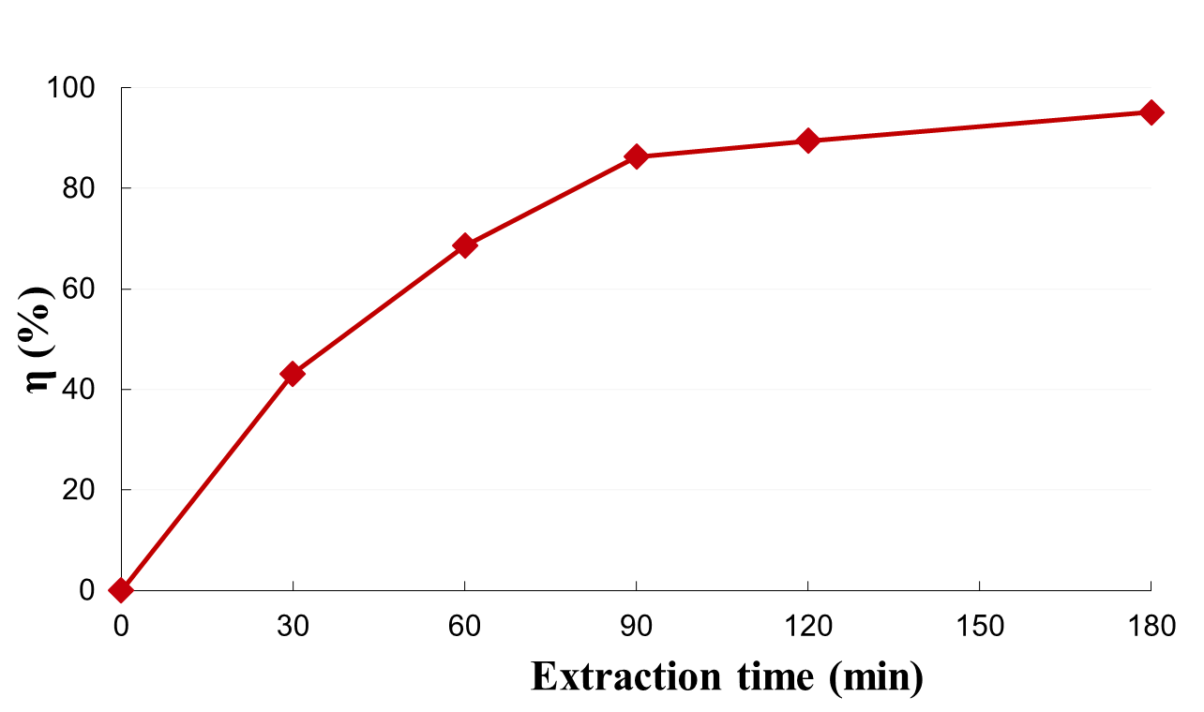
Figure 1. Extraction kinetic curve evaluated for oil extracted from dried olive pomace, using Norflurane system.
When extraction trials were performed on wet pomace, final extraction yields of 35 % % and 88.6 % for oil and water, respectively, were reached after 440 min of process.

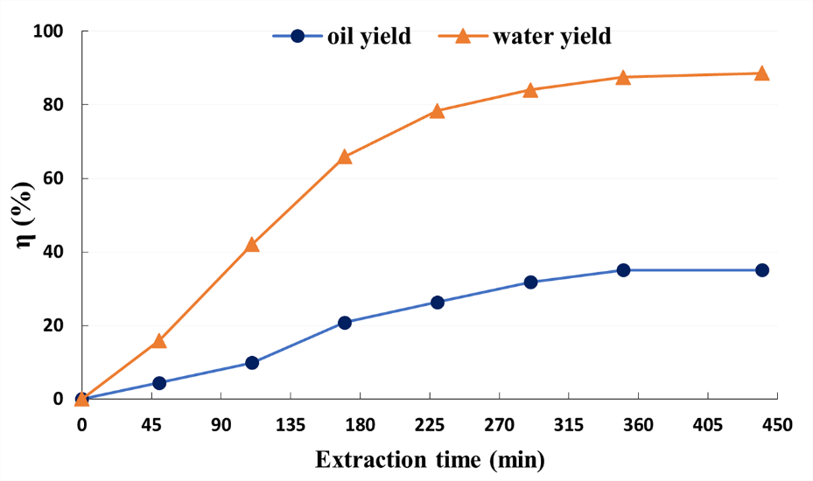
Figure 2. Extraction kinetic curve evaluated for oil and water extracted from wet olive pomace, using Norflurane system.

As shown in Figure 2, Norflurane solvent showed a higher selectivity towards water and a lower recovery of oil from the wet matrix was observed than that found with dried pomace. Probably, water competed with oil for solubilization in Norflurane and/or interfered with the oil diffusion of oil into the solid structure [7].
Total polyphenol and flavonoid contents equal to 0.214 mg GAE/mL and 4.56 × 10⁻³ mg QE/mL, respectively, were determined in the aqueous fraction, simultaneously extracted with oil during the process. In particular, the polyphenol concentration found in the extracted water was comparable with the values shown by Chanioti and Tzia [1], which reported a phenolic amount of approximately 13 ÷ 30 mgGAE/g _{dry pomace} using different extraction techniques. Moreover, the antioxidant activity of Norflurane aqueous extracts was calculated as 0.0015 mmol (Fe ²⁺)/mL, corresponding to 0.21 mg (TE)/mL. This suggested a much better antioxidant power than that reported by Böhmer-Maas et al. [13], where lower values of Trolox equivalents were reported for aqueous pomace extracts (10 ÷ 20 mg (TE)/mL).
4. Conclusions
The work was aimed at proposing a novel patented extraction method using hydrofluorocarbon Norflurane, as solvent, as alternative to traditional extraction techniques currently used for olive pomace oil recovery. Milder operating conditions, lower environmental impact, absence of expensive safety measures owing to the toxicity and flammability of organic solvents, and absence of all the additional costs associated to the subsequent phases of extract/solvent separation, purification, and disposal of the exhausted materials, represent the real strength of this technology.
Moreover, the process allowed to treat also wet matrices, without preventive drying, ensuring, essentially, the recovery of the water fraction rich in antioxidant compounds, such as polyphenols. Furthermore, as future purpose, the present results will be integrated with a technical-economic analysis of the traditional process compared to that evaluated for the innovative process using Norflurane, to verify the effective economic convenience of the proposed process.
References
[1] S. Chanioti, C. Tzia, J. Am. Oil Chem. Soc. 95 (2018) 371-382.
[2] S. Khoufi, M. Hamza, S. Sayadi, Bioresour. Technol. 102 (2011) 9050–9058.
[3] E. Tsagaraki, H. Lazarides, Food Bioproc. Tech. 5 (2012) 584–592.
[4] S. Chanioti, P. Siamandoura, C. Tzia, Waste Biomass Valorisation, 7 (2016) 831–842.
[5] J. Fernandez-Bolanos, G. Rodríguez, R Rodríguez Arcos, R. Guillen, A. Jiménez, Grasas y Aceites, 57 (2006) 95-106.
[6] R. Colucci Cante, I. Prisco, I. Garella, M. Gallo, R. Nigro, Chem. Eng. Res. Des .157 (2020) 174–181.
[7] R. Colucci Cante, I. Garella, M. Gallo, R. Nigro, Chem. Eng. Res. Des. 165 (2021) 172–179.
[8] R. Colucci Cante, M. Gallo, L. Varriale, I. Garella, R. Nigro, Appl. Sci. 12 (2022) 2822.
[9] I. Garella, Patent n.0001396896, issued by C.C.I.A.A. 2012
[10] P. E., Aikpokpodion, L.N., Dongo, Int. J. Sustain. Agric. Res. 5 (2010) 66-70.
[11] H. F, Ismail, Z. Hashim, W.T., Soon, N.S.A., Rahman, A.N., Zainudin, F.A.A., Majid, (2017). J. Tradit. Complement. Med. 7 (2017) 452-465.
[12] S. Chanioti, C. Tzia, LWT-Food Sci. Technol. 79 (2017) 178-179.
[13] B. W. Böhmer-Maas, D. Murowaniecki, O. Rui, C. Zambiazi, B. C. Aranha, Rev. Ceres 67 (2020) 181-190

