Advancements of scale-up methods for stirred aerobic fermenters

Federico Alberini, Francesco Maluta, Giuseppina Montante, Alessandro Paglianti*
Dipartimento di Chimica Industriale, Università di Bologna, viale Risorgimento 4, 40136 Bologna
*Corresponding author E-Mail: alessandro.paglianti@unibo.it

1.Introduction
Aerobic fermentations are adopted in an increasing variety of industrial productions, but their application is often limited from high dissolved oxygen requirements, which result in unaffordable cost unless low volume and/or high value compounds are produced [1]. The issue of the determination of the most advantageous scale of the production is industrially relevant and it has been often tackled employing lumped correlations, both in design and techno-economic analysis. Since around 90% of industrial bioprocesses using bacteria and yeast are carried out in stirred bioreactors [2], the choice of the stirred tank geometry, its size and operating conditions is of primary importance. Scale-up and scale-down of aerated bioreactors is a very challenging and complex task, due to the interplay of many factors, such as oxygen transfer rates and flow regimes, that inherently depend on the system scale [3], and additional coupling with key variables related to morphology and physiology of microorganisms.
This contribution is focused on the experimental and computational investigation of a pilot scale gas-liquid stirred tank, with the main aim of deepening the detection and prediction capability of fundamental two-phase flow variables that affect aerobic fermentation. To this end, experimental and computational methods are adopted in a very challenging context combining the physical complexity of turbulent gas-liquid dispersions and the geometric complexity of baffled stirred tanks.
The experimental part of the investigation is based on the adoption of Electrical Resistance Tomography (ERT). It provides detailed information on the spatial distribution of the gas phase and on the effect of bubbles on the liquid homogenization dynamics. The selected experimental technique allows to overcome the typical limitations of optical methods and to gain insight into the two-phase flow characteristics of sparged stirred tanks without restriction on the upper value of overall gas hold-up, that is of great interest for industrial aerobic fermentation. The outcomes of the experimental work can be directly adopted for obtaining practical guidelines for design and intensification of aerobic fermentation in stirred tanks. In addition, novel local data suitable for detailed model validation are obtained. The computational part of the investigation is carried out in the realm of Computational Fluid Dynamics (CFD). The modelling method contributes to move a step forward in the development of a comprehensive model for the simulation of aerobic stirred bioreactors of complex geometry ensuring consistency of the predictions in a variety of multiphase conditions at any scale [4].

2. Methods
The investigated pilot-scale baffled stirred tank consisted of a cylindrical, flat bottomed vessel of diameter, T, equal to 0.48 m and height, H, equal to 1.6 m, equipped with four equally-spaced baffles of width, W, equal to T/10. In order to evaluate the gas dispersion features, a standard configuration, resembling a single stage of a typical multiple impeller stirred fermenter, was considered. The analysis was carried out under variable gas flow rates, Q_{G}, and impeller speeds, N, thus covering different regimes of gas-liquid and gas-impeller interaction, as obtained by the conventional Rushton Turbine and the innovative Bakker Turbine. Both the Rushton turbines of diameter, D, equal to 0.19 m (D=0.40T) and the Bakker Turbine of D=0.215m (D=0.45T) were located at an off-bottom clearance, C, of T/2. In all the experiments, the tank was filled with demineralized water up to a height, H_{L} slightly higher than T. Afterwards, air was fed in water through a ring sparger located at a clearance, Cs, equal to 85 mm (Cs=0.18T).
The mixing time and the gas hold-up distribution were determined on three horizontal planes by using an ITS P2000 ERT instrumentation by Industrial Tomography Systems Ltd. On each measurement plane, 16 equally spaced electrodes of 30 mm side and 1 mm thickness were fixed to the vessel wall. The electrodes were connected to the data acquisition system (DAS) by coaxial cables. The measurements were based on the circular adjacent strategy, in which electric current is injected from adjacent electrodes pair at a time and the voltage difference is measured from the remaining pairs of electrodes. The procedure is repeated for all the independent pairs of electrodes. The conductivity maps were reconstructed from the electric potential measurements by the linearized (non-iterative) modified sensitivity back projection (MSBP) algorithm.
The CFD modelling was based on the Two Fluid Model (TFM) formulation of the Reynolds averaged Navier-Stokes (RANS) equations. Details on the computational model can be found elsewhere [5].
3. Results and discussion
The local gas volume fraction distribution on the three measurement planes in the vessel stirred with the Bakker turbine is shown in Figure 1, together with numerical predictions on the same planes. By means of example, just the condition of Q_{G}=25L/min and N=200rpm is reported.
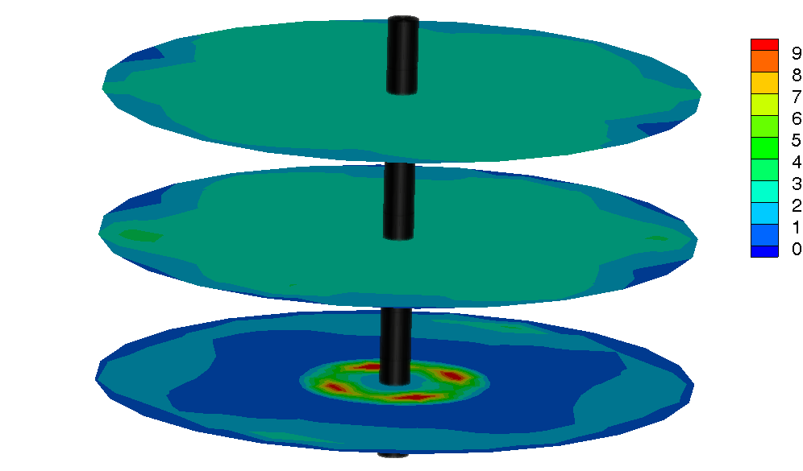  (A) | 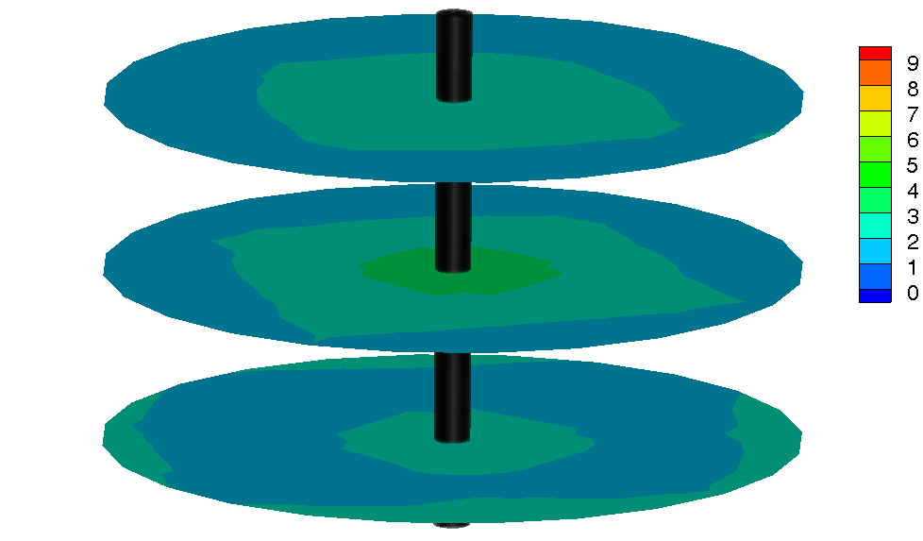  (B)
Figure 1. Percentage gas volume fraction obtained from (A) CFD and (B) ERT at the elevation z=0.18 m, z=0.30 m and z=0.42 m from the bottom of the tank. The impeller is located at z=0.24m
In these conditions, the gas phase is in complete recirculation, having a consistent amount of gas below the impeller plane. On the other hand, the bubbles are not homogeneously distributed in the vessel volume, with the most peculiar features observed in the tank zone below the impeller. Here, large amounts of gas are found both towards the center of the vessel, where the coherent gas stream from the sparger is not dispersed by the action of the impeller, and at the radial periphery of the tank, where the lower recirculation loop generated by the impeller entrains the bubbles just in the proximity of the cylindrical walls of the system. At intermediate radial coordinates, there is a well-defined volume devoid of bubbles. This behavior is observed both from the ERT measurements and the CFD simulations, as apparent on the lowest plane of Figure 1. Overall, the proposed computational approach validated in this work may help in the design of industrial aerated stirred fermenters, since it proved very reliable in fully predictively reproducing the power consumption and the gas-liquid flow regimes, and it may be applied to other geometries and impeller types, without the need for global correlations and ad hoc experiments.
References
[1] D. Humbird, R. Davis, J.D. McMillan, Biochem. Eng. J. 127 (2017) 161–166.
[2] F. Garcia-Ochoa, E. Gomez, V.E. Santos, Biochem. Eng. J. 164 (2020) 107803.
[3] H.J. Noorman, W. van Winden, J.J. Heijnen, R.G.J.M. van der Lans, RSC Green Chem., Royal Society of Chemistry, 2018.
[4] F. Maluta, A. Paglianti, G. Montante, Biochem. Eng. J. (2022) 108405.
[5] F. Maluta, F. Alberini, G. Montante, A. Paglianti, Can. J. Chem. Eng. (2022) in press.

