Influence of side injection position on the mixing process in a tubular reactor equipped with Sulzer Static Mixers

Jody Albertazzi, Valentina Busini, Federico Florit, Renato Rota
Politecnico di Milano, Department of Chemistry, Materials and Chemical Engineering “Giulio Natta”, Piazza Leonardo da Vinci 32, 20133, Milano, Italy
*Corresponding author E-Mail: valentina.busini@polimi.it

1.Introduction
Mixing is an important process in many food, pharmaceutical and chemical processes^{1,2,3}. The time (or space) needed to achieve complete homogenization is a key parameter depending on several variables such as fluid dynamics conditions and fluid properties.
While it is relatively easy to achieve complete mixing of chemical species for fully developed turbulent flows in pipes (i.e., for Reynolds numbers values greater than 4000)⁴, since vortexes and turbulent diffusion tend to lower the composition gradient along the radial coordinate, a much more compelling situation happens when laminar flows are involved, which is a common scenario for many chemical reactions that require long residence times to obtain satisfactory values of conversion; in laminar case, a parabolic profile velocity is obtained and strong gradients exist along the radial coordinate, which could only be lowered by molecular diffusion.
A complete homogenization can be obtained using active mixers, such as ultrasonic micromixers and pulse-flow mixers. However, these devices, while very efficient in mixing, are expensive and their operation is difficult, with high failure rates⁵.
A very promising alternative is represented by motionless mixers, or static mixers: these devices consist of a series of stationary and rigid inserts and are installed in tubular reactors, pipes and transfer tubes.
Unlike active mixers, they have no moving parts and require the mechanical energy coming from the flow momentum itself, so they need lower energy consumption and lower maintenance^{6,7}. Due to their relatively easy nature, they are employed in various industrial processes, such as wastewater treatment, paper, food, pharmaceutical, petrochemical and polymer industry⁷ and are considered to be key instruments in the transition from batch processes into continuous ones⁸.
There are various types of static mixers available: among them, the Sulzer SMX are known for being very efficient in mixing fluids, especially when fluids with very different properties (mass flow rate ratio and viscosity) are considered, as well as fluids with complex rheological behavior^{7,9}.
A complete understanding of the mixing process inside these devices is needed to optimize industrial processes in terms of productivity and energy consumption: indeed, pressure drops are known to be a critical factor in the choice of a static mixer¹⁰, and particularly Sulzer SMX are known to have higher pressure drops with respect to other passive mixing devices¹¹.
Various analyses varying the viscosity and the spatial velocity inside the reactor have already been performed¹²⁻¹⁴. Moreover, in previous works, both the mixing process as well as the residence time distribution ($RTD)$ curve inside a side injection tubular reactor have been studied^{15,16}, finding that the Reynolds number and the Richardson number (for different densities flows) were the main parameters influencing the radial dispersion inside the reactor. Nevertheless, to the best of the authors’ knowledge, the influence of the injection position on the mixing process has not been fully analyzed up to this: thus, the aim of this work is to expand the mixing analyses previously done and to assess, through Computational Fluid Dynamics simulations, if a significant difference in terms of mixing efficiency exists when different configurations of injections are considered.

2. Methods
2.1 Reactor geometry
The modeled geometries consist of three tubulars reactors, each one equipped with 15 Sulzer SMX and each one having a different typology of side injection: more in detail, Reactor A, reported in Figure 1a consists of a side-injection tubular reactor with the lateral injection placed on the section of the reactor before the static mixers, Reactor B, reported in Figure 1b is a side-injection tubular reactor having the injection exactly on the first static mixer, while Reactor C, shown in Figure 1c consists of a coaxial tubular reactor, with the side injection centered with respect to the reactor axis. The SMX element is formed by an array of adjacent crossed bars rotated with an angle of 90° with respect to each other. Several SMX mixing elements form together a mixer. Subsequent elements are rotated by 90° with respect to the previous element, so that the cross-flow mixing direction changes from one element to the next. Each SMX element is composed of eight blades and its aspect ratio, i.e., the length of the SM to the reactor diameter ratio, is equal to 1.

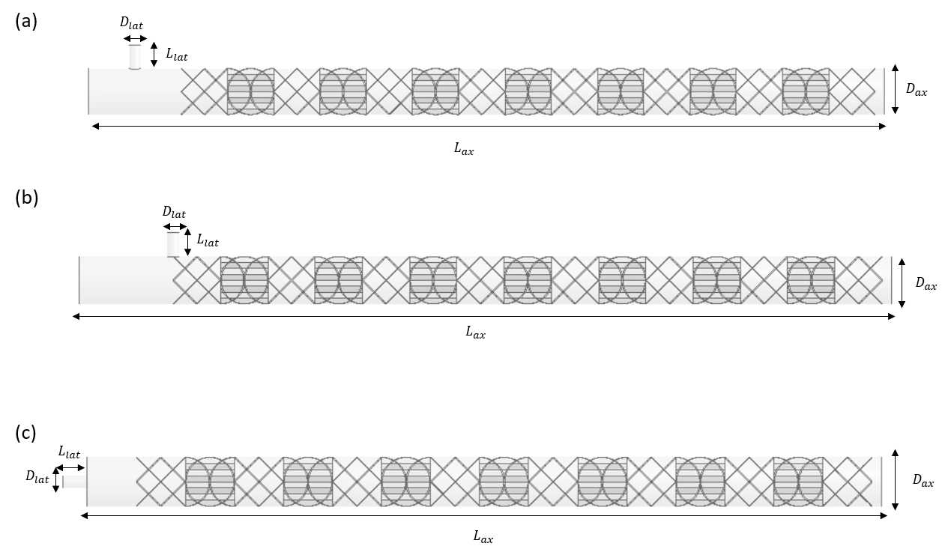
Figure 1. Reactor with side injection placed before the static mixers (1a); reactor with side injection placed on the
First static mixer (1b); reactor with coaxial injection (1c).

The A component is fed through the axial tube inlet, which has a diameter equal to $D_{ax}$ and a length equal to $L_{ax}$ (in case of Reactor C, A is fed through the outer circular crown), while the smaller tube (diameter equal to $D_{lat}$ and length equal to $L_{lat}$) allows the injection of the B component. The distance between the lateral tube and the first static mixer, in Reactor A and in reactor C is equal to one diameter. The geometrical properties of the reactors are resumed in Table 1.

Table1. Geometrical properties of the modelled reactors.
$$D_{ax} [m]$$ | $$D_{lat} [m]$$ | $$L_{ax} [m]$$ | $$L_{lat} [m]$$
$$0,0508$$ | $$0,0127$$ | $$0,872$$ | $$0,0254$$

In all the performed simulations, both the flow rates and the viscosity of the species A were varied to obtain various values of the Reynolds number ($Re)$, which is defined as the ratio of inertial forces to viscous forces and it was calculated as follows:

$Re=\frac{ρ_{mix}⋅v⋅D_{ax}}{μ_{mix}}$

where $ρ_{mix}\left[kg/m^{3}\right]$ is the mass weighted mixture density and is calculated as $ρ_{mix}={\left(ω_{A}/ρ_{A}+ω_{B}/ρ_{B}\right)}^{-1}$, with $ω_{A}$ and $ω_{B}$ being the mass fractions of the species A and B, respectively, $v [m/s]$ is the spatial velocity inside the reactor and is obtained as $v=\frac{\left(m_{A}+m_{B}\right)⋅4}{ρ_{mix}⋅π⋅D_{ax}^{2}}$ and $μ_{mix} \left[Pa⋅s\right]$ is the mass weighted mixture viscosity, obtained through the following $μ_{mix}=μ_{A}⋅ω_{A}+μ_{B}⋅ω_{B}$. The mass flow rate ratio between the streams A and B, $\dot{m_{A}}/\dot{m_{B}}$, was considered constant and equal to 10.

2.1 Mixing length analysis
The mixing of the two streams were characterized by the coefficient of variation, defined as follows:

$$COV\left(x\right)= \frac{\sqrt{\left( \overline{ω_{B,x}^{2}}- {\overline{ω_{B,x }}}^{2}\right)}}{\overline{ω_{B,x }}}$$

where $\overline{ω_{B,x}^{2}}$ is the mass-flow average of the squared mass fraction of B calculated at the axial position x and ${\overline{ω_{B,x }}}^{2}$ is the mass-flow average of the mass fraction of B calculated at the axial position x. When COV < 0.05, uniformity over the cross section can be safely assumed. The mixing length is defined as the length from the injection of the B component for which $COV ≤0.05$. The mixing length will be reported in terms of number of pipe diameters necessary to achieve perfect mixing, $L_{mix}/D$.

2.4 Mesh and CFD simulations
In this work, the results were obtained by solving continuity, momentum, and species mass fraction transport equations with the RANS approach by means of the Ansys Fluent 19.1 CFD suite of programs. A closure turbulence model is needed: the Shear-Stress Transport ($SST$) $k-ω$ model was chosen, since it has been reported that it can correctly simulate the flow motions, from laminar to turbulent regime ¹⁷.
The geometry was discretized through an unstructured mesh composed by tetrahedral cells, with cell refinement in correspondence of the static mixers wall, as shown in Figure 2a and 2b. In order to have reliable results, a mesh independent test must be performed: thus, a series of simulations (considering Reactor C) were performed considering mesh with increasing number of cells and the velocity outside the reactor was monitored.

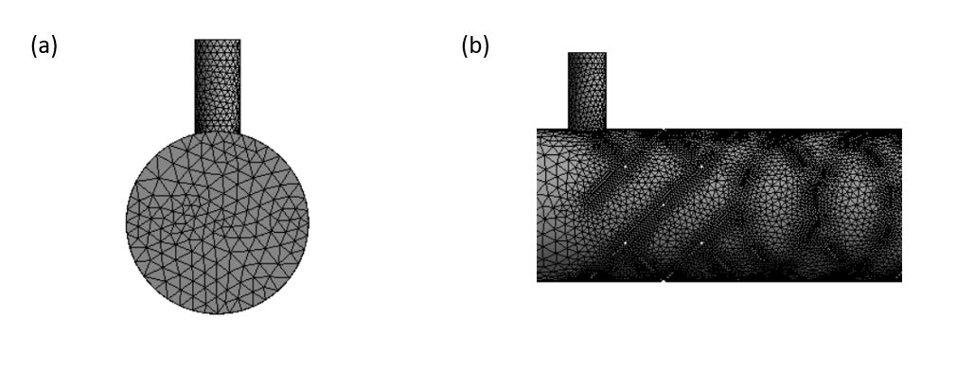
Figure 2. Inlet section mesh detail (a); Lateral reactor mesh detail (b).

Results are shown in Figure 3, which reports the values of the velocity as a function of the number of cells: the difference registered between the mesh with 6 million of cells and 13 million of cells is negligible, indicating a mesh independent result.

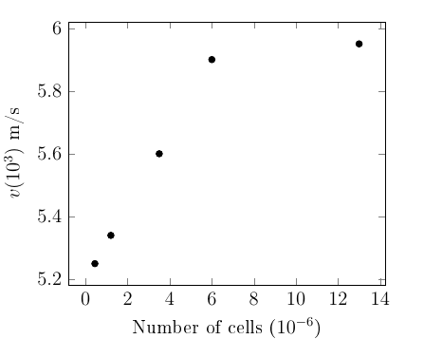
Figure 3. Grid independence test.

Moreover, since pressure drops are known for being particularly susceptible to flow perturbations ³, as a further test the pressure drops obtained in a series of simulations at various $Re$, with the 6 million cells mesh were compared with the pressure drops obtained using a well-established empirical correlation ⁷, defined as:

$$ΔP=\frac{K_{L}}{Re}⋅ρ⋅v^{2}⋅\frac{L}{D}$$

where $K_{L}$ is a dimensionless factor, which is comprised between 820 and 1280, depending on the technical details of the static mixer. In this case, considering a standard static mixer composed by 8 bars, $K_{L}$ should be considered equal to 1070⁷. In the performed simulations the viscosity of the B component was kept constant and equal to $μ_{B}=1⋅{10}^{-3}\left[Pa⋅s\right]$, while the viscosity of the A component was varied. Results are reported in Figure 4, confirming that the 6 million cells mesh can provide reliable results.

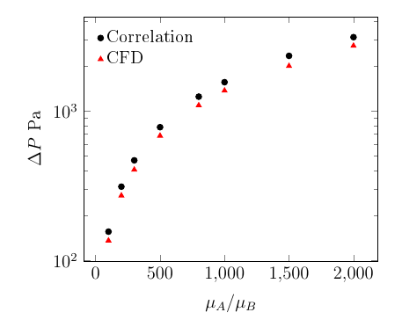
Figure 4. Validation of pressure drop with empirical correlation.

3. Results and discussion
A series of simulations were performed: in order to obtain various values of $Re$, both the mass flow rates and the mixture viscosity were varied. In all the simulations, the viscosity of the $B$ component was kept equal to $μ_{B}=1⋅{10}^{-3}\left[Pa⋅s\right]$. Moreover, for sake of simplicity, buoyancy forces were neglected and the density of both species was kept constant and equal to $ρ_{A}=ρ_{B}=ρ_{mix}=1000 \left[kg/m^{3}\right]$.

Table 2. Mixing length analysis boundaries conditions
$$\dot{m_{A}}\left[kg/s\right]$$ | $$μ_{A}\left[Pa⋅s\right]$$ | $$\dot{m_{B}}\left[kg/s\right]$$ | $$Re$$
$$0,01$$ | $$10$$ | $$0,001$$ | $$0,03$$
$$0,01$$ | $$1$$ | $$0,001$$ | $$0,30$$
$$0,01$$ | $$0,1$$ | $$0,001$$ | $$3,03$$
$$0,01$$ | $$0,01$$ | $$0,001$$ | $$30,0$$
$$0,03$$ | $$0,007$$ | $$0,003$$ | $$128$$
$$0,01$$ | $$0,001$$ | $$0,001$$ | $$275$$
$$0,01$$ | $$0,0005$$ | $$0,001$$ | $$505$$
$$0,04$$ | $$0,001$$ | $$0,004$$ | $$1103$$
$$0,08$$ | $$0,001$$ | $$0,008$$ | $$2206$$
$$0,2$$ | $$0,001$$ | $$0,02$$ | $$5517$$

Results are reported in Figure 5, in which the mixing lengths as a function of $Re$ obtained for the three reactor configurations are reported. It is possible to see that when a side-injection tubular reactor is adopted (reactor A and reactor B), the mixing lengths obtained align on a curve which presents two asymptotes for, roughly, $Re < 10$ and $Re > 1000$. Considering the side-injection reactors, it is possible to see that positioning the lateral tube in the section before the static mixers has a negative effect on the mixing length: indeed, there is a difference in the mixing lengths between the two configurations of one diameter, which is the same distance that goes from the lateral injection and the first static mixer, in Reactor A. All the mixing lengths are comprised between 3 and 11 diameters, approximately.
On the other hand, when a coaxial reactor is considered (Reactor C), a very different trend is obtained: in this case, the mixing lengths obtained are approximately constant and equal to 5 diameters, even when strongly viscous flows are considered. This means that if a coaxial and centred injection is adopted, it is possible to neglect the influence of $Re$ on the mixing process, since all the mixing lengths are comprised in a much smaller interval (roughly $5<L_{mix}/D_{ax}<4$). This represents a difference with respect to the other two reactor configurations, which mixing lengths appear to be strongly influenced by $Re$. These results suggest that a coaxial injection should always be preferred to efficiently achieve complete mixing. This is true for a single injection, but if more than one injection is needed in the same pipe (such as in reactor configurations used for the transition from semi-batch to continuous processes¹⁹⁻²¹), then a lateral injection must be adopted in practice (otherwise the SM cannot be inserted between the injection points). As an alternative, more injections in the same reactor can be achieved with flanged fittings between the various parts (this way coaxial flow can be implemented), but at a higher investment cost. Therefore, depending on the type of reactor (with single or multiple injections) coaxial flow can be exploited to lower the mixing length, otherwise lateral injections can be used considering larger mixing lengths.

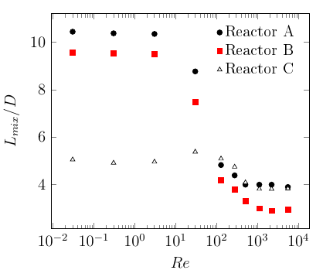
Figure 5. Mixing lengths as a function of $Re$ for the three reactor configurations.

Figure 6 and Figure 7 show the contour of B mass fraction in the three reactors configurations for $Re = 3$ and $Re = 275$, respectively. It is possible to see that, considering Reactor A and Reactor B, the length in which the injected component is homogeneously dispersed across the section changes at the varying of $Re$; on the other hand, when Reactor C is considered, the contours obtained for $Re = 3$ and $Re = 275$ do not differ significantly, thus confirming the results previously obtained. When $Re > 1000$ all the mixing lengths tend to align on an asymptote: indeed, it has been reported by experimental studies that, starting from this point, a complete turbulent regime is reached inside the Sulzer static mixers ¹⁸. Thus the turbulent forces become predominant and the influence of the side injection position on the mixing length, for Reactor A and Reactor C, becomes negligible, since in both cases the side injection was placed at the same distance from the mixing elements. On the other hand, the mixing lengths obtained with Reactor B and $Re > 1000$ are one diameter lower, because in this case the side injection was placed directly upon the first static mixer.

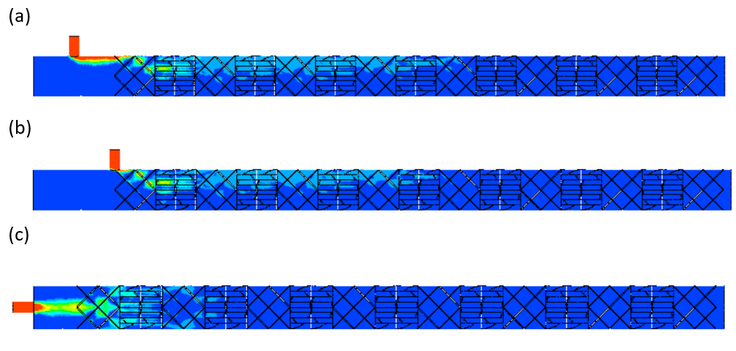
Figure 6. Mixing lengths obtained with the three reactor configurations for $Re = 3$.
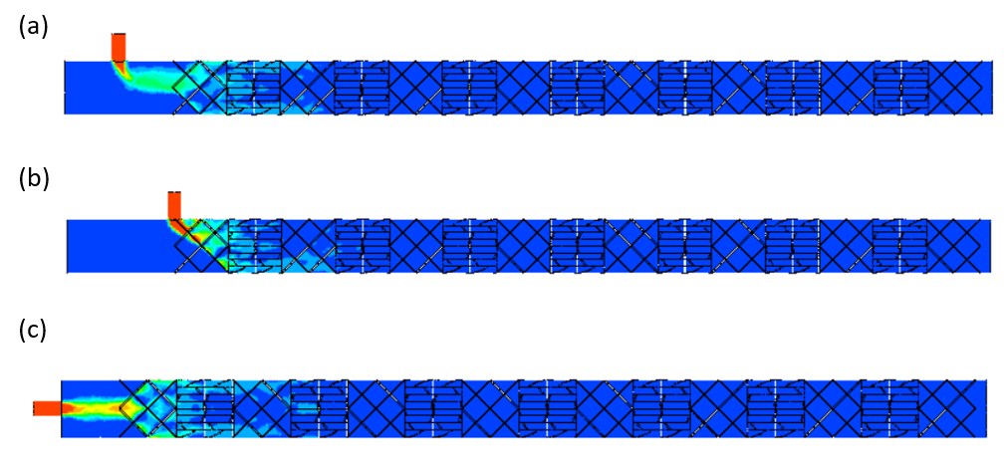
Figure 7. Mixing lengths obtained with the three reactor configurations for $Re = 275$.

4. Conclusions
A series of computational simulations were performed, with the aim of determine the influence of the injection position on the mixing efficiency of a tubular reactor equipped with Sulzer SMX. It was found that placing the side injection before the static mixers does not favor the mixing process; moreover, the mixing length is strongly reduced for $Re < 100$ when a coaxial injection is considered. These results should be considered in order to maximize the productivity and mixing efficiency of industrial processes, while at the same time lower the total energy consumption: indeed, a lower mixing length means that a complete homogenization can be reached with less mixing elements, which implies that a lower pressure drop is needed in the reactor. Future studies may focus on the influence of the side injection position also when buoyancy forces are considered in a horizontal reactor, such as in the mixing of miscible fluids with different density and in multiphase flows.
References
- R. Thakur, C. Vial, K. Nigam, E. Nauman, G. Djelveh, Static mixers in the process industry-a review Chem. Eng. Res. Des. 81 (2003) 787-826.
- M. M. Haddadi, S. H. Hosseini, D. Rashtchian, M. Olazar, Comparative analysis of different static mixers performance by CFD technique: An innovative mixer, Chin. J. Chem. Eng. 28 (2020) 672-684.
- B. W. Nyande, K. M. Thomas, R. Lakerveld, CFD Analysis of a Kenics Static Mixer with a Low Pressure Drop under Laminar Flow Conditions, Ind. Eng. Chem. Res. 14 (2021) 5264-5277.
- C. Dyioke, U. Ngwaka, CFD Analysis of a Fully Developed Turbulent Flow in a Pipe with a Constriction and an Obstacle, Int. J. Eng. Res. Technol.4 (2015) 2278-0181.
- S. Klutz, S. K. Kurt, M. Lobedann, N. Kockmann, Narrow residence time distribution in tubular reactor for Reynolds number range of 10-100 Chem. Eng. Res. Des.95 (2015) 22-23.
- S. S. Soman, C. M. R. Madhuranthakam, Effects of internal geometry modifications on the dispersive and distributive mixing in static mixers, Chem. Eng. Process 122 (2017) 31-43.
- S. Hirschberg, R. Koubek, F. Moser, F. Schöck, An improvement of the Sulzer SMXTM static mixer significantly reducing the pressure drop, Chem. Eng. Res. Des. 87 (2009) 524-532.
- G. Montante, M. Coroneo, A. Paglianti, Blending of miscible liquids with different densities and viscosities in static mixers, Chem. Eng. Sci. 141 (2016) 250-260.
- L. Z Huai, C. Fasol, L. Choplin, Residence time distribution of rheologically complex fluids passing through a Sulzer SMX Static Mixer, Chem. Eng. Commun. 165 (1998) 1-15.
- R. Munter, Comparison of Mass Transfer Efficiency and Energy Consumption in Static Mixers, Ozone Sci. Eng. 32 (2010) 399-407.
- G. Forte, E. Brunazzi, F. Alberini, Effect of residence time and energy dissipation on drop size distribution for the dispersion of oil in water using KMS and SMX+ static mixer, Chem. Eng. Res. Des. 148 (2019) 417-428.
- C. Belhout, M. Bouzit, B. Menacer, Y. Kamla, H. Ameur, Numerical Study of Viscous Fluid Flows in a Kenics Static Mixer, Mechanika. 16 (2020) 206-211.
- J. Zalc, E. Salai, F. Muzzio, Mixing Dynamics in the SMX Static Mixer as a Function of Injection Location and Flow Ratio, Polym. (43) (2003) 875-890.
- M. Regner, K. Ostergren, C. Trägårdh, Influence of Viscosity Ratio on the Mixing Process in a Static Mixer: Numerical Study, Ind. Eng. Chem. Res. 47 (2008) 3030-3036.
- J. Albertazzi, F. Florit, V. Busini, R. Rota, Mixing Efficiency and Residence Time Distribution of a Side-Injection tubular reactor equipped with Static Mixers, Ind. Eng. Chem. Res. 60 (2021) 10595-10602.
- J. Albertazzi, F. Florit, V. Busini, R. Rota, Influence of Buoyancy Effects on the Mixing Process and RTD in a
Side-Injection Reactor Equipped with Static Mixers, Ind. Eng. Chem. Res. 60 (2021) 16490-16497.
- ANSYS Inc., ANSYS Fluent Theory Guide, release 19.1, 2018.
- F. Theron, N. Le Sauze, Comparison between three static mixers for emulsification in turbulent flow, Int. J. Multiph. Flow 37 (2011) 488-500.
- F. Florit, V. Busini, G. Storti, R. Rota, From semi-batch to continuous tubular reactors: A kinetics-free approach. Chem. Eng. J., 354 (2018) 1007–1017.
- F. Florit, V. Busini, G. Storti, R. Rota, Kinetics-free transformation from non isothermal discontinuous to continuous tubular reactors. Chem. Eng. J., 373 (2019) 792–802.
- F. Florit, V. Busini, R. Rota, Kinetics-free process intensification: From semi-batch to series of continuous chemical reactors. Chem. Eng. Process., 354 (2020) 108014.

