**Simulation of a methane-based Poly(3-hydroxybutyrate) production process: the effect of internal gas recycling**

Claudia Amabile1, Teresa Abate1, Simeone Chianese1*, Dino Musmarra1

*1 Department of engineering, University of Campania “Luigi Vanvitelli”, Via Roma 29, 81031, Aversa;*

*\*Corresponding author E-Mail: simeone.chianese@unicampania.it*

**1.Introduction**

Poly(3-hydroxybutyrate) (PHB) is a thermoplastic polyester belonging to the family of Polyhydroxyalkanoates (PHAs), which are well-known biobased and biodegradable biopolymers [1]. Many microorganisms, mainly type II methanotrophs, are capable to grow on methane and oxygen and to accumulate granules of PHB into the cell structure when a metabolic stress due to the lack of nutrients in the medium is induced (Figure 1) [2]. These granules can then be extracted from the cells, processed, and used to produce several products [3][4].

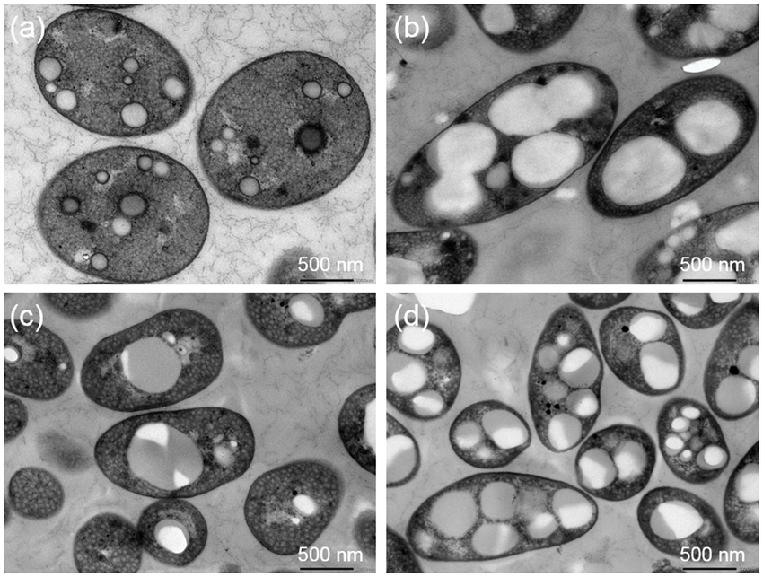

**Figure 1.** Granules of PHB

The properties of PHB make it a potential substitute for conventional plastics, which nowadays represent one of the main causes of environmental pollution [5]. Anyway, the high market price of these polymers and the poor scalability of the process result in inefficient PHB production. Moreover, the low productivities, which have been largely estimated using continuous bioreactors at a laboratory scale, remain at approximately ≈0.03 kg m-3d-1 [6]. In this context, among the several factors that affect the process yields, mass transfer from the gas to the liquid represent a key aspect [6]. Normally, methanotrophs use oxygen and methane for growing in presence of nutrients and accumulating the polymer into the cell structure under an induced metabolic stress, but the low solubility of methane often limits the availability of these gaseous reactants into the liquid phase. Many strategies for improving gas-liquid mass transfer and saving methane have been studied in the literature, some of them reporting interesting results in terms of PHB productivity [6]. For example, the use of an internal gas recycling strategy in a bubble column bioreactor operating in a continuous mode to produce Poly(3-hydroxybutyrate) from methane, resulted in a higher productivity of 1.4 kg m-3d-1.

In this work, a double step process was simulated to grow *Methylocystis Hirsuta* and to accumulate PHB in 400L bubble column bioreactors working in series in a semi-continuous mode. The process was simulated twice: first, a process scheme without internal gas recycling was considered, then, the same conditions were repeated in two reactors provided with a gas recycling unit and working at several recycling rate.

**2. Methods**

The process to produce Poly(3-hydroxubytyrate) was simulated using two 400L semicontinuous bubble column bioreactors working in series. The first step consisted in the growth of a Type II methanotroph in presence of NO3- and methane as nitrogen and carbon source, respectively; the second phase was aimed at the accumulation of PHB in absence of nutrients in the medium. The flowsheet was designed both with and without a gas recycling unit (Figure 2a and 2b) to assess the effects of gas recirculation on PHB yields with respect to the methane fed. When the recycling unit was not included in the flowsheet, the empty bed residence time (EBRT) (eq.1) was set to 2 min, which corresponded to a superficial gas velocity of 0.027 cm s-1; when gas recirculation was considered, the virtual residence time (VRT) (eq.2) was set to 2 min, to have a fixed final velocity of 0.027 cm s-1. This condition was reached starting from empty bed residence time of 30, 15, 10 and 5 min and increasing the recycling ratio (eq.3) from 1.5 to 14. The summary of the scenarios simulated is reported in Table 1.

$EBRT=\frac{V_{r}}{Q_{fed}}$ (1)

$VRT=\frac{V_{r}}{Q_{fed}+Q_{rec}}$ (2)

$RR=\frac{Q_{rec}}{Q_{fed}}$ (3)

In the previous equations, *Vr* is the volume of the reactors, *Qfed* is the fresh methane fed to the reactors and *Qrec* is the recycled flow.

**Table 1.** Details of the scenarios simulated, with and without the internal gas recirculation

|  |  |  |  |  |
| --- | --- | --- | --- | --- |
| EBRT [min] | VRT [min] | Qfed [m3gas m-3reatth-1] | Qrec [m3gas m-3reatth-1] | RR |
| 2 | 2 | 1.2 | 0 | 0 |
| 5 | 2 | 0.48 | 0.72 | 1.5 |
| 10 | 2 | 0.25 | 1.02 | 4 |
| 15 | 2 | 0.16 | 1.04 | 6.5 |
| 30 | 2 | 0.08 | 1.12 | 14 |

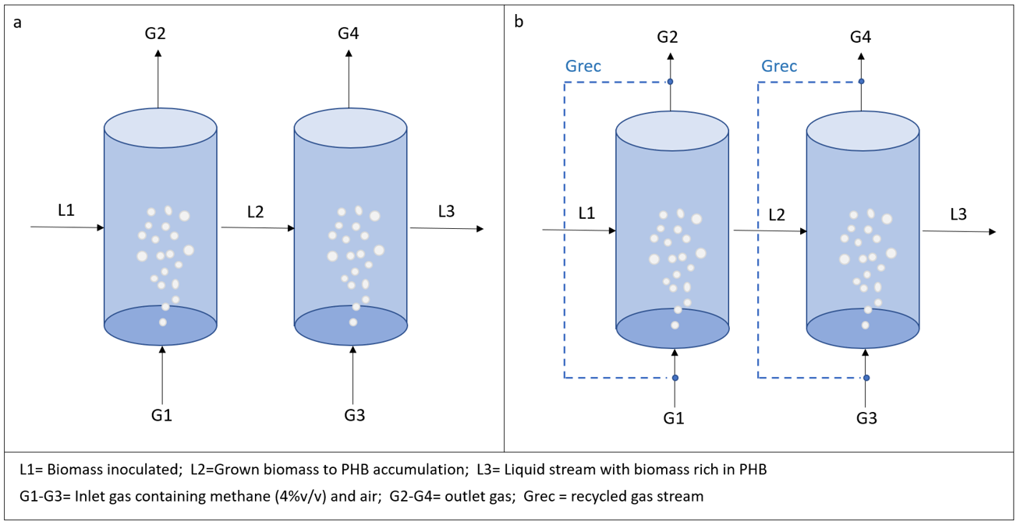

**Figure 2.** Flowsheet used for the simulations without a recycling unit (a) and with a recirculation system (b)

**3. Results and discussion**

The results of the simulations are reported in terms of biomass and PHB produced at the end of the cycle, production of PHB for unit of substrate (SPHB) and methane utilization capacity (eq.4). When working with a recycling unit, methane saving was also evaluated.

$EC-CH_{4}=\frac{Q_{gas}\left(C_{CH_{4_{in}}}-C_{C{H_{4}}_{out}}\right)}{Vr}$ (4)

In eq.4, *Qgas* is the gas fed to the reactor, *CCH4in* and *CCH4out* are the inlet and outlet methane concentrations, respectively, and *Vr* is the volume of the reactors (400L).

The total biomass produced at the end of the growth cycle was 1.22 kg, the PHB amounted to 0.76 kg after 12 days of accumulation, thus resulting in 38% w/w, and the methane utilization capacity calculated according to eq.4 remained constant at 59 gCH4 m-3 h-1. It should be noted that these results were the same for all cases, since the final operating conditions were fixed: the total methane fed (fresh + recycled) was kept constant at 300 g h-1, the superficial gas velocity was set at 0.027 cm s-1 and the VRT at 2 min. Anyway, Figure 3 shows the convenience of using a recycling unit with a high RR: it resulted that, the higher the EBRT, the higher the recycling ratio and the production of PHB for unit of substrate, with an evident saving of methane (93% of methane saved at a RR=14).

The convenience in using a recycle stream for reducing the VRT and saving methane at the same time was previously stated, with an increase of *EC-CH4*which was function of the EBRT and of the recycling ratio. For example, an increase of methane utilizing capacity from 29.8 ± 2.0 g CH4 m−3 h−1 at *EBRT*=30 min with no internal gas recirculation to 73.8 ± 2.1 g CH4 m−3 h−1 with a final *VRT* of 1 min employing a recycle ratio of 30, was reported [6]. Others [7] confirmed the opportunity of enhancing the methane consumption by using a recirculation strategy, with an increase of EC-CH4 from 8.5 ± 0.3 gCH4 m−3 h−1 to 18.7 ± 0.2 gCH4 m−3 h−1 when increasing the recycling rate from 0 m3gas m-3reatt min-1 at *EBRT*= 60min to 0.25 m3gas m-3reatt min-1 at VRT=4 min starting from *EBRT*=60min.



**Figure 3.** Elimination capacity of methane and production of PHB for unit of substrate fed as function of the recycling ratio

**4. Conclusions**

The process for producing PHB from methane through a double step configuration was simulated in this work. *Methylocystis hirsuta* was grown for 20 days and accumulated PHB in lack of nitrate. The opportunity for enhancing gas-liquid mass transfer and saving methane was evaluated through the addition of a gas recycling unit, with a recycling ratio ranging from 0 to 14. The production of PHB at the end of the cycle was 0.76 kg, which corresponded to 38%w/w of PHB with respect to the total suspended solids. The best condition, in terms of methane saved, was reached at the highest recycling ratio (14), saving 93% of methane compared to the condition in which no gas recycling was considered.

**References**

[1] C. S. K. Reddy, R. Ghai, Rashmi, and V. C. Kalia, Bioresour. Technol. 87 (2003) 137–146

[2] L.-Y. Liu, G.-J. Xie, D.-F. Xing, B.-F. Liu, J. Ding, and N.-Q. Ren, Environ. Sci. Ecotechnology 2 (2020) 100029

[3] L. L. Madison and G. W. Huisman, Microbiol. Mol. Biol. Rev. 63 (1999) 21–53

[4] G.Q. Chen, China Plastic and Rubber Journal, April Issue, 2010.

[5] J. Chee, S. Yoga, N. Lau, S. Ling, and R. M. M. Abed, (2010) pp. 1395–1404

[6] M. R. García-Pérez, C.J. López, F. Passos, R. Lebrero, S. Revah, “Chem. Eng. J. 334 (2018) 691–697

[7] Y. Rodríguez, P. I. M. Firmino, V. Pérez, R. Lebrero, and R. Muñoz, Waste Manag. 113 (2020) 395–403