Assessment of Failure Frequencies of Pipelines caused by Earthquakes in the Natech Risk Assessment Framework

Fabiola Amaducci*, Alessio Misuri, Valerio Cozzani

LISES - Laboratory of Industrial Safety and Environmental Sustainability, DICAM – University of Bologna, Italy

*Corresponding author E-Mail: fabiola.amaducci2@unibo.it

1.Introduction
During a seismic event, underground pipelines can undergo significant damages releasing relevant quantities of hazardous substances with severe implications in terms of life safety and economic impact. This type of scenarios falls under the definition of Natech [1]. In recent years, quantitative risk analysis became a pivotal tool to assess and manage Natech risk. Among the tools required to perform the quantitative assessment of Natech risk, vulnerability models are aimed to characterize equipment damages from natural events. This contribution is focused on the review of the pipeline vulnerability models available for the case of earthquakes. Furthermore, a comparison of the features of the models deemed more suitable for the application to a QRA framework for Natech events is proposed.
2. Methods
A review of the academic literature was carried out in order to find empirical vulnerability models for pipelines. The search focused on the Natech area using keywords such as “pipeline”, “earthquake”, “fragility curves”, “vulnerability model” and “Probit” and their combination. In addition, more references were found looking at each reference cited by the retrieved contributions [2]. For each model, information was collected on the number of earthquakes considered for its development, the type of model proposed, the inputs required and the damage states. Finally, the most suitable models for QRA analysis are implemented for a comparison.
3. Results and discussion
The overview of the complete models found in the literature is shown in Table 1 and Table 2, where the input parameters and the number of earthquakes considered in the development are also reported. Two main categories of models have been identified in the literature. A first category proposes the repair rate as a performance indicator for the damage of pipeline due to seismic load, and provides as output the number of required repairs per unit length. A second category proposes fragility curves associated with risk states depending on the mechanism of ground failure.
Table 1 Summary of models expressing the result in terms of repair rate. N = Number of past earthquakes used to develop the models.
Reference | Seismic intensity parameter | N |  | Reference | Seismic intensity parameter | N
[3] | PGA | 6 |  | [4] | PGV, PGD | 3
[5] | PGA | 6 |  | [6] | PGV | 1
[7] | PGA | 1 |  | [8] | PGA | 1
[9] | PGV | 3 |  | [10] | PGV, PGD | 12
[11] | MMI | 4 |  | [12] | PGA | 1
[13] | PGA | 2 |  | [14] | PGA, PGV | 1
[15] | MMI, PGD | 7 |  | [16] | PGV | 1
[17] | PGD | 2 |  | [18] | PGA, PGV | 1
[19] | PGV | 6 |  | [20] | PGV | 5
[21] | PGV | 7 |  | [22] | PGV | 1
[23] | PGD | 5 |  | [24] | PGA | 1
[25] | PGV | 7 |  | [26] | PGV²/PGA | 1
[27] | PGA, PGV, PGD, MMI | 4 |  | [28] | PGV | 4
[29] | PGA, PGV | 1 |  | [30] | PGV | 2
Table 2 Summary of models expressing the result in terms of fragility curves. N = Number of past earthquakes used to develop the models.
Reference | Seismic intensity parameter | N
[31] | PGV | 40
[32] | PGA, PGV | 20

Only the models proposed by ALA [10] (12 earthquakes), by Lanzano [32] (20 earthquakes) and by Lanzano [31] (40 earthquakes) are suggested because they are developed on a consistent number of empirical data. Following, this subset is implemented to compare their relative merits and shortcomings. The curves for SGS (strong ground shaking) and GF (ground failure) are shown in Figure 1 and Figure 2, specifying the material and (where present) also the types of joints and the damage state.
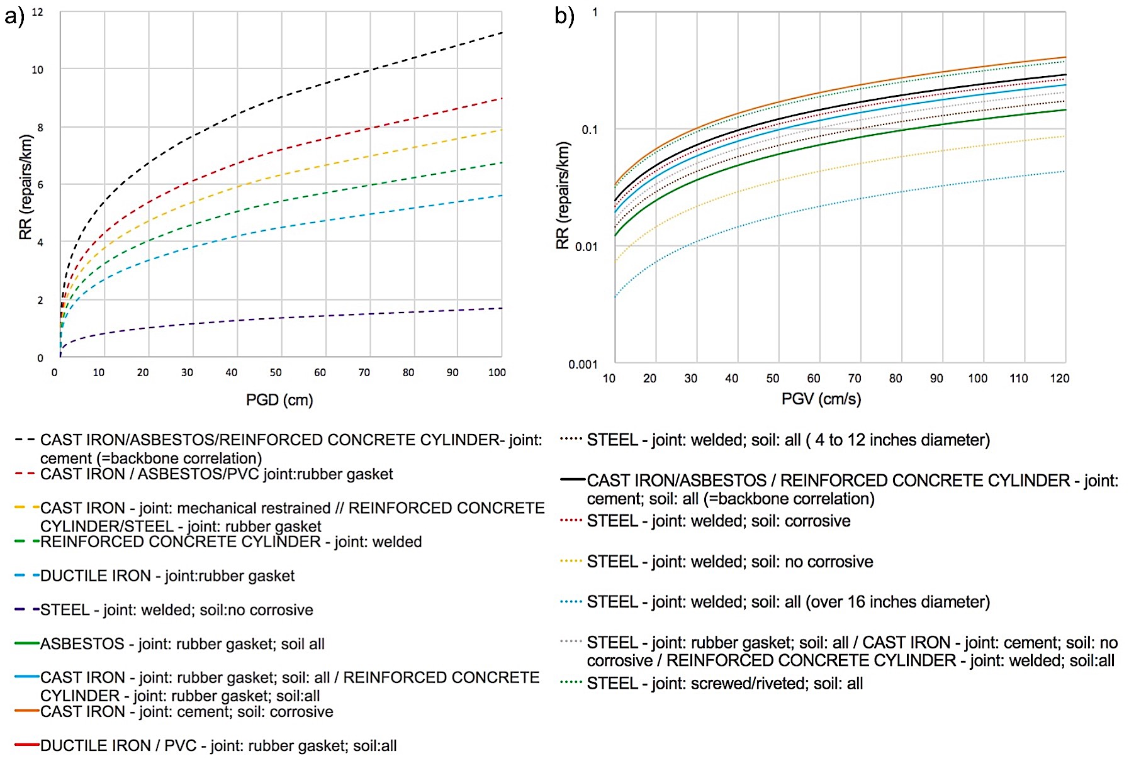
Figure 1 Vulnerability model for buried pipes developed in [10] for a) GF and b) SGS

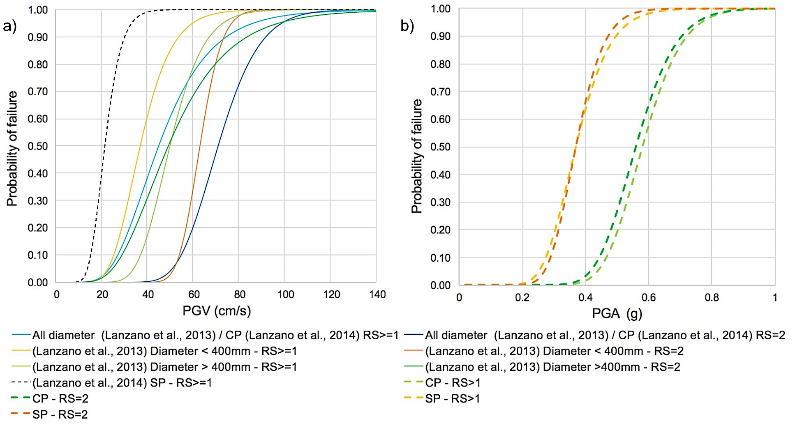
Figure 2 Vulnerability model for buried pipes developed in a) [31,32] for SGS and in b) [32] for GF
The models proposed by ALA [10] have been conceived for water-carrying pipelines, whereas the curves developed in the works of Lanzano [31,32] are possibly more generalizable. In addition, the former is more detailed in the type of soil and joint material. For what concerns the definition of risk states, the works of Lanzano [31,32] are more rigorous, while the models by ALA [10] give only thumb rules on the typology of expected failures. But in spite of this, the models by ALA [10] are suggested because to use the models of Lanzano [31,32] it is necessary to make strong assumptions about the unit length for which the failure probability is calculated, unlike the ALA [10] model.
4. Conclusions
A review of vulnerability models for pipelines subjected to seismic events is presented. Furthermore, the models deemed most suitable for a Natech QRA are implemented and discussed.

References
[1] Krausmann E, Cruz AM, Salzano E. Natech risk assessment and management: reducing the risk of natural-hazard impact on hazardous installations. Amsterdam ; Boston, Massachusetts: Elsevier; 2017.
[2] Fatemi F, Ardalan A, Aguirre B, Mansouri N, Mohammadfam I. Social vulnerability indicators in disasters: Findings from a systematic review. International Journal of Disaster Risk Reduction 2017;22:219–27.
[3] Katayama T, Kubo K, Sato N. Earthquake damage to water and gas distribution systems. 1975:396–405.
[4] Eidinger J, Avila E. Guidelines for the seismic evaluation and upgrade of water transmission facilities. American Society of Civil Engineers; 1999.
[5] Katayama T, Kubo K, Sato N. Quantitative Analysis of Seismic Damage to Buried Utility Pipelines. Proceedings Sixth World Conference Earthquake Engineering Institute Association 1977:3369–75.
[6] O’Rourke T, Jeon S-S. Factors Affecting the Earthquake Damage of Water Distribution Systems 1999.
[7] Isoyama R, Katayama T. Reliability evaluation of water supply systems during earthquake. Report of the Institute of Industrial Science, University of Tokyo 1982;30:64p.
[8] Isoyama R, ishida E, yune K, shirozu T. Seismic damage estimation procedure for water supply pipelines. Anti-Seismic Measures on Water Supply (Tokyo, 15-18 November 1998) 2000:63–8.
[9] Barenberg ME. Correlation of Pipeline Damage with Ground Motions. Journal of Geotechnical Engineering 1988;114:706–11.
[10] ALA. Seismic fragility formulation for water systems 2001.
[11] Eguchi RT, Chrostowski JD, Tillman CW, Ayala AG. Rapid post-earthquake damage detection method for underground lifelines, Publ by ASCE; 1991, p. 714–24.
[12] Jui Huang Hung. The Analysis of Water Pipeline Damages of Wufeng Shiang in the 921 Ji-Ji Earthquake 2001.
[13] Hamada M. Estimation of earthquake damage to lifeline systems in Japan. Proceedings of the Third Japan-US Workshop on Earthquake Resistant Design of Lifelines Facilities and Countermeasures for Soil Liquefaction (1991) 1991.
[14] Chen WW, Shih B, Chen Y-C, Hung J-H, Hwang HH. Seismic response of natural gas and water pipelines in the Ji-Ji earthquake. Soil Dynamics and Earthquake Engineering 2002;22:1209–14.
[15] O’Rourke TD, Gowdy TE, Stewart HE, Pease JW. Lifeline and geotechnical aspects of the 1989 Loma Prieta earthquake. International Conference on Recent Advances in Geotechnical Earthquake Engineering and Soil Dynamics [Proceedings] 1991;2, Vol. 2:1601–12.
[16] Pineda-Porras O, Ordaz-Schroeder M. Seismic Vulnerability Function for High-Diameter Buried Pipelines: Mexico City’s Primary Water System Case. New Pipeline Technologies, Security, and Safety, Baltimore, Maryland, United States: American Society of Civil Engineers; 2003, p. 1145–54.
[17] Porter KA, Scawthorn C, Honegger DG, O’Rourke TD, Blackburn F. Performance of water supply pipelines in liquefied soil. Publ by Natl Inst of Standards & Technology; 1992.
[18] Hwang H, Chiu Y-H, Chen W-Y, Shih B-J. Analysis of Damage to Steel Gas Pipelines Caused by Ground Shaking Effects during the Chi-Chi, Taiwan, Earthquake. Earthquake Spectra 2004;20:1095–110.
[19] O’Rourke M, Ayala G. Pipeline Damage Due to Wave Propagation. Journal of Geotechnical Engineering 1993;119:1490–8.
[20] O’Rourke M, Deyoe E. Seismic Damage to Segmented Buried Pipe. Earthquake Spectra 2004;20:1167–83. https://doi.org/10.1193/1.1808143.
[21] Eidinger JM, Maison BF, Lee D, Lau B. East Bay Municipal Utility District Water Distribution Pipe Damage in 1989 Loma Prieta Earthquake, New York, NY; ASCE; 1995, p. 240.
[22] Jeon S-S, O’Rourke TD. Northridge Earthquake Effects on Pipelines and Residential Buildings. Bulletin of the Seismological Society of America 2005;95:294–318.
[23] Heubach WF. Seismic Damage Estimation for Buried Pipeline Systems, New York, NY; ASCE; 1995, p. 312.
[24] Yeh C-H, Shih B-J, Chang C-H, Chen WYW, Liu G-Y, Hung H-Y. Seismic Damage Assessment of Potable Water Pipelines, 2006.
[25] Eidinger JM. The Loma Prieta, California, Earthquake of October 17, 1989 - lifelines. US Gov. Print. Off.; 1998.
[26] Pineda-Porras O, Ordaz M. A New Seismic Intensity Parameter to Estimate Damage in Buried Pipelines due to Seismic Wave Propagation. Journal of Earthquake Engineering 2007;11:773–86.
[27] O’Rourke TD, Toprak S, Sano Y. Factors affecting water supply damage caused by the Northridge earthquake. Proceedings of the Sixth US National Conference on Earthquake Engineering 1998.
[28] Maruyama Y, Yamazaki F. Construction of fragility curve for water distribution pipes based on damage datasets from recent earthquakes in Japan. 9th US National and 10th Canadian Conference on Earthquake Engineering 2010, Including Papers from the 4th International Tsunami Symposium, vol. 1, 2010, p. 781–90.
[29] Toprak S. Earthquake effects on buried lifeline systems. 1998.
[30] Sakai H, Pulido N, Hasegawa K, Kuwata Y. A new approach for estimating seismic damage of buried water supply pipelines: New Water Supply Pipeline Damage Estimation Approach. Earthquake Engng Struct Dyn 2017;46:1531–48.
[31] Lanzano G, Salzano E, de Magistris FS, Fabbrocino G. Seismic vulnerability of natural gas pipelines. Reliability Engineering & System Safety 2013;117:73–80.
[32] Lanzano G, Salzano E, Santucci de Magistris F, Fabbrocino G. Seismic vulnerability of gas and liquid buried pipelines. Journal of Loss Prevention in the Process Industries 2014;28:72–8.

