Valuable C-based chemical intermediates and bio-char from “end of life” olive stone waste: analysis in thermal pyrolytic conditions

Sina Ebrahim Atakoohi¹, Elena Spennati¹, Alessandro A. Casazza¹, Paola Riani², Gabriella Garbarino¹*
1 Department of Civil, Chemical and Environmental Engineering, University of Genoa, Via Opera Pia 15, 16145 Genoa, Italy
2 Department of Chemistry and Industrial Chemistry, University of Genoa, via Dodecaneso 31, 16146, Genoa, Italy
*Corresponding author E-Mail: gabriella.garbarino@unige.it

1. Introduction
Pyrolysis of biomass is a promising method for the production of distributed and renewable energy, producing pyrolytic gas, bio-oil and bio-char [1]. Produced bio-char and bio-oil can be used as starting materials for other added-value products such as carbon-based materials, chemical intermediates, and fuels that are attractive for several industrial applications. However, the presence of heteroatoms might lead to limitations in the exploitation of available technologies. In the first stage of evaluation, we considered several biomasses of potential interest, and “end of life” olive stone waste has been identified as a possible and promising raw material. In fact, among pros, olive stones have a great potential to be used as the biomass for pyrolysis because the world’s annual production of olive mill waste exceeds 30 million m³ [2]. In addition, the olive oil industry is an important economic sector in the European Union (EU), mainly Mediterranean Sea countries [3], and based on 2019 data of FAO report, Italy was the second producer of olive in the world with 2 million metric tons [4]. Therefore, the present work aims to evaluate the possible production of useful C-based products from this waste, when considering that the major use for “end of life” olive stones is energy generation through conventional combustion processes.
2. Methods
In this work, pyrolysis on a dried industrial “end of life” olive stone waste was performed in batch or semi-batch conditions using a tubular quartz reactor. For each test, 10.0 g of the starting material with a particle size of 1-4 mm were loaded. The thermal treatment was provided by an electric oven at a temperature of 500 °C and in the preliminary study two different operating conditions for N₂ have been investigated: fully batch conditions or a constant N₂ flow (100 mL min⁻¹). Also, for each condition, reaction times of 1 and 3 h were considered. A Liebig condenser with water as coolant was used to collect the condensable gas as liquid (hydrophilic and lipophilic parts), while gas has been collected in a latex balloon (batch experiment) or vented (N₂ continuous flow). In this preliminary study, the amount of liquid and bio-char were evaluated gravimetrically and the produced gas one was calculated by the difference method. The starting material has been characterized by ashes content and SEM-EDX. Produced liquid and gases have been analyzed by FT-IR and GC-MS as reported from previous investigations [5,6]. The produced solid materials have been characterized by SEM-EDX, FT-IR, UV-vis and the following treatment stages are under evaluation at the present time.
3. Results and discussion
The density of the starting olive stone material was measured to be 1480 kg·m⁻³ while after all the pyrolysis tests, it is reduced to 480 kg·m⁻³ (bio-char). Ashes content in the starting material is ~1%, thus supporting the correct choice of the raw material for the present study.
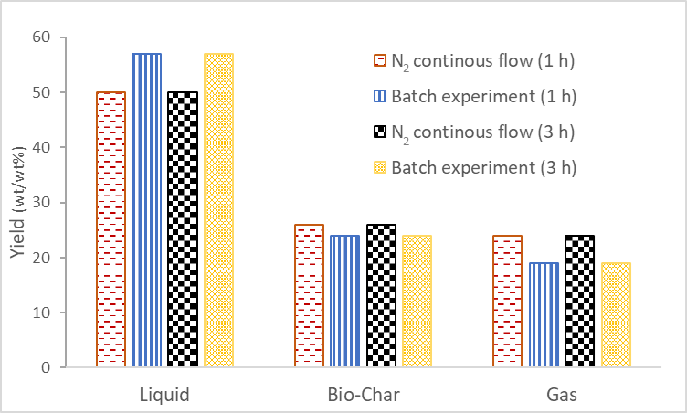
Yields to liquid, bio-char and pyrolytic gas has been evaluated as: Y_{i}=mass_{i}/mass_{biomass}, with the methodology described above. As shown in Figure 1, when the pyrolysis condition changed from batch inert environment to nitrogen flow, the yield of the liquid was decreased from 57 to 50 % and the yield of the bio-char was slightly increased from 24 to 26 %.
Figure 1. Yields to pyrolysis products as a function of reaction time and process conditions at 500°C
Conversely, the yield of the gas increased from 19 to 24 %. The reason for the reduction of liquid yield and subsequent increase of gas one when using nitrogen flow could be attributed to the different reaction conditions or removal of volatile liquid compounds. Likewise, a slight increase in bio-char yield could be attributed to the removal of the pyrolysis gas from the reactor by nitrogen flow, removing volatile compounds and maybe reducing possible interaction of bio-char with gaseous components [7]. Instead, no remarkable effect has been obtained by varying the reaction time mainly because, in the adopted experimental setup, pyrolysis process mainly occurs in the first 30 minutes, in agreement with reaction times reported in the literature on different biomasses [8]. Therefore, it could be concluded that pyrolysis time higher than 1 hour, will probably affect the properties and reactivity of bio-char [9] which is an important parameter for char use, currently under investigation. Assessment of the liquid composition and bio-char properties and morphology are currently under evaluation.
4. Conclusions
Pyrolysis of dried “end of life” olive stone waste was performed at 500 °C with different reaction times in both batch and semi-batch operating mode. The effect of the experimental process condition applied to the pyrolytic treatment on the yield of bio-char, liquid and gas was evaluated. Also, composition of produced liquid was analyzed. When the pyrolysis condition changed from batch to N₂ flow, the yield of char and gas was increased by 8% and 26% respectively while the liquid yield was decreased by 14%. No remarkable difference was observed upon a variation of the reaction time (1 vs. 3 h). An extensive discussion on stream composition and properties of the produced bio-char will be given.
References
[1] G. Wang, Y. Dai, H. Yang, Q. Xiong, K. Wang, J. Zhou, Y. Li, S. Wang, Energy & Fuels. 34 (2020) 15557–15578.
[2] M. Corral-Bobadilla, R. Lostado-Lorza, F. Somovilla-Gómez, R. Escribano-García, J. Clean. Prod. 294 (2021).
[3] K. Khwaldia, N. Attour, J. Matthes, L. Beck, M. Schmid, Compr. Rev. Food Sci. Food Saf. (2022) 1–36.
[4] NationMaster, 2022, www.nationmaster.com/nmx/ranking/olives-production-fao
[5] M. Borella, A.A. Casazza, G. Garbarino, P. Riani, G. Busca, Energies, 15 (2022) 991.
[6] E. Spennati, A.A. Casazza, A. Converti, G. Busca, Energies, 13 (2020) 5246.
[7] M. Iwanow, T. Gärtner, V. Sieber, B. König, Beilstein J. Org. Chem. 16 (2020) 1188–1202.
[8] Y.H. Chan, S. Yusup, A.T. Quitain, Y. Uemura, S.K. Loh, Biomass Bioenergy 107 (2017) 155–163.
[9] H. Liu, M. Kaneko, C. Luo, S. Kato, T. Kojima, Fuel 83 (2004) 1055–1061.

