Multiscale modeling of solubility in semi-crystalline polymers:
Bridging Molecular dynamics simulations with Lattice Fluid theory

Omar Atiq^{1,4}, Eleonora Ricci^{1,3,4}, Marco Giacinti Baschetti^{1,4}, Maria Grazia De Angelis^{1,2,4}
1 Department of Civil, Chemical, Environmental and Material Engineering, (DICAM), Alma Mater Studiorum –Università di Bologna, via Terracini 28,40131 Bologna, Italy.
2 Institute for Materials and Processes, School of Engineering, University of Edinburgh, Sanderson Building, Robert Stevenson Road, EH9 3FB, Scotland, UK.
3 Institute of Informatics and Telecommunications & Institute of Nanoscience and Nanotechnology, National Center for Scientific Research Demokritos, 15341 Aghia Paraskevi, Athens, Greece.
4 Dutch Polymer Institute (DPI), P.O. Box 902, 5600 AX Eindhoven, the Netherlands.
*Corresponding author E-Mail: omar.atiq2@unibo.it

1. Introduction
The mechanical and barrier properties of semi-crystalline polymers are strictly related to their biphasic nature.
In such polymers, upon cooling from the melt, partial crystallization occurs hence leading to the intercalation of two phases. Nevertheless, not all the chains have sufficient energy to fold into highly oriented lamellar structures hence random coils of chains, namely the amorphous domains, are always present along with the crystallites. An interesting feature of some semi-crystalline polymers is the limited gas and vapor permeability which therefore makes them excellent barriers. The permeability in non-porous materials, so are semi-crystalline polymers, is commonly derived, according to the solution-diffusion model as the product of the Solubility and the Diffusivity [1]. Both the solubility and diffusivity are strongly reduced by the presence of the crystal phase. The reduced solubility can be ascribed to the fact that the crystal domains are impermeable, thus the penetrant sorbs only in the amorphous phase. Moreover, the experimental evidence suggests that the amorphous phase exhibits a lower solubility than the one it would show in the absence of the crystalline domains hence suggesting that the crystals act as a physical constraint causing an increased rigidity and reduced swelling capacity of the amorphous phase.
In this context, a series of works addressed the modeling of the solubility in semi-crystalline polymers introducing the mechanistic effect provided by the crystal phase. We gathered and described such modeling strategies in a detailed review article that can be found in [2].

2. Methods
The new modeling strategy here presented follows a multi-scale paradigm that effectively couples molecular dynamics simulations with thermodynamic modeling. High-density polyethylene was chosen as a benchmark material for the development and optimization of the modeling strategy with carbon dioxide as a penetrant. The next pages are addressed to the description of the atomistic and macroscopic modeling and their integration.

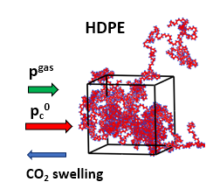
2.1 Molecular Modeling
Since the penetrant does not sorb the crystal phase, the chosen molecular model was a fully amorphous polymer structure in which the crystal was implicitly accounted with the addition of a constraint pressure ‘p_{c}⁰’ prevailing the gas pressure which mimics the increased density state and reduced swelling.
NPT simulations were used to evaluate the volumetric properties of the amorphous polyethylene at different temperatures, pressures (gas + constraint), and CO₂ concentrations using LAMMPS software.
Figure 1 Constrained amorphous phase molecular representation

2.2 Thermodynamic Modeling
The thermodynamic modeling was performed via Lattice Fluid theory [3]. The idea behind our modeling is to consider the constrained amorphous phase of the semi-crystalline polymer as in a non-equilibrium fashion because of the volume relaxation hindered by the crystallites. In this context, the sorbing amorphous phase volume relationship with temperature, pressure (gas + constraint), and concentration was derived from molecular dynamics simulation results rather than an equation of state which is valid only for fully rubbery and molten polymers. The solubility evaluation was made at the macroscopic level using the Non -Equilibrium Lattice Fluid (NELF) model [4] fed with the polymer simulated density. Once the constraint pressure parameter p_{c}⁰ was adjusted on one solubility isotherm, the same value was used to predict the solubility at different temperatures. Such an approach was tested for the modeling and prediction of carbon-dioxide isotherms.

2.3 Multiscale modeling
In the first stage, the Lattice Fluid theory in its equilibrium version was used to model CO₂ solubility isotherms in molten polyethylene. The pure penetrant equation of state solution provided the pure gas density and chemical potential. The penetrant chemical potential equalization gas-side and polymer side was then simultaneously solved with the mixture equation of state providing an estimation of the penetrant solubility in the molten polymer matrix ($ω_{1})$. The predicted solubility was matched with the experimental isotherm by adjusting the value of the binary interaction parameter $k_{{CO}_{2}-HDPE}$. The set of equations to be solved is reported in (1).
$\left\{\begin{aligned}{\tilde{ρ}}_{{CO}_{2}}=1-exp\left[-\frac{{{\tilde{ρ}}_{{CO}_{2}}}^{2}}{{\tilde{T}}_{{CO}_{2}}}-\frac{{\tilde{p}}_{{CO}_{2}}}{{\tilde{T}}_{{CO}_{2}}}-{\tilde{ρ}}_{{CO}_{2}}\left(1-\frac{1}{r_{{CO}_{2}}^{o}}\right)\right] \\ {\tilde{ρ}}_{mix}=1-exp\left[-\frac{{{\tilde{ρ}}_{mix}}^{2}}{{\tilde{T}}_{mix}}-\frac{{\tilde{p}}_{mix}}{{\tilde{T}}_{mix}}-{\tilde{ρ}}_{mix}\left(1-\left(\frac{Φ_{{CO}_{2}}}{r_{{CO}_{2}}}+\frac{Φ_{pol}}{r_{pol}}\right)\right)\right] \\ µ_{{CO}_{2}}^{ pol}\left(T,p_{{CO}_{2}},ω_{{CO}_{2}},k_{{CO}_{2}-HDPE}\right)=μ_{{CO}_{2}}^{0}\left(T,p_{{CO}_{2}}\right)\end{aligned}\right.$ (1)

Once the binary interaction parameter was fitted for all the solubility isotherms at the molten state it was possible to derive a linear expression for the binary parameter as a function of temperature$k_{12}(T)$ that was extrapolated even below melting temperature in the semi-crystalline state.
The modeling of the semi-crystalline solubility isotherms required to retrieve the experimental solubility isotherms on the sole sorbing amorphous fraction as follows:

$ω_{{CO}_{2}}^{am}=$ $\frac{ω_{{CO}_{2}}^{sc}}{\left(1-χ_{cr}\right)}$ (2)
where $ω_{{CO}_{2}}^{am}$ and $ω_{{CO}_{2}}^{sc}$ are the constraint amorphous and semi-crystalline solubility respectively and $χ_{cr}$ the mass degree of crystallinity.
The modeling of the solubility isotherms in the constrained amorphous phase was performed solving the following set of equations fed with the binary interaction parameter temperature relationship previously retrieved $k_{{CO}_{2}-HDPE}(T)$ and adjusting the constraint pressure parameter p_{c}⁰ to fit a sole experimental solubility isotherm.
$\left\{\begin{aligned}{\tilde{ρ}}_{{CO}_{2}}=1-exp\left[-\frac{{{\tilde{ρ}}_{{CO}_{2}}}^{2}}{{\tilde{T}}_{{CO}_{2}}}-\frac{{\tilde{p}}_{{CO}_{2}}}{{\tilde{T}}_{{CO}_{2}}}-{\tilde{ρ}}_{{CO}_{2}}\left(1-\frac{1}{r_{{CO}_{2}}^{o}}\right)\right] \\ ρ_{pol}^{am}\left(T,p_{{CO}_{2}}+p_{c}^{0},ω_{{CO}_{2}}^{am}\right) from MD simulations \\ µ_{{CO}_{2}}^{NE, am}\left(T,p_{{CO}_{2}}+p_{c}^{0},ω_{{CO}_{2}}^{am},ρ_{pol}^{am}\right)=μ_{{CO}_{2}}^{0}\left(T,p_{{CO}_{2}}\right)\end{aligned}\right.$ (3)

3. Results
The yet presented modeling paradigm was used to predict carbon-dioxide solubility isotherms. In particular, the solubility prediction provided by the solution of the system reported in (3) at T = 25°C with the corresponding volumetric results coming from MD simulations was fitted on the experimental solubility isotherm adjusting the constraint pressure parameter. Once the constraint pressure parameter was adjusted on the solubility isotherm at 25°C, the fitted value was used to predict the solubility at other temperatures by using molecular dynamics simulations at the relative temperature.
The results of the MD simulated constrained amorphous density at T = 25 °C are reported in Figure 2 while the solubility isotherms evaluation (fitted and predicted) derived from the coupling with the NELF model are displayed against the experimental results in Figure 3.
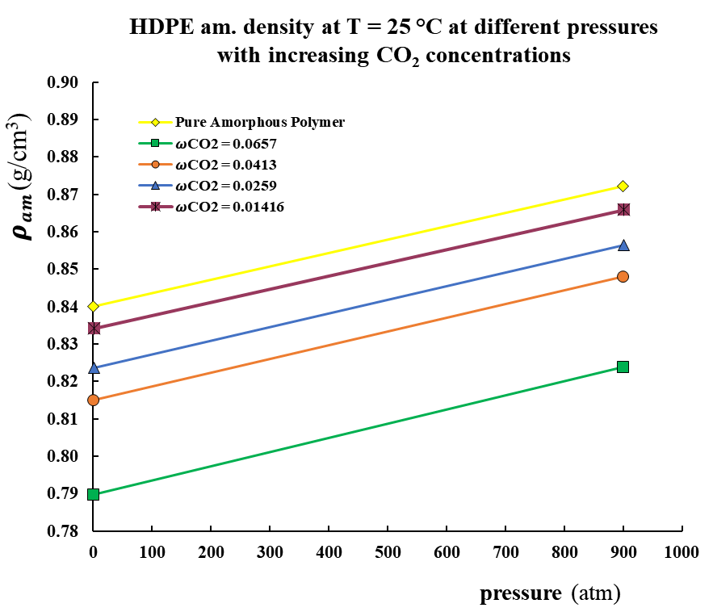
Figure 2 NPT simulations results at T = 25°C. Constrained amorphous phase as a function of pressure (gas + p_{c}⁰) for different concentrations: yellow (pure polymer), purple ($ω_{{CO}_{2}}=0.01416)$, blue ($ω_{{CO}_{2}}=0.0259)$, orange ($ω_{{CO}_{2}}=0.0413$), green ($ω_{{CO}_{2}}=0.0657)$.

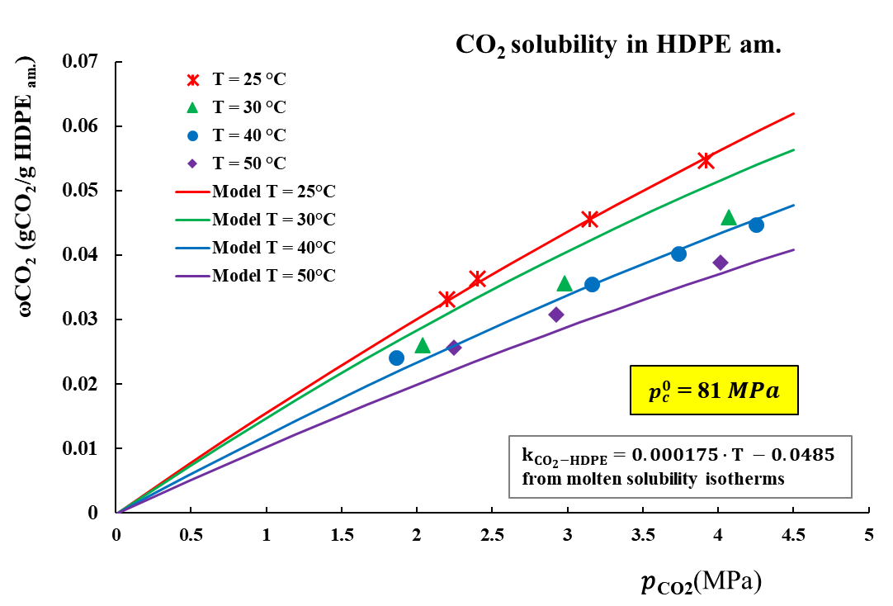
Figure 3 CO₂ Solubility isotherms in the constrained amorphous phase:
- Experimental solubility data $ω_{{CO}_{2}}$ (gCO₂/gpol.am) [5]: T = 25 °C (red crosses), T = 30 °C (green triangles), T = 40 °C (blue circles), T = 50°C (purple diamonds) .
- Multi-scale model (MD simulations + NELF) prediction: T = 25 °C (red line), T = 30 °C (green line), T = 40 °C (blue line), T = 50 °C (purple line).

4. Conclusions
A constant p_{c}⁰ fitted parameter was demonstrated to reliably predict the CO₂ solubility data at other temperatures hence the modeling strategy showed as a promising tool for the estimation of sorption in semi-crystalline polymers. Nevertheless, the modeling strategy still needs to be optimized and tested with other penetrants and polymers.
References
[1] J.G. Wijmans, R.W. Baker, The solution-diffusion model: a review, J. Memb. Sci. 107 (1995) 1–21. https://doi.org/10.1016/S0166-4115(08)60038-2.
[2] O. Atiq, E. Ricci, M.G. Baschetti, M.G. de Angelis, Modelling solubility in semi-crystalline polymers: a critical comparative review, Fluid Phase Equilib. 556 (2022) 113412. https://doi.org/10.1016/j.fluid.2022.113412.
[3] I.C. Sanchez, R.H. Lacombe, Statistical Thermodynamics of Polymer Solutions, Macromolecules. 11 (1978) 1145–1156. https://doi.org/10.1021/ma60066a017.
[4] F. Doghieri, G.C. Sarti, Predicting the low-pressure solubility of gases and vapors in glassy polymers by the NELF model, J. Memb. Sci. 147 (1998) 73–86. https://doi.org/10.1016/S0376-7388(98)00123-9.
[5] N. Von Solms, J.K. Nielsen, O. Hassager, A. Rubin, A.Y. Dandekar, S.I. Andersen, E.H. Stenby, Direct measurement of gas solubilities in polymers with a high-pressure microbalance, J. Appl. Polym. Sci. 91 (2004) 1476–1488. https://doi.org/10.1002/app.13371.

Acknowledgment: This research forms part of the research program of DPI, project 844 | Modelling and Design of Multiphase Polymeric Materials for High-Performance Applications Across Multiple Scales (MuMPol).

