Feasibility study of a soft sensor predicting the vapor composition inside a flammable liquid storage tank

Gabriele Baldissone, Micaela Demichela, Davide Fissore
Politecnico di Torino, C.so Duca degli Abruzzi 24 Torino, Italy;
*Corresponding author E-Mail: gabriele.baldissone@polito.it

1.Introduction
Often process plants include the storage of flammable liquids. Storage is generally considered a low-risk part of the plant, even if it can be involved in major accidents [1, 2, 3]
To guarantee tanks safety, the blanketing is usually adopted; despite it is a technique widely used in industry, it was scarcely investigated in the literature [4, 5]. In blanketing [6] the atmosphere inside the tank is kept far from the flammability conditions thanks to the presence of an inert gas, usually nitrogen. PSVs are installed on the tank to avoid damage from critical pressure deviations. In case of high pressure, the PSVs release the vapor phase contained in the tank. On the other hand, in the case of low pressure, the PSV allows air (or other gas) to enter. In this situation, the entry of air can bring the atmosphere in the tank in flammability conditions.
To keep the tank safe even when the PSV is open, it is necessary to know the composition of the vapor phase inside the tank. As an alternative to the direct monitoring of the composition of the vapor phase, a soft sensor can be adopted.
A soft sensor allows to obtain an indirect measurement of a variable from the measurement of related variables, through a mathematical model [7]. In the specific case, by measuring the inlet and outlet flow rates and the liquid level, an estimate of the composition of the atmosphere inside the tank is obtained.
This paper presents a first feasibility test of a soft sensor to estimate the composition of the vapor phase of a storage tank of liquid methanol. To develop the soft sensor, a dynamic model of the tank operation is used, as detailed in the subsequent paragraphs.
2. Methods
A dynamic model of the tank is developed as a preliminary step for the development of the soft sensor. The tank model is used to get the data required for soft sensor training and subsequent soft sensor validation.
Dynamic model
An isothermal model of the tank operation has been developed, which derives the liquid level and the composition of the internal atmosphere of the tank as a function of the inlet and outlet flow rates, according to the following equations:
$$\left\{\begin{matrix}\frac{dN_{}^{L}}{dt}=N_{L,in}-N_{L,out}-A∙ϕ \\ \frac{dN_{}^{V}}{dt}=N_{Nit,in}+N_{Air,in}+A∙ϕ-N_{V,out} \\ \begin{matrix}\frac{dN_{Nit}^{V}}{dt}=N_{Nit,in}+N_{Air,in}∙y_{Air, Nit}-N_{V,out}∙y_{ Nit} \\ \frac{dN_{Ox}^{V}}{dt}=N_{Air,in}∙y_{Air, Ox}-N_{V,out}∙y_{ Ox} \\ \begin{matrix}\frac{dN_{Met}^{V}}{dt}=A∙ϕ-N_{V,out}∙y_{ Met} \\ ϕ=k_{Met}^{v}\left(y_{Met}^{*}-y_{Met}^{}\right) \\ V_{TOT}=V_{L}-V_{V}\end{matrix}\end{matrix}\end{matrix}\right.$$

where N^{L} is the number of moles of liquid, in the tank N_{L,in} is the flow rate of liquid methanol entering the tank, N_{L,out} is the flow rate of liquid methanol leaving form the tank, A is the tank area, Φ is mass transfer rate between the liquid and the gas phase. N^{V} is the number of moles of gas in the tank, N_{Nit,in} is the flow rate of nitrogen entering the tank, N_{Air,in} is the flow rate of air entering the tank, N_{V,out} is flow rate of gas leaving from the tank. N^{V}_{Nit} is the number of moles of nitrogen in the gas phase, N^{V}_{Ox} is the number of moles of oxygen in the gas phase and N^{V}_{Met} is the number of moles of methanol in the gas phase. Instead y_{Air,Nit} is the nitrogen concentration in the air, y_{Air,Ox} is the oxygen concentration in the air, y_{Nit} is the nitrogen concentration in the tank gas phase, y_{Ox} is the oxygen concentration in the tank gas phase and y_{Met} is the methanol concentration in the tank gas phase. And k^{V}_{Met} is the methanol transfer coefficient between liquid and gas phase, y*_{Met} is the equilibrium concentration of methanol in the gas phase. V_{TOT} is the tank volume, V_{L} is the liquid volume and V_{V} is the gas volume.
For the calculation of the pressure the law of ideal gases is used.
The incoming air flow and the outgoing gas flow through the PSV is calculated according to the API2000:1998.
The model estimates the composition of the vapor phase of a tank containing methanol, of a capacity of 100m³. Tank’s height is approx. 5.3 m and 245 kg/h of methanol are removed from the tank to be used in the process downstream. With the nitrogen supply, the pressure inside the tank is kept constant. Due to process consumption, when the methanol level falls below 30%, the tank is re-filled to 80% of its capacity. The PSV is set to intervene at an overpressure of 7 kPa and a depression of 1 kPa.
Soft sensor
A soft sensor is developed to estimate the composition inside the tank. The soft sensor estimates the concentration of nitrogen and methanol vapors in the atmosphere inside the tank, the concentration of oxygen is obtained as a complement to one of the other concentrations. The soft sensor uses the structure shown in figure 1. The soft sensor consists of two neural networks, one estimates the concentration of methanol and the other the concentration of nitrogen.
y_{Met}
y_{Nit}
Soft sensor
Neural network 1
Neural network 2
N_{L,in}
N_{L,out}
N_{Nit,in}
Liquid level
Figure 1. Soft sensor structure
To develop the neural networks constituting the soft sensor, a set of data is generated that describes the operation of the tank in different conditions. The data set obtained is used for the training of the neural networks.
Subsequently, the neural networks are tested in different operating conditions to evaluate the accuracy.
3. Results and discussion
In the test case study, after around 8353 h (5000 time steps of 10 minutes, needed to reach the steady state conditions for the initial conditions here considered) the nitrogen flow is reduced to 30% of the nominal value, with a step deviation. As a result, a pressure reduction occurs, and air enters following the intervention of the PSV. After another 5000 time steps, the nitrogen flow is restored.
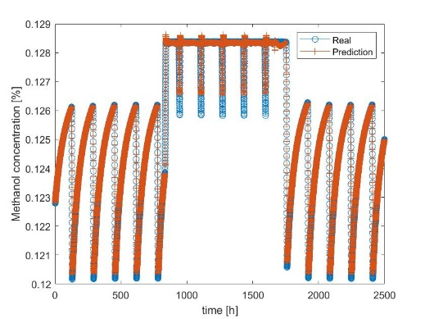
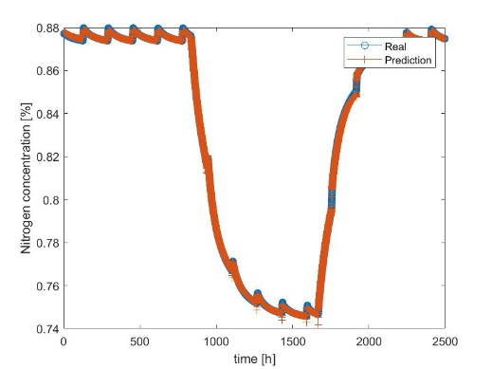
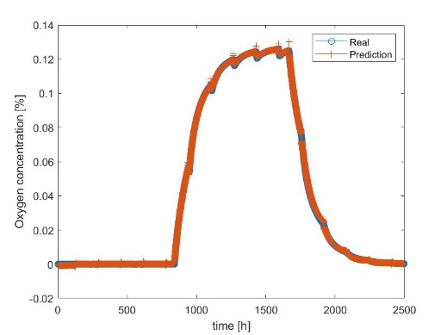
Figure 2 shows the nitrogen, methanol and oxygen concentrations trends, both obtained from the model and from the soft sensor. Figure 2 shows that the soft sensor approximates the trend of the concentrations obtained with the model.
A
B
C
Figure 2. Composition trend, A: Methanol, B: Nitrogen, C: Oxygen
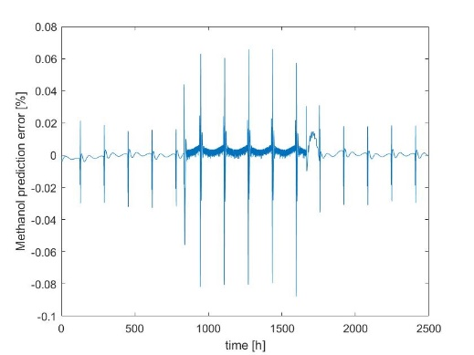
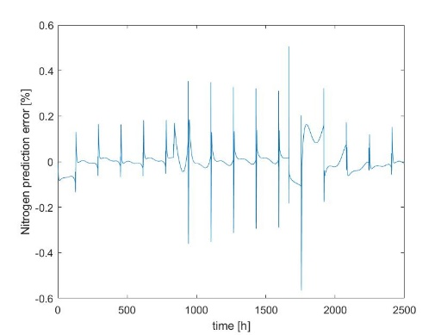
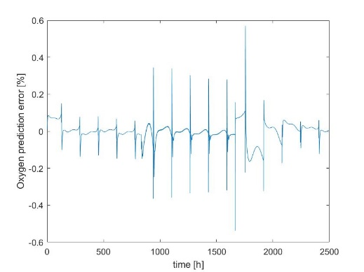
Figure 3 shows the prediction error of the soft sensor, identified as the difference between the values obtained from the model and those obtained from the soft sensor. As shown in the Figure, the maximum prediction error is about 0.6%.
A
B
C
Figure 3. Prediction error A: Methanol, B: Nitrogen, C: Oxygen
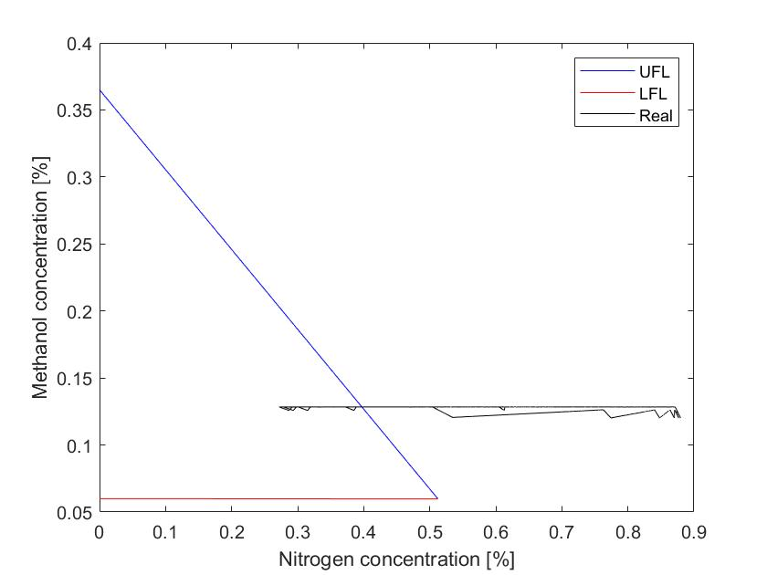
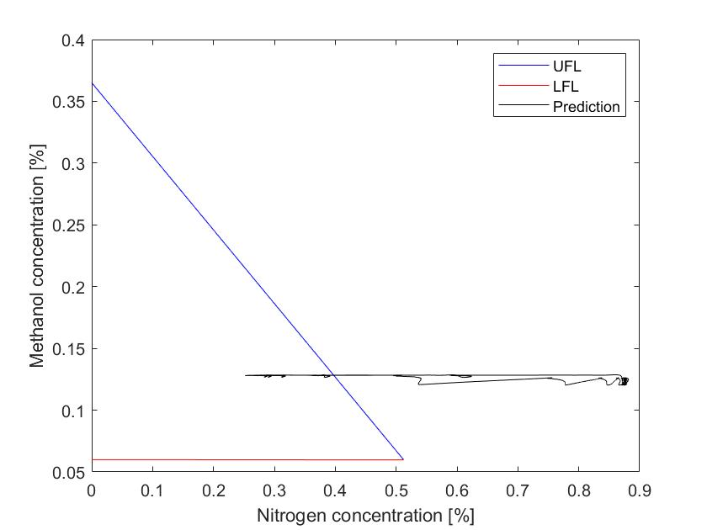
Figure 4 shows the trend of the composition of the atmosphere inside the tank. The composition of the internal atmosphere of the tank enters the flammability peninsula, the flammability peninsula is obtained in accordance with Ma [8]. Figure 4 indicates that the soft sensor returns a trend close to that obtained from the model.
A
B
Figure 4. Atmosphere composition trend A: Real, B: Soft sensor

4. Conclusions
To keep tanks that contain flammable liquids safe, blanketing is usually adopted. In case of a pressure drop in the tank, generally related to the unavailability of blanketing gas, the opening of the PSV allows air to enter. The entry of air can bring the the atmosphere inside the tank to flammable conditions.
A soft sensor is developed to estimate the composition inside the tank. The soft sensor, based on the inlet flow rate of liquid and nitrogen, the outflow of liquid and the liquid level, that are usually monitored, or, in any case, easier to be measured than the internal concentrations, estimates the composition of the atmosphere inside the tank. The soft sensor consists of 2 neural networks, one estimating the nitrogen concentration and the other the concentration of methanol. The oxygen concentration is obtained as a complement to one.
The soft sensor has been tested in a case study in which the nitrogen flow is reduced to 30% and then restored. In this case, the soft sensor reported results in line with what is obtained from the model.
These encouraging initial results will be further extended, gradually reducing the initial simplifying hypothesis adopted in the model.

References
- N. C. Markatos, C. Christolis, C. D. Argyropoulos, Mathematical modeling of toxic pollutants dispersion from large tank fires and assessment of acute effects for fire fighters, International Journal of Heat and Mass Transfer, . 52(2009) 4021–4030.
- D. Wang, P. Zhang, L. Chen, Fuzzy fault tree analysis for fire and explosion of crude oil tanks, Journal of Loss Prevention in the Process Industries, 26(2013) 1390–1398.
- J. I. Chang, C. C. Lin, A study of storage tank accidents, Journal of Loss Prevention in the Process Industries, 19 (2006) 51–59.
- D. A. Crowl, J. F. Louvar, Chemical Process Safety: Fundamentals with Applications, Prentice Hall, Upper Sandle River, 2002.
- T. J. De Paola, C. A. Messina, Nitrogen Blanketing, Plant operations progress, 3(1984) 203–212.
- Y. Amrouche, C. Dave, K. Gursahani, R. Lee, L. Montemayor, General rules for aboveground storage tank design and operation Chemical Engineering Progress, 98 (2002) 54–58.
- L. Fortuna, S. Graziani, A. Tizzo, M. G. Xibilia, Soft Sensors for Monitoring and Control of Industrial Processes, London: Springer, 2007.
- T. Ma, A thermal theory for estimating the flammability limits of a mixture, Fire Safety Journal, 46(2011) 558–567

