Simulation and optimization of an innovative thermochemical water splitting cycle for the production of Green Hydrogen

Alice Bertino¹, Maria Beatrice Falasconi¹*, Alberto Giaconia², Vincenzo Piemonte¹
1 Departmental faculty of engineering, Chemical-Physics Fundamentals in Chemical Engineering research unit, Campus Bio-Medico University, Via Alvaro del Portillo 21, 00128, Rome, Italy;
2 Department of Energy Technologies and Renewable Sources, ENEA, Casaccia Research Center, Via Anguillarese 301, 00123, Rome, Italy;
*Corresponding author E-Mail: maria.falasconi@unicampus.it
1.Introduction
Nowadays the increasing energy demand and greenhouse gas emissions are becoming more and more relevant problems. Green Hydrogen, produced from water as raw material using renewable energy sources, is becoming one key energy carrier in a future sustainable economy.
To date, two main processes can be considered to produce Green Hydrogen: water electrolysis (WE) and thermochemical water-splitting cycles (TWSCs) [1]. Among the TWSCs, sulphur-based cycles are considered promising and, hence, have been widely studied.
In particular, ENEA proposed an innovative thermochemical water-splitting cycle called “NIS” (Nickel/Iodine/Sulphur), which is a modification of the more conventional “IS” (Iodine/Sulphur) cycle. The “NIS” cycle shows the same advantages as the “IS” cycle when compared to water electrolysis (which suffers energy losses due to electricity-to-heat transition) or to direct thermal dissociation (which requires temperatures > 2000 °C). Compared to the “IS” cycle, the “NIS” cycle potentially has a simpler flow-sheet, milder materials corrosion issues dealing with acid solutions at high temperature, absence of catalysts and membranes, higher hydrogen purity level and, possibly, higher thermochemical efficiency [1].
Although the cycle is very promising from a theoretical point of view, studies on the closed cycle have not yet been done. In fact, so far, some experimental tests have been carried out by ENEA to prove the five main chemical steps of the cycle, which were only studied separately and not connected in a closed cycle [1].
The main purpose of this work is to analyze the actual feasibility of the “NIS” cycle through an Aspen Plus V10 simulation of the closed cycle in a flow-sheet. Whitin the cycle, the five main steps have been optimized through sensitivity studies also carried out using Aspen Plus V10.

2. Methods
The proposed cycle consists of a series of five reactions:
$${(1+4)I}_{2}+ {(2+14)H}_{2}O+ {SO}_{2(g)} →{{{(2HI+{10H}_{2}O+{4I}_{2})}_{iodine-phase} +(H}_{2}{SO}_{4}+{4H}_{2}O)}_{sulphuric-phase}$$ | $$∆H= -134,7 \frac{kJ}{mol}$$ | (1)
$${(2HI+{10H}_{2}O+{4I}_{2})}_{iodine-phase}+NiO↓ → {(NiI}_{2}+ H_{2}O+{10H}_{2}O+ {4I}_{2})$$ | $$∆H= -103,6 \frac{kJ}{mol}$$ | (2)
$${(NiI}_{2}+ H_{2}O+{10H}_{2}O+ {4I}_{2}) →Ni ↓+{ I}_{2}+{4I}_{2}+ {H_{2}O+10H}_{2}O$$ | $$∆H= 140,6 \frac{kJ}{mol}$$ | (3)
$${{(H}_{2}{SO}_{4}+{4H}_{2}O)}_{sulphuric-phase}+Ni↓ → {(NiSO}_{4}+ {4H}_{2}O) + H_{2(g)}$$ | $$∆H= -88,3 \frac{kJ}{mol}$$ | (4)
$${(NiSO}_{4}+ {4H}_{2}O) →NiO↓+ {SO}_{2(g)}+{0,5O}_{2(g)}+ {4H}_{2}O$$ | $$∆H= 306,5 \frac{kJ}{mol}$$ | (5)
The simulation scheme of the closed cycle, carried out using Aspen Plus V10 simulation software, is represented in Fig. 1.
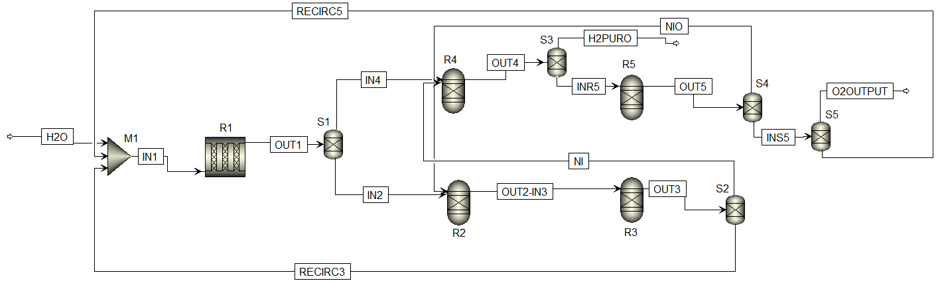
Fig. 1. Aspen simulation flowsheet of the NIS cycle.

The Bunsen reaction (Eq. 1) is carried out in R1 and, from H₂O, I₂ and SO₂, produces two liquid phases, which must be separated in S1 before being sent to the next steps: a heavier HI-rich phase (called iodine-phase, IN2) and a lighter H₂SO₄-rich phase (called sulphuric-phase, IN4). In order to avoid unwanted side reactions and to facilitate phase segregation, the Bunsen reaction must be carried out with an excess of I₂ and H₂O; according to literature [1], 4 moles in excess of I₂ and 14 in excess of H₂O have been set.
Once separated from the H₂SO₄-phase, the iodine-phase IN2 is neutralised in R2 by NiO to obtain NiI₂ and H₂O (Eq. 2); NiI₂ is afterwards decomposed in R3 to regenerate I₂ and Ni (Eq. 3). The products of R3 are separated in two streams by S2: the former (RECIRC3), containing I₂ (i.e. 4 unreacted excess moles) and H₂O (i.e. 10 unreacted excess moles), is recirculated to R1; the latter consisting of Ni (solid) is sent to the H₂ production step.
In the H₂ production step, Ni reacts in R4 with the sulfuric phase IN4 to produce NiSO₄ and H₂ (Eq. 4), which is the main product of the cycle. The obtained NiSO₄ is separated from H₂ in S3, and decomposed in R5 to regenerate NiO and SO₂ (Eq. 5) and producing O₂ that is the second final product of the cycle. NiO is separated by S4 and is recirculated to the neutralization reactor R2, while O₂ is separated in S5 from SO₂ and 4 unreacted excess moles of H₂O, which are recirculated to the Bunsen reactor R1.
Among the five reactions, the Bunsen reaction (Eq. 1) is the only one whose kinetic data are available from the literature [2],[3]. Therefore, only for the Bunsen reaction it was possible to carry out the simulation with a reactor that took kinetics into account; in particular, a PFR (R1) 2.5 m long and with 0.5 m diameter was chosen. The Bunsen reaction was simulated as a POWERLAW reaction occurring in liquid phase with the following rate expression:
$\left(-r\right)= A∙e^{-\frac{E_{a}}{R∙T}}∙C_{I_{2,L}}^{n_{1}}∙C_{{SO}_{2,L}}^{n_{2}}$
with
$E_{a}$ (activation energy) = 5.86 kJ/mol;
$A$ (kinetic factor) = 10 m³/kJ$∙$s;
$n_{1}$ (order of the reaction with respect to I₂) = 1;
$n_{2}$ (order of the reaction with respect to SO₂) = 1.
Since no kinetic data of the other four reactions (Eqs. 2-5) are available, the respective reactors (R2-R5) were simulated as GIBBS REACTORS, which calculate thermodynamic equilibrium by minimizing the Gibbs free energy.
Finally, SEPARATORS (S1-S5) were used to simulate separation steps, MIXER M1 for mixing Bunsen reagents and HEATERS (E1-E5) for heat exchanges.
For all five reactors, process parameters taken from the literature [1] and shown in Table 1 were chosen as a first attempt; the conditions of the streams and other equipment were set accordingly. After comparing the results with literature data, a sensitivity analysis was carried out on the process parameters of the five reactors in order to optimize them.
 | T [°C] | P [bar] | Inlet flow rates [kmol/h]
R1 | 100 | 1 | IN1: 16 H₂O, 5 I₂, 1 SO₂
R2 | 100 | 1 | IN2 (iodine-phase): 2 HI, 10 H₂O, 4 I₂, 1 NiO
R3 | 600 | 1 | IN3: 1 NiI₂, 11 H₂O, 1 I₂
R4 | 100 | 1 | IN4 (sulphuric-phase): 1 H₂SO₄, 4 H₂O, 1 Ni
R5 | 880 | 1 | IN5: 1 NiSO₄, 4 H₂O
Table 1. First-attempt process parameters entered for the simulation of NIS reactors.

3. Results and discussion
The following results have been obtained with a sensitivity analysis of pressure and temperature of the reactors:
PRESSURE
Pressure is confirmed at 1 bar, since:
- Pressure does not significantly affect reagents’ conversion and products’ yields in R1, R2 and R4;
- Reaction yields of R3 and R5 decrease as pressure increases.

TEMPERATURE
- Temperature of R1 is confirmed at 100 °C as trade-off between SO₂ and I₂ solubility in the liquid reaction medium: one the one hand, increasing the temperature would reduce the absorption of SO₂ into H₂O and undesirable reactions could occur; on the other hand, lowering the temperature reduces the solubility of iodine that could even solidify and lead to reactor plugging.
- In R2 and R4, the temperature sensitivity analysis shows a wide range of available temperatures: the maximum product yields can be obtained in the range of 20-500 °C in R2 (Figure 2), and in the range of 20-650 °C in R4 (Figure 3).
- In R3, the temperature sensitivity analysis confirmed that the reaction doesn’t occur for temperatures lower than 500 °C and yields are stoichiometric just starting from 600 °C; temperature of R3 is therefore set at 620 °C, in order to have a safety margin in case of temperature fluctuations during the operating cycle of the process, also considering possible temperature fluctuations when the reactor is driven with solar heat.
- In R5, the temperature sensitivity analysis showed that 930 °C is the minimum temperature above which reaction yields are stoichiometric, as shown in Figure 4; temperature of R5 is therefore increased from 880°C to 950 °C, 20 °C above the minimum in order to have a safety margin as in R3.

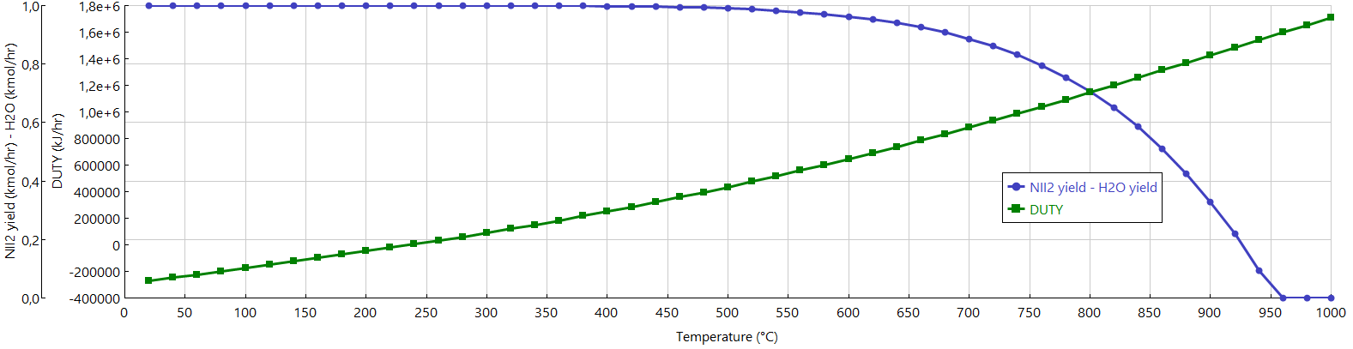
Figure 2. Temperature sensitivity analysis for R2.

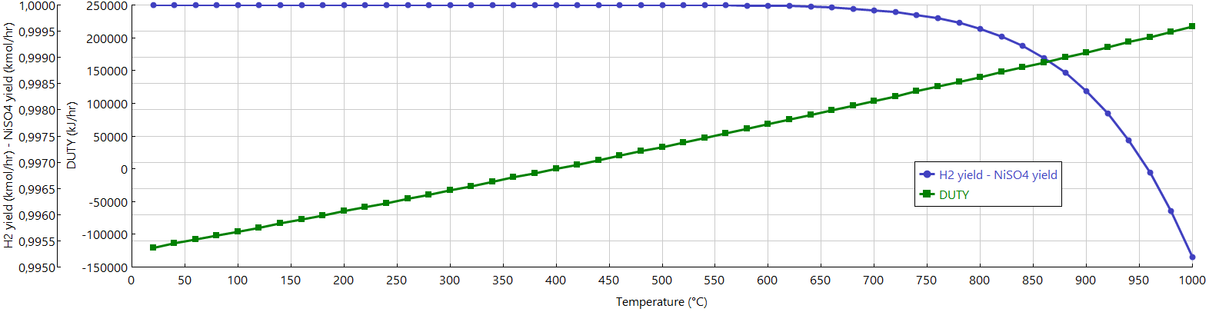
Figure 3. Temperature sensitivity analysis for R4.

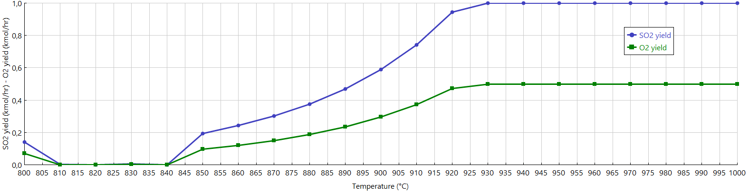
Figure 4. Temperature sensitivity analysis for R5.

Simulation of the complete process loop was thus carried out with the process parameters determined with the above sensitivity analysis; the simulation results, obtained from 1 kmol/h of H₂O as input to the cycle, are shown in Table 2.
Mole flow | Units | OUT1 | OUT2 | OUT3 | OUT4 | OUT5 | H_{2,puro} | O_{2,out}
I₂ | kmol/h | 3.94198 | 3.94199 | 4.94199 | ND | ND | ND | ND
H₂O | kmol/h | 13.977 | 10.7839 | 10.7839 | 4.5931 | 4.59307 | ND | ND
SO₂ | kmol/h | ND | ND | ND | 0.200006 | 0.857983 | ND | ND
HI | kmol/h | 2.11603 | 0.116006 | ND | ND | ND | ND | ND
H₂SO₄ | kmol/h | 1.05801 | ND | ND | 3.1$∙$10⁻¹⁷ | 2.5$∙$10⁻⁵ | ND | 2.5$∙$10⁻⁵
NIO | kmol/h | ND | ND | ND | ND | 0.858008 | ND | ND
NII₂ | kmol/h | ND | 0.999999 | ND | ND | ND | ND | ND
NI | kmol/h | ND | ND | 0.999999 | 0.141992 | ND | ND | ND
H₂ | kmol/h | ND | 1.2$∙$10⁻⁵ | ND | 0.658002 | 3.4$∙$10⁻⁷ | 0.65800 | 3.4$∙$10⁻⁵
NISO₄ | kmol/h | ND | ND | ND | 0.858008 | ND | ND | ND
O₂ | kmol/h | ND | ND | ND | 2.4$∙$10⁻⁶¹ | 0.428992 | ND | 0.42899
TOT | kmol/h | 21.093 | 15.8419 | 16.7259 | 6.4511 | 6.73808 | 0.65800 | 0.42902
Table 2. Results of the Aspen simulation of the NIS cycle (ND: Not Detected).
4. Conclusions
The following conclusions can be obtained by analysing the data obtained from the sensitivity analysis:
- For all the five reactors, the possibility of working at atmospheric pressure was confirmed; this allows the use of non-pressurized equipment for the cycle, with considerable advantages in economic and safety terms.
- For R1 and R3, temperatures reported in the literature have been confirmed.
- For the exothermic reactors R2 and R4 there is a wide temperature range in which the conversion remains stoichiometric. It is therefore possible to compare two different scenarios: to set the minimum possible temperature, thus economically optimizing the individual steps by using costless materials for milder temperatures, or to set the maximum possible temperature in order to recover the produced heat in other process sections, thus gaining in terms of the overall energy efficiency of the cycle.
- For R3 and R5, a minimum temperature was identified above which reagents’ conversion and products’ yields result stoichiometric and, given the endothermicity of the reactions, it wouldn’t be convenient to increase it.
For the four reactions, except for Bunsen reaction, it is noteworthy that a purely thermodynamic approach was used given the lack of kinetic data from the literature. Therefore, a possible future activity is to carry out laboratory tests in order to obtain appropriate kinetic data that can be inserted as input to the simulation and thus be validated. In this way, for all reaction steps it will be possible to use reactors that take kinetic into account, and then dimension them appropriately as done for Bunsen.
It can also be observed from the simulation results that the pure H₂ exiting the cycle is not stoichiometric; this is due to losses of some intermediates within the cycle. These losses will have to be minimized once the reactors have been suitable optimized with kinetic data.
Another important step will be to study the separation and the heating/cooling steps in more detail, also calculating the relative absorbed/released heat. This way it will be possible to accurately calculate the energy required by the cycle considering all possible internal heat recoveries, and to size the equipment in the process.
The complete simulation will serve for the realization of a complete laboratory pilot plant with a productivity of 2 Nm³/h, which is the final goal of our project. This realization will result in a complete set-up of the cycle at laboratory level, including the design, implementation and coupling of each and all of its individual units, and will serve as the base for future scale-up to a pre-industrial pilot plant.

References
[1] P. P. Prosini, C. Cento, A. Giaconia, G. Caputo, and S. Sau, “A modified sulphur-iodine cycle for efficient solar hydrogen production,” Int. J. Hydrogen Energy, vol. 34, no. 3, pp. 1218–1225, Feb. 2009, doi: 10.1016/j.ijhydene.2008.11.011.
[2] A. Shriniwas Rao, S. Sujeesh, V. Nafees Ahmed, H. Z. Fani, P. K. Tewari, and L. M. Gantayet, “Study of effect of high pressures and elevated temperatures on Bunsen reaction of Iodine–Sulfur thermo-chemical process,” Int. J. Hydrogen Energy, vol. 40, no. 15, pp. 5025–5033, Apr. 2015, doi: 10.1016/j.ijhydene.2015.02.092.
[3] J. Li, A. Moniri, and H. Wang, “Apparent kinetics of a gas-liquid-liquid system of Bunsen reaction with iodine-toluene solution for hydrogen production through H2S splitting cycle,” Int. J. Hydrogen Energy, vol. 40, no. 7, pp. 2912–2920, Feb. 2015, doi: 10.1016/j.ijhydene.2014.12.073.

