PLA-based active food packaging production with antioxidant properties
Maria Bolla¹*, Margherita Pettinato¹, Roberta Campardelli¹, Giuseppe Firpo², Patrizia Perego¹
1 Department of Civil, Chemical and Environmental Engineering, University of Genoa, via Opera Pia, 15, 16145 Genoa, Italy;
2 Department of Physics, University of Genoa, via Dodecaneso 33, 16146, Genova, Italy.
*Corresponding author E-Mail: maria.bolla01@edu.unige.it

1.Introduction
Food packaging is fundamental to protect food against mechanical damage, chemical, biochemical changes and microbiological spoilage, guarantying its stability over time. Nowadays, more rigorous food safety regulations, modernized manufacturing, retailing and distribution practices, led to the necessity of a suitable food packaging, with the aim of reducing food losses and extending the product shelf-life [1]. For these reasons, recent developments in materials and engineering resulted in new food packaging techniques, including active food packaging [2]. It plays an active role in the food protection by having direct interactions with food and/or its surroundings [1]. Among the most promising active materials, antioxidant agents are able to reduce reactive free radicals, providing higher food stability and nutritional value [3]. Spent coffee grounds (SCG) extracts are suitable candidates in this purpose, thanks to their high content of caffeine, phenolic compounds, flavonoids and melanoidins [4]. Furthermore, as other natural additives, they are safer and with a lower environmental footprint, with respect to the synthetic antioxidants [5,3].
In addition, in order to mitigate the alarming concern about the disposal and environmental issues raised from traditional oil-based plastics, natural and eco-friendly polymers represent an auspicious alternative. Among them, polylactic acid (PLA) is one of the most promising, thanks to its biodegradability, excellent transparency, good water resistance and good processability with standard plastic techniques, such as solvent casting [6].
Thus, the main aim of this work involved the production of active food packaging through a solvent casting technique, starting from PLA enriched with various amounts of spent coffee grounds extracts.
2. Methods
Antioxidant compounds were extracted from dried SCG using a hydroalcoholic solvent by a high pressure and temperature extraction (HPTE) at the operating conditions defined by a previous study [4]. The product was further purified through a liquid-liquid extraction (LLE) in chloroform. Both the obtained fractions were added to the PLA-based solutions during the packaging production process, by following the protocol reported by Cacciotti et al. [7] .
The two final films were then characterized and compared in terms of morphology, gas permeability and specific migration of caffeine into a food simulant. Particularly, films morphology was investigated by the optical microscope (OM, Olympus BX51) and an ultra-high resolution field-emission-source scanning electron microscope (FESEM, Zeiss CrossBeam XB 1540). Furthermore, O₂ permeability measurements were carried out by the method reported by Firpo et al. [8] . Finally, packaging migration properties after eight days at 4°C, 25°C, 40°C and in 10% ethanol (v/v), as food simulant, were evaluated in accordance with the Plastic Regulation [9,10] and caffeine content was determined according to the protocol reported by Belay et al. [11].
3. Results and discussion
The packaging morphology, investigated by OM and SEM, is reported in Figure 1 for three representative samples: the blank and those enriched with the two fractions of extract at different caffeine contents.
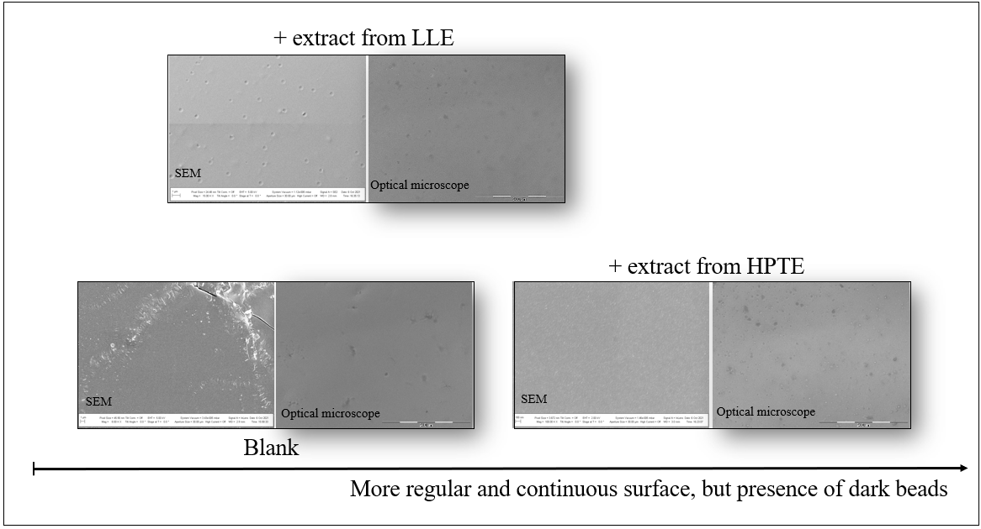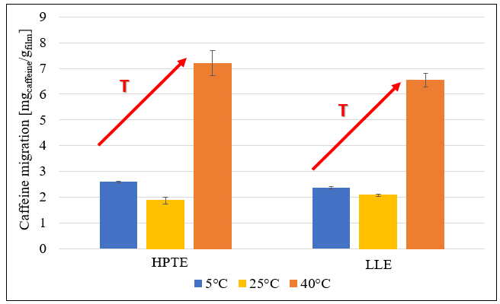
Figure 1. Packaging morphology. Figure 2. Comparison between films enriched
Images from OM and SEM. with the HPTE extract and LLE extract.
Films enriched with the extract from HPTE exhibited a more continuous surface than the blank and that containing the fraction from LLE, but with some dark beads.
Regarding O₂ permeabilities, the same three samples were characterized by a decreasing permeability as the extract content increased. This can also be explained by considering the antioxidant action of the extracts.
Finally, in Figure 2 the specific migration of caffeine at 5°C, 25°C and 40°C in 10% ethanol (v/v) as food simulant is reported. As expected, as the temperature increased, caffeine release into the food simulant was facilitated by the improved mass transfer.
4. Conclusions
In this work, an innovative active food packaging was produced through the solvent casting technique, thanks to the use of a biodegradable polymer and the valorization of spent coffee grounds residue, which exhibits a considerable antioxidant action. The presence of the extracts affected the morphology of the final packaging, as well as its physical and chemical properties, showing higher barrier properties and antioxidant action.
References
[1] M. Ozdemir, J.D. Floros, Crit Rev Food. 44 (2004) 185 – 193.
[2] J. Ju, X. Chen, Y. Xie, H. Yu, Y. Guo, Y. Cheng, H. Qian, Y. Yao, Trends Food Sci. Technol. 92 (2019) 22– 32.
[3] C. Vilela, M. Kurek, Z. Hayouka, B. Röcker, S. Yildirim, M.D.C. Antunes, J. Nilsen-Nygaard, M. K. Pettersen,
C.S.R. Freire, Trends Food Sci. Technol. 80 (2018) 212–222.
[4] M. Pettinato, A.A. Casazza, P.F. Ferrari, D. Palombo, P. Perego, Food Bioprod. Process. 114 (2019) 31–42.
[5] E. Drago, R. Campardelli, M. Pettinato, P. Perego, Foods. 9 (2020).
[6] M.J. Fabra, M.A. Busolo, A. Lopez-Rubio, J.M Lagaron, Trends Food Sci. Technol. 31 (2013) 79–87.
[7] I. Cacciotti, S. Mori, V. Cherubini, F. Nanni, Int. J. Biol. Macromol.. 112 (2018) 567–575.
[8] G. Firpo G., J. Setina, E. Angeli, L. Repetto, U., Vac. 191 (2021).
[9] Commission Regulation (EC) No 10/2011 of 14 January 2011 on plastic materials and articles intended to come
into contact with food.
[10] Commission Regulation (EC) No 2016/1416 of 24 August 2016 amending and correcting Regulation (EU)
No 10/2011 on plastic materials and articles intended to come into contact with food.
[11] B. Belay, K. Ture, M. Redi, A. Asfaw, Food Chem. 108 (2008) 310–315.

