Stabilization and characterization of microbial strains in liquid formulation

Chiara Bufalini¹*, Roberta Campardelli¹, Pier Francesco Ferrari^{1,2}, Domenico Palombo², Patrizia Perego¹
1 Department of Civil, Chemical and Environmental Engineering, University of Genoa, via Opera Pia, 15, 16145, Genoa, Italy
2 Department of Surgical and Integrated Diagnostic Sciences, University of Genoa, viale Benedetto XV, 6, 16132, Genoa, Italy
*Corresponding author E-Mail: chiara.bufalini@edu.unige.it

1.Introduction
Emulsions are temporarily stable mixture of two immiscible fluids, such as oil and water, which are mixed using mechanical shear and surfactant. One phase, called dispersed phase, is mixed in the other, called the dispersing phase, in the form of droplets. The formation of emulsion requires surfactants which have the role of reducing the interfacial tension and facilitate dispersion of immiscible liquids [1]. There are different type of emulsifier and it is fundamental the choice of the correct one, not only for the formation of emulsion but also for its long-term stability. Emulsions can be conveniently classified according to the relative spatial distribution of liquid phases and the different type are: simple emulsion, like oil-in-water and water-in-oil type, and double emulsion, such as water-in-oil-in-water and oil-in-water-in-oil type. In particular, double emulsions have several advantages respect to single emulsion, such as carrying, protecting, or controlling the release of active ingredients [2]. Emulsions are used in many industrial sectors and are widely used in the food, pharmaceutical and cosmetic industries [3].
One of the most common applications of emulsions is the encapsulation of bioactive components, thanks to the compatibility with a wide range of lipophilic, hydrophilic and amphiphilic molecules, the high efficiency encapsulation and possibility of controlled release [4]. In addition to bioactive components, microorganisms can be encapsulated in emulsion with the objective of stabilization and protection from external environment [5]. One of the most application is encapsulation of probiotic bacteria for food applications [6]. Therefore, mainly strains with food application have been encapsulated and microorganisms with different applications have rarely been studied.
Therefore, this study is based on the encapsulation of different microbial strains, selected for improvement of soil microflora, in double emulsion of the water-in-oil-in-water (W₁/O/W₂) type, where the microbial strains in its growth solution constitute the internal phase of the emulsion (W₁). The effectiveness of this encapsulation technique is evaluated by analyzing the droplet size distribution, morphology of the emulsion, vitality and concentration of microorganisms within the emulsion.
2. Methods
Selected microorganisms consist of: microorganism belonging to the genus Bacillus spp. acronym B1, Streptomyces spp. acronym S1, Pichia spp. acronym P1 and 2 microorganisms belonging to the genus Trichoderma spp. acronym T1 and T2. Besides the selected strains, the emulsion is composed of soybean oil and water with a non-ionic surfactant soluble in water phase.
All microorganisms were stabilized individually in double emulsions of water-in-oil-in-water type (W₁/O/W₂) using a rotor-stator type emulsifier (Silverson Machines Ltd, Chesham, England). For the stabilization of the microorganism in double emulsion are necessary two steps: production of primary emulsion W₁/O setting agitation at 6000 rpm for 3 minutes and then production of secondary emulsion W₁/O/W₂ with 7000 rpm for 5 minutes. For the comparative study empty emulsion was produced, indicated as E, with the same procedure, but in this case the microorganism is replaced by deionized water.
The characterization of double emulsion after production has been done through the following analyses: analysis of morphology and homogeneity of the emulsion droplets by optical microscope (Olympus IX51), particle size analysis using the laser diffraction granulometer (Mastersizer 3000, Alphatest, Cinisello Balsamo, Italy) and study of microbial viability by cell seeding on an agar plate.
3. Results and discussion
Microorganisms were stabilized in W1/O/W2 emulsion based on soybean oil. The same conditions of emulsion procedure were adopted for all the microorganisms. All emulsions produced were homogeneous with milk white appearance. They were observed under an optical microscope to see the morphology soon after production (Figure 1). As can be seen from the microscope images, both empty emulsion and loaded emulsions are well formed with non-coalescent droplets. Furthermore, the morphology of loaded emulsions is similar to that of the empty emulsions, indicating that the microorganisms does not interfere with the formation of the emulsion. It is also confirmed by the average diameter of the various emulsions (Figure 2). In fact, it can be seen that emulsions have a uniform PSD, without particular difference between empty and loaded emulsions, and it is about 5 μm.
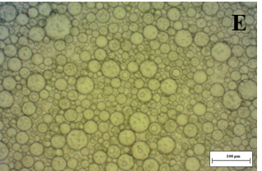 | 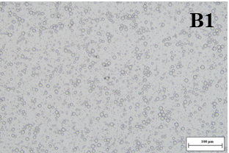 | 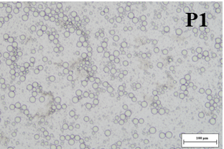
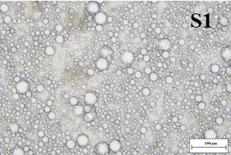 | 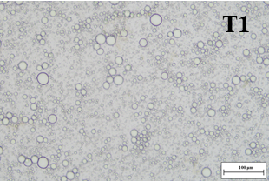 | 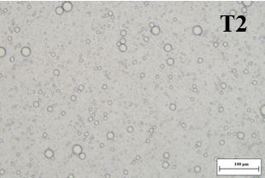
Figure 1. Optical microscope image of empty emulsion E and emulsion of strains B1, P1, S1, T1 and T2.
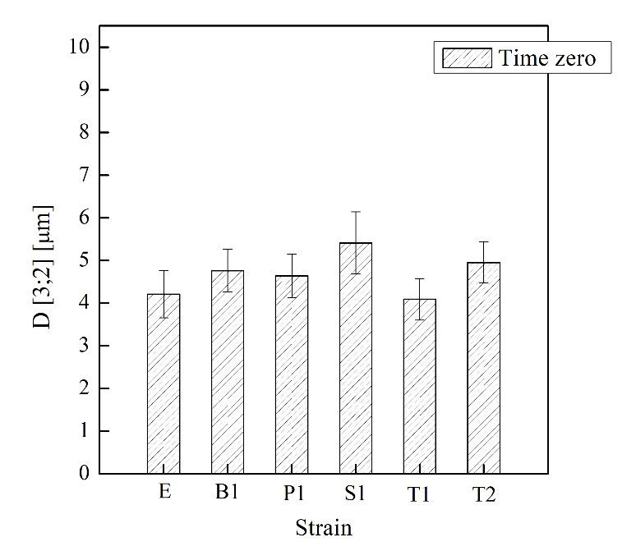
Figure 2. Average diameter and standard deviation of empty emulsion and emulsion of strains B1, P1, S1, T1 and T2 at time zero.
The study of microbial vitality of strains after encapsulation process was performed and the value of CFU/mL with standard deviation at time zero are reported in the histogram (Figure 3). As can be seen, all microorganisms are viable in double emulsion, with a concentration more than 10⁶. There is a drop in concertation from stock solution, that represents the starting microorganism in growth medium, to emulsion, that can vary from 10¹ to 10³. This decrease is probably due to the dilution factor and the loss of biomass. The vitality of strains is also confirmed by their appearance on the plate (Figure 4). In fact, each strains develop the typical morphology.
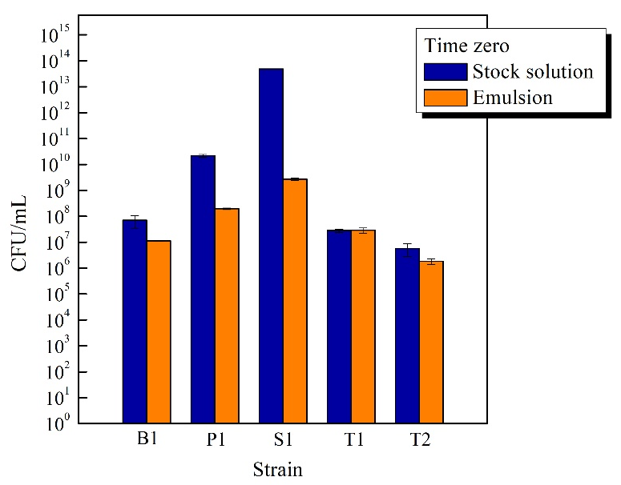
Figure 3. Histogram of CFU/mL and standard deviation at time zero for stock solution and emulsion of strains B1, P1, S1, T1 and T2 at time zero.

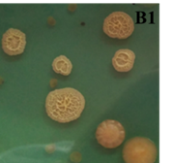 | 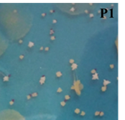 |  | 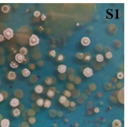
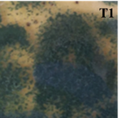 |  | 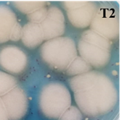
Figure 4. Detail of agar plate of emulsions containing B1, P1, S1, T1 and T2 strains at time zero.
Subsequently, the emulsions were analyzed over time in order to analyze the stability. From the results obtained it was possible to observe a good physical and microbial stability up to 360 days from production both for the sample stored at 4 ° C and at room temperature.
4. Conclusions
The aim of this work was to study the encapsulation of different strains in emulsion. From the obtained results, it can be verified that the emulsions are well formed and uniform, with the same average diameter of approximately 5 μm. Furthermore, the viability of all strains after encapsulation is guaranteed. There is only a decrease in concentration from stock solution to emulsion was found, which is attributable to the dilution factor and biomass losses. Thanks to these good results, future studies on the evaluation of the physical and microbial stability of these emulsions can be carried out to understand the shelf life of this formulation.

References
- S.N. Kale, & S.L. Deore (2017). Emulsion Micro Emulsion and Nano Emulsion: A Review. Sys Rev Pharm., 8(1), 39-47.
- G. Muschiolik & E. Dickinson (2017). Double Emulsions Relevant to Food Systems: Preparation, Stability, and Applications. Compr. Rev. Food Sci. Food Saf., 16, 532-555.
- D.J. McClements (2016). Food Emulsions: Principles, Practices, and Techniques, Third Edition. Taylor & Francis Group.
- D.J. McClements, E.A. Decker, Y. Park & Y. Weiss (2009): Structural Design Principles for Delivery of Bioactive Components in Nutraceuticals and Functional Foods. Crit Rev Food Sci Nutr, 49(6), 577-606.
- N.S. Mohd Isa, H. El Kadri, D. Vigolo, & K. Gkatzionis (2021). Optimisation of bacterial release from a stable microfluidic-generated water-in-oil-in-water emulsion. RSC Adv., 11, 7738-7749.
- L. Wang, M. Song, Z. Zhao, X. Chen, J. Cai, Y. Cao, Y. & J. Xiao (2020). Lactobacillus acidophilus loaded pickering double emulsion with enhanced viability and colon-adhesion efficiency. LWT- Food Sci Technol, 121, 108928.

