Heterogeneous catalysts for hydrogen storage formates in aqueous solution
Marcella Calabrese^{1*}, Danilo Russo¹, Raffaele Marotta¹, Roberto Andreozzi¹, Almerinda Di Benedetto¹
1 Dipartimento di Ingegneria Chimica, dei Materiali e della Produzione Industriale, Università degli Studi di Napoli Federico II, P.le Vincenzo Tecchio 80, 80125, Napoli.
*Corresponding author E-Mail: marcellacalabrese.2@unina.it
1. Introduction
In order to have reliable large-scale solutions for energy storage, hydrogen carriers are receiving special scientific attention. In recent years, there has been an interest in the development of new hydrogen vectors capable of releasing it at near ambient conditions. An interesting solution is represented by the salts of formic acid HCOOM (M = Li ⁺, Na ⁺, K ⁺, Cs ⁺, NH₄ ⁺), prepared through the catalytic hydrogenation of bicarbonate ions. This can represent an alternative approach to safely and economically store and transport large quantities of H₂, to be released when needed in the presence of a catalyst, at temperatures lower than 80°C.
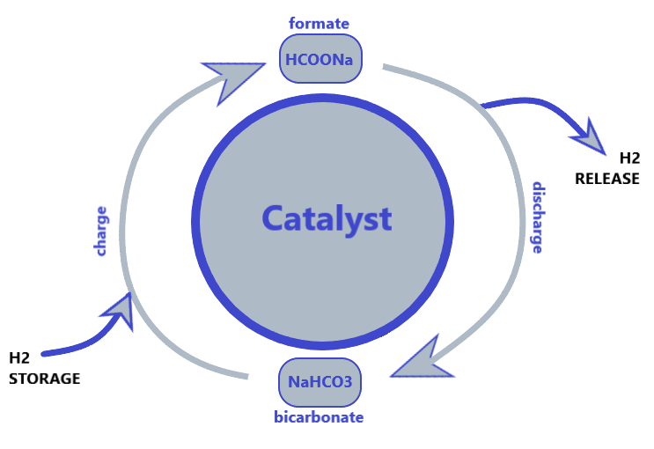
Figure 1 - Schematic representation of (sodium) formate-bicarbonate cycle [1]
Information on the stability of the proposed catalysts to release hydrogen from formiates is still scarce. Furthermore, most of the heterogeneous catalysts studied to date need to be reactivated often with the best ones showing a longevity of up to fifteen reversible cycles. [2] Based on the literature, [1]-[3-5] the most studied catalytic system is supported Pd on carbonaceous materials, oxides, etc. Some of these catalysts were found to be stable and capable of guaranteeing satisfying hydrogenation /dehydrogenation rates for industrial applications. In this work, particular attention will be devoted to identifying the supports among semiconductor oxides, that would permit to use a simple preparation technique such as the photodeposition of the palladium from solutions of its salts, as an alternative to impregnation.
2. Methods
All reagents were purchased from sigma-Aldrich and used as received. Dehydrogenation of formates tests were carried out using TiO₂ and WO₃ as the substrate of the catalyst. The photodeposition of palladium onto illuminated surfaces of TiO₂ [6] and WO₃ [7], was carried out in an annular photocatalytic reactor under UV irradiation and inert atmosphere. For the production of the catalyst an aqueous solution at 12wt. % of Pd in ​​180 mg of TiO₂ or WO₃, starting from PdCl₂, and at 10% v/v of EtOH was prepared. The photodeposition is done with a UV lamp with a wavelength λ=254 nm. The collected samples are centrifuged and dried at 75 ° C under inert atmosphere. Catalytic tests were run in a closed jacketed reactor, under N₂ inert atmosphere, adding 0.5 M sodium formate and the required amount of catalyst. Liquid samples were collected at different reaction time and analyzed by HPLC. Accumulated gas in the reactor was sampled at the end of each run and analyzed by GC.
3. Results
Various operating parameters that can influence the reaction (concentration of the reagent, preparation technique of the catalyst and its concentration, temperature, pH) have been investigated for dehydrogenation of sodium formate. In Fig. 2, the most promising results are summarized with respect to catalysts obtained by photo-deposition of Pd on different semiconductors, with a particular focus on pH, temperature, and support influence on dehydrogenation kinetics. At present, photodeposited Pd on TiO₂ resulted in the best performances compared to WO₃ and ZnO (data not shown). pH affects reaction kinetics, the best range being 7-9. As expected, temperature increase significantly affects formates conversion and hydrogen release rates.
b)
a)
Figure 2 - a) effect of pH for the dehydrogenation reaction of HCOONa 0.5 M at T=75°C using 12 wt% Pd/TiO₂ as catalyst; b) production of NaHCO₃ starting from the dehydrogenation reaction at pH=8; orange: Pd/TiO₂, T=85°C; blue: Pd/TiO₂, T=75°C; grey: Pd/WO₃, T=75°C;
4. Conclusions
Preliminary results show the activity of photo-deposited noble metals on semiconductors to catalyze formates dehydrogenation. pH of the solution, as well as the choice of the support and the operating conditions are crucial to determine hydrogen release kinetics. Based on this, in an approach based on the principles of the circular economy, the possibility of using solutions containing the noble metal coming from leaching processes (solid-liquid extraction) of waste materials such as exhausted catalytic converters or cards from electronic waste will be evaluated. The activity will also be extended to the activity of other noble metals, such as Ru, Pt, Cu, and Ni, and alloys deposited on suitable supports.
References
[1] A. Bahuguna and Y. Sasson, “Formate-Bicarbonate Cycle as a Vehicle for Hydrogen and Energy Storage,” ChemSusChem, vol. 14, no. 5, pp. 1258–1283, 2021, doi: 10.1002/cssc.202002433.
[2] X. Zhu et al., “Tandem catalysis induced by hollow PdO: Highly efficient H2 generation coupled with organic dye degradation: Via sodium formate reforming,” Catal. Sci. Technol., vol. 8, no. 23, pp. 6217–6227, 2018, doi: 10.1039/c8cy01551a.
[3] E. González et al., “Hydrogenation of sodium hydrogen carbonate in aqueous phase using metal/activated carbon catalysts,” Appl. Catal. B Environ., vol. 224, pp. 368–375, 2018, doi: 10.1016/j.apcatb.2017.10.038.
[4] C. Fellay, P. J. Dyson, and G. Laurenczy, “A viable hydrogen-storage system based on selective formic acid decomposition with a ruthenium catalyst,” Angew. Chemie - Int. Ed., vol. 47, no. 21, pp. 3966–3968, 2008, doi: 10.1002/anie.200800320.
[5] X. Shao, X. Miao, T. Zhang, W. Wang, J. Wang, and X. Ji, “Pd Nanoparticles Supported on N- And P-Co-doped Carbon as Catalysts for Reversible Formate-Based Chemical Hydrogen Storage,” ACS Appl. Nano Mater., vol. 3, no. 9, pp. 9209–9217, 2020, doi: 10.1021/acsanm.0c01830.
[6] H. Yoneyama, H. Shiotani, N. Nishimura, and H. Tamura, “ ACTIVE SITES OF TiO 2 SINGLE CRYSTAL SURFACE FOR PHOTODEPOSITION OF PALLADIUM ,” Chem. Lett., vol. 10, no. 2, pp. 157–160, 1981, doi: 10.1246/cl.1981.157.
[7] S. Y. Toledo Camacho, A. Rey, M. D. Hernández-Alonso, J. Llorca, F. Medina, and S. Contreras, “Pd/TiO2-WO3 photocatalysts for hydrogen generation from water-methanol mixtures,” Appl. Surf. Sci., vol. 455, no. September 2017, pp. 570–580, 2018, doi: 10.1016/j.apsusc.2018.05.122.

