An application of Reverse ElectroDialysis: energy production from produced water.
Giovanni Campisi¹, Alessandro Cosenza¹, Andrea Cipollina¹, Alessandro Tamburini¹*, Giorgio Micale¹.
1 Dipartimento di Ingegneria, Università degli Studi di Palermo, Viale delle Scienze ed.6, 90128 Palermo, Italy
*Corresponding author E-Mail: alessandro.tamburini@unipa.it
1. Introduction
Produced water (PW) is extracted from crude oil and represents the main waste in oil industry. The volumes of water extracted are prominent: approximately, for each barrel of crude oil drilled, 3-4 barrels of produced water come up on average [1]. With the continuous increasing demand of fuel, these volumes are going to increase and it is everyday more relevant to find a way to valorize or at least treat them in an efficient and sustainable way. These wastewaters are characterized by a large concentration of dissolved salts, up to 300.000 ppm [1] and by a high level of contamination especially with dangerous organic compounds, like hydrocarbons (included BTEX, PAHs and phenols, harmful for the environment). For the first time, Reverse Electrodialysis (RED), an emerging salinity gradient power technology, is proposed, as method to harvest energy from these wastewaters, thus valorizing them. Furthermore, since the RED technology converts the salinity gradient in electrical energy by mixing two solutions with different salinity, the reduction of concentration in the PW could ease a subsequent treatment process.
2. Methods
A RED unit (stack) is constituted by the repetitions of ionic exchange membranes (IEMs) separated by spacers (that create the diluted and concentrated compartments) [2]. These repetitive units (cell-pairs) are stacked between two end electrode plates (situ of redox reactions), which are externally connected to an electric circuit. Electrode compartments and red-ox reactions are used to convert the ionic flux generated in the unit into electrons flux flowing in the external circuit when an external load is connected. In the present experimental campaign, a real PW (filtered through a 5 µm cartridge filter), with a conductivity of 104.5 mS/cm (corresponding to a total salinity of 74g/l) was used as concentrated feed solution (H). Conversely, the diluted solution (L) is a synthetic solution of 0.73 g/l of NaCl and demineralized water. A Feed and Bleed system was used in order to keep the concentration of both solutions constant. According to this operation mode, the lab scale unit can be considered as representative of a small section of an industrial scale unit fed always with the same feed. The features of the investigated system are presented in Table 1 a simplified layout of the experimental set-up is shown in Figure 1.

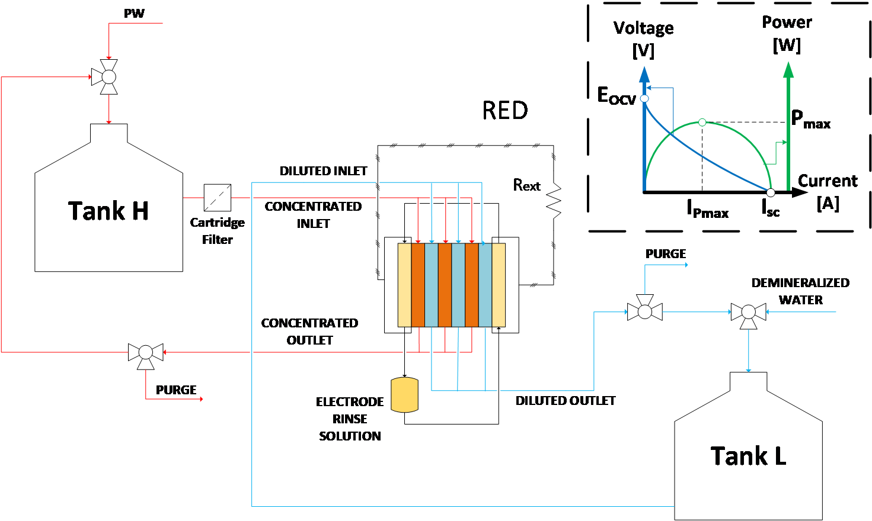 | Features  Membrane Fujifilm Type10  $$N_{cp}$$ no. cell pair 10  $$A_{m}$$ active membrane area 100 cm²  $$δ_{sp}$$ spacers width 300 µm  $$v_{H, }v_{L}$$ feed velocity 0.5 cm/s  $$σ_{Hin}$$ concentrated initial conductivity 104.4 mS/cm  $$σ_{Lin}$$ diluted initial conductivity 1.49 mS/cm  $$R_{load}$$ external load 6.8 Ω
Figure 1. Block flow diagram of the experimental set-up. | Table 1. Reverse Electrodialysis data.
The experimental test lasted 15 days during which solution conductivities, pressure drops, voltage and current were recorded. The characteristic quantities as power density [3] and specific energy provided by RED can be calculated as shown by equations (1), (2) and (3):
Gross power density | $$P_{d}=\frac{E_{stack}∙I_{stack}}{N_{cp}∙A_{m}}$$ | (1) |  | Specific Energy | $$E_{sp}=\frac{1}{H_{treated}}\int_{t=0}^{t}{E_{stack}∙I_{stack}}dt$$ | (2)
Net power density | $$P_{d,net}=P_{d}-P_{d,loss}=P_{d}-\frac{H∙∆P_{H}-L∙∆P_{L}}{N_{cp}∙A_{m}}$$ |  |  |  |  | (3)
where $E_{stack}$and $I_{stack}$ are the voltage and current experimentally measured in the stack, $H$ and $L$ are the volumetric flow rate of concentrated and diluted solutions, $∆P$ is the pressure drop inside the unit channels and $H_{treated}$ is the total volume of PW treated during the entire duration ($t$) of the test. During the test, in order to counteract the effects of fouling, a maintenance operation was carried out, consisting of a physical and a chemical wash of the unit. In fact, the physical wash is expected to remove the particles that could obstruct the unit channels, meanwhile a treatment with acid and alkaline (pH 3 and pH 11 respectively) solutions can act on scaling or on a deeper fouling as the biofouling.
3. Results and discussion
During the first 3 days, a transitory is observed, due to the dilution of the PW from 104.4 to 74.4 mS/cm and to the conditioning of the membranes to the feed conditions. As shown in figure 2, taking off the first 3 days, the gross power density is mostly constant for the entire test, presenting a pick of about 1.02 W/m². Fouling phenomena occurred during the test, caused an increase of the pressure drops inside the RED unit, for this reason the net power density decreased with time. After the 15th day, the test was interrupted because the net power density became negative and no more energy would have been produced. The main fouling phenomenon observed was a physical clogging of the channel unit probably caused by the bacteria colonies growth inside the manifold.
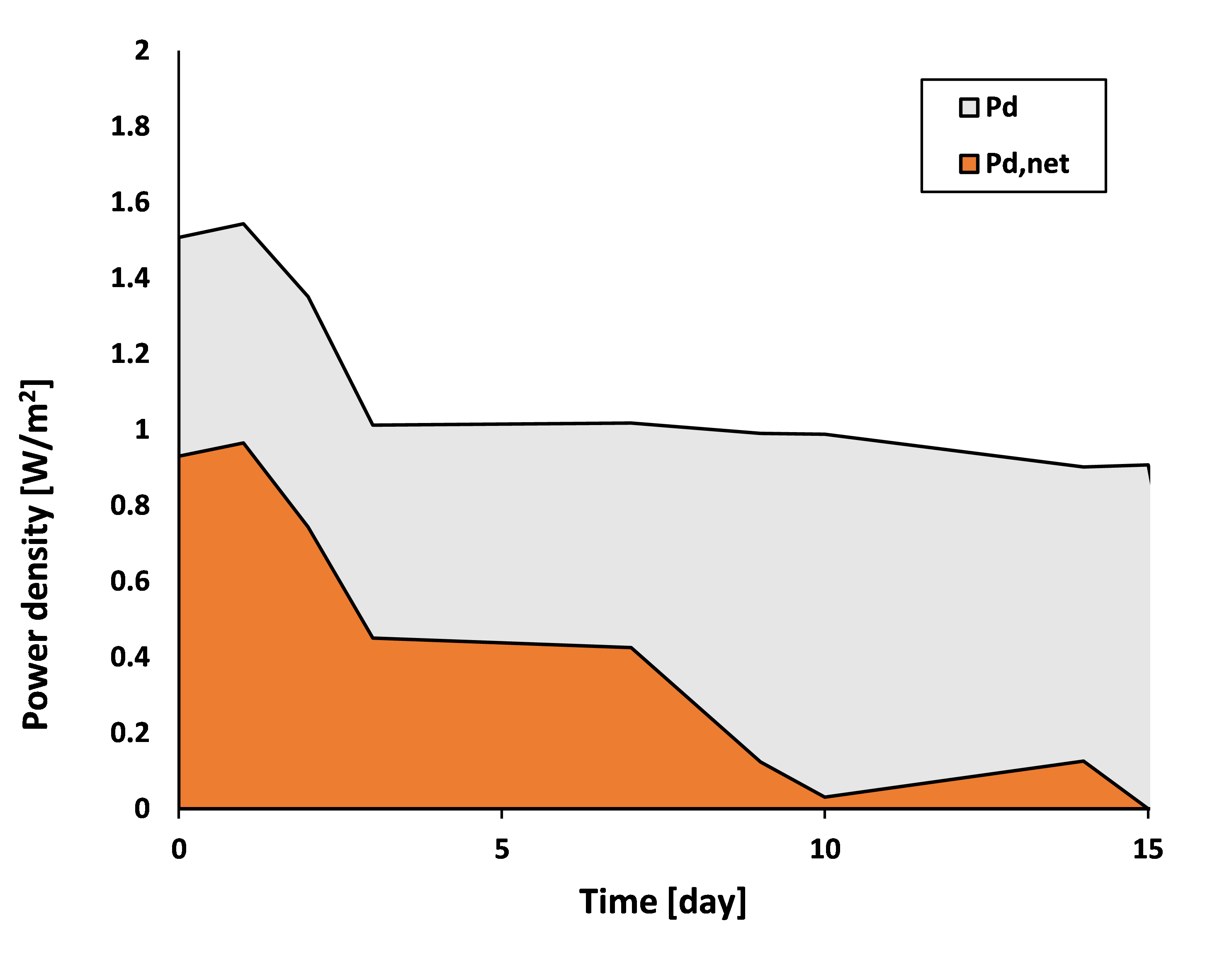 | 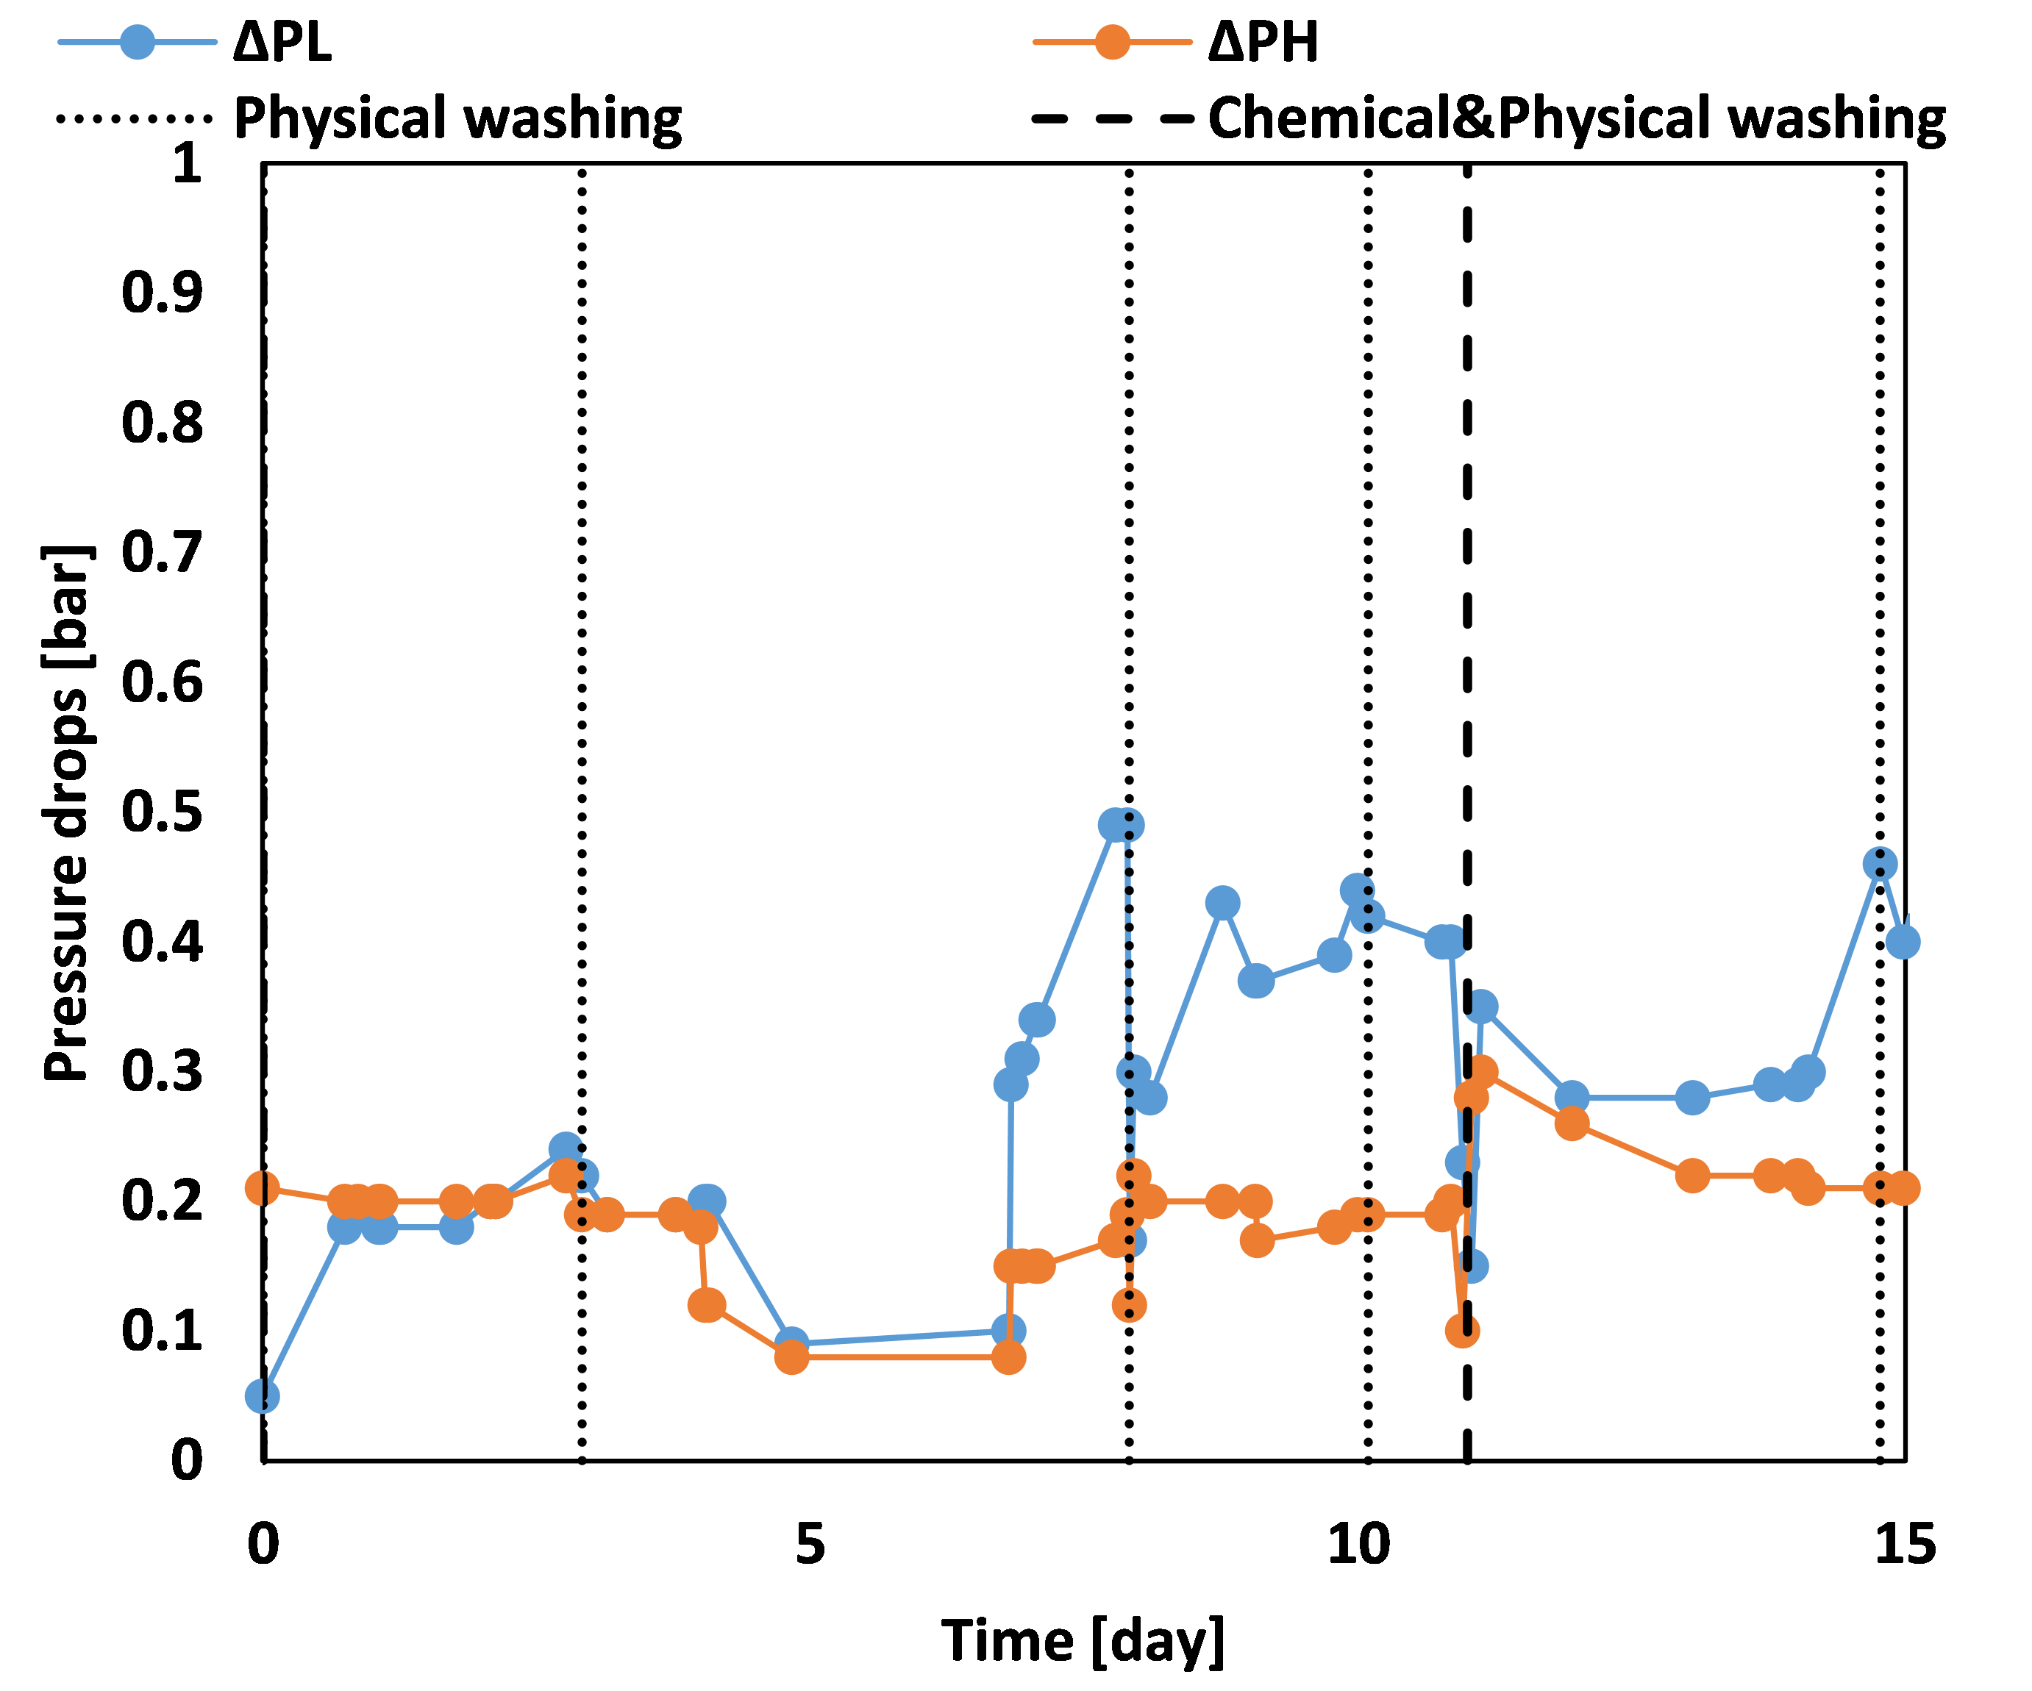
Figure 2. Power gross density (grey) and net power density (orange) trend during the test. | Figure 3. Pressure drops trend of diluted (L) and concentrated (H) compartments.
The area under the curve of figure 2 represents the energy generated by the stack during the entire test. A specific energy (2) of 0.36 kWh/m³ was generated during the test, although the net specific energy (i.e. subtracting the pump energy requirement) is about 0.11 kWh/m³.
The vertical dashed lines in the graphs of figure 3 indicate the moments when physical and chemical washings were performed. As it is possible to observe in the figure, the washings reduced the pressure drops and, once optimized, might have a positive effect on the system, allowing to increase the test duration.
4. Conclusions
PWs are an enormous problem in oil industry, but they might represent a resource for power production thanks to the RED technology. The preliminary results collected suggest that there is room for improvements and that suitable antifouling strategies should be set-up in order to allow a long operation at industrial scale.
References
- Y. Liua, Hao Lu, Yudong Li, Hong Xu, Zhicheng Pan, Pinyi Dai, Hualin Wang, Qiang Yang, “A review of treatment technologies for produced water in offshore oil and gas fields” Science of the Total Environment, 775 (2021) 145485
- J. Veerman, D.A. Vermaas, “Reverse electrodialysis: Fundamentals” in Sustainable Energy from Salinity Gradients; A. Cipollina.; G. Micale, Eds.; Woodhead Publishing, (2016) 77-134.

