Nanostructured nickel–zinc alloy electrodes for hydrogen evolution reaction in alkaline electrolyzer.

Sonia Carbone ^{1*}, Francesco Bonafede^{1,2}, Fabrizio Ganci¹, Bernardo Patella¹, Giuseppe Aiello¹, Rosalinda Inguanta¹
1 Applied Physical Chemistry Laboratory, Department of Engineering, Università degli Studi di Palermo, Viale delle Scienze, 90128 Palermo, Italy
2 Department of Civil Engineering and Architecture, University of Catania, 95123 Catania, Italy
*Corresponding author E-Mail: sonia.carbone@unipa.it

1.Introduction
Over the last decade, the interest towards green hydrogen has drastically increased due to need for the global decarbonization of energy processes. Green hydrogen is obtained by water electrolysis using the electricity obtained only from renewable sources [1]. It is considered one of the best vector energy in terms of environmental sustainability but it is not yet cost-competitive [2]. Nowadays, the research is focused on improving the Alkaline Water Electrolysis (AE) to reduce the cost of hydrogen produced. In this frame, the development of more efficient electrolyzers with low-cost electrode-electrocatalyst materials can play a key role [3]. The eligible materials must have some fundamental characteristics, such as good electrocatalytic properties, high conductivity, high availability, low cost, and good chemical stability. In alkaline environment, transition metals, in particular the iron group elements, are the most suitable electrocatalyst for hydrogen evolution reaction (HER) [4]. In this work, we have studied the electrochemical fabrication of electrodes of nickel-zinc alloys with nanowires morphology to use for the hydrogen evolution reaction in alkaline solution and at room temperature.
2. Methods
Ni-Zn nanowires (NWs) electrodes were obtained by template electrosynthesis by means of polycarbonate nanoporous membranes. The NWs were obtained by potential-controlled pulse electrochemical deposition in a solution containing ammonium chloride, sodium acetate, boric acid and different concentration of nickel sulphate hexahydrate and zinc sulphate heptahydrate at pH 5. After NWs deposition, the polycarbonate membrane was etched in chloroform. The performances of the obtained electrodes were evaluated through electrochemical and electrocatalytic tests that were performed in KOH 30% w/w aqueous solution. The tests were performed in a three electrodes cell using as counter electrode a Ni sheet and Hg/HgO as reference electrode. The electrochemical characterization was performed at room temperature and without agitation. The electrodes have been studied morphologically and chemically through scanning electrode microscopy (SEM), Xray diffraction (XRD), and energy dispersive spectroscopy (EDS ). Fabrication methods and characterization are detailed in [5].
3. Results and discussion
NiZn alloys with different composition were obtained by changing the Zn/Ni ratio of the electrodeposition bath. The Zn atomic composition in NWs almost follows the Zn composition in the electrodeposition bath. Morphology of the electrodes consists in ordered arrays of nanowires well anchored to the Ni current collector also obtained by electrodeposition (Figure 1). The electrochemical and electrocatalytic behavior was evaluated by cyclic voltammetry (CV), quasi steady-state polarization (QSSP), galvanostatic-step polarization (GS) and galvanostatic polarization to evaluate the mid-term behavior of nanostructured electrodes. All electrochemical tests show that nanowires with about 44.4% (obtained from an electrodeposition bath containing 50% of the two elements) of zinc have the best performances. Particularly, an overpotential (η10) of -0.251 mV was measured while the Tafel's slope is -99 mV/ dec, suggesting that the hydrogen evolution reaction is controlled by the Volmer step. This overpotential value is lower than pure Ni nanowire. NiZn nanowires show also a good stability over time because are able to work at a constant current of -10 mAcm⁻² for 18 h without noticeable signs of performance decay.

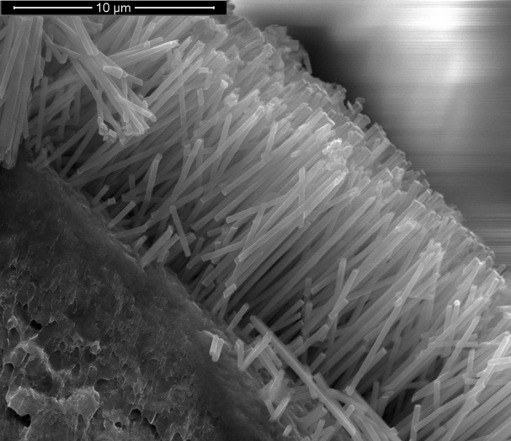
Figure 1. SEM images of NiZn nanostructured electrode
4. Conclusions
Template electrosynthesis method was employed for the fabrication of nanostructured NiZn alloys. Electrodes were obtained by pulsed electrochemical deposition and consists of regular arrays of nanowires uniformly distributed on Ni current collector. The alloys composition was controlled by tuning the concentration of Ni and Zn in the electrodeposition bath. The nanostructured NiZn alloy electrodes were tested as cathodes for alkaline electrolyzers in 30% w/w KOH aqueous solution at room temperature. All obtained alloys have good electrocatalytic performance compared to electrodes of pure Ni even if the most promising electrodes are those obtained from electrodeposition bath containing an almost similar concentration of Ni and Zn. In particular, the electrodes containing 44.4% of Zn showed the best performance for HER.
References
[1] B. Ceran, Multi-Criteria Comparative Analysis of Clean Hydrogen Production Scenarios, ENERGIES. 13 (2020). https://doi.org/10.3390/en13164180.
[2] J.L.L.C.C. Janssen, M. Weeda, R.J. Detz, B. van der Zwaan, Country-specific cost projections for renewable hydrogen production through off-grid electricity systems, Appl. Energy. 309 (2022). https://doi.org/10.1016/j.apenergy.2021.118398.
[3] Y. Chen, G. Zhao, W. Sun, Strategies of engineering 2D nanomaterial-based electrocatalysts toward hydrogen evolution reaction, Mater. Renew. Sustain. Energy. 9 (2020). https://doi.org/10.1007/s40243-020-00170-w.
[4] Q. Hu, G. Li, Z. Han, Z. Wang, X. Huang, H. Yang, Q. Zhang, J. Liu, C. He, Recent progress in the hybrids of transition metals/carbon for electrochemical water splitting, J. Mater. Chem. A. 7 (2019) 14380–14390. https://doi.org/10.1039/c9ta04163j.
[5] F. Ganci, B. Patella, E. Cannata, V. Cusumano, G. Aiello, C. Sunseri, P. Mandin, R. Inguanta, Ni alloy nanowires as high efficiency electrode materials for alkaline electrolysers, Int. J. Hydrog. Energy. 46 (2021) 35777–35789. https://doi.org/10.1016/j.ijhydene.2020.11.208.

