Scale-up of electrodialysis with bipolar membrane (EDBM) unit for valorisation of waste brine by experimental analysis
Calogero Cassaro, Andrea Culcasi, Andrea Cipollina*, Alessandro Tamburini, Giorgio Micale
Dipartimento di Ingegneria, Università degli Studi di Palermo - viale delle Scienze Ed.6, 90128 Palermo, Italy;
*Corresponding author E-Mail: andrea.cipollina@unipa.it
1.Introduction
The valorisation of brines, of both natural and industrial origin, represents one of the most important challenges of modern society. Another equally desirable aspect concerns achieving a circular economy within various industrial processes to make the process itself more sustainable, from an economic and environmental point of view. The bipolar membrane electrodialysis (EDBM) process is particularly suited to achieving these goals [1]. It is an electro-membrane process that can valorize waste brines and produce acid and alkaline solutions, which can be recirculated inside the equipment located upstream/downstream. The bipolar membranes, which allow the dissociation of water into H⁺ and OH⁻ ions, play a critical role. These ions, in turn, combine with those of the salt present in the waste brine, resulting in high value-added chemicals. The enormous potential inherent in this technology has piqued the European Community's interest. The European project H2020 WATER-MINING, in particular, has integrated this technology into a pilot-scale demonstrative treatment chain. The goal of using the EDBM is to produce chemicals in-situ, allowing for resource circularity and, ultimately, waste minimization. This work aims to design of an EDBM stack at the pilot scale exploiting the data collected by a laboratory-scale unit, with operating conditions similar to those of an industrial context.
2. Methods
The experiments were conducted using a Fumatech® laboratory unit equipped with FAB®, FKB®, and FBM® membranes, as well as PVC/ECTFE spacers. Five repeating units were used to assemble the stack. The experiments were carried out in closed-loop mode (i.e., with recirculation) to achieve a target concentration of 1M NaOH in the base compartment. The saline compartment was initially filled with 1.5M or 2M NaCl solutions, while the acid and base compartments were filled with 0.05M HCl and NaOH, respectively. The experiments were carried out galvanostatically with current densities ranging between 100 and 300 Am⁻². The identification of the best operating condition for the laboratory-scale stack allowed the calculation of parameters independent of the membrane surface. These parameters, along with the design constraints, were then inserted into a mathematical algorithm that provided the design of the equipment at the pilot scale.
3. Results and discussion
The results show that the tests at 200 A m⁻² and a salt input concentration of 2M are the best compromises between NaOH Specific Energy Consumption (SEC) and current efficiency. Indeed, this operating condition has a current efficiency of 79.9 percent, similar to the 80.8 percent obtained in the tests at 300 A m⁻². Excellent results were also achieved in terms of the relationship between real time and theoretical test time. This in fact, at 200 A m⁻², turns out to be equal to 1.25 which is close to the 1.2 obtained at 300 A m⁻². However, the specific consumption at 200 A m⁻² is equal to 1.27 kWh kg⁻¹_{NaOH}, which is comparable to the SEC obtained at 100 A m⁻². Furthermore, using a salt input concentration of 2M allows for the achievement of and exceeding the NaOH target.
The developed mathematical algorithm enabled the design of the EDBM pilot plant to be identified. The results show that a total membrane area of 6.71 m² is required to produce 500 moles of NaOH (corresponding to a solution of 500 liters and a NaOH concentration of 1M) over a 5h process time.
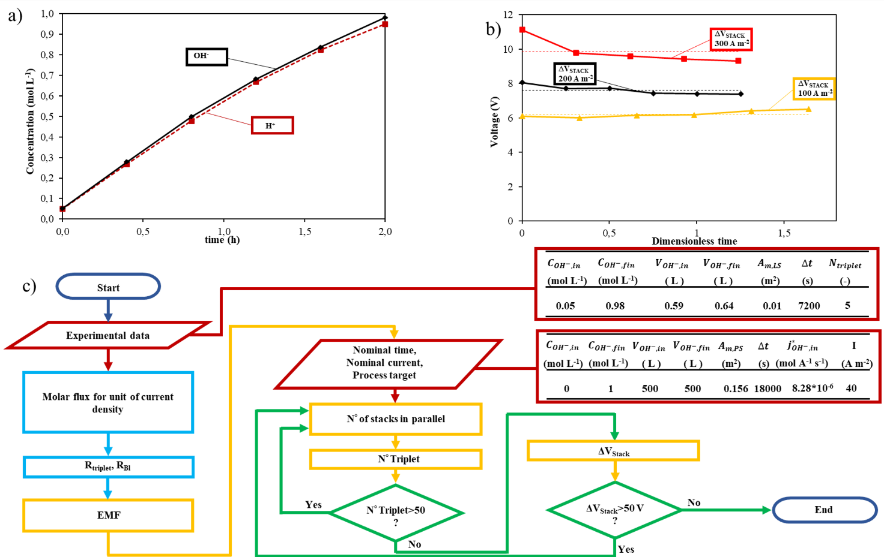
Figure 1. Illustration of the main results achieved. a) H + and OH- concentration profiles, b) voltage of the stack at three different applied current densities , c) Flowchart of the mathematical tool used for the design of the pilot plant .
4. Conclusions
This study investigated an EDBM unit on a laboratory scale, providing important insights into the best trade-off of process conditions in terms of current density and solution composition. Finally, this work resulted in the design of a pilot-scale EDBM stack that will be built and installed as part of a waste brine treatment chain, which is one of the main goals of EU project WaterMining. These studies may enable this system to progress from a Technology Readiness Level (TRL) of 4 to 7, laying the groundwork for future industrialization.
5. Acknowledgement
This project has received funding from the European Union’s Horizon 2020 research and innovation program under Grant Agreement no. 869474 (WATER-MINING – Next generation water-smart management systems: large scale demonstrations for a circular economy and society). www.watermining.eu.
References
[1] L. Gurreri, A. Tamburini, A. Cipollina, and G. Micale, “Electrodialysis applications in wastewater treatment for environmental protection and resources recovery: A systematic review on progress and perspectives,” Membranes, vol. 10, no. 7. 2020. doi: 10.3390/membranes10070146.

