Basing offshore energy vectors production on optimized energy mixes: a methanol facility in the Adriatic Sea
Mariasole Cipolletta*, Valeria Casson Moreno, Valerio Cozzani
Laboratory of Industrial Safety and Environmental Sustainability – DICAM
University of Bologna, Via Terracini 28, Bologna, 40131, Italy
* mariasole.cipolletta@unibo.it
1. Introduction
When the extraction from end-of-life wells is claimed to be no more economically viable, reservoirs still have high amounts of potentially exploitable fossil fuels [1]. These residual resources may be valorized if combined with offshore energy generation, where near-to-decommissioning platforms can be converted into stations for energy collection, transmission and storage, once the structure’s integrity is ascertained [2]. Power to X (PtX) strategies enable to convert Renewable Energy (RE) into liquid or gaseous chemical vectors that can be transported anywhere easily by conventional means, overcoming the issues of either lack of electricity infrastructure or grid saturation [3]. This solution is particularly interesting in the framework of energy transition to boost Blue Economy and exploit the offshore potential of multiple Renewable Energy Sources (RESs) [4].
This contribution introduces a methodology for the valorization of multiple RESs in a selected site. The outcome is the design of an integrated energy system based on offshore RESs that can provide the required energy to an offshore facility producing a targeted energy vector. The proposed method has two main aims: i) identifying the more sustainable energy mix in any location where a RES exploitation opportunity is present; ii) optimally designing the hybrid power system so that it can independently support a facility producing an energy carrier of interest. The method is demonstrated by its application to an offshore platform in Northern Adriatic Sea where residual natural gas (NG) and oxygen in air are the in-loco substrates used for methanol production via methane partial oxidation [5].
2. Methods
The methodology starts with the selection of a site where the exploitation potential of multiple RESs is attractive. A set of factors that represent constraints for the application of the methodology are then checked, i.e. surface limitations and regulations in force for the installation of renewable systems. Then, the available energy from each RES is estimated in order to evaluate the site energetic potential. The estimation of the available power starts from real site data retrieved on a reference period on a hourly basis, specifically for each source [6]. Then, the selection of the Renewable Energy Conversion Technologies (RECT) is carried out on the basis of RESs potentials on the site. Per each RES, a first screening step is performed to exclude the converters that do not suit the location features in terms of observed RES parameters, site characteristics and installation requirements. The operation performance of remaining RECTs is simulated in the reference period. Each power output profile is studied through power classes in order to identify the optimal RECT for each source. Subsequently, several energy mixes are considered by varying properly the number of RECTs applied to each RES. In parallel, a set of power duties likely to be coupled with the energy mixes are also defined. Finally, the optimal coupling “energy mix – duty” is found as the one assuring the higher number of energy-independent hours with respect to the minimal relative increase of nominal potentiality of the integrated system. The resulting conservative steady power provision that is assured by the system is set as the total energy supply available for methanol production, based on the most appropriate production process. The plant potential is thus derived using an iterative scale-up procedure. The facility technical, safety and environmental performances are then assessed by specific key performance indicators (KPIs).
3. Results and discussion
The site considered for a case-study with the aim of demonstrating the method is the offshore Garibaldi C platform in the Northern Adriatic Sea, close to decommissioning [7]. After data retrieval, RESs potential are evaluated for year 2017: yearly averages obtained are 1 kW/m for waves, 189 W/m² for solar power, 114 W/m² for wind energy.
Based on the low marine potential, wave energy converters are excluded from the project. RECTs screening and simulation provide an average-performance PV panel [8] and a 1.5 MW horizontal-axis wind turbine [9] to properly exploit solar irradiation and wind speeds. The optimal combination “energy mix – duty” results in an integrated renewable energy plant of 1.68 MW nominal capacity (780 m² of PV panels, 1 wind turbine) coupled to a fixed duty of 150 kW insured for the 50% of time by RES. The final methanol facility (in Figure 1) is thus designed in order to steadily operate with 150 kW supply.
Section 1 aims at NG dewatering, section 2 consists of an air separation unit and the related oxygen compression train. In section 3, the reactants are heated before entering the methane partial oxidation reactor, which operates at 50 bar and 450 °C [10]. The reacted gases are separated in section 4 where fuel grade purity methanol is obtained. In section 5, recovery, compression and storage of propane-rich gaseous streams is carried out. These can be directed to a flexible turbine operating as a back-up system. The iterative sizing leads to a methanol productivity of 285 t/y, with a steady propane accumulation from purge gases of 97.5 kg/h, sufficient to satisfy the power demand by the back-up turbine in the time periods when RES generation is lower than 150 kW. The designed methanol plant fully relies on the electric power obtained by the in situ RE exploited.
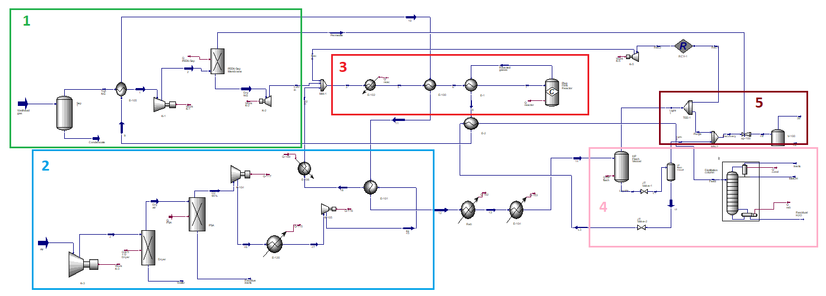
Figure 1. Process scheme of the methanol facility.
4. Conclusions
A methodology for the valorisation of integrated multiple offshore RESs through the coupling with Power-to-X processes is presented and is applied to a case-study. Methanol production on an offshore platform in the Adriatic Sea is considered. The methodology allowed the definition of the optimal design for both the RE exploitation systems and the methanol facility. The energy requirements of the methanol production process are totally satisfied by the RE exploitation system. The results also allow carrying out the assessment of the broad sustainability of the project.
References
- J. Chécko, T. Urych, M. Magdziarczyk, A. Smolínski, Energies 13 (2020), 1–20
- S. R. Kolian, M. Godec, P. W. Sammarco, Ocean. Coast. Manag. 167 (2019), 52–59
- A. Buttler, H. Spliethoff, Renew. Sustain. Energy Rev. 82 (2018), 2440–2454
- V. Aryai, R. Abbassi, N. Abdussamie, F. Salehi, V. Garaniya, M. Asadnia, Process Saf. Environ. Prot. 148 (2021), 437–461
- G. A. Olah, A. Goeppert, G. K. S. Prakash, Beyond Oil and Gas: the Methanol Economy, third ed., Wiley-VCH, 2018
- E. Dallavalle, M. Cipolletta, V. Casson Moreno, V. Cozzani, B. Zanuttigh, Renew. Energy 174 (2021), 426–443
- Ministero dello Sviluppo Economico, 2020
- SUNPOWER, Datasheet MAXEON 3 - 400 W (2020)
- GOLDWIND, 1.5 MW PMDD wind turbine - Technical report (2020)
- P. S. Yarlagadda, L. A. Morton, N. R. Hunter, H. D. Gesser, Ind. Eng. Chem. Res. 27 (1988) 252-256

