Catalysis by Confinement: an application to Diels-Alder reactions
within voids of molecular dimensions
Gabriele Contaldo¹, Zhao-Bin Ding², Matteo Maestri¹*
1 Politecnico di Milano, Milano, Italy; 2 Sun Yat-Sen University, Zhuhai, China
*matteo.maestri@polimi.it

1.Introduction
Zeotypes are effective catalysts for many chemical reactions. These structures are characterized by voids of molecular dimensions. Recent studies have shown that the catalytic consequences of confinement define reactivity and selectivity differently, depending on the reaction temperatures. Such effects of confinement are noteworthy at low temperature range and for low enthalpic barrier reactions and have been experimentally proven for the oxidation of NO in mesoporous silicas and pure silicious frameworks (SIL, CHA, BEA) [1]. The main cause of this enhanced reactivity is identified as the trade-off between the enthalpic stabilization, provided by the van der Waals (vdW) interactions between the molecules and the confining walls, and the entropic penalties inferred by a loss of mobility upon confinement. In particular, the enthalpic effects predominate over the concomitant entropy losses at low temperature, hence lowering the confined Gibbs free energy with respect to the homogeneous route. Furthermore, these interpretations are consistent with the theoretical treatments which predict no detectable enhancement when the vdW interactions are excluded [2]. Such catalysis by confinement is expected to be the real consequence for the Diels-Alder cyclization of buta-1,3-diene to 4-vinyl-cylohexene [3]. Hence, we explain the experimentally observed rate enhancement on the basis of transition state enthalpic stabilization brought forth by dispersive forces.

2. Methods
Density Functional Theory (DFT) calculations that include dispersive forces (Grimme D2) were performed by adopting a generalized gradient approximation for the exchange functional proposed by Perdew, Burke and Ernzerhof (PBE), plane-waves basis-set and ultrasoft pseudo-potentials using the QuantumEspresso package. Brillouin zone samplings were restricted to the Γ-point. The transition states and the minimum energy paths were identified using the climbing image nudge elastic band methodology (CI-NEB). Statistical thermodynamic formalisms were adopted for the description of the entropy, enthalpy and Gibbs free energy for reactants, products and transition states, by accounting for the translational, rotational and vibrational contributions. Vibrational frequency calculations were performed by using a finite-difference approximation of the Hessian matrix implemented in Atomic Simulation Environment (ASE). Molecules in gas phase are assumed ideal.
3. Results and discussion
Here we performed a detailed study of the confinement effects induced by the narrow pore dimensions of chabazite (CHA), zsm-12 (MTW) and beta (BEA) zeolites for a set of three Diels-Alder reactions. In particular, the first reaction analyzed involves (1) the cycloaddition of ethylene and butadiene to cyclohexene, while the second and the third ones are two isomeric forms of the cyclodimerization of butadiene to (2) cis-4-vinyl-cyclohexene (VCH) and (3) trans-VCH. The analysis conducted in all the frameworks show larger rates when temperature decreases, as reported in Figure 1 for the showcase reactions (1) and (3), demonstrating how enthalpic stabilization more than prevails over the concomitant entropy losses in this range. Indeed, entropic penalties of confinement become more relevant when temperature increases. DFT-derived rates under confinement are up to 10⁸ times larger than the homogeneous routes, as a consequence of differences between the energy of the confined transition states and the correspondent value in gas phase. In particular, reaction (1) is found to be more strongly stabilized (by 71.4 kJ mol⁻¹) by the smallest zeolite cavity of MTW; reactions (2) and (3), instead, show larger rates because the bigger TS structures are closer to the internal walls of the cavity, thus exhibiting stronger stabilization effects, as observed for CHA (89.7 kJ mol⁻¹ for (2) and 92.6 kJ mol⁻¹ for (3)) and MTW (91.6 kJ mol⁻¹ for (2) and 89.7 kJ mol⁻¹ for (3)). As a result, the size and the shape of the pores play a fundamental role in stabilizing molecules under confinement without affecting the geometrical properties of confined structures with respect to the gas phase counterpart. However, this effect is compensated by repulsive interactions when molecules are too close to the internal surface of the cavities, giving rise to a decrease of the rate enhancement as shown by the confinement within CHA and MTW in Figure 1.b). Finally, these results further confirm how the size of molecules and cavities notably affects the strength of dispersion forces, key contribution in catalysis by confinement for reacting systems under confined spaces.
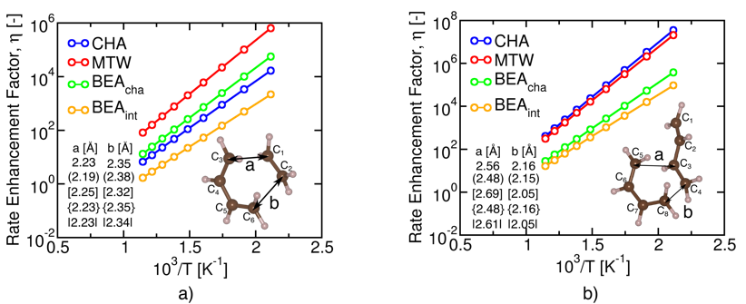
Figure 1. a) Rate Enhancement Factor for reaction (1) and b) Rate Enhancement Factor for reaction (3). Confinement prevails at low T because enthalpic stabilization more than compensates for the entropy losses. () = CHA, [] = MTW, {} = BEA_{cha}, || = BEA_{int}.

4. Conclusions
This work provides fundamental underpinnings on the role of pore dimensions in the stabilization under confined environments. We provide the mechanistic underpinnings for interpreting the rate enhancements for Diels-Alder reactions under confined environments. The results will allow to improve and optimize the catalyst design for industrially relevant catalytic processes by a molecular scale investigation within the framework of multiscale reaction engineering. Computational time at CINECA-Bologna is gratefully acknowledged.
References
- Artioli, N; Lobo, Raul F.; Iglesia, E. J. Phys. Chem. C 2013, 117, 40, 20666-20674
- Maestri, M.; Iglesia, E. PCCP 2018, 20.23, 15725-15735.
- Dessau, R. M. J. Chem. Soc. 1986, 15, 1167-1168

