**Upcycling of PU waste via microwave-assisted chemolysis process**

Riccardo Donadini, Carlo Boaretti, Alessandra Lorenzetti, Michele Modesti*

*Dipartimento di Ingegneria Industriale (DII), Università degli studi di Padova*

*\*Corresponding author e-mail: michele.modesti@unipd.it*

**1.Introduction**

In this work we explored a microwave-assisted (MW) glycolysis process to chemically recycle rigid polyurethane (PUR) foam waste to obtain a single-phase product with suitable physio-chemical properties as secondary raw material for the synthesis of new PUR products. Such approach was compared to a conventionally heated (CH) process, analysing the performances of different catalysts.

In the last years, several emerging techniques have attracted the attention of the research community due to their considerable process intensification potential. Among them, microwaves heating has been established as an efficient strategy for both organic synthesis and extraction processes [1–3]. Through a controlled irradiation, microwaves can indeed be absorbed by suitable substances and readily converted into heat. Such mechanism is capable to produce a volumetric heating effect far more efficient than the surface conduction of traditional heating elements.

Polyurethane is the 6th polymer most used all over the world [4]. Polyurethane demand comes mainly from the construction sector, but its use is also widespread in the automotive, furniture, footwear sector and in the electronic industry. As a direct consequence of the commercial success of polyurethane, a growing amount of waste is being disposed of by landfilling in the last decades. Among possible polyurethane end-of-life scenarios chemical recycling could be the cornerstone for polyurethane recycling [5,6]. All reactions involve the cleavage of the urethane bonds of the polymer. Hydrolysis, aminolysis, phosphorolysis, acidolysis and glycolysis are different routes to recycle polyurethane [7]. Glycolysis is a transesterification reaction between the ester part of the urethane group of the waste polyurethane and the alcoholic groups of a glycol. MDA (methylenedianiline) is the main by-product of this process, and it is produced by hydrolysis, pyrolysis and by glycolysis of ureic groups in the polyurethane network [8]. Humidity present in the polymer foam is responsible for the hydrolysis. Pyrolysis occurs because of the high reaction temperature .

**2. Methods**

*Glycolysis reactions*

Glycolysis tests for the chemical depolymerisation of PUR foams were carried out using two different configurations to provide the heat necessary to sustain the reaction. The first configuration is based on a conventional heat conduction apparatus comprising an isomantle equipped with a flask, a temperature sensor and mechanical stirring. The second configuration is based on a microwave reactor equipped with hermetically sealed PTFE vessels, a magnetic stirring mechanism, and a fibre optic temperature sensor. All experiments were run at 200°C, to balance catalyst activation with minimal side products formation, and atmospheric pressure. According to different preliminary tests, a mass feed ratio (mPU⁄mDEG) equal to 1.5 was employed. Catalysts were tested at 30 and 50 mmol/100gPU concentrations. According to several preliminary experiments, reaction times were set to 4h in the case of conventional heating and 15 min with microwave in order to obtain glycolysis product with comparable properties.

Glycolysis product were characterized in terms of aromatic amine content (HPLC), infrared spectroscopy (FT-IR), dynamic viscosity, hydroxyl value and gel permeation chromatography (GPC).

*Foams*

The polyols mixtures obtained from the glycolysis of PUR wastes were tested to evaluate PUR foam production suitability and subsequently characterized for performance evaluation. Several foams were produced, using different percentages of recycled polyol, and evaluated in comparison to equivalent products obtained from virgin polyols.

Foams were characterized in terms of apparent density, compression resistance, thermal conductivity, and morphology (SEM).

**3. Results and discussion**

*Conventional and microwave-assisted glycolysis*

Viscosity is the main property monitored in order to assess the extent of depolymerization of the waste polyurethane. The amount of MDA is measured to assess the extent of secondary reactions, whereas the hydroxyl value is useful during the subsequent synthesis of new foams. Table 3.1 summarizes experimental data, viscosity, and MDA, categorized by heating method and catalyst concentration.

**Table 3.1:** Properties of CH and MW products. Maximum errors for viscosity measurements is ±80cP, ±0.1%wt for MDA concentrations and ±15 mgKOH/g for hydroxyl values.

|  |  |  |  |  |  |  |  |
| --- | --- | --- | --- | --- | --- | --- | --- |
|  | Heating | CH | | | MW | | |
| Cat | **ccat, [mmol/100gPU]** | **μ, [mPa·s]** | **MDA, [%wt]** | **HV, [mgKOH/g]** | **μ, [mPa·s]** | **MDA, [%wt]** | **HV, [mgKOH/g]** |
| KOAc | 30 | 2346 | 1.65 | 505 | 1840 | 2.27 | 497 |
| 50 | 2201 | 2.48 | 538 | 762 | 4.92 | 517 |
| Sn(Oct)2 | 30 | 2541 | 1.33 | 540 | 2263 | 2.08 | 532 |
| 50 | 2299 | 1.86 | 550 | 1154 | 3.22 | 549 |
| MEA | 30 | 8570 | 1.03 | 482 | N.A. | 0.19 | 512 |
| 50 | 7025 | 0.38 | 475 | 11844 | 0.30 | 528 |

According to Table 3.1, the viscosity of the glycolyzate is highly influenced by both the type of catalyst and its concentration; the same can be said for the aromatic amine content. These two outputs are inversely related as the lower the viscosity, the higher the degree of depolymerization, and therefore the higher the amount of by-products formed at constant reaction time. On the one hand, a lower viscosity is desirable, as too viscous liquids are not easily handled in production facilities. Furthermore, the higher the viscosity of the glycolyzate, the higher the energy expenditure of the pump in the industrial foam production plant. On the other hand, MDA amount must be kept as low as possible; however, its abatement will be treated in another work.

From the catalyst point of view, it is clear that the higher the concentration of MDA, the lower the viscosity. However, the observed differences are notable in the use of monoethanolamine; it is the least active catalyst tested, producing high viscosities although having very low MDA concentrations. This evidence is confirmed and cleared when examining MW glycolysis results. In the case of 30 mmol/100gPU it was not possible to measure the viscosity as the polyurethane was not completely dissolved and reacted.

In both the case of potassium acetate and stannous octoate, glycolyses proceeded quickly: microwaves drastically improved the recycling process since 15 minutes of microwave irradiation led to lower viscosities and higher MDA concentration than 240 minutes through conventional heating. This result is very interesting, since the reduction in reaction time is of 94%. The higher MDA concentration found in MW glycolyses can be explained by considering two facts. First, MW glycolyzates have viscosities lower than those of their CH counterparts, which means that less than 15 minutes is required to reach the same viscosity obtained through CH. Second, metal salts such as KOAc and Sn(Oct)2 coupled with DEG provoke highly efficient dielectric heating and ionic polarization, providing the suitable conditions to let depolymerization reactions undergo. Furthermore, stannous octoate and potassium acetate are equally capable of promoting transesterification as obtained viscosities are comparable, however, the latter allows hydrolysis and pyrolysis to occur more than the former. As a result, with Sn(Oct)2, a lower concentration of MDA is achieved together with a comparable viscosity with the KOAc-catalysed product.

In addition to these considerations, in Figure 3.1 the characteristic peaks of the urethane structure can be monitored; optical path is constant when working with ATR. Peaks at 1515 cm-1 (C-C carbon in the aromatic ring) and 1130 cm-1 (C-O ether stretching) are used as reference peak to study relative variations of other significant peaks. Lower transmittances of peaks at 1720 cm-1 (C=O carbonyl stretching of the urethane), 1540 cm-1 (N-H amide stretching of the urethane), and 1230 cm-1 (C-O carbonyl stretching of the urethane) indicate that the polymer structure is less degraded than in the other two cases. Shoulder-type peaks can be noticed at 1630 cm-1: those are more marked for KOAc rather than Sn(Oct)2 and MEA, testifying the presence of a higher concentration of free amino groups.

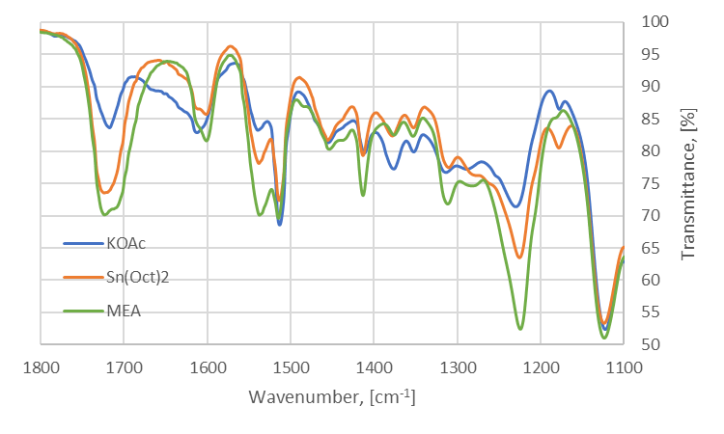

**Figure 3.1:** Infrared spectra of CH glycolyzates, catalyst concentration is $30mmol/{100g}_{PU}$. Same trends were obtained with $50mmol/{100g}_{PU}$.

The energy expenditure, EE, is calculated as the ratio between energy delivered to the system and total mass heated. In CH glycolysis, the power delivered by the isomantle is constant and 1400W as it has an on-off controller, the energy supplied is therefore the product of power and exposure time, $t_{h}$, the time the heating resistance is switched on. This is approximately 3h, considering both heating (one hour) and the reaction phase (two out of four hours). The hot plate has an on-off controller as the power cannot be controlled. Conversely, the energy given to the system in MW glycolysis is calculated as an integral of the power profile or as average power, $P_{av}$, multiplied by exposure time, therefore:

$${EE}_{CH}=\frac{P_{max}∙t_{h}}{m_{tot}}=\frac{1.4kW∙3h}{0.35kg}=12 kWh/kg$$

$${EE}_{MW}=\frac{\int_{0}^{t_{h}}{Pdt}}{m_{tot}}=\frac{P_{av}∙t_{h}}{m_{tot}}=\frac{0.3kW∙0.25h}{0.035kg}=2.1 kWh/kg$$

The energy expenditure for the CH glycolysis is almost six times that necessary for the MW glycolysis, with an energy savings of 82%.

In conclusion, products obtained with potassium acetate and stannous octoate show a best performance from the glycolyzate point of view. 30 mmol/100gPU as catalyst concentration is sufficient to reach an acceptable viscosity (i.e. degree of depolymerization) keeping as low as possible by-product concentration. Stannous octoate displayed a higher selectivity with respect to potassium acetate as it allows for comparable viscosity but lower MDA content. In the case of monoethanolamine, conventional heating and 50 mmol/100gPU as concentration are necessary to obtain a suitable product.

*Synthesis and characterization of foams*

Once it was proved that the CH and MW product are comparable, new foams were synthesized starting from MW products. New PUR foams were produced with an increasing percentage of glycolyzate as a substitute for virgin polyol, at 0, 15, 30, and 45% with respect to the total amount of polyol.

Figures 3.2-4 show the results related to the new foam synthesis in terms of average cell diameter, and compressive strength, for foams obtained with 30 mmol/100gPU KOAc-catalysed glycolyzate.

Substitution of part of virgin polyol with recycled material allows for better thermal and mechanical performances with respect to a reference foam. The percentage of substitution reaches 30% without having a property decay. As can be seen in Figures 3.2 and 3.3, higher compression strength results from a smaller cell diameter. Aromatic rings already contained in the glycolysis polyol increase the compatibility with the isocyanate, leading to a finer cellular morphology. Same considerations can be made in terms of thermal performances, as the lower the average cell diameter, the lower the thermal conductivity (Figure 3.4). However, this was not observed as thermal conductivities are comparable. This may be caused by a higher percentage of open cells. With 45% substitution, a very slight and acceptable decrease (with respect to lower substitution percentages) of the properties is observed; this is due to a trade-off between two factors: glycolysis products contain aromatic rings that increase the miscibility with isocyanate component as well as diethylene glycol which decreases the average functionality of the mixture. At 45% substitution DEG contribution becomes relevant, leading to decrease in the mechanical performances due to lower crosslinking density in the foam. Best foams were obtained with KOAc-catalysed glycolysis product. A higher compression strength can be explained considering that potassium acetate is commonly used as trimerization catalyst. Isocyanurate structures formation promoted by trimerization catalysts leads to higher mechanical performances [9].

Foams obtained with an increasing amount of Sn(Oct)2-catalysed glycolysis product showed no variations in thermal performances and an increased compression strength, up to 25% higher than reference with 45% substitution. However, reactive mixtures were difficult to deal with when stirring, reaction times were drastically shortened due to the fact that stannous octoate is a strong gel catalyst used also during PUR synthesis. When increasing the glycolyzate content, stannous octoate concentration is increased as well: for this reason maximum percentage substitution is limited to 15%. Above 15% foams obtained were dimensionally unstable.

Foams obtained with monoethanolamine showed higher mechanical performances than the reference foam, up to 40% higher with 45% substitution, and no thermal properties variations. Despite this, a brittle and chalky structure was observed. Even with MEA-catalysed products mixing problems were experienced as these have a higher viscosity, therefore the maximum substitution percentage was 15%.

**Figure 3.3:** Compression resistance along with percentage substitution.

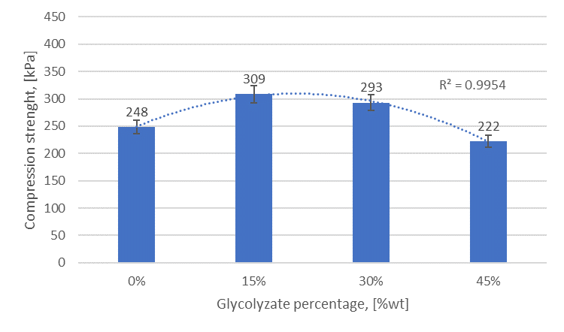

**Figure 3.4:** Thermal conductivity along with percentage substitution.

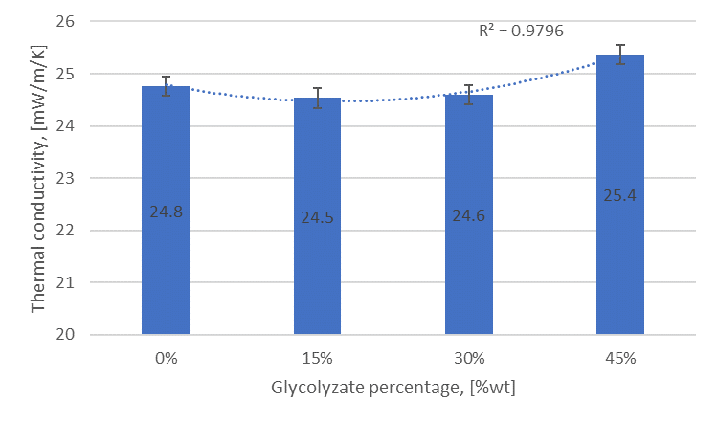

**Figure 3.2:** Average cell diameter of the foam along with substitution percentage.

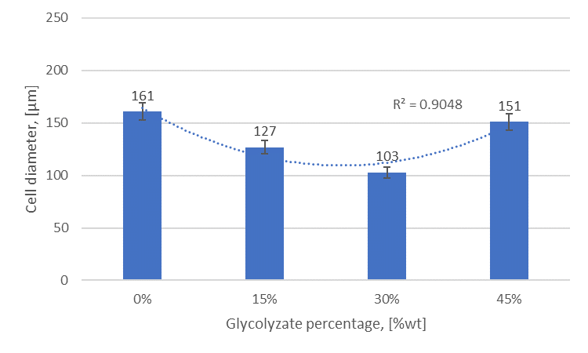

**4. Conclusions**

In this work, we assessed the feasibility of a microwave-assisted glycolysis reaction to recover a polyol-like liquid product from rigid polyurethane waste. Reaction conditions chosen allowed to obtain a single-phase product, which eases its handling with respect to a split-phase process, suitable for rigid foams production. In all trials, except on, microwaves drastically decreased the reaction time to reach a proper viscosity of the product, which decreases of 94% going from 240 minutes, with conventionally heated process to 15 minutes with microwave heating. Among the three catalysts were tested, products obtained with metal-based catalysts provided better properties than those obtained with organic catalysts. A simple energy balance showed microwave-assisted glycolysis is convenient with respect to the conventionally heated process as allowed for an energy saving of 82% (2.1 kWh/kg).

Foams obtained with metal-catalysed products, in particular KOAc, are also the ones that provide the best results. A substitution of virgin polyol up to 30% permits one to slightly reduce the thermal conductivity of the foam, coupled with an increase of roughly 20% of the compression strength. Maximum percentage of substitution with Sn(Oct)2 and MEA-catalysed product is 15% as the mixing process was complicated by high reactivity of the first product and high viscosity of the second one. However, the higher substitution percentage with respect to other works was achieved improving the circularity of the process.

**References**

1. P. Lidström, J. Tierney, B. Wathey, J. Westman, Microwave assisted organic synthesis—a review, Tetrahedron. 57 (2001) 9225–9283. https://doi.org/10.1016/S0040-4020(01)00906-1.
2. C.O. Kappe, Controlled microwave heating in modern organic synthesis, Angew. Chemie - Int. Ed. 43 (2004) 6250–6284. https://doi.org/10.1002/anie.200400655.
3. L. Rinaldi, D. Carnaroglio, L. Rotolo, G. Cravotto, A microwave-based chemical factory in the lab: From milligram to multigram preparations, J. Chem. 2015 (2015). https://doi.org/10.1155/2015/879531.
4. Polyurethane market size, share & trends analysis report by product, by end use, by region and segment forecasts, 2021-2028: https://www.grandviewresearch.com/industry-analysis/polyurethane-pu-market, (2021) 105. Last accessed 11.03.2022.
5. A.J. Martín, C. Mondelli, S.D. Jaydev, J. Pérez-Ramírez, Catalytic processing of plastic waste on the rise, Chem. (2021) 1–47. https://doi.org/10.1016/j.chempr.2020.12.006.
6. S.C. Kosloski-Oh, Z.A. Wood, Y. Manjarrez, J.P. de los Rios, M.E. Fieser, Catalytic methods for chemical recycling or upcycling of commercial polymers, Mater. Horizons. (2021). https://doi.org/10.1039/d0mh01286f.
7. D. Simón, A.M. Borreguero, A. de Lucas, J.F. Rodríguez, Recycling of polyurethanes from laboratory to industry, a journey towards the sustainability, 76 (n.d.) 147–171. https://doi.org/10.1016/j.wasman.2018.03.041.
8. M. Modesti, F. Simioni, R. Munari, N. Baldoin, Recycling of flexible polyurethane foams with a low aromatic amine content, 26 (n.d.) 157–165. https://doi.org/10.1016/1381-5148(95)00031-A.
9. M. Modesti, F. Costantini, E. dal Lago, F. Piovesan, M. Roso, C. Boaretti, A. Lorenzetti, Valuable secondary raw material by chemical recycling of polyisocyanurate foams, Polym. Degrad. Stab. 156 (2018) 151–160. https://doi.org/10.1016/j.polymdegradstab.2018.08.011.