Development of active food packaging with thermal insulating properties

Emanuela Drago*, Roberta Campardelli, Antonio Barbucci, Patrizia Perego
Department of Civil, Chemical and Environmental Engineering (DICCA), University of Genoa, Via all’Opera Pia 15, 16145, Genova (GE), Italy
*Corresponding author E-Mail: emanuela.drago@edu.unige.it

1.Introduction
Packaging plays a fundamental role in the protection of food products, the most well-known functions are: protection, communication, convenience and containment, but for some food products, such as fresh ones, this is not enough. In fact, according to the Food and Agriculture Organization of the United Nations (FAO), every year in the world, about 1/3 of all food produced for human consumption, is lost or wasted. One of the main causes is the loss of quality during distribution and storage which can occur due to sudden changes in temperature that can give rise to chemical, biological and physical degradation. Respect for the cold chain is a crucial aspect to guarantee the safety and quality of fresh food [1]. Traditional materials used in the packaging sector (e.g., plastic, cardboard, etc.) often have limited thermal insulation and poor thermal buffering capacity. Furthermore, the environmental impact deriving from the accumulation of non-degradable plastics, to which the packaging sector contributes greatly, is today an alarming problem to be taken into account globally. In this context, two new concepts have contributed, in recent years, to achievement of an advanced idea of packaging for safer and healthier foods: active and intelligent packaging [2], designed no longer as passive barriers but rather to interact with products. Among the active packaging, the most investigated are the migratory ones with antimicrobial and antioxidant action [3 - 5]. However, the innovative idea of this work is to use the active packaging concept to control temperature fluctuations of packaged foods. One way to attribute an insulating action to packaging is to use phase change materials (PCMs), substances that undergo a phase transition at a certain temperature, absorbing or releasing latent heat, i.e., paraffins, fatty acids and hydrated salts. To date, these interesting materials are widely used in the construction and textile fields, while in the food sector their use is limited to the development of insulated boxes and refrigerated equipment with only commercial paraffin mixtures [6]. Instead, very few information exists on incorporating PCMs directly into polymeric packaging materials [7]. Therefore, the main challenge and aim of this work was to use biodegradable and natural materials to develop an innovative active packaging with thermal insulating properties obtained through the direct loading of ecofriendly fatty acids (linoleic acid and oleic acid) into biopolymer matrices consisting of polycaprolactone (PCL) by means of the electrospinning process [8].
2. Methods
The first step of the work was dedicated to identifying the best solvent for the dissolution of PCL among those accepted as GRAS (Generally Recognized as Safe), thus excluding chloroform, the most used with PCL, and testing acetone, acetic acid and their mixtures. The work then focused on the electrospinning technique to obtain a fibrous material. In particular, the solution parameters (i.e., PCL molecular weight, polymer concentration) and process parameters (i.e., voltage, feed flow rate, needle-collector distance) were evaluated and optimized through a morphological investigation by means of SEM analysis. Once the fiber morphology was optimized, the selected PCMs (linoleic acid, oleic acid and dodecane as comparison compound) were loaded, separately, through electrospinning, evaluating their influence on the morphology of the fibers. The materials produced were characterized in terms of mean fibers diameter, film thickness and mechanical properties by means of tensile tests, to verify their potential use as materials for packaging applications. The thermal properties were investigated by Differential Scanning Calorimetry (DSC) and the peroxide values were studied to evaluate the possible degradation of fatty acids during storage time. Overall migration tests were also performed in food simulants according to the reference regulations [9].
3. Results and discussion
The first step of the work focused on optimizing the polymer solution, testing PCL at different molecular weights (14000-80000 Da), different concentrations (from 10 to 25% w/v) and different solvents, choosing from those accepted as GRAS and identifying a mixture of acetone and acetic acid 7:3 v/v as the most suitable. The polymeric solutions were then processed by electrospinning, systematically varying the process parameters in order to identify the optimal conditions for obtaining a good morphology. This study allowed to identify the operative limits and ranges of conditions that give rise to three types of morphologies, schematized in Figure 1, from only beads for low PCL concentrations to sub-micrometric fibers without imperfections for higher concentrations and voltages. Once the process conditions and therefore the morphology were optimized, the PCMs selected were loaded in different concentrations (from 5 to 15 % by weight with respect to the PCL content). The morphology of the fibers analyzed by SEM showed the maintenance of the good structure even after loading.
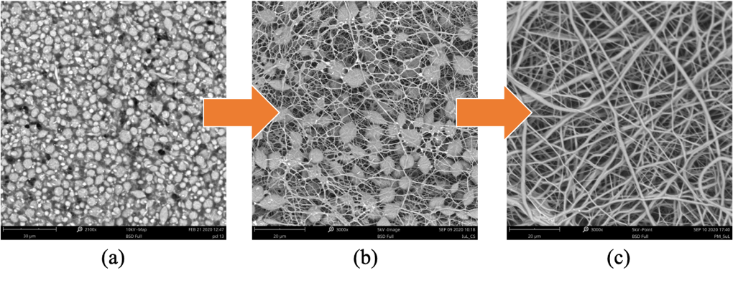
Figure 1. Morphological optimization of the electrospun PCL samples: from beads (a) and mixed morphology (b) to clean fibers (c).
In all cases, sub-micrometric fibers with a mean diameter of 860 nm were obtained, while the thickness of the films was quite variable between 85 and 335 μm due to the random deposition of the fibers on the collector during the electrospinning process. The variability of the thicknesses also influenced the mechanical tests conducted. Samples that showed more repeatability were those of linoleic acid, which showed a Young’s modulus of about 9 MPa, better than that shown by PCL alone, highlighting a plasticizing action of fatty acid, elongation at break of 80% and a maximum stress value of about 4.5 MPa, higher than the value of 3.5 MPa identified as the minimum required for a material to be use as food packaging by conventional standards [10]. The thermal properties, peroxide value and the overall migration test allowed the selection of the best system.
4. Conclusions
The main challenge was posed by the goal of using biodegradable materials and non-toxic solvents, adopting green techniques to produce a packaging capable of protecting the shelf-life of food along the entire supply chain. Given these preliminary results, the materials produced seem to be suitable to be used as food packaging systems, since with the electrospinning technique it was possible to load rather high percentages of PCM while maintaining the desired structure. Furthermore, the produced materials exhibit good mechanical properties.
References
- K.K. Gaikwad, S. Singh, Y.S. Lee, Environ. Chem. Lett. 16 (2018) 523
- E. Drago, R. Campardelli, M. Pettinato, P. Perego, Foods 9 (2020) 1628
- E. Drago, P. Franco, R. Campardelli, I. De Marco, P. Perego, Food Hydrocoll. 122 (2022) 107082
- M. Pettinato, E. Drago, R. Campardelli, P. Perego, Chem. Eng. Trans. 86 (2021)
- F. Topuz, T. Uyar, Food Res. Int. 130 (2020)
- D. Leducq, F. Ndoye, G. Alvarez, Int. J. Refrig. 52 (2015) 133-139
- W. Chalco-Sandoval, M.J. Fabra, A. López-Rubio, J.M. Lagaron, J. Food Eng. 192 (2017) 122-128
- L. Zhao, G. Duan, G. Zhang, H. Yang, S. He, S. Jiang, Nanomaterials 10 (2020) 150
- European Commission Regulation No. 10/2011, OJEU, 12, 75-80
- S.F. Hosseini, M. Rezaei, M. Zandi, F. Farahmandghavi, Food Hydrocoll. 44 (2015) 172-182

