Comparative study of catalytic methane dry reforming, with microwave heating vs. conventional heating
Francesco Esposito, Paolo Canu*
University of Padua, Department of Industrial Engineering, Via Marzolo 9, Padua, 35131, Italy
*Corresponding author E-Mail: paolo.canu@unipd.it

1.Introduction
The minimization of energy consumption is a key factor in process intensification. To be minimized, energy should be transferred from the source to the sample in the required form, amount, at the required time and position [1]. This is particularly important in processes where high energy inputs are required, such as in endothermic gas-solid catalytic reactions like methane-dry reforming (MDR), where Methane and Carbon Dioxide reacts to produce Syngas, a source of various added-value chemicals. Energy is usually supplied in furnaces as heat, generated by flames or electrical resistances (conventional heating systems); however, these heating methods do not fulfill the conditions required to achieve energy minimization. Dielectric heating using microwaves (MW) represents an alternative heating strategy, which can meet the requirements imposed by process intensification [2]. In this work a high-temperature microwave reactor was developed by modifying a commercial MW oven; a suitable temperature measurement and control strategy were developed. The highly endothermic MDR was performed under either MW or conventional heating (CH), using the same reactor and catalytic bed; the most significant performance indices were analyzed, to quantitatively compare the effectiveness of both heating strategies.
2. Methods
The MW reactor used in the tests was internally developed in our lab, by modifying a household oven, to include a temperature control loop and a crossing quartz tube used as flow reactor. The reactor position into the oven cavity was determined by a numerical simulation of the electromagnetic field, and is located where the electromagnetic field intensity was higher [3]. The temperature control strategy is selected among three different measurement methods: air thermometers, infrared (IR) pyrometry coupled with fiber optics (FO), and metallic thermocouples. The catalytic bed is made by a mixture of SiC as MW-absorbing material, and an industrial catalyst (JM, Katalco 25-4). Temperature distribution in the fixed bed is analyzed by 3 grounded thermocouples. The feed mixture used is CH₄:CO₂=1:1; 5%v of Ar is added as internal standard, to determine the volumetric variations of the reacting mixture. A GHSV of 2000 h⁻¹ based on the catalyst bed volume was set in both heating systems. The heat required to perform the MDR reaction is supplied using microwaves or electrical resistances, in two separate tests. The same reactor is used in both heating systems, to maintain the tests conditions as similar as possible. Prior to the tests, the catalyst is reduced to its active form in a Temperature Programmed Reduction (TPR) using Hydrogen. After the test, the catalytic bed is regenerated through a Temperature Programmed Oxidation (TPO), which removes the Carbon deposited on the catalyst during the test, re-establishing the initial catalytic activity. The product mixture is condensed to remove steam and it is analyzed in a gas chromatograph. Different temperatures (500°C, 600°C, 700°, 800°C and 900°C) have been investigated, and the results compared to the equilibrium. Under MW heating, the reactor is not insulated, to allow for a visual detection of hot-spots.
3. Results and discussion
Temperature measurement and control in the MW heating system is achieved with metallic thermocouples, properly grounded. Both the air thermometer and IR pyrometry measurement techniques were discarded, since the former only allows for an average bed temperature measure (making it impossible to measure temperature locally), while the latter is only able to measure the superficial reactor temperature (making it impossible to measure the reactor’s center temperature). To be used, a thermocouple must be grounded [4] to avoid charge accumulation in the sheath, which may lead to electric discharges; the thermocouple’s hot junction, located beneath the tip, has to be shielded by a sufficiently thick layer of SiC, estimated in about 3 mm from studies on the penetration depth of MW into SiC. Significant axial temperature gradients have been measured in the bed, under MW heating; such gradients changes with the set temperature, being influenced by variations of the SiC dielectric properties with temperature. Gradients are limited by implementing a short catalytic bed, of 2 cm, having high SiC mass fraction (80%), the rest being catalyst. Interestingly, too small (< 0.1 mm) SiC particles were proved unable to absorb enough radiation to achieve temperature above 200°C without leading to magnetron overheating. This bed configuration allows to easily reach 900°C, while simultaneously prevent excessive reflected radiation to the MW source (magnetron), protecting it from overheating. The low catalyst content prevents arching (formation of electric discharges) in the bed, while maintaining a satisfactory catalytic activity. Fig.1 shows the CH₄ conversion and selectivity to H₂ from CH₄ profiles as function of temperature; the CH systems appear to perform better than the MW heating system. However, the lack of insulation in the MW heating system may contribute to the lower performances. Differences in selectivity may be traced back to the very different temperature distribution in the two heating systems: however, this result may also suggest different reaction pathways. Finally, energy consumption in the MW oven was measured to be more than twice the one of the CH system.
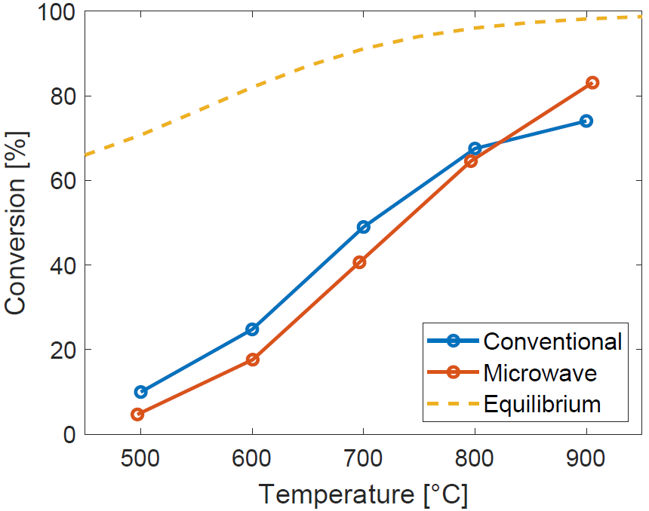 | 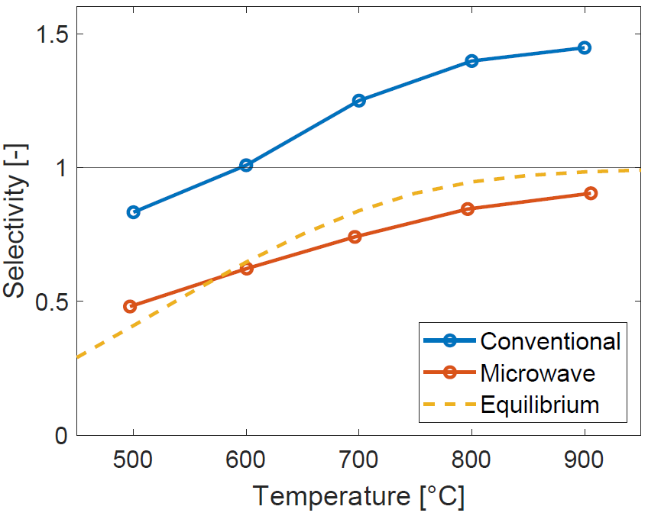
Figure 1. Conversions (left) and Selectivity to H₂ from CH₄ (right) as function of temperature, under microwave (red line) and Conventional (blue line) heating.
4. Conclusions
The possibility of operating highly endothermic reactions in a microwave oven has been demonstrated in this study. Temperature control can be achieved using metallic thermocouples; however, appropriate precautions must be taken to ensure the probe’s correct operation. In particular, the thermocouple needs to be grounded and shielded with a sufficiently thick layer of MW-absorbing material. The effect of several operating parameters (thermocouple diameter, bed height, SiC particle size, catalyst loading, magnetron temperature) was assessed, and often a compromise between reactor performances and the oven component’s integrity was required. The comparative study reported a superior performances of conventional heating, contrary to most literature studies (not directly comparative). Inhomogeneous temperature distribution and lack of insulation impact the MW heating system performances. Also the measured energy consumption was found higher in the MW oven, suggesting a poor radiation use. A systematic optimization on all the operating parameters is underway and may lead to a consistent improvement of the MW reactor performances.
References
- G.D.Stefanidis, A.N.Muñoz, G.S.J.Sturm, A.Stankiewicz. Reviews in Chemical Engineering 30.3 (2014), 233-259
- V.Palma, D.Barba, M.Cortese, M.Martino, S.Renda, E.Meloni. Catalysts 10.2 (2020), 246
- C. Bianchi, P. Bonato, F. Dughiero, P. Canu. Chemical Engineering and Processing - Process Intensification, 120, 2017, 286-300
- S.Hamzehlouia, J.Shabanian, M.Latifi, J.Chaouki. Chem. Eng. Sci. 192 (2018), 1177-1188

