A data-driven approach to assess the rheological properties of Durum Wheat Dough by indirect FTIR measurements

Fabio Fanari¹, Francesco Desogus¹, Massimiliano Grosso¹*, Manfred Wilhelm²
1 Dipartimento di Ingegneria Meccanica, Chimica e dei Materiali, Università degli Studi di Cagliari, Cagliari, Italia
2 Institute for Chemical Technology and Polymer Chemistry, Karlsruhe Institute of Technology, Karlsruhe, Germany
*Corresponding author E-Mail: massimiliano.grosso@unica.it

1. Introduction
Fourier Transform Infrared Spectroscopy (FTIR) is an up-and-coming technique for dough characterization since measurements are easy to perform and fast. At the same time they can give both qualitative and quantitative chemical information about the microstructure. This work aims to propose and test a method capable to infer rheological information from indirect spectral measurements by resorting to a PLS model. The procedure could be important in view of a possible implementation of an online monitoring system based on rapid and non-invasive FTIR measurements.
2. Methods
Samples of semolina and distilled water in different amounts (40%, 50% and 60%) were kneaded using a measuring mixer type 350 (Brabender). Three different types of semolina were investigated. Two are non-commercial monovarietal species resulting from Karalis (KAR) and Cappelli (CAP) grains milling. The third kind is a commercial blend (COM). Their properties are quite different in protein amount, gluten percentages, and gluten index. The IR measurements were performed using a Vertex 70 spectrometer (Bruker), equipped with a Universal ATR sampling device. Spectra were collected at room temperature in the 600-4000 cm⁻¹ spectral range, as an average of 32 scans at 2 cm⁻¹ resolution. Rheological experiments were performed at 25 °C with an ARES-G2 strain-controlled rheometer (TA Instruments) with a 25 mm parallel plate geometry. Frequency sweep tests were performed with frequencies ranging from 1 to 100 rad·s⁻¹ with a constant strain of γ_{o} = 0.1%. Complex module data were modelled using the Weak Gel model [1], reported in Eq. 1, where parameter A_{F} is related to the network strength while z is linked to its extension.
$G^{*}\left(ω\right)=\sqrt{{G^{'}\left(ω\right)}^{2}+{G^{''}\left(ω\right)}^{2}}=A_{F} ω^{1/z}$ (1)
The spectral data were related to the rheological parameters of the samples by means of a PLS model [2], which links the dependence of IR spectra to the rheological parameters A_{F} and z. After PLS regression had been accomplished, the interest was focused on selecting the wavelengths in which the absorption signal is the most influential on the changes in the rheological parameters. This can be carried out by computing the VIP scores. Wavelengths at which the VIP scores were above the unity value were considered significant [3].
3. Results and discussion
In Figure 1a, FTIR spectra of CAP, KAR and CAR samples are reported for a 50% water percentage. Interest is focused on the "Amide III" band (A3), at 1200-1340 cm⁻¹, which mainly arises from N-H bending and C-N stretching vibrations. Although its intensity is limited, it is informative about the protein structure characterization. KAR50 and COM50 samples show similar spectra, especially in the water-linked peaks, while CAP50 presents quite different intensities. Figure 1b shows the semolina variety influence on |G*| together with the Weak Gel model predictions. Notice that the CAP50 sample has the highest G' and G" values, so the Cappelli semolina variety is the strongest, followed by KAR. At the same time, COM turns out to be the weakest, in rheological terms. A PLS regression model relating A_{F} and z to the spectra of the A₃ band was developed to address a correlation between rheological properties and changes in the Amide III band spectrum. The number of latent variables chosen was 5. The results for A_{F} are reported in Figure 2a. A good agreement was found, as confirmed by the high value of R²= 0.832. On the other hand, the PLS technique failed to establish a solid correlation for z. Therefore, one can assume that the strength of the network, related to the A_{F} value, is influenced by the protein structure's conformation and quantities.
VIP scores were then computed to establish the proteins' secondary structures more relevant in defining the rheological properties. VIP scores are reported in Figure 2.b as a function of the wavenumbers. As previously asserted [4], the amide III band can be divided into four spectral regions, corresponding to β-sheets (β-S), random coils (RC), β-turns (β-T), and α-helices (α-H), respectively. In this case, it is possible to see that VIP scores are higher than 1 in correspondence β-sheet and α-helix regions. Thus, one can conclude that these latter protein configurations are more important in defining the network rheological strength.
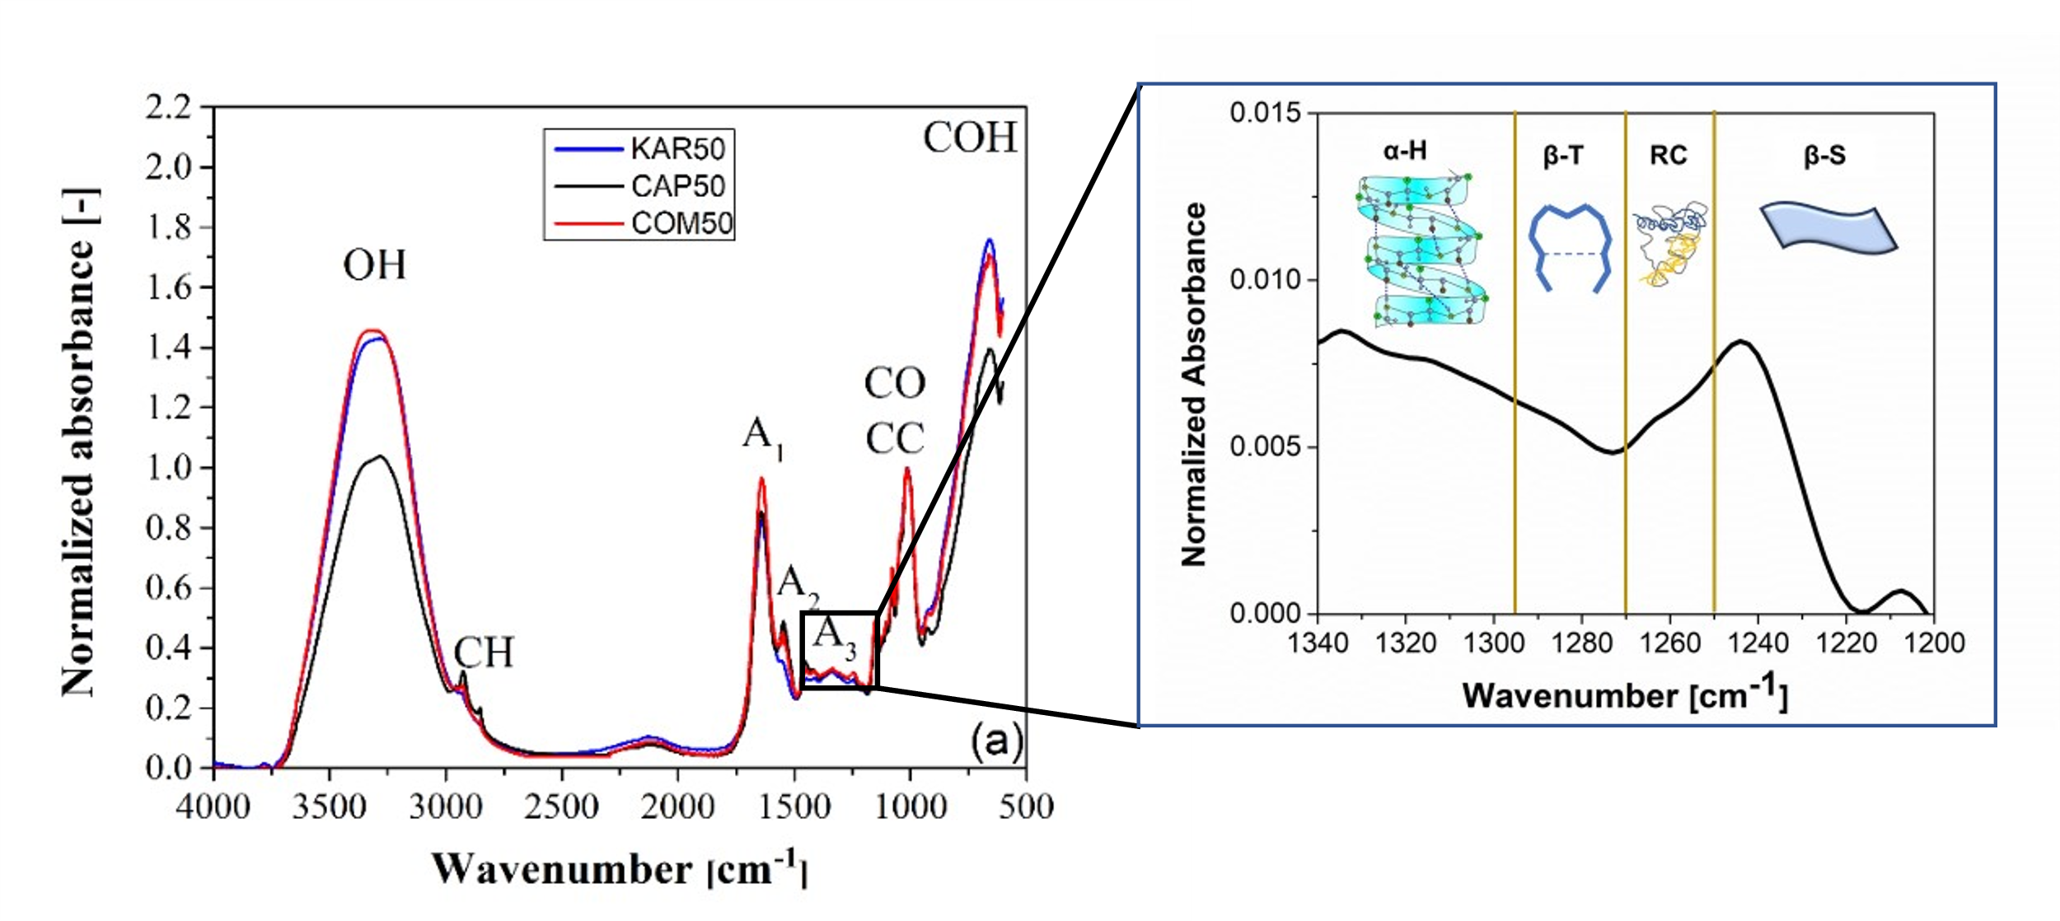 | 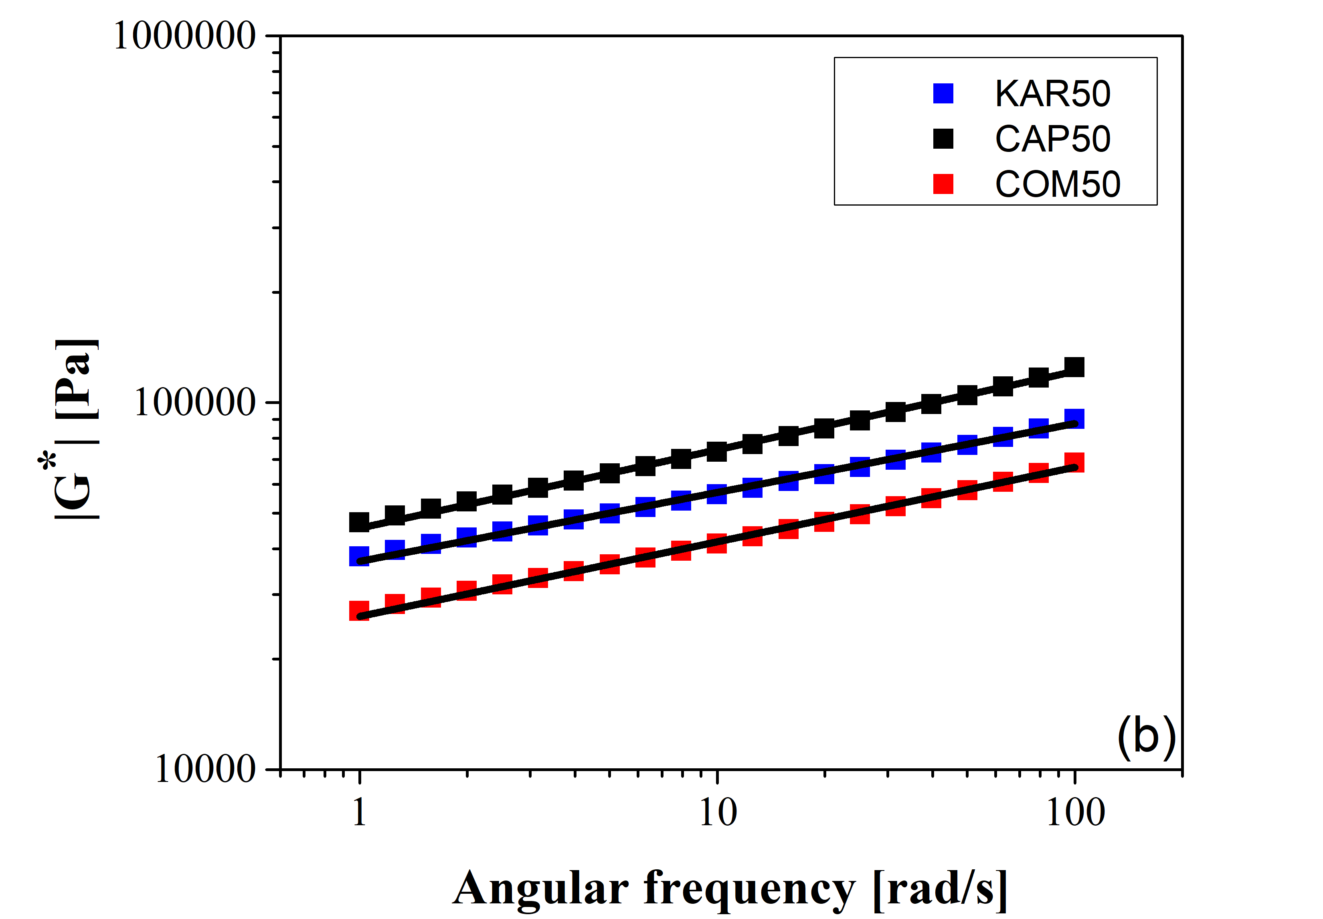
Figure 1. FTIR absorbance spectra (figure a) with particular focus on A3 band and complex modulus (figure b), measured for the CAP50 (black), KAR50 (blue), and COM50 (red) samples. Comparison with the Weak Gel model is also reported in Figure 1b
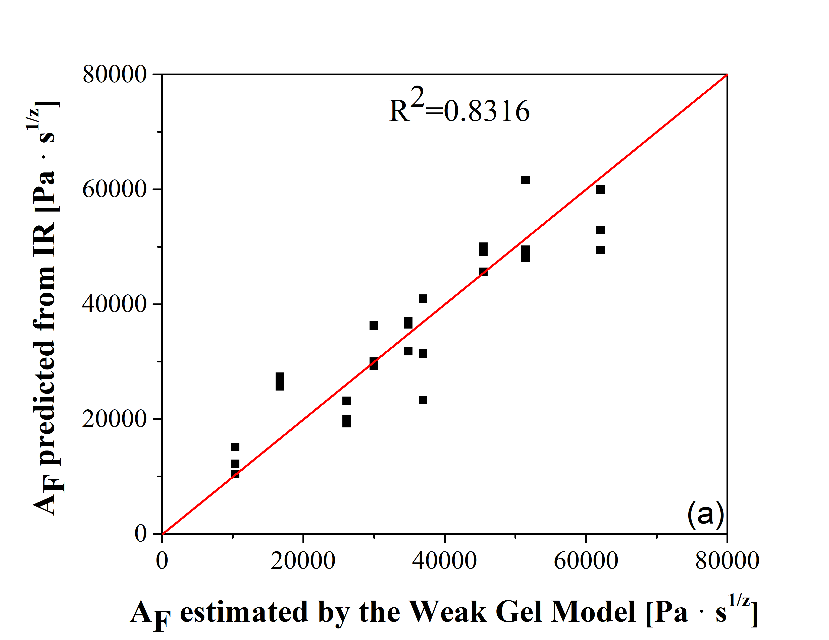 | 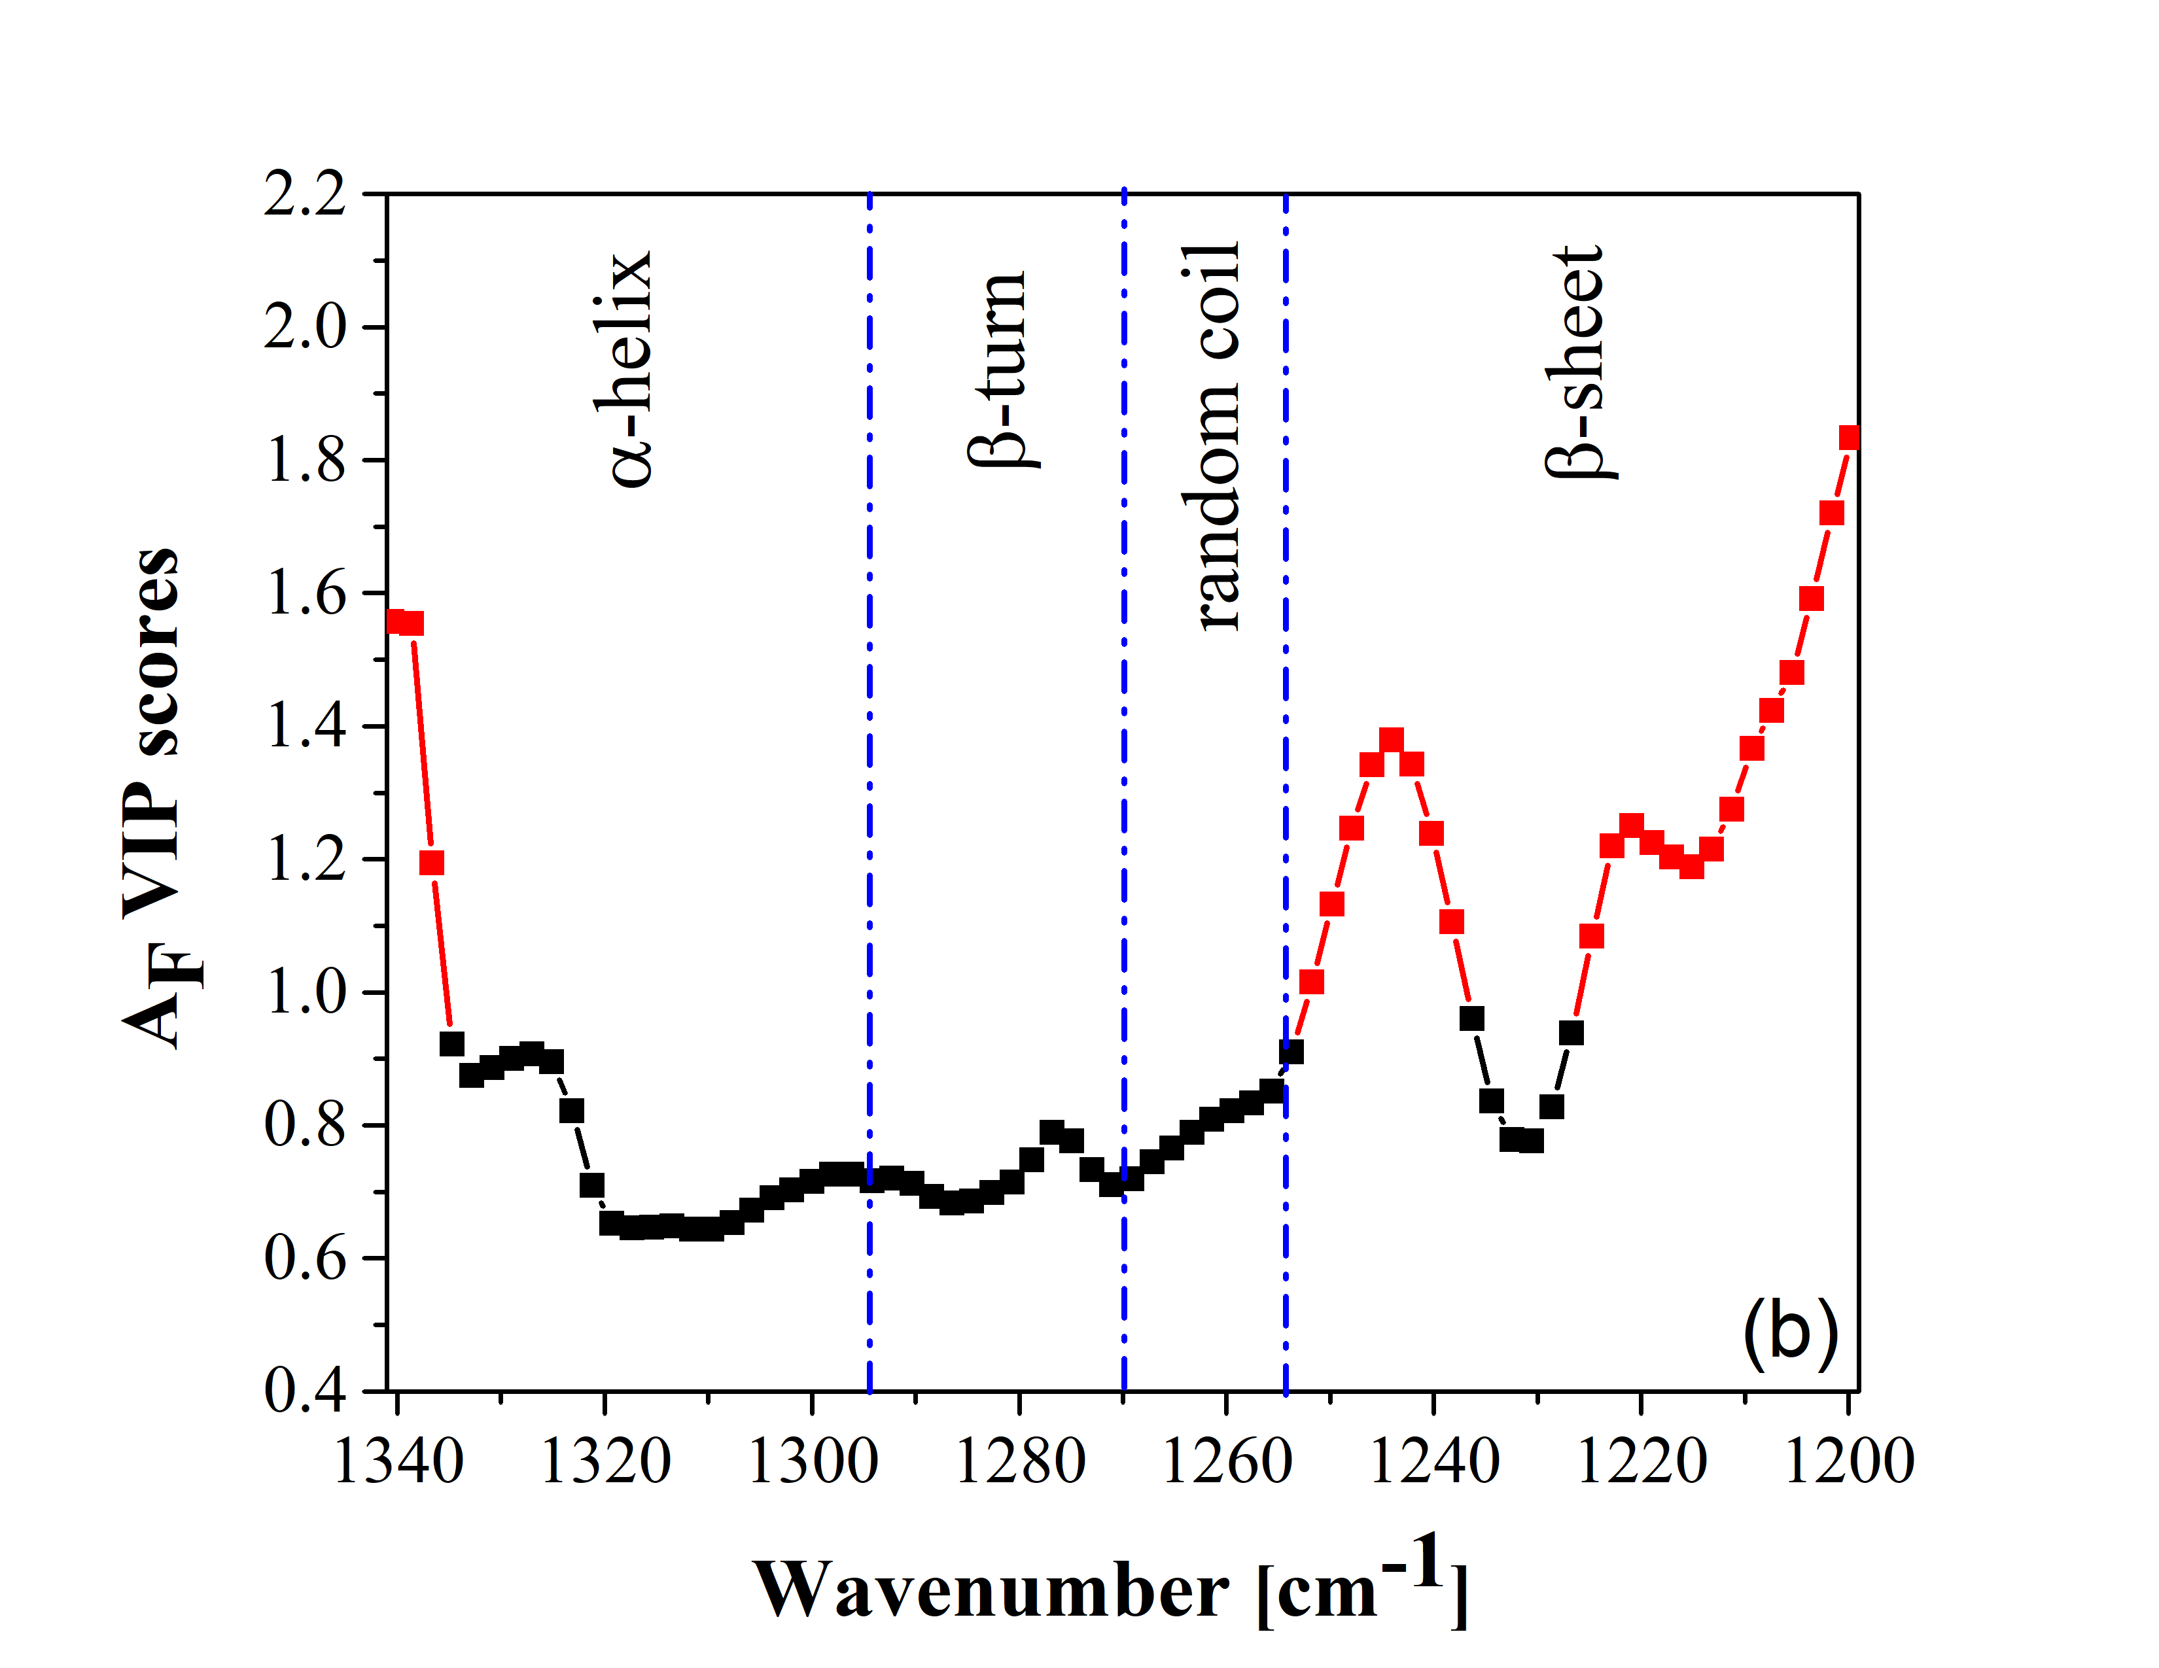
Figure 2. (a) A_{F} data predicted by the PLS regression reported as a function of the ones estimated by the Weak Gel model; (b) VIP scores for the PLS regression. Significant wavenumbers are highlighted in red
4. Conclusions
Rheological and infrared spectral analyses were used to infer rheological information from indirect spectral measurements. Satisfactory results were found regarding the prediction of the gluten network strength. Additionally, the methodology could give valuable insights into the interplay between protein conformations and rheological behaviour. In detail, β-sheets and α-helices protein conformations were shown to affect the gluten network's mechanical strength significantly. The method appears to be promising for future development of FTIR-based prediction systems for the online monitoring of rheological and structural properties of dough in the baking industry, considering the fast response times guaranteed by FTIR measurements.
References
- D. Gabriele, B. De Cindio, P. D’Antona, Rheol. Acta, 40(2) (2001) 120–127.
- P. Geladi, B. R. Kowalski, Anal. Chim. Acta, 185(C) (1986) 1–17.
- L. Eriksson, N. Kettaneh-Wold, J. Trygg, C. Wikström, S. Wold, (2006). Multi-and megavariate data analysis: Part I: basic principles and applications. In Computer and Information Science (Vol. 1). Umetrics Academy, 2006.
- S. Cai, B. R. Singh, Biophys. Chem., 80(1) (1999) 7–20.

