**Engineered small-diameter vascular prostheses: a study in bioreactor**

Pier Francesco Ferrari1*, Giulia De Negri Atanasio1, Jan Oscar Pralits1, Domenico Palombo2, Patrizia Perego1

*1 Department of Civil, Chemical and Environmental Engineering, University of Genoa, via Opera Pia, 15, Genoa, Italy 2 Department of Surgical and Integrated Diagnostic Sciences, University of Genoa, viale Benedetto XV, 6, Genoa, Italy*

*\*Corresponding author: pier.francesco.ferrari@unige.it*

**1. Introduction**

Cardiovascular diseases represent the global leading chronic-degenerative pathologies due to their high morbidity and mortality with a heavy impact on National Health Systems [1]. Among them, occlusive peripheral arterial diseases are caused by the accumulation of fatty material within the arterial wall, generating alterations of the blood circulation in downstream tissues as the main effect [2]. To overcome this problem, vascular bypass or stent are needed [3]. Synthetic vascular prostheses are not considered as a good choice for restoring the blood circulation in the case of vascular constructs with a diameter lower than 6.0 mm because of possible thrombotic events, intimal hyperplasia, calcification, inflammatory response, and arising of infections starting from the prosthesis itself. Different strategies, *i*.*e*., electrospinning, 3D printing, freeze-drying, and decellularization of tissues and organs have been investigated in order to fabricate vascular constructs able to perform well even with a small-diameter. [4]. In this work, electrospun vascular prostheses, made of a polymeric blend, were obtained by electrospinning and they were engineered by incorporating quercetin, as a modulator of inflammation, and gelatin, as a coating protein. To predict the *in* *vivo* behavior of these engineered electrospun polymeric scaffolds, studies in an *ad* *hoc* bioreactor were performed. In details, it was studied the morphology of the vascular constructs, the influence of the testing conditions (pressure, residence time, *etc*.) on the release of quercetin and gelatin from the scaffolds, their physico-chemical properties (fluid uptake, degradation over time, *etc*.), their mechanical characteristics, and their bio- and hemocompatibility.

**2. Methods**

The studied vascular scaffolds were produced by electrospinning as reported by Ferrari et al., 2017 [5] using poly (ε‐caprolactone) (PCL) and poly (glycerol sebacate) (PGS) in the presence of quercetin (Q) (0.05 %, w/v) and then they were coated with a thin layer of gelatin (G) at 37°C in order to reduce their porosity. These vascular grafts were tested in a bioreactor made up of a peristaltic pump, a flow chamber, pressure transducers, and a reservoir. A Newtonian fluid flowed in the bioreactor at different working pressures.

**3. Results and discussion**

In scanning electron micrographs, it was possible to notice that the fabricated scaffolds presented a randomized, bead-free microfibrous structure (Figure 1).

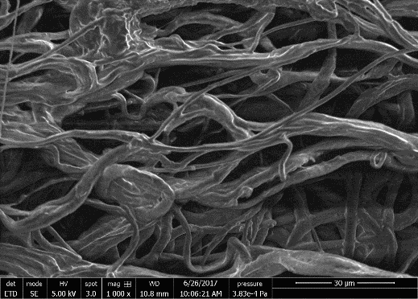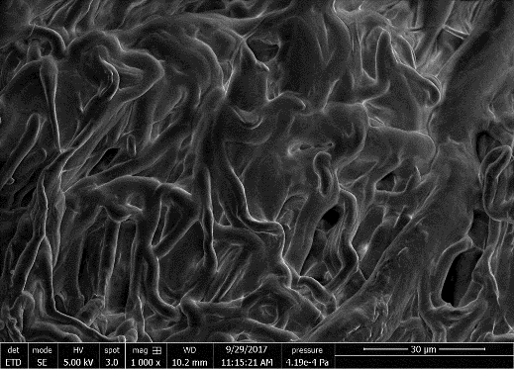

**A**

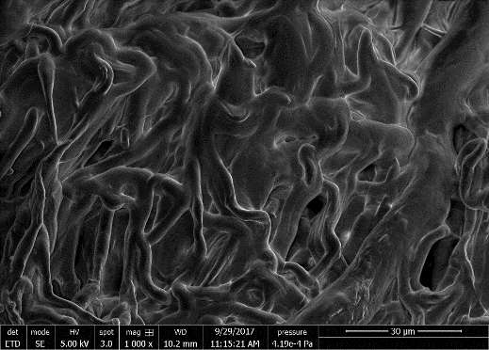

**B**

**Figure 1.** Representative scanning electron micrographs of (A) PCL:PGS scaffold and (B) PCL:PGS scaffold engineered with quercetin and coated with gelatin.

The addition of quercetin and the gelatin coating did not alter the mean diameter of the fibers (Table 1).

|  |  |  |
| --- | --- | --- |
|  | PCL:PGS | PCL:PGS with Q and G |
| Fiber diameter (μm) | 4.36 ± 1.37 | 4.03 ± 0.51 |

**Table 1.** Fiber diameter of electrospun polymeric vascular constructs.

The amount of released quercetin was able to modulate the post-implantation inflammatory response and the release of gelatin was sufficient to prevent blood leakage during the prosthesis implantation (Figure 2).



**Figure 2.** (A) Quercetin and (B) gelatin release from scaffolds at different working pressures.

The mechanical behavior, in terms of Young’s modulus, tensile strength, and elongation percentage, was similar to that possessed by native human arteries (Figure 3).



**Figure 3.** (A) Young’s modulus, (B) tensile strength, and (C) elongation percentage of scaffolds after being tested at different working pressures.

**4. Conclusions**

The importance of testing engineered electrospun grafts in an *ad* *hoc* bioreactor at different working pressures was fundamental to develop mathematical models able to predict the *in* *vivo* behavior of the scaffolds. Considering all the obtained results, this engineered vascular prosthesis could become a promising tool for the next generation vascular tissue engineering.

**References**

1. M. Amini, F. Zayeri, M. Salehi, BMC Public Health 21 (2021) 1–12.
2. E.E. Bezsonov, I.A. Sobenin, A.N. Orekhov, Int. J. Mol. Sci. 22 (2021) 1–6.
3. Z. Wang, L. Liu, S.M. Mithieux, A.S. Weiss, Trends Biotechnol. 39 (2021) 505–518.
4. B.B.J. Leal, N. Wakabayashi, K. Oyama, H. Kamiya, D.I. Braghirolli, P. Pranke, Front. Cardiovasc. Med. 7 (2021) 1–18.
5. P.F. Ferrari, B. Aliakbarian, A. Lagazzo, A. Tamayol, D. Palombo, P. Perego, Int. J. Polym. Mater. 66 (2017) 635–643.