Production of acidic and alkaline solutions via Electrodialysis with bipolar membranes from synthetic and real brines from saltworks

Antonia Filingeri¹, Andrea Culcasi¹, Andrea Cipollina¹*, Alessandro Tamburini^{1,2}, Giorgio Micale¹
1 Dipartimento di Ingegneria, Università degli Studi di Palermo - viale delle Scienze Ed.6, 90128 Palermo, Italy;
2 ResourSEAs SrL, viale delle Scienze Ed.16, 90128 Palermo
*Corresponding author E-Mail: andrea.cipollina@unipa.it
1. Introduction
In recent decades, there has been a great deal of interest at both the industrial and academic levels in identifying unconventional sources for chemical production and raw material recovery. In this context, brine disposal, which was previously addressed as a priority to reduce environmental problems, is now seen as an opportunity to apply new or existing technologies in circular processes that allow for the valorization of previously considered waste solutions [1]. In this regard, Electrodialysis with bipolar membranes (EDBM) can be used to produce acidic and alkaline solutions from salty solutions. EDBM is an electro-membrane process distinguished by the alternated position of Ion Exchange Membranes (IEMs) for selective ion separation and the use of bipolar membranes that allow water dissociation [2]. In this work, a novel application of EDBM was proposed to valorize the remaining brine provided by the saltworks, which is typically returned to the sea despite being a highly concentrated solution (i.e., 20–40 times more concentrated than seawater). In more detail, an EDBM unit was tested for the first time with (i) synthetic and (ii) real brines from Trapani’s saltworks (Italy), which had previously been treated for mineral recovery.
2. Methods
A laboratory-scale EDBM unit, supplied by SUEZ-WTS France®, was equipped with 5 triplets of commercial IEMs (0.028 m² of membrane active area). Closed-loop tests (see Figure 1) were carried out at constant current (typically 100-300 A m⁻²) and for a time duration sufficient to achieve a target NaOH concentration of 1M in the base compartment. Tests with various compositions were carried out in the salt compartment: (i) a reference case with pure NaCl solutions, (ii) synthetic brines containing NaCl, Na₂SO₄, and KCl, and (iii) real bitterns, containing traces of other minor elements. The initial composition of the feeds was assumed to be variable between several scenarios in the ranges reported in Table 1 in order to analyze the effect of different feeds in the process performance and acid and base solutions purities. Specific energy consumption, current efficiency, yield, and products purities were evaluated as performance indicators.
Table 1. Initial composition of the feeds for closed-loop experiments.
 | Salt compartment |  |  | Base compartment | Acid  compartment
 | Pure NaCl solutions | Synthetic brines | Real brines
NaCl | 1-3 M | 0.5-4 M | 0.5-4 M | 0-4 M | 0-4 M
Na₂SO₄ | - | 0.1-1.2 M | 0.1-1.2 M | 0.1-1.2 | 0.1-1.2
KCl | - | 0.1-0.7 M | 0.1-0.7 M | 0.1-0.7 M | 0.1-0.7 M
HCl | - | - | - | - | 0-0.05 M
NaOH | - | - | - | 0-0.05 M | -
Other elements | - | - | traces | - | -
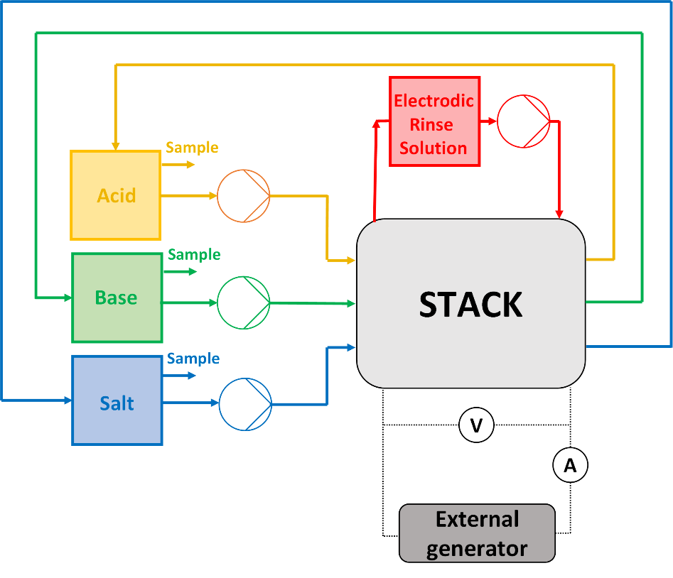
Figure 1. Closed-loop (batch) experimental configuration (adapted from [2]).
3. Results and discussion
For tests performed at the highest current density, the target concentration of 1M of NaOH for the alkaline solution was reached after $\sim$45 minutes. Specific energy consumptions (SEC) of $\sim$2.4 kWh kg⁻¹_{NaOH} were obtained at the target condition with pure NaCl solutions in the salt compartment at an initial concentration of 2M, whereas the use of a more concentrated synthetic brine reduced SECs to values less than 2 kWh kg⁻¹_{NaOH}. Current efficiency as a function of time showed a decreasing trend, but it remained relatively high (in the $\sim$70-80% range) at the end of the test. In the case of ion mixtures, purities of $\sim$90% were obtained in acid and base compartments, respectively.
4. Conclusions
A new application of EDBM for the valorization of highly concentrated brines from the saltworks process was proposed. The results obtained at laboratory-scale unit demonstrated the feasibility of the process for producing chemicals, specifically HCl and NaOH solutions, as an alternative to brine disposal. The process could then be tested at the pilot scale with long-run tests to determine its scalability at the industrial level.
Acknowledgements
This project has received funding from the European Union’s Horizon 2020 research and innovation programme under Grant Agreement No. 869467 (SEArcularMINE). This output reflects only the author’s view. The European Health and Digital Executive Agency (HaDEA) and the European Commission cannot be held responsible for any use that may be made of the information contained therein.
References
- A. Panagopoulos, K.J. Haralambous, M. Loizidou, Desalination brine disposal methods and treatment technologies - A review, Sci. Total Environ. 693 (2019) 133545. https://doi.org/10.1016/j.scitotenv.2019.07.351.

- Culcasi, A., Gurreri, L., Cipollina, A., Tamburini, A., & Micale, G. (2022). A comprehensive multi-scale model for bipolar membrane electrodialysis (BMED). Chemical Engineering Journal, 437(P1), 135317. https://doi.org/10.1016/j.cej.2022.135317

