Understanding the role of imidazolium-based ionic liquids in the electrochemical CO₂ reduction reaction: an experimental and theoretical study
Alessia Fortunati¹, María José Rubio¹, Boyan Iliev², Thomas J.S. Schubert², Francesca Risplendi¹, Michele Re Fiorentin¹, Giancarlo Cicero¹, Nunzio Russo¹, Simelys Hernández^{1*}
¹ Department of Applied Science and Technology, Politecnico di Torino, Corso Duca degli Abruzzi 24, 10129, Turin, Italy
² Iolitec Ionic Liquids technologies GmbH, Im Zukunftspark 9, 74076 Heilbronn, German
*Simelys Hernández (simelys.hernandez@polito.it); Alessia Fortunati (alessia.fortunati@polito.it)

1.Introduction
The exponential increase in the concentration of greenhouse gases in the atmosphere is considered as one of the most important reasons for climate change. Carbon dioxide is the most significant anthropogenic gas that contributes to global warming. CO₂ capture and storage (CCS) has been proposed as one of the most important strategies to mitigate CO₂ emissions. Moreover, conversion of carbon dioxide into energy-rich chemicals is a viable approach to reduce the global carbon footprint. The most common techniques to remove CO₂ from industrial gas streams are the chemical and physical absorption by liquid solvents. Traditionally, aqueous amine solutions have been used as chemical solvents because of their high selectivity, high reactivity and low price. Unfortunately, they also present many disadvantages associated with the high energy demand required for the solvent regeneration, corrosion issues and loss of solvent because of their high volatility. Hence, in the need to find more efficient solvents for CO₂ capture and conversion, Ionic Liquids (ILs) have been highlighted as very good alternatives to the common amine solutions.[1] Within this field lies this research, which in turn is part of a much broader European project called SunCoChem. For this project we are testing the stability and performance of various ionic liquids, provided by Iolitec Ionic Liquids technologies GMBH, and, in particular, their ability to capture and favor the electrochemical conversion of a pure CO₂ stream to CO with high efficiencies.
2. Methods
The electrochemical (EC) studies were performed by using ionic liquids made of imidazolium salts. The ILs listed in Table 1 were supplied by IOLITEC GmbH (high purity grade, >99%) and used without any further puriﬁcation.

 | Ionic Liquid | Abbreviation | Cation | Anion
 | 1-Butyl-3-Methylimidazolium Tetrafluoroborate | [BMIM][BF₄] | 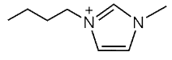 | 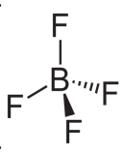
 | 1-Butyl-3-Methylimidazolium Acetate | [BMIM][CO₂CH₃] |  | 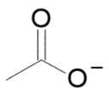
 | 1-Butyl-3-Methylimidazolium Triflate | [BMIM][SO₃CF₃] |  | 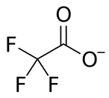
 | 1-Butyl-3-Methylimidazolium Trifluoroacetate | [BMIM][CO₂CF₃]
 | 1-Ethyl-3-Methylimidazolium Acetate | [EMIM][CO₂CH₃] | 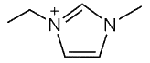
 | 1-Ethyl-3-Methylimidazolium Triflate | [EMIM][SO₃CF₃]
Table 1: Ionic liquids investigated.
The experimental setup is described in Figure 1. The EC CO₂ reduction tests with each IL-based electrolyte were done in a two-compartment H-type cell. The cell used for the experiment and all other glassware were cleaned by several rinsing ultrasonicated cycles with Milli-Q water (R > 18.2 MΩ, 25°C) and dried with nitrogen stream. The cathodic chamber contained the working (Ag Foil, active area of ​​3 cm²) and reference (Ag/AgCl) electrodes, which were immersed in a solution of the ionic liquids in an organic solvent ([IL]=0.3M in Acetonitrile, ACN). Due to their high viscosity, ionic liquids are often mixed with organic solvents or water.[2] Because of the low CO₂ solubility and the competitive hydrogen evolution reaction (HER), aqueous solutions are not favorable for the CO₂ conversion. It has been reported in the literature that ACN is a highly suitable organic solvent for the electro-reduction of CO₂ since, in addition to increasing the conductivity and decreasing the viscosity of the imidazole salts, the CO₂ solubility in it is eight times greater than in water. [3] In the anodic chamber there was a platinum mesh, used as counter electrode, immersed in a solution of strong electrolyte, such as KOH 0.1M. A very conductive aqueous solution helps an effective passage of current. [4],[5] A solution of potassium hydroxide was chosen as anodic electrolyte because of its properties such as high conductivity, that affect the total current density of the system. The cell chambers were separated by a commercial bipolar membrane (BM) (Fumasep FBM - Bipolar Membrane by Fumatech). The BM consists of an anion exchange layer (AEL), and a cation exchange layer (CEL) facing the anode and cathode compartments of the cell, respectively. At the interface between the AEL and CEL, water dissociates into OH⁻ and H⁺ ions. This configuration prevents the mixing of the chamber contents and avoids further oxidation of the formed CO₂ reduction products.
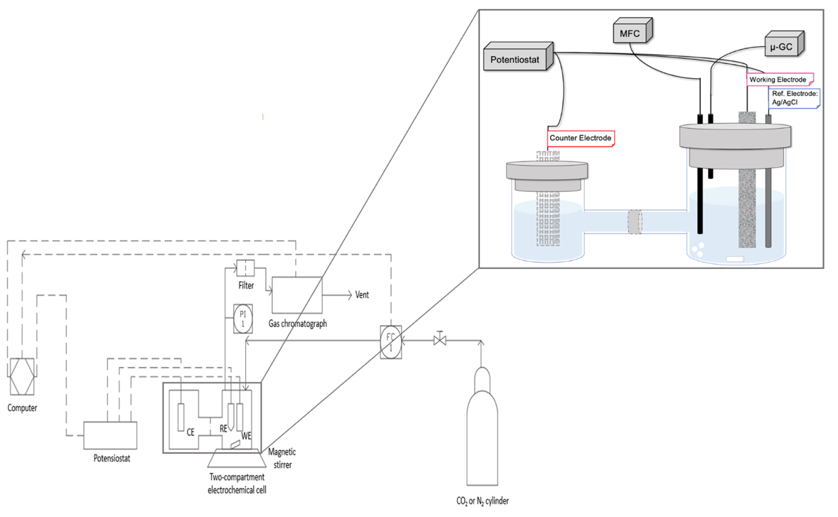

Figure 1: Set-up scheme for the EC CO₂RR with IL-based electrolytes.

3. Results and discussion
The ILs tested so far have a cationic part based on imidazole, which is expected to stabilize and lower the activation energy for the reduction of CO₂, namely [BMIM][BF₄], [BMIM][CH₃CO₂], [BMIM][CF₃CO₂] and [BMIM][CF₃SO₃]. This trend was confirmed by a shift to more positive potentials of the onset for the CO₂ reduction reaction in the presence of these Ionic Liquids. Our results evidence relevant current density values, a good stability during chronopotentiometry (CP) tests and a high selectivity towards the target product: CO, which however changes depending on the used IL.
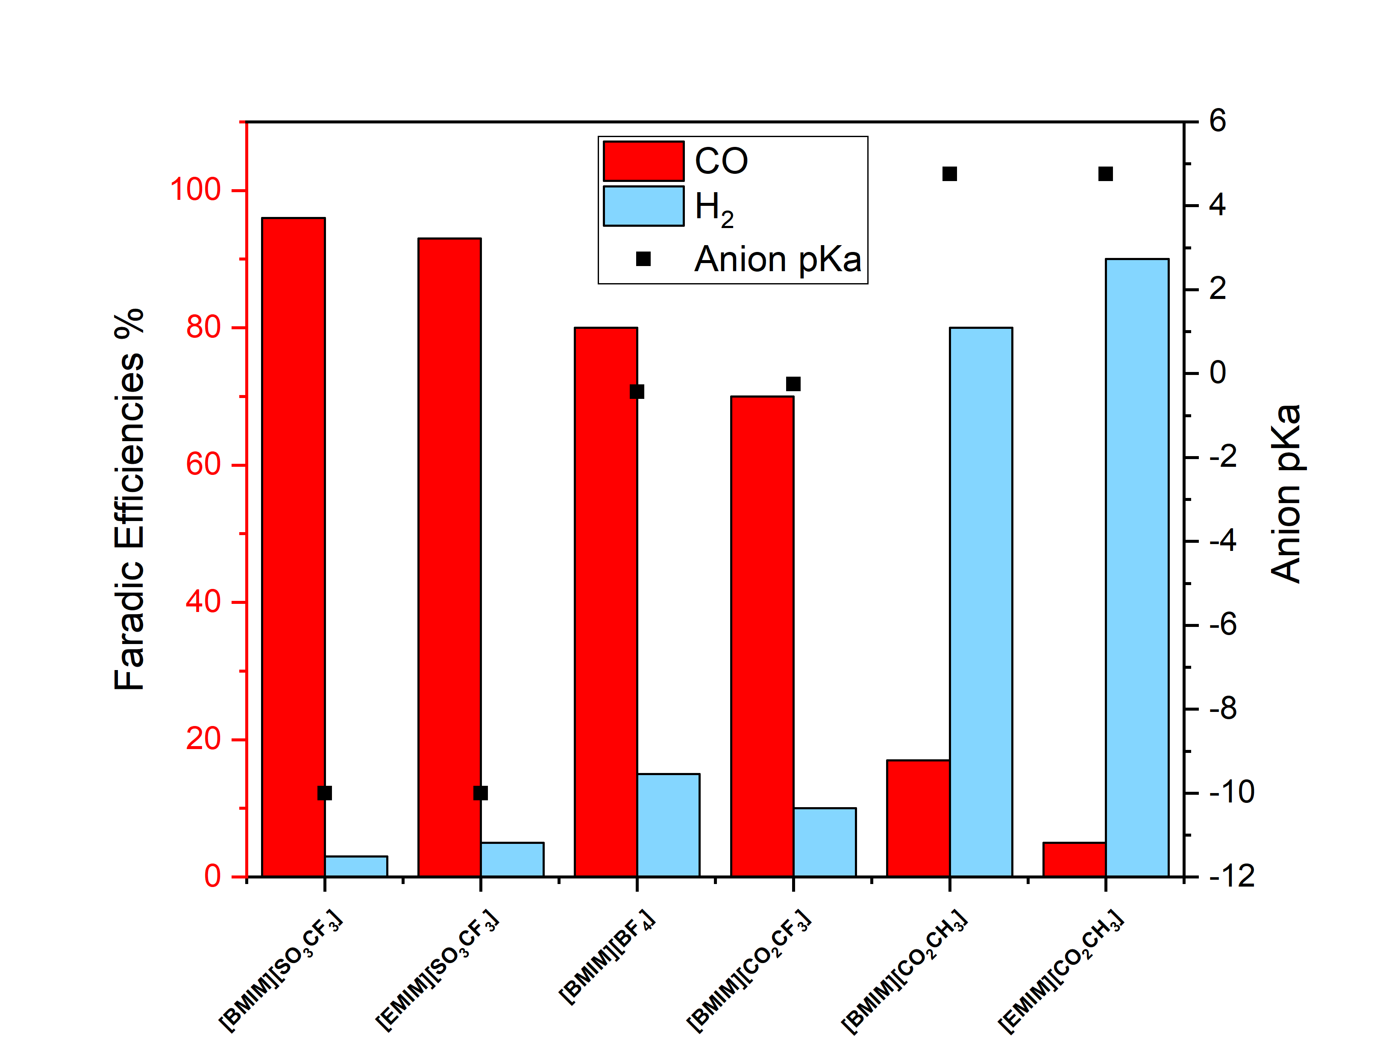
Figure 2: Bar graph summarizing faradic efficiency values of the gaseous products of CO2 ECR for six different ionic liquid. The faradic efficiencies are also compared with the pKa IL anion. The pKa values ​​refer to the respective acid of the conjugate base, which in this work is assumed to be the anion of the IL.
In fact, by analyzing the faradic efficiencies an interesting CO production was verified, mostly considering [SO₃CF₃] salts. In that case, a high amount of carbon monoxide (FE% ~ 90%) and a low amount of hydrogen (FE% ~ 5%) were evidenced. In the case of the acetate anion, a very low amount of CO was collected. Moreover, a correlation between the CO or H₂ productions and the pKb values of the anions was found. Acetate salts have the highest pKb value and the highest H₂ selective production, while triflate salts have the lowest pKb value and the highest CO selective production.
A more in-depth study by means of Density Functional Theory (DFT) allowed to confirm the experimental hypotheses. Deprotonated EMIM and BMIM in presence of acetate, are found to strongly chemisorb on the Ag electrode surface and to spontaneously capture the CO₂ molecule, thus hindering its reduction. The reaction mechanisms of CO₂ reduction in presence of the cation of the ionic liquid have been investigated and a dependence on the length of the alkyl chain linked to the imidazole ring and on the type of counterion present in the ionic liquid has been observed.
4. Conclusions
Different imidazolium salts were tested as electrolytes for the electrocatalytic CO₂ conversion to CO: 0.3M solutions of ILs in acetonitrile were used to reduce the viscosity of the pure compounds. Acetonitrile was chosen as solvent thanks to its ability to solubilize ILs, its lower molecular weight than most organic solvents that guarantees high conductivity and low viscosity. Moreover, non-aqueous solutions were used as catholyte to limit the hydrolysis of hydrolytically unstable fluorinated-based anion and the consequent HF production. The anionic part of imidazolium salts influences the CO₂ solubility, and the cationic part plays mainly a role in stabilizing the reaction intermediates and determines a lowering of the activation energy for CO₂RR. Imidazolium salts of acetate are more selective towards the production of H₂ given their large binding energy with the electrode surface and the ability to form a carboxylated species. [SO₃CF₃] salts promote CO₂RR better than the commonly used [BMIM][BF₄] in terms of onset potential and FE% to CO. Acetate salts are more selective towards the production of H₂ than CO, which supports the fact that the CO₂ reduction reaction depends also on the type of anion in ionic liquids.
5. Acknowledgment
The research leading to these results has received funding from the European Union’s Horizon 2020 Research and Innovation Action programme under the SunCoChem project (Grant Agreement No 862192).
References
[1] S. Sarmad, J. P. Mikkola, and X. Ji, “Carbon Dioxide Capture with Ionic Liquids and Deep Eutectic Solvents: A New Generation of Sorbents,” ChemSusChem, vol. 10, no. 2. 2017, doi: 10.1002/cssc.201600987.
[2] T. R. Anderson, E. Hawkins, and P. D. Jones, “CO2, the greenhouse effect and global warming: from the pioneering work of Arrhenius and Callendar to today’s Earth System Models,” Endeavour, vol. 40, no. 3, pp. 178–187, 2016, doi: 10.1016/j.endeavour.2016.07.002.
[3] I. Ganesh, “BMIM-BF4 Mediated Electrochemical CO2 Reduction to CO Is a Reverse Reaction of CO Oxidation in Air - Experimental Evidence,” J. Phys. Chem. C, vol. 123, no. 50, pp. 30198–30212, 2019, doi: 10.1021/acs.jpcc.9b09819.
[4] J. Feng, S. Zeng, J. Feng, H. Dong, and X. Zhang, “CO2 Electroreduction in Ionic Liquids: A Review,” Chinese J. Chem., vol. 36, no. 10, pp. 961–970, 2018, doi: 10.1002/cjoc.201800252.
[5] N. J. Firet and W. A. Smith, “Probing the Reaction Mechanism of CO2 Electroreduction over Ag Films via Operando Infrared Spectroscopy,” ACS Catal., vol. 7, no. 1, pp. 606–612, 2017, doi: 10.1021/acscatal.6b02382.

