Evaluating the mass transfer properties of 3D printed catalyst substrates with catalytic H₂ oxidation in rich conditions

Federico S. Franchi¹, Matteo Ambrosetti¹, Mauro Bracconi¹, Riccardo Balzarotti¹, Gianpiero Groppi¹*, Enrico tronconi¹
1 Dipartimento di Energia, Politecnico di Milano, Via La Masa, 34, Milano (Italy)
*Corresponding author E-Mail: gianpiero.groppi@polimi.it

1.Introduction
Nowadays, the need to comply with more and more stringent environmental legislations is leading towards the implementation of innovative, high performance catalytic systems. The advancement in 3D printing technologies is enabling the manufacture of catalyst supports with better tradeoffs between gas/solid mass transfer and pressure drops than state of the art honeycomb monoliths [1]. To characterize the large number of geometries that can be manufactured with these techniques, an efficient screening methodology is required. Among the different addictive manufacturing techniques, stereolithography (SLA) combine high precision and accuracy with low cost and fast production times resulting in the ideal technology for fast prototyping machines. The technique can use a wide range of polymeric materials, of which, a resin with a significant resistance to high temperature is selected. CO oxidation over noble metal catalysts in external mass transfer regime, was used in previous works [2-4], as a probe to evaluate the gas/solid mass transfer performances. However, the range in which this reaction is limited by external mass transfer is usually limited to temperatures above 300°C which will lead to the degradation of the resin substrate. To cope with the temperature limits of the resin samples (290°C), catalytic H₂ oxidation is a good candidate. Moreover, O₂ was used as the limiting reactant to reduce the conversion in the mass transfer regime.
SLA 3D printed samples have been used for other process intensification devices (e.g. static mixers), however, no catalytic applications have been yet reported in the literature. In this work, we propose the use of 3D printed resin samples for the investigation of external mass transfer properties by running H₂ oxidation catalytic tests in rich conditions.
2. Methods
POCS samples (cylinders, id = 9 mm, length = 15 mm) are printed using FLHTAM01 high-temperature (HT) resin (HDT_{@0.45MPa} = 289°C) and a Form2 SLA 3D printer. The finished samples are washcoated with a 3% Pd/CeO₂ slurry and the excess slurry is removed by spin-coating and flash dried in air at 200°C for 3 min. Samples are then reduced in situ at 200°C in a 2.5% v/v H₂ in N₂ feed mixture. Catalytic tests are performed using a N₂/H₂/O₂ 95/4/1 % v/v feed mixture. Operation with H₂ excess allows to avoid the potential oxidation and degradation of the polymer; furthermore, O₂ diffusion (5.6*10⁻⁵ m²/s @ 250°C) avoid the reach of complete conversion. O₂ conversion is evaluated at increasingly high temperatures until full external mass transfer limited regime is reached.
For validation purposes, a resin POCS tested with the presented protocol, is directly compared with an identical FeCrAlloy sample tested in mass transfer limited CO oxidation tests (1.5% CO in Air). Mass transfer coefficients, expressed as ShSc^{-1/3}, are calculated from O₂ conversion (for the resin sample) and CO conversion (for the FeCrAlloy POCS) in the external mass transfer regime assuming a PFR behavior.
3. Results and discussion
The dip/spin-coating procedure followed by flash drying resulted in a thin and homogeneous catalyst layer that does not significantly modify the geometrical properties of the investigated structures. Moreover, the Pd-based catalyst used for the activation procedure, resulted in the light-off of the reaction at room temperature and allows to reach the diffusional regime at a temperature of 200°C, as shown in Fig 1 A).
As shown in Fig 1 B), that the dimensionless mass transfer coefficients evaluated trough the use of the presented protocol are in very good agreement with the results provided by CO oxidation. A parametric investigation of mass transfer properties in POCS structures is currently ongoing.
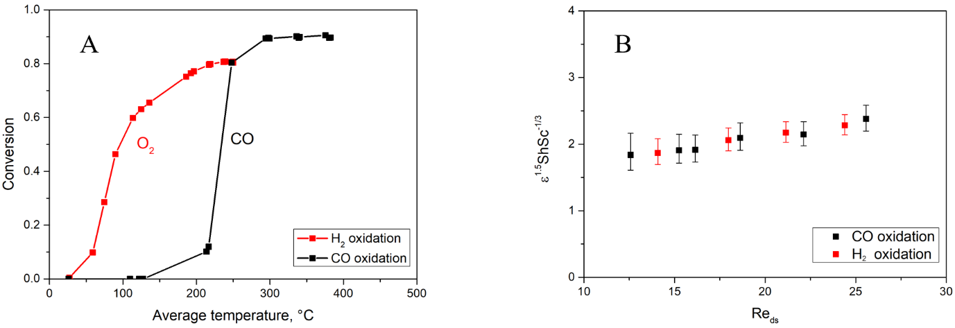
Figure 1. Limiting reactant conversion for CO and H₂ oxidation. Q = 3 l/min (STP), (A) and ε^{1.5}ShSc^{-1/3} vs. Re for TKKD POCS: cell diameter = 2.5mm, ε = 0.90 (B)
4. Conclusions
A novel experimental protocol has been developed to allow accurate, fast and low-cost screening of complex 3D cellular substrates through the use of: i) HT resin for the manufacturing of 3D printed catalyst supports, and ii) rich H₂ oxidation as the test reaction.
5. References
- Busse C., et al., Chem. Eng. Process., (2018), 124, 199
- Groppi G., et al., Ind. Eng. Chem. Res., (2007), 46, 3955
- Ullah U., and Waldram S.P., Chem. Eng. Sci., (1992), 47, 2413
- Bracconi M., et al., Chem Eng. J., (2018), 352, 558

