Soot coatings wettability with different liquids. Preliminary results.
Raffaella Griffo^{1,*}, Arianna Parisi², Gianluigi De Falco², Mariano Sirignano², Francesco Di Natale², Mario Minale¹, Claudia Carotenuto¹.
¹Dipartimento di Ingegneria, Università della Campania “L. Vanvitelli”, 81031 Aversa (CE), Italy
²Dipartimento di Ingegneria Chimica, dei Materiali e della Produzione Industriale, Università degli Studi di Napoli “Federico II”, 80125 Napoli, Italy

*Corresponding author E-Mail: raffaella.griffo@unicampania.it

1.Introduction
The wettability of a solid surface is defined as the ability of the surface to hold contact with a liquid. It is frequently measured through the contact angle, CA, defined as the angle between the tangent to the liquid-vapor interface and the solid surface at the three-phase contact line (Figure 1a). By convention, the contact angle is measured from the liquid side. The contact angle can assume values from 0° to 180° identifying different types of surfaces (Figure1b): superphilic surface (CA<5°), philic surface (5°<CA<90°), phobic surface (90°<CA<150°) and superphobic surface (CA>150 °)[1, 2].
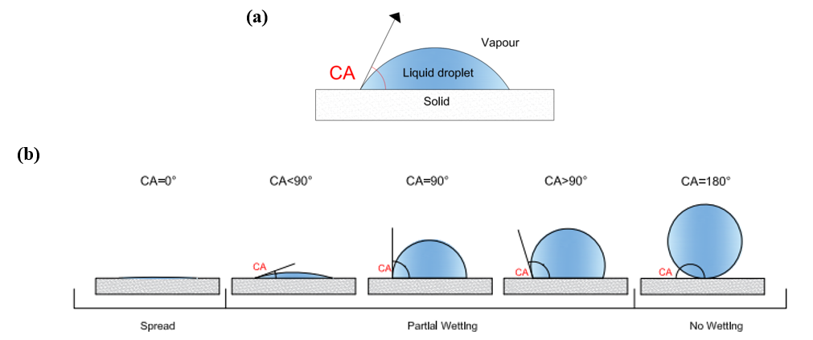
Figure 1– a) Profile of a drop deposited on a solid surface with the indication of the contact angle, b) Wettability scale.
In nature, there are numerous examples of superhydrophobic surfaces, which therefore have high water repellency, such as the lotus leaf[2]. The behavior of this surface is attributed to the peculiar leaf structure, in particular to its upper epidermis covered with wax crystals that create a nano/micrometric roughness. In recent decades, research has tried to "imitate" nature to create highly hydrophobic or even omniphobic surfaces with potential applications in the textile field, self-cleaning coatings, anti-icing coatings, anti-bacterial coatings, solar panels, etc[3][1].
If we refer to a smooth surface, for which the liquid/solid interactions are governed exclusively by the chemistry of the system, the maximum contact angle that can be found is 120°[4]. Therefore, to reach contact angles above 150°, and obtain a superhydrophobic surface, it is necessary to intervene on the surface texture and increase its roughness[1].
In this regard, it has been shown that soot deriving from flame can be used for the preparation of superhydrophobic surfaces[5, 6] with a rapid, modular and cost effective production process. Indeed, the first synthetic superhydrophobic surface was fabricated in 1907 by coating a substrate using candle soot [2]. One of the methods used to produce carbon nanofilm consists in repeatedly inserting the substrate that will host the soot deposit into a flame for a few milliseconds. The substrate and the forming film enter and exit intermittently from the combustion zone[7]. The residence time in the flame is short enough to prevent heating of the substrate but long enough to allow the deposition of the soot by thermophoresis (from the hot flame to the cold substrate). The chemical-physical properties of the nanofilm can be finely modulated by acting on various process parameters (type of fuel, fuel/comburent ratio, position, duration and number of insertions of the substrate in the flame, etc.).
This abstract reports preliminary results on wettability analysis of carbon nanofilms produced under different flame conditions. The wettability is firstly studied by measuring the contact angle using distilled water as the test liquid. To highlight the differences in the nanostructure of the various produced films, we also use water-ethanol mixtures to reduce and tune the interfacial tensions of the test liquid.
2. Materials and Methods
A flat laminar premixed ethylene-air flame stabilized on a water-cooled McKenna burner was used to produce carbon nanofilms. The speed of the cold gas is set at 9.8 cm/s and the carbon/oxygen (C/O) ratios were: C/O = 0.72 (slightly sooty flame), C/O = 0.82, and 0.87 (more sooty flame).
The soot produced in flame is deposited on glass substrates. The glass plate is repeatedly inserted inside the burner to allow soot particle deposition by thermophoresis. The number of insertions varies from 1 to 32 (1, 2, 4, 8, 16, 32), each insertion lasts 2 seconds, and the rest time (that is the time for sample cooling before inserting it again in the flame) is set at 10 seconds. The distance from the burner surface (HAB)is fixed at 15 mm.Table1 reports pictures of all the samples tested in this work; the degree of blackening increases by increasing the insertions number and the C/O ratio, indicating larger film depositions.
The wettability of the produced carbon nanofilms was tested with distilled water produced with a distiller (Ecotec) available in the laboratory of University “Luigi Vanvitelli”and with water-ethanol mixture (Ethanol, purity≥99.8%, supplied by Honeywell). The surface tension, ST, of distilled water is high and equal to 73 mN/m. The use of water-ethanol mixtures allows tuning the surface tension of the wetting liquid. Figure 2a shows the surface tension as a function of water-ethanol mixture composition. The wettability of the glass substrate with distilled water and water-ethanol mixture is shown in Figure 2b.
Table1 – Picture of the samples produced under different flame conditions
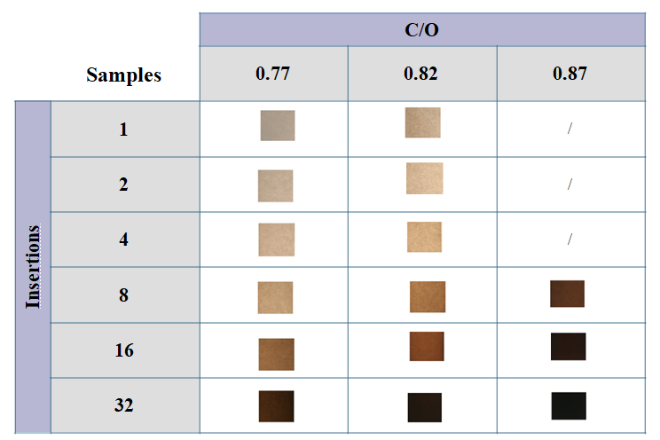

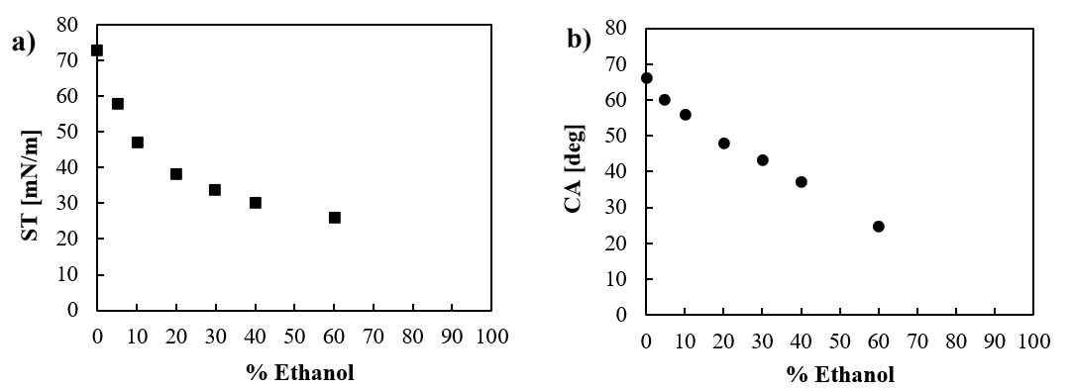
Figure 2–a) Surface tension and b) contact angle on the glass substrate as a function of the water-ethanol mixture composition.
The contact angle, CA, was measured with the First Ten Angstroms–1000tensiometer. The needle used for depositing the drop on the sample has an internal diameter of 0.406 mm. Depending on the wetting liquid, a drop of a certain volume is formed before it falls under its weight (e.g. for distilled water the drop volume is 8 μL) [8]. The distance between the needle tip and the surface is carefully evaluated to be minimized, so that the impact with the falling drop does not modify the nanostructure of the nanofilm. Despite this caution, soot particles may detach from the nanofilm and enter the drop. In any case, this is a negligible phenomenon not affecting the results. For each experimental test, at least ten replicates have considered and average values are reported therein.
3. Results and discussion
Table2 shows, for each carbon nanofilm sample, the images of the water drops deposited on it and the corresponding average contact angle. It is immediately evident that by increasing the C/O ratio and the number of insertions, the samples passed from a hydrophilic to a superhydrophobic behavior. The increase of the contact angle is not gradual, but revealed an abrupt transition from hydrophilic surfaces (CA<90°) to superhydrophobic ones (CA>150°). As expected, the number of insertions necessary to observe this hydrophilic-superhydrophobic transition is smaller for a higher C/O ratio and occurs in correspondence of similar blackening of the sample (see Table 2 and3).
Table2–Images of water drops and corresponding contact angle for carbon nanofilms produced with ethylene-air flame with three C/O ratios and a different number of insertions.
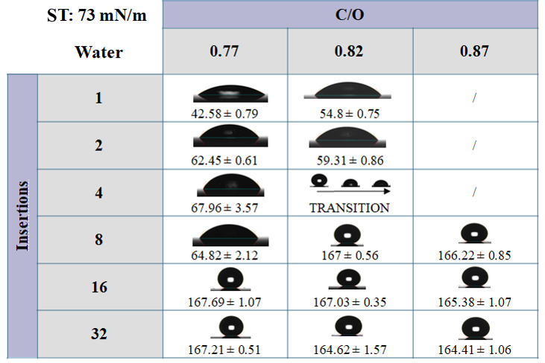

The hydrophilic behavior is probably related to a not uniform soot coating of the glass substrate; when the soot completely covers the substrate the sample becomes superhydrophobic. It is worth noticing that the CA of all the superhydrophobic nanofilms does not depend on the flame conditions and it is on average equal to 166°. Furthermore, Table 2 shows a peculiar wettability behavior for C/O = 0.82 and 4 flame insertions: the surface was superhydrophobic for the first seconds after the drop deposition, then a sudden reduction of the CA, below 90°, was measured. This behavior individuates the limit conditions for a coating good enough to reach superhydrophobicity.
Table3 shows the results obtained with the water-ethanol 95/5 mixture (with 5% of ethanol) having a surface tension of58 mN/m. The results are very similar to those observed with pure water in Table 2; in particular, the transition from philic to superphobic samples occurs in correspondence of the same flame conditions. For each sample, the CA measured with this water-ethanol mixture is equal or slightly smaller than the one obtained with pure water. In addition, the sample that previously showed an evolution from superhydrophobic to philic over time (C/O = 0.82 - 4 insertions) is immediately philic in this case.
Table3–Picture and contact angle of water-ethanol 95/5 drop deposited on carbon nanofilms produced with ethylene-air flame with three C/O ratios and a different number of insertions.
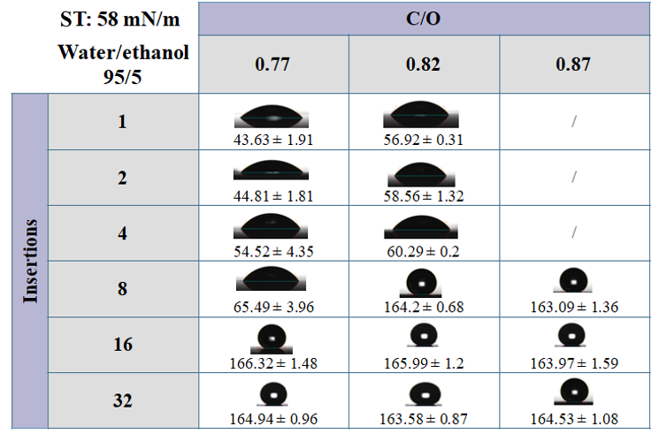
Table4– Picture and contact angle of water-ethanol 85/15 drop deposited on carbon nanofilms produced with ethylene-air flame with three C/O ratios and different number of insertions.
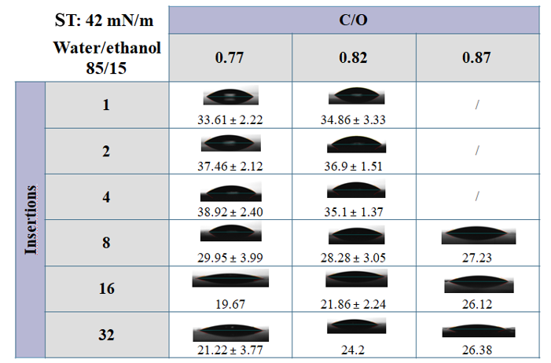
Table4shows the results obtained with a 85/15water-ethanol mixture, having a surface tension of 42 mN/m. With this low value of the surface tension, all the samples exhibit philic behavior. The contact angles are lower than those indicated in Table 3 and, unexpectedly. the lower CAs occur for those samples previously showing superhydrophobicity, i.e. for sample with higher C/O values and larger number of insertions.
The strong reduction of the surface tensions from 58 to 42 mN/m implies a complete switch of the wettability of all the superhydrophobic samples. We can better distinguish among them by individuating a wetting liquid with opportunely tuned surface tension. In particular, we selected a water-ethanol 93/7 mixture, with a surface tension of51 mN/m and we measured the contact angle of samples obtained with 16 insertions and three different C/O values. With this selected liquid, the surface wettability of each sample results variable, as shown in Figure 3. In particular, by depositing liquid droplets in different points of the sample surface, we found both philic (blue dots) and superphobic (red dots) regions, together with regions showing transition from superphobic-to-philic (green dots) behavior (as already observed in Table 2for the sample C/O = 0.82 and 4 insertions). Figure 4 shows that the nanofilm with C/O = 0.77 is prevalently philic with few superphobic and transition points, while for the nanofilms with C/O = 0.82 the number of superphobic points increases (with only three transition and one philic points). Nanofilms with C/O = 0.87are almost entirely superphobic with only two transition points and no philic points.
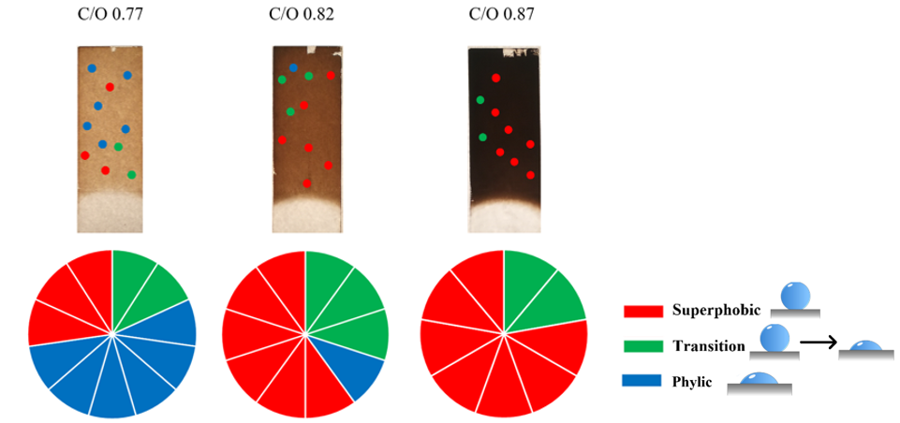
Figure 3 - Images representing philic, transition, and superphobic areas for samples made with 16 insertions and three different C/O ratios.
4. Conclusions
This study reports the preliminary results on the wettability of carbon nanofilms produced by deposing, on a glass substrate, soot deriving from premixed air-ethylene flame. Three C/O values equal to 0.77, 0.82 and 0.87 were tested and, in each case, we varied the number of substrate insertions in flame from 1 to 32 to obtain different coatings. Their wettability was measured with water, having a surface tension of 73 mN/m, and water-ethanol mixtures whose surface tension can be progressively reduced by increasing ethanol concentration.
Regarding tests with water, we observe that there is a critical soot coating level below which the carbon nanofilms are hydrophilic, above which they are superhydrophobic. In the latter case, CA is around 166° without any distinction among samples deriving from different flame conditions.
The nanofilms wettability measured with water-ethanol mixtures depend on the ethanol concentration. For low ethanol concertation (e.g.95/5 water-ethanol mixture), no significant modification of the CA is observed with respect to the case of pure water. For high ethanol concentration (e.g.85/15 water-ethanol mixture), all the nanofilms show philic behavior. For a selected ethanol concentration equal to 93/7water-ethanol mixture, we can discriminate among samples produced with different C/O ratios and a fixed number of insertions. This mixture can highlight heterogeneity in the wettability of the sample's surface. In particular, the coating obtained with the less sooting flame (C/O = 0.77) has large philic areas and small superphobic ones, while passing to more sooting flame (C/O = 0.82 and 0.87) the superphobic regions progressively enlarges. These preliminary results demonstrate that the use of wetting liquid with tunable surface tension is a rapid and extremely sensitive tool to assess surface homogeneity/heterogeneity and to discriminate among nanofilms obtained under different flame conditions.

5. Acknowledgements
This work is financially supported by the PRIN project 2017PJ5XXX: “MAGIC DUST”.

Reference
[1] A. Marmur, "Solid-surface characterization by wetting," Annual Review of Materials Research, vol. 39, pp. 473-489, 2009.
[2] S. Li, J. Huang, Z. Chen, G. Chen, and Y. Lai, "A review on special wettability textiles: theoretical models, fabrication technologies and multifunctional applications," Journal of Materials Chemistry A, vol. 5, pp. 31-55, 2017.
[3] Z. Cai, J. Lin, and X. Hong, "Transparent superhydrophobic hollow films (TSHFs) with superior thermal stability and moisture resistance," RSC advances, vol. 8, pp. 491-498, 2018.
[4] E. Fadeeva, S. Schlie-Wolter, B. Chichkov, G. Paasche, and T. Lenarz, "Structuring of biomaterial surfaces with ultrashort pulsed laser radiation," in Laser Surface Modification of Biomaterials, ed: Elsevier, 2016, pp. 145-172.
[5] M. R. Mulay, A. Chauhan, S. Patel, V. Balakrishnan, A. Halder, and R. Vaish, "Candle soot: Journey from a pollutant to a functional material," Carbon, vol. 144, pp. 684-712, 2019.
[6] B. Zhang, J. Duan, Y. Huang, and B. Hou, "Double layered superhydrophobic PDMS-Candle soot coating with durable corrosion resistance and thermal-mechanical robustness," Journal of Materials Science & Technology, vol. 71, pp. 1-11, 2021.
[7] G. De Falco, M. Commodo, M. Barra, F. Chiarella, A. D’Anna, A. Aloisio, et al., "Electrical characterization of flame-soot nanoparticle thin films," Synthetic Metals, vol. 229, pp. 89-99, 2017.
[8] J. Drelich, "Guidelines to measurements of reproducible contact angles using a sessile-drop technique," Surface innovations, vol. 1, pp. 248-254, 2013.

