Catalytic Assisted Non Thermal Plasma Process for Degradation of Acid Orange 7 Dye in Aqueous Solution

Giuseppina Iervolino*, Vincenzo Vaiano and Vincenzo Palma
Affiliation and address; 2 Affiliation and address
*Corresponding author E-Mail: giiervolino@unisa.it

1.Introduction
Non-thermal plasma is one of the most promising technologies used for the degradation of hazardous pollutants in wastewater. Recent studies evidenced that various operating parameters influence the yield of the Non-Thermal Plasma (NTP)-based processes. In particular, the presence of a catalyst, suitably placed in the NTP reactor, induces a significant increase in process performance with respect to NTP alone. For this purpose, several researchers have studied the ability of NTP coupled to catalysts for the removal of different kind of pollutants in aqueous solution. The most used method to create NTP is gas discharge in which the energy from the electric field is accumulated by the electrons through collision, and only a fraction of the energy will then be transferred to other molecules [1]. In order to induce NTP there are different types of reactors such as corona discharge, dielectric barrier discharge (DBD), plasma jet [25] or gliding arc [17]. Among these reactors, dielectric barrier discharge (DBD) presents, as advantages, a high removal rate for contaminants and a simple functioning, receiving for these reasons, more attention among the water treatment field in recent years [2]. However, some studies showed that sometimes the only use of non-thermal plasma (NTP) generated by the DBD does not guarantee the complete degradation of organic contaminants. Furthermore, without a catalytic material, it may be necessary to adopt operating conditions, requiring the use of very high voltages to induce NTP. For this reason, the synergistic effect of NTP with catalysts is certainly an interesting topic. In this work the aim is the optimization of the performance of the cold plasma technology coupled with a structured catalyst for the discoloration and mineralization of “acid orange 7” (AO7) azo dye.
2. Methods
The structured catalyst consists of Fe₂O₃ immobilized on glass spheres, and it was prepared by the “dip coating” method and characterized by different chemico-physical techniques. The experiments were carried out in a dielectric barrier discharge (DBD) reactor. It is a quartz cylindrical DBD reactor characterized by the presence of two electrodes: an inner electrode (a copper tube) and an outer one (stainless-steel mesh), placed at a specific distance between them. In the present study, the applied voltage between the two electrodes was lower, and it was equal to 12 kV. The aqueous solution to be treated is characterized by a specific initial concentration of AO7 dye (20 mg/L). During the tests the gas and liquid phase were analyzed.
3. Results and discussion
The effect of Fe₂O₃ amount immobilized on glass spheres (in the range 0.13 - 0.37 wt %), in terms of AO7 (20 mg/L) discoloration (a) and mineralization, (b) is shown in Figure 1.

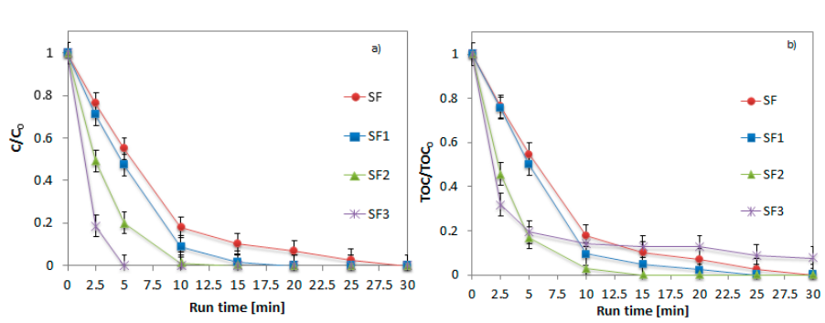

Figure 1. Influence of Fe₂O₃ amount on glass spheres in AO7 cold plasma degradation. Discoloration (a) and mineralization (b) behaviour during the run time. AO7 initial concentration: 20 mg/L. Glass spheres amount: 36 g. Applied voltage:12 kV. O₂ flow rate: 0.18 NL/min.
During the tests, it was possible to note a progressive decrease of AO7 concentration, obtaining a discoloration equal to 53, 80 and 100% with the SF1, SF2 and SF3 samples (Figure 1a), respectively after only 5 minutes of reaction time; after the same treatment time, the mineralization was equal to 53, 80 and 78% for the identical samples (Figure 1b). This effect is due to the presence of iron oxide (Fe2O3) which acts as a photocatalyst, activated by the presence of UV light emitted by the ionized gas.
4. Conclusions
The efficiency of the catalytic assisted cold plasma process, in the removal of AO7 azo dye pollutant in aqueous solution, was demonstrated. Furthermore, through the dip coating method, it is possible to immobilize Fe₂O₃ on the glass spheres surface and use it as catalyst in the NTP process. The catalytic packed material (named SF2) improved the performance of the DBD reactor, reducing the time required for discoloration and mineralization. In particular, in presence of this catalyst, it was possible to observe a simultaneous discoloration and mineralization behaviour, confirming the absence of reaction by-products.
References
The reference format is provided below [1 – 3]. [Times New Roman 10].
- Fridman, A. Plasma Chemistry; Cambridge University Press: Cambridge, UK, 2008
- Chen, J.; Du, Y.; Shen, Z.; Lu, S.; Su, K.; Yuan, S.; Hu, Z.; Zhang, A.; Feng, J. Non-thermal plasma and BiPO4 induced degradation of aqueous crystal violet. Sep. Purif. Technol. 2017, 179, 135–144

