Hemp fibers modified with graphite oxide as a sustainable system for removal of cationic dyes from wastewaters
Elena Lamberti^{1*}, Gianluca Viscusi¹, Giuliana Gorrasi¹
¹Department of Industrial Engineering, University of Salerno, Via Giovanni Paolo II, 132, 84084, Fisciano (SA), Italy
*Corresponding author E-Mail: ellamberti@unisa.it
1.Introduction
Nowadays, the presence of synthetic dyes in industrial effluents is leading to environmental concerns due to the impact of such contaminants on ecosystems and human health [1,2]. Dyes are substances used in many industrial fields [3]. Among all, methylene blue is a cationic dye with high water solubility. Many methods have already been applied to remove synthetic dyes from industrial wastewaters [4]. Adsorption process is the most used one since its technological simplicity, low cost and wide availability of adsorbents [5]. The use of common sorbents and their regeneration could noticeably increase the cost of the adsorption process [6]. In our case, in an effort to address the need to develop more sustainable biomaterial-based sorbents, modified and engineered hemp fibers are fabricated to be a versatile class of sorbents. The use of hemp fiberboards will allow to easily handle the adsorbent facilitating the desorption and reusability processes and limiting, in this way, the operating costs.
2. Methods
Low density hemp fiberboards (HF) were supplied by Nafco Company (Naples). (3-Aminopropyl)triethoxysilane (APTES), NaOH in pellet form, HCl solution 37% v/v, graphite oxide (GO) and methylene blue (MB) were used as reagents.
Scanning electron microscopy (SEM) was adopted to investigate the hemp fibers morphology. Before the analysis, hemp fabric samples (0.25*0.25 cm²) were covered with a thin film of gold by sputtering. Images were acquired by a Quanta 200 F microscope, working in high-vacuum mode.
Fourier transform infrared (FTIR) analysis was performed using a Bruker spectrometer model Vertex 70 (average of 64 scans, resolution of 4 cm⁻¹). The spectra were normalized taking as reference the peak absorbance at 1054 cm⁻¹ (=C–CO/C–C stretching vibration) [7].
Point of zero charge (pH_{PZC}) was evaluated as reported hereinafter. The point of zero charge (PZC) is the pH of the solution at which the net surface charge is zero. An initial solution of NaNO3 (0.1 M) was prepared. An aliquot of 40 mL of NaNO₃ solution (0.1 M) was collected in ten flasks. The pH was set from 3 to 12 by using HCl (1 M) and NaOH (1 M) solutions. Then, a fixed amount of adsorbent was placed inside the flasks, shaked for 24 h, at room T and 350 rpm. After that, the solid adsorbent was removed and the final pH (pH_{f}) was evaluated by using a pH-meter (Crison-pH-Burette 24 1S). The change in pH was calculated and a plot of ΔpH versus the initial pH (pH_{i}) was obtained from the experimental data. The pH_{PZC} was easily estimated by the intercept on x-axis of the curve.
Adsorption tests, in batch process, were carried out. Dye solutions were prepared by dissolving MB in distilled water, in order to obtain three solutions at concentrations of 5 mg/L, 20 mg/L and 35 mg/L. Then, a pre-weighed amount of adsorbent was immersed in MB solution. The adsorption dosage was fixed at 10 g/L. The pH of the MB solutions was adjusted by adding NaOH (1 M) or HCl (1 M) solutions. The adsorption tests were carried out in batch conditions by shaking the samples at set temperature for 24 h. The concentration of MB in the solution was then calculated through UV–Vis technique by taking the absorbance at 664 nm which refers to the maximum absorption wavelength of methylene blue.
Desorption studies were carried out by agitating the used HF/GO adsorbent with ethanol (40 mL) for 4 h at 350 rpm. The adsorbent was then dried at 100 °C for 8 h. After that, the regenerated adsorbent was ready to be further used for adsorption tests.
For examining the probability of leaching out of GO from adsorbent surface, 0.04 g were immersed in 50 mL of distillate water at pH = 7 and room temperature. The release of GO into the solution was measured after 1 h, 5 h, 10 h, 24 h and 5 days through UV–Vis technique by taking the absorbance at 230 nm.
3. Results and discussion
The use of hemp fibers modified with graphite oxide for the removal of methylene blue from aqueous solutions was investigated. SEM micrographs of untreated HF and HF modified with GO. After GO treatment, hemp fiber surface still keeps its morphology.
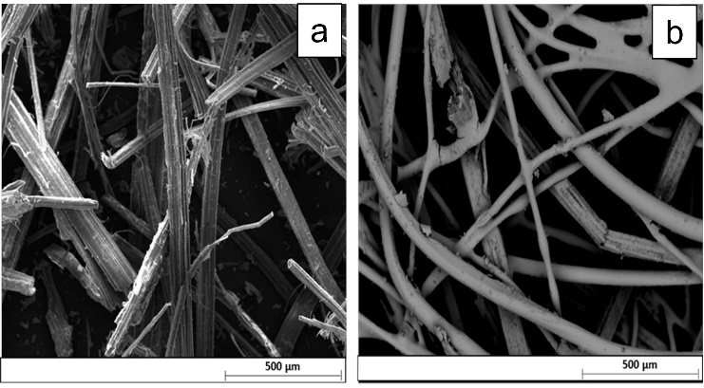
Figure 1. SEM micrographs of a) HF and b) HF/GO
Figure 2a reports the FTIR spectra of untreated hemp fiberboards and GO treated ones. Regarding the not modified HF, the IR region 3000 cm⁻¹-3600 cm⁻¹ is indicative of hydroxyl groups (OH) in polysaccharides. In the HF/GO IR-spectrum, the C=O carbonyl stretching at 1728 cm⁻¹ and the C–O epoxide group stretching at 1229 and 1061, 1036 cm⁻¹ are observed. Finally, the peak at 1625 cm⁻¹ can be associated to the sp² character of C=C functional groups. The results mentioned above indicated the effective deposition of GO onto the surface of hemp fibers. To further prove that, the peaks belonging to OH broad band (3600-3000 cm⁻¹) are analyzed by applying a deconvolution algorithm followed by a curve fitting procedure (Figure 2b and 2c).
Figura 2. FTIR spectra of untreated and GO treated hemp fiberboards; b and c) FTIR deconvoluted spectra of untreated and GO treated hemp fiberboards.
Parameters such as contact time, pH, temperature and initial concentration of dye were varied and their effects on the adsorption recovery were evaluated.

Figure 3. qt versus t for adsorption of MB at different temperatures and different pH. On the right side, UV-Vis spectra variations as function of contact time are present
The adsorption process attained the equilibrium within 30 minutes while the adsorption capacity was found to increase with increasing contact time. Maximum adsorption capacity slightly increases with temperature indicating that the process is slightly endothermic (∆H=3.43 KJ/mol). The amount of dye was found to be highly dependent on pH regime, initial concentration of dye and slightly dependent on temperature. The pH level has important bearing on adsorption content indicating that weak electrostatic interactions could exist between cationic dye and electron rich sites of surface. Regeneration studies showed 5% drop in adsorption capacity after 7 cycles. A mathematical algorithm was applied to individuate the optimal set of process parameters (pH=9.25, T=53.8°C and C₀=13.2 mg/L) which maximizes the removal capacity.
4. Conclusions
The present study concerns the use of an agro-based waste material, such as hemp fibers, modified with graphite oxide as an innovative and sustainable adsorbent for the removal of organic dye from aqueous solutions. Effect of temperature, sorbate concentration and pH on adsorption was investigated. The produced adsorbent is chemically stable, showing no noticeable leaching of GO. It follows that hemp fibers modified with carbons could be used as an easily available adsorbent. So, it is raising up as an alternative for costlier adsorbent materials used in wastewater treatment processes.
References
Bibliography
[1] Guo R, Wilson LD. Synthetically engineered chitosan-based materials and their sorption properties with methylene blue in aqueous solution. J Colloid Interface Sci 2012;388:225–34. https://doi.org/10.1016/j.jcis.2012.08.010.
[2] Renita AA, Vardhan KH, Kumar PS, Ngueagni PT, Abilarasu A, Nath S, et al. Effective removal of malachite green dye from aqueous solution in hybrid system utilizing agricultural waste as particle electrodes. Chemosphere 2021;273:129634. https://doi.org/10.1016/j.chemosphere.2021.129634.
[3] Crini G, Torri G, Lichtfouse E, Kyzas GZ, Wilson LD, Morin-Crini N. Dye removal by biosorption using cross-linked chitosan-based hydrogels. Environ Chem Lett 2019;17:1645–66. https://doi.org/10.1007/s10311-019-00903-y.
[4] Forgacs E, Cserháti T, Oros G. Removal of synthetic dyes from wastewaters: A review. Environ Int 2004;30:953–71. https://doi.org/10.1016/j.envint.2004.02.001.
[5] Bhattacharya KG, Sharma A. Kinetics and thermodynamics of Methylene Blue adsorption on Neem (Azadirachta indica) leaf powder. Dye Pigment 2005;65:51–9. https://doi.org/10.1016/j.dyepig.2004.06.016.
[6] Sarioglu M, Atay ÜA, Sarioglu M, Atay UA. Removal of methylene blue by using biosolid. vol. 8. 2006.
[7] Das M, Chakraborty D. Influence of alkali treatment on the fine structure and morphology of bamboo fibers. J Appl Polym Sci 2006;102:5050–6. https://doi.org/10.1002/app.25105.

