Flashback phenomenon in domestic condensing boiler in H₂-enriched admixtures

Rachele Lamioni^{1*}, Filippo Fruzza¹, Leonardo Tognotti¹, Chiara Galletti¹
1 Dipartimento di Ingegneria Civile e Industriale, Università di Pisa, 56126 Pisa, Italy;
*Corresponding author E-Mail: rachele.lamioni@ing.unipi.it

1.Introduction
In the context of the energy transition, hydrogen may play a fundamental role following the European road map which forecast its use for up to 24% of the final energy demand by 2050 [1]. Hydrogen can be produced through the electrolysis of water, from the excess of solar and wind energy, representing the carbon-free energy vector par excellence. Furthermore, in controlled quantities, it can be directedly introduced into the existing gas network. Moreover, current EU policies are focusing of regional hydrogen ecosystems, so-called hydrogen valleys, exploiting the local availability of renewable energies to promote decarbonization of local industrial process and domestic heating.
However, the conversion of this green fuel in existing end-user appliances, as domestic condensing boilers, must be carefully evaluated as hydrogen has thermo-chemical characteristics that are extremely different from natural gas. With the same equivalence ratio, hydrogen has significantly higher adiabatic temperatures and laminar flame velocities (S_{L}) than natural gas. In particular, the laminar velocity of the flame increases from S_{L} = 0.4 m/s to S_{L} = 2.5 m/s when switching from natural gas to hydrogen under stoichiometric conditions. Hence, a serious problem can be flashback phenomena, i.e., with the flame returning to the injection, that can lead to significant safety problems.
Domestic appliances such as condensing boilers are equipped with perforated burners injecting a premixed gas mixture into the combustion chamber. Such burners are typically designed through the experience of the manufacturer [2] based, of course, on the use of natural gas. In this context, with the desire to switch to green fuels a better understanding of the combustion process and, above all, of the mechanisms for stabilizing the premixed flames is fundamental.
This work aims to suggest a numerical model to evaluate the possible occurrence of flashback in when feeding H2-admixtures in conditions relevant for domestic boilers. Indeed, the analysis of the minimum issuing velocity needed to avoid flashback is of key importance. It is worth mentioning that such issuing velocity may be remarkable different that the laminar flame speed as it depends on the manner the flame anchors to the burner.
For this purpose, a preliminary analysis is carried out using one-dimensional flames to estimate he characteristics of the premixed flames as the h2 content varies, such as laminar speed and adiabatic flame temperature. Then, 2D transient numerical simulations (in axial symmetry) are performed with detailed kinetics to characterize the flame from a circular hole, exploiting periodic boundary conditions to simulate a perforated burner of condensing boilers domestic. Since the burner plate is crucial in flame stabilization, the numerical model also includes the corresponding solid domain with a conjugated heat transfer approach.
2. Methods
Initially, 1D simulations of freely propagating premixed flames are carried out with the open-source software Cantera [3], to estimate the characteristics of the flames at different operating conditions in terms of equivalence ratio (in the range from 0.5 to 1.0) and percentage of H₂ (from 0% to 100%).
Then, numerical simulations with computational fluid dynamics (CFD) techniques are performed of hydrogen-methane/air premixed laminar flames in a 2-D field. In particular, the geometry of an axially symmetrical hole of diameter D is considered using detailed chemical kinetics through the KEE58-Mech [4] mechanism, consisting of 17 chemical species and 58 reversible reactions. The system of conservation equations of the equations of mass, momentum, energy, and transport/reaction of chemical species with both a stationary and transient approach is solved through the ANSYS Fluent 2021.v1 code, based on finite volume methods. The computational grid is structured with 11k cells.

A sufficiently high flow rate, corresponding to the 50% of the nominal boiler power (i.e., 12 kW) in the steady-state is simulated to have a stable and developed condition for the flame, even in the vicinity of the burner plate. The latter is treated as a solid domain, through a conjugate heat transfer (CHT) approach. The interaction between the fluid and solid allows us to also estimate the burner temperature as operating conditions vary. To evaluate the flashback phenomenon, transient simulations are set up starting from the stable steady-state condition, progressively decreasing the input flow rate. An implicit second-order method and a time-step ∆t= 5.0e-6 s are used for time advancement, using the PISO pressure-velocity coupling algorithm. This procedure, for decreasing the input speed, allows estimating the speed at which the backfire phenomenon. In particular, we have considered 23% of H₂ content, corresponding to the G222 gas test, using an equivalence ratio fixed, ϕ= 0.8, typical for this type of operation.
3. Results and discussion
The laminar flame speed and adiabatic temperature, estimated through the 1-D simulations of freely propagating premixed flames, are reported in Figure 1(a) and Figure 1(b), respectively, for different CH₄-H₂ mixtures, namely 77%-23%, 50%-50% 20%-80% and pure H₂, and equivalence ratio ϕ = 0.5-1.0, all corresponding to lean conditions. It is noted that as the percentage of H₂ in the mixture increases, the laminar speed increases up to values of 2.5 m/s when considering the mixture of pure H₂. The laminar flame speed represents the speed at which the flame propagates from the burnt gas to the cool zone. Hence, in theory, the burner flow rate must exceed this speed to avoid flashback. However, this speed is the result of 1-D simulations of freely propagating flame, hence they do not consider the real domain of use and in particular the solid-fluid interaction as well as radiation effects. Figure 1(b) shows that by increasing the H₂ content, the adiabatic flame temperature T increases, and this trend may pose issues regarding the NO_{x} emissions, whose formation via the thermal route may be promoted.

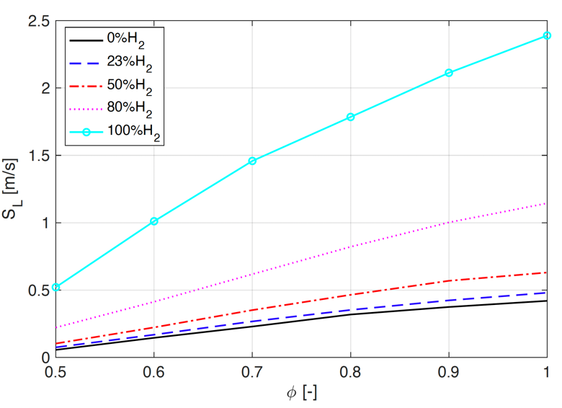
(a)
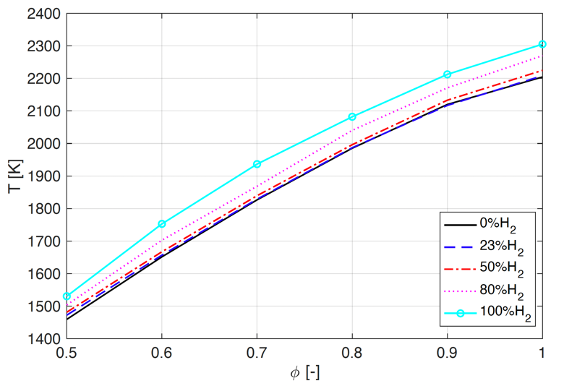
(b)
Figure 1. Laminar flame speed (a) and adiabatic temperature (b) for different H₂ content and different equivalence ratio.

Subsequently, an equivalence ratio equal to ϕ = 0.8 is chosen to carry out the CFD simulations in the 2-D field, considering the geometry of the hole in axial symmetry. This value is chosen as it represents a typical operating condition of domestic condensing boilers [5].
Figure 2 shows the temperature distribution for G222 gas mixture, having 23% H₂, as predicted to estimate the issuing velocity at which flashback occurs. Note that the axes are normalized with the diameter of the hole, which is D. The top panel of the Figure 2 shows the stable conditions for high velocity inlet. From this condition, the burner wall temperature is 950 K, which complies with the experimental values. Note that as the speed decreases, the flame front moves towards the entrance until it reaches the wall, here depicted through a dashed line.
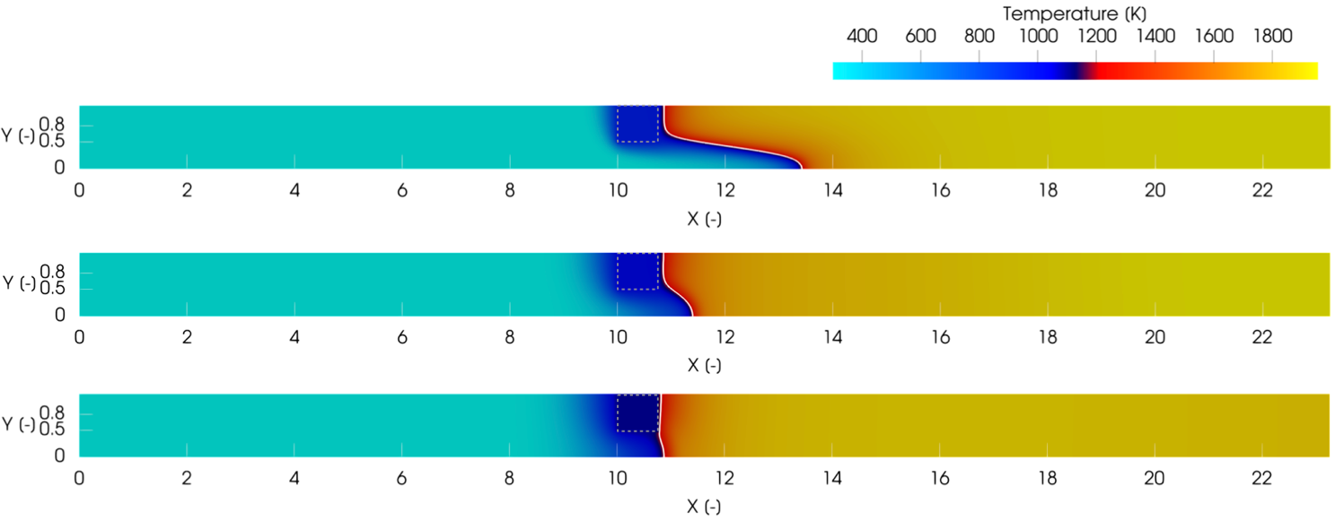
Figure 2. Temperature distribution for 23%H₂ and different velocity inlets: V_{i}=0.6-0.16-0.08 m/s.

In particular, for an input speed equal to V_{i} = 0.08 m/s the flashback phenomenon is triggered and the temperature of the solid increases up to 1150 K, as can be seen from the bottom panel of the Figure 2. Following this analysis, it was estimated that the flashback speed is 1.29 times higher than the S_{L} calculated by 1-D free-propagating flame simulations, as S_{L} = 0.35 m/s.

4. Conclusions
This work proposes a numerical procedure, based on CFD simulations, to estimate the velocity at which flashback of H2-admixtures may occur in conditions that are relevant for domestic condensing boiler. Preliminary, the characteristics of the freely propagating premixed flames in terms of adiabatic flame temperature and laminar flame speed are analyzed for different H₂ contents and equivalence ratios. through 1-D simulation. It is observed that the interaction of the flame with the solid walls is fundamental in triggering the flashback phenomena. In particular, it was found from the transient 2-D CFD simulations, that the issuing velocity at which flashback occurs is 1.29 time higher that the laminar flame speed in case of the G222 test gas with 23% of H₂. This study may help investigating strategies of burner design aimed dealing with high H₂ contents in the perspective of decarbonize the domestic heating sector.
References
- F. Cell and H. J. Undertaking, “Hydrogen roadmap europe: A sustainable pathway for the european energy transition,” Hydrogen Knowledge Centre, no. 2019, 2019.
- F. Schiro and A. Stoppato, “Experimental investigation of emissions and flame stability for steel and metal fiber cylindrical premixed burners,” Combustion Science and Technology, vol. 191, no. 3, pp. 453–471, 2019.
- D. G. Goodwin, R. L. Speth, H. K. Moffat, and B. W. Weber, “Cantera: An object-oriented software toolkit for chemical kinetics, thermodynamics, and transport processes.” https://www.cantera.org, 2021. Version 2.5.1.
- R. Bilger, S. Stårner, and R. Kee, “On reduced mechanisms for methane-air combustion in non-premixed flames,” Combustion and Flame, vol. 80, no. 2, pp. 135–149, 1990.
- Lamioni, R., Bronzoni, C., Folli, M., Tognotti, L., & Galletti, C. (2022). Feeding H2-admixtures to domestic condensing boilers: Numerical simulations of combustion and pollutant formation in multi-hole burners. Applied Energy, 309, 118379.

