Using Dissipative Particle Dynamics as a Computational Rheological Tool: simulation of high Schmidt number fluids

Nunzia Lauriello¹, Antonio Buffo¹*, Gianluca Boccardo¹, Daniele Marchisio¹, Martin Lisal^{2,3}
1 DISAT – Institute of Chemical Engineering, Politecnico di Torino, C.so Duca degli Abruzzi 24, Torino 10129, Italy;
2 Department of Molecular and Mesoscopic Modelling, The Czech Academy of Sciences, Institute of Chemical Process Fundamentals, Prague, Czech Republic;
3 Department of Physics, Faculty of Science, J. E. Purkinje University, Ústí n. Lab, Czech Republic
*Corresponding author E-Mail: antonio.buffo@polito.it

1.Introduction
One of the challenges of modern chemical engineering is to model the rheology of structured fluids, exploiting the increasing computational power together with more efficient computational methods. These modelling activities are extremely useful, as they contribute to reduce the number of experiments for investigating the scale-up and design of equipment for the processing of structured fluids. Structured fluids are very common in the food, personal-care, house-hold cleaner and pharmaceutical industries and include polymeric solutions and melts, suspension of colloidal particles, micellar solutions and liquid foams ^{[1]}. Their rheological properties are very important as they define their possible applications, and they play a crucial role in the definition of design and scale-up rules for the corresponding processes and equipment. Depending on the system composition and the shear stresses, structured fluids arrange themselves in different micro-structures corresponding to different rheological behaviors. In the last years, several computational models have been developed to describe the behaviour of these fluids. At the largest scale of interest, Computational Fluid Dynamics (CFD) can be used to predict flow field in industrial scale equipment, giving the possibility to estimate important macroscopic quantities, such as pressure drop or power input, which are crucial for process design and optimization. However, the transport properties of the complex fluid are an input information of a CFD simulation, and such important information requires the fluid characterization at lower scales. Because of the characteristic size of the system and the time evolution of the process under investigation, conventional molecular simulation methods are not suitable for the description of structured fluids, in fact they rely on fully-atomistic approach, resulting in high computational costs. To overcome this limitation, Dissipative Particle Dynamics (DPD) is here employed ^{[2]}. DPD is considered one of the most flexible simulation techniques: both static and flowing structured fluids, and more in general soft matter systems, are treated at physically interesting length- and time-scales. This method involves the use of Coarse-Grained (CG) models, in which groups of atoms and molecules, so-called “beads”, are processed as single units, each representing a complex molecular component of the system. In this perspective, it is therefore possible to simulate the hydrodynamic behaviour of structured fluids with a considerably lower number of particles, thereby reducing the computational effort. Dissipative Particle Dynamics is a powerful mesoscopic modelling technique widely used to qualitatively predict complex fluid morphology and structural properties. While its ability to rapidly scan conformational space is well known, it is unclear whether DPD can correctly calculate the viscosity of complex fluids ^{[3]}. Indeed, although standard DPD gives good results in predicting static equilibrium properties, several studies in the literature report that the DPD method fails in reproducing the transport properties of real fluids. In particular, in their work, Groot and Warren showed that the original DPD scheme results in a Schmidt number of O(1), unacceptably low for the simulation of liquid water at room temperature and pressure. The Schmidt number, Sc, is a dimensionless number defined as the ratio between the fluid kinematic viscosity $ν$, and the self-diffusion coefficient $D$:
$$\begin{aligned}Sc=\frac{ν}{D}. \#\left(1\right)\end{aligned}$$
It groups two important transport properties giving a measure of the relative importance between fluid particle diffusion and momentum diffusion. For a typical liquid, the Schmidt number is O(10³), meaning that the momentum is usually transported more efficiently than fluid particles themselves, because of the caging effect of the interparticle potential. The dependence of the Schmidt number on the various DPD parameters can be expressed as:
$$\begin{aligned}Sc \sim { γ}^{2}ρ^{2}r_{c}^{8},\#\left(2\right)\end{aligned}$$
where $γ$ is the dissipative parameter, $ρ$ is the density of DPD fluid and $r_{c}$ is the cutoff radius for interparticle forces. However, even if these parameters strongly affect the Schmidt number simply by increasing them, also the computational costs would increase either directly, or indirectly by having to decrease the time step in order to maintain the simulation stability. In this work, we decided to investigate the performance of the transverse DPD thermostat, specifically formulated for the prediction of transport properties via DPD, in simulating high Sc number fluids with equilibrium simulations ^{[4]}. We carried out a parametric study aiming at finding the DPD parameters capable of properly recovering the rheological behaviour of liquid water at room temperature and pressure, which is an important physical example requiring high Sc number and is a preliminary step to simulate complex fluids as aqueous polymer mixtures. We devoted particular attention to the numerical techniques for computing the transport properties from equilibrium simulations. Specifically, we compared the most adopted techniques for the viscosity calculation formulating a method that can be used for further investigations. Indeed, while non-equilibrium simulations are routinely employed in DPD to calculate both simple fluids and polymer viscosity with minimal computational cost it remains unclear whether the equilibrium approaches for the viscosity calculation can be confidently used with DPD, since these methods are subject to significant statistical error. This is a crucial point as we want to calculate the viscosity of morphologies resulting from the simulations without perturbing them, using an equilibrium simulation ^{[3]}.
2. Methods
As previously mentioned, DPD is a CG mesoscale simulation technique that simulates a fluid as a set of particles, often called beads which group together a certain number of atoms or molecules. In the case of a simple DPD fluid, bead $i$ experiences the force, $f_{i}$ defined by
$\begin{aligned}f_{i}=\sum_{j≠i}{{(F}_{ij}^{C}+F_{ij}^{D}+F_{ij}^{R})}.\#\left(4\right)\end{aligned}$A conservative contribution, $F_{ij}^{C}$, is a soft-repulsive force acting between two beads $i$ and $j$ and is defined as$\begin{aligned}F_{ij}^{C}=\left\{\begin{matrix}a_{ij}\left(1-\frac{r_{ij}}{r_{c}^{C}}\right){\hat{r}}_{ij}, & r<r_{c}^{C} \\ 0, & r≥r_{c}^{C}\end{matrix}\right.\#\left(5\right)\end{aligned}$
where $a_{ij}$ determines the strength of the repulsion between beads $i$ and $j$ and the compressibility of the simulated fluid; $r_{ij}=\left|r_{ij}\right|=|r_{i}-r{}_{j}|$ is the separation distance between the beads, ${\hat{r}}_{ij}=\frac{r_{ij}}{r_{ij}}$ is the unit vector of the bead-bead separation distance and $r_{c}^{C}$ is the cutoff radius for the conservative interactions. Dissipative and random contributions/forces, $F_{ij}^{D}$ and $F_{ij}^{R}$, respectively, introduce viscous drag and thermal noise to the system, respectively, and act as a thermostat. Dissipative cutoff radius, $r_{c}^{D}$, is introduced for these forces. As originally introduced ^{[5,6]}, the dissipative and random forces act, similarly as the conservative force, along the bead-bead separation distance and are pairwise additive. In this work, the standard DPD thermostat is combined with the transverse DPD thermostat ^{[7]} acting in the plane perpendicular to the bead-bead separation distance. The expressions for dissipative and random forces can then be written as
$$\begin{aligned}F_{ij}^{D}=-γ_{∥}w_{∥}^{2}\left(r_{ij}\right)\left({\hat{r}}_{ij}∙v_{ij}\right){\hat{r}}_{ij}-γ_{⊥}w_{⊥}^{2}\left(r_{ij}\right)\left(I-{\hat{r}}_{ij}{\hat{r}}_{ij}^{T}\right)v_{ij},\#\left(6\right)\end{aligned}$$
$$\begin{aligned}F_{ij}^{R}=σ_{∥}w_{∥}\left(r_{ij}\right)\frac{ξ_{ij}}{\sqrt{Δt}}{\hat{r}}_{ij}+σ_{⊥}w_{⊥}\left(r_{ij}\right)\left(I-{\hat{r}}_{ij}{\hat{r}}_{ij}^{T}\right)\frac{ξ_{ij}}{\sqrt{Δt}}.\#\left(7\right)\end{aligned}$$
Here $γ_{∥}$ and $γ_{⊥}$ are parallel and perpendicular dissipative parameters, respectively, analogously $σ_{∥}$ and $σ_{⊥}$ are parallel and perpendicular noise parameters, $w_{∥}\left(r_{ij}\right)$ and $w_{⊥}\left(r_{ij}\right)$ are weighting functions (WFs) for the parallel and perpendicular contributions. The dissipative and noise parameters are related to each other in order to satisfy the fluctuation-dissipation theorem:
$$\begin{aligned}σ_{α}=\sqrt{2k_{B}Tγ_{α}} , α∈\left\{∥,⊥\right\},\#\left(8\right)\end{aligned}$$
where $k_{B}$ denotes the Boltzmann constant and $T$ the system temperature. The WFs have the following functional form:
$$\begin{aligned}w_{α}\left(r_{ij}\right)={\left(1-\frac{r_{ij}}{r_{c}^{D}}\right)}^{s_{α}}, α∈\left\{∥,⊥\right\},\#\left(9\right)\end{aligned}$$
and its exponent, $s_{α}∈\left(0,1\right]$, plays an important role in modeling of dynamic properties of a DPD fluid.
The estimation of transport coefficients in DPD simulations takes place with numerical techniques developed for atomistic simulations. The self-diffusion coefficient in this work is calculated by the Einstein relation according to which it is proportional to the mean-square displacement (MSD) of the beads.
The methods for the evaluation of the viscosity from atomistic simulations are divided into two groups: equilibrium and non-equilibrium methods. To the first category belong methods such as Green-Kubo ^{[8,9]} and Einstein-Helfand ^{[10]}, while to the latter one the reverse non-equilibrium molecular dynamics (RNEMD). We were interested in the use of equilibrium methods to estimate the viscosity from the simulation. However, the RNEMD method by Müller-Plathe^{[11]} is used as a benchmark to double-check and verify the evaluation of viscosity by the equilibrium methods. Green-Kubo relation allows to calculate the viscosity by integrating the stress autocorrelation function (SACF) and has the following form:
$$\begin{aligned}μ=\frac{V}{k_{B}T}\int_{0}^{∞}{〈σ_{αβ}\left(t_{0}\right)σ_{αβ}\left(t_{0}+t\right)〉 dt}, \left(α≠β\right),\#\left(10\right)\end{aligned}$$
where $V$ is the system volume and $σ_{αβ}$ is the off-diagonal component of the stress tensor.
All simulations were performed by using the open-source software LAMMPS. The DPD model with extended thermostat was implemented as a user package. Regarding the calculation of the viscosity with the Green-Kubo approach, it is worth mentioning that LAMMPS uses an approximate algorithm to evaluate SACF, since the calculation according to its definition would be computationally intensive. Only a limited data set is actually employed in the SACF evaluation, namely the data points correlated every $N_{ev}$-th timestep for ${N_{ev}∙(N}_{rep}-1)$ timesteps. Instead, the SACF averages are computed every $N_{freq}$ timesteps. However, the final simulation time needs to be sufficiently long to carry out a correct estimation because, the algorithm makes use of the ergodic hypothesis to evaluate the ensemble average as a time integral. Therefore, the choice of $N_{ev}$, $N_{rep}$ and $N_{freq}$ is critical in the proper evaluation of SACF and, in general, in the viscosity evaluation.

3. Results and discussion
The crucial point for the viscosity calculation based on Green-Kubo method stands mainly in the numerical evaluation of the time integral of the SACF. This issue is linked to the well-known behaviour of the SACF which is reported in Fig. 1: after a first clear decaying trend the values of the SACF oscillate around zero with a certain noise, assuming also negative values. Therefore, the calculation of such time integral with a simple trapezoidal rule is affected by the tail oscillations. This behaviour results from the large fluctuations associated with the stress tensor element values affected by an extra noise due the presence of stochastic force leading to poor accuracy in the resulting viscosity. Moreover, the tail oscillations increase with increasing the friction coefficient. Different integration algorithms and the effect of finite timestep also play a role in the low statistical accuracy. A first challenge associated with the equilibrium method is both to improve statistical accuracy and to quantify results uncertainty. An additional challenge is to decide on the limit of the integration point. To overcome these issues, we tested several procedures. A first approach, denoted as “Procedure A”, was to adopt the procedure proposed by Jung and Schmid ^{[12]}. The procedure consists of the numerical integration by using the trapezoidal rule until the SACF values reached about 1% of their initial values. Then, the tail is fitted using a power-law, i.e.: $At^{-B}$, and integrated analytically. An alternative is to follow a procedure similar to the previous one, but with the preliminary application of a moving average filter to smooth out the tail oscillations. This is denoted as “Procedure B”. However, the fitted power-law always approaches have a common problem: the power law tends to zero asymptotically more slowly than the actual values of the SACF. The latter begins to oscillate between positive and negative values when the power law still does not reach the asymptotic value. For this reason, we tried to use two approaches for the analytical integration of the fitted power-law. In the first approach, the final integration time is the final SACF available from the simulation post-processing, depending on the $N_{rep}$ and $Δt$, and is labelled with number 1 in Table 1. In the second approach, the analytical integration is carried out up to $∞$ and is labelled with the number 2 in Table 1. Despite of the second approach has a significant impact on final viscosity values the effect of the tail noise is still not quantified by using these procedures.
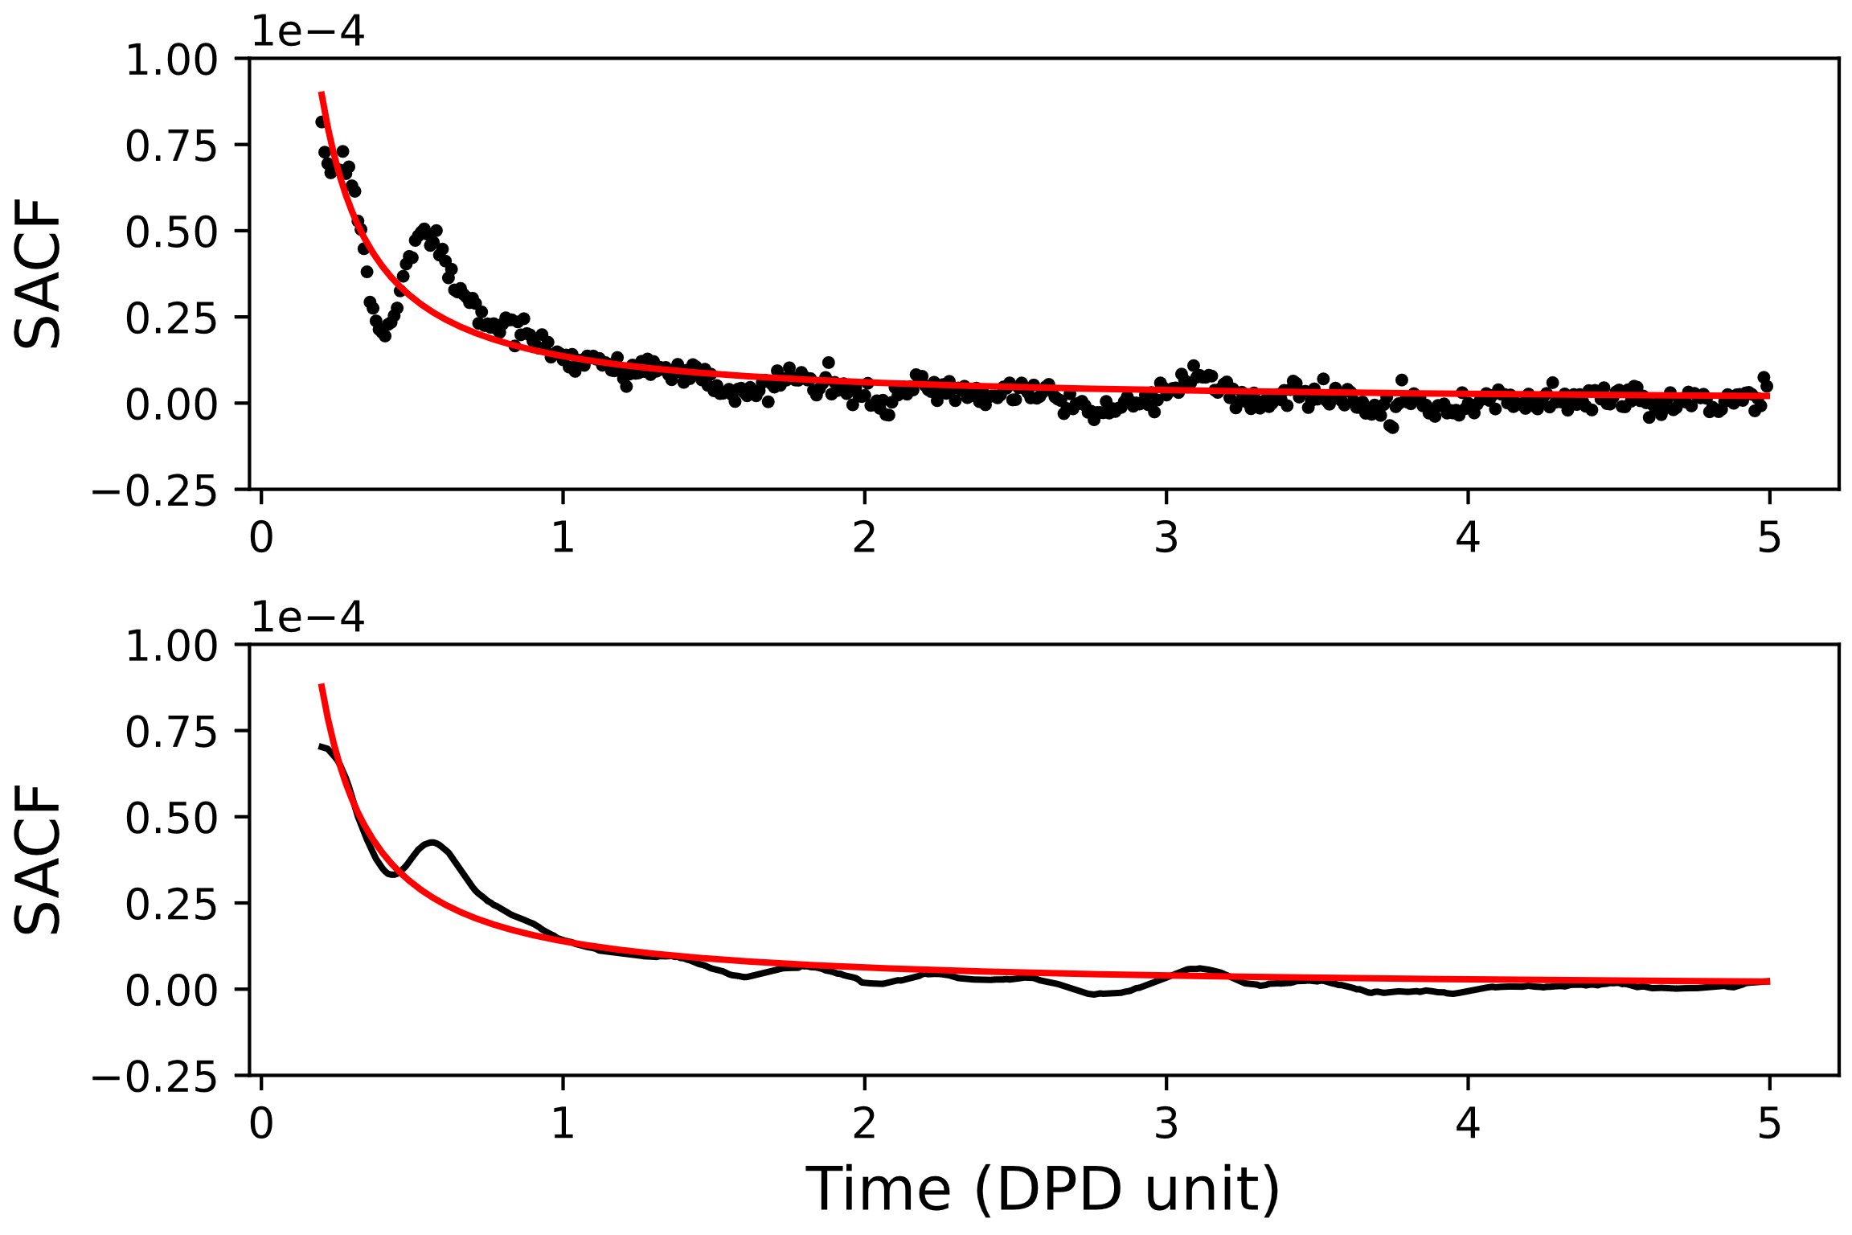
Figure 1. Two different representations of the tail of the same SACF. Top: procedure A. Black circles: points of the SACF. Red line: power-law fit. Bottom: procedure B. Black line: SACF after a moving average filter. Red line: power-law fit.
For this reason, we tried to use an approach based on the calculation of the viscosity cumulative integral function of time, denoted as in what follows as “Procedure C”. The idea behind this latter procedure is to evaluate the viscosity by using Eq. (10) progressively extending the integration interval up to the final SACF time. The result of Procedure C should theoretically be a monotonic curve that approaches an asymptotic value that corresponds to the system viscosity. However, this is impossible to reach exactly due to the intrinsic stochastic noise within DPD simulations and an example of such calculation is depicted in Fig. 2. Therefore, we opt to evaluate the system viscosity as the average value of the curve considering only the last DPD time units, avoiding the initial transient. Moreover, Procedure C is particularly convenient since it allows us to evaluate standard deviation and a coefficient of variation, providing therefore not only the expected viscosity value but also the associated uncertainty.
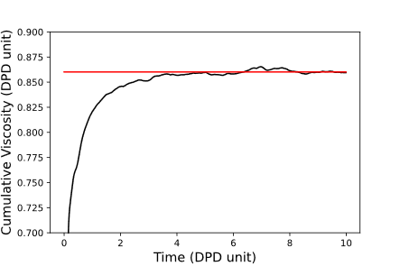
Figure 2 Cumulative integral of viscosity calculated using the Green-Kubo approach. Black line: viscosity cumulative integral. Red line: mean value and coefficient of variation calculated between $t=5$ and 10.
Table 1. Viscosity values (in DPD unit) calculated with various approaches. Procedure A: power-law fitting. Procedure B: moving average filter before power-law fitting. The superscripts 1 and 2 correspond respectively to a final integration time of $N_{rep}∙Δt$ and infinite. Procedure C: cumulative integral. E-H and RNEMD refers to Einstein-Helfand and reverse non-equilibrium molecular dynamics methods.
$$γ_{∥}$$ | A¹ | A² | B¹ | B² | C (mean) | C (Stand. dev.) | C (Coef. of var.) | E-H | RNEMD
4.5 | 0.8535 | 0.8846 | 0.8706 | 0.9399 | 0.860 | 0.002 | 0.002 | 0.847 | 0.860
9 | 0.9699 | 1.0018 | 0.9892 | 1.0613 | 0.957 | 0.004 | 0.004 | 0.923 | 0.930
15 | 1.1128 | 1.1468 | 1.1308 | 1.2065 | 1.065 | 0.002 | 0.002 | 1.071 | 1.055

Procedure C gives the closest results with the other two benchmark methods, and this procedure is then used in the rest of the work and has been automated. Furthermore, we integrated, also, this post-processing procedure into an iterative algorithm which during the simulation progressively identifies the simulation and the correlation post-processing parameters for the calculation of the SACF and capable to give us a value of viscosity within an acceptable range of uncertainty linked to the intrinsic stochastic noise of the method and timestep independent. This allows us to employ the minimal computational time in order to have an accurate statistic for the calculation of the SACF and consequently of the viscosity.
Once a reliable procedure for calculating the viscosity was found, the effect of different DPD parameters on Schmidt number of DPD fluid was investigated by performing different simulations, aiming to reproduce the Schmidt number of water at 25˚C equal to about 370. The parameters varied are the dissipative cutoff radius, $r_{c}^{D}$, the weighting function exponent, $s$ and the dissipative parameters, $γ_{∥}$ and $γ_{⊥}$. We, also, investigated the combined effect of timestep and integration algorithm on the computation of transport properties.

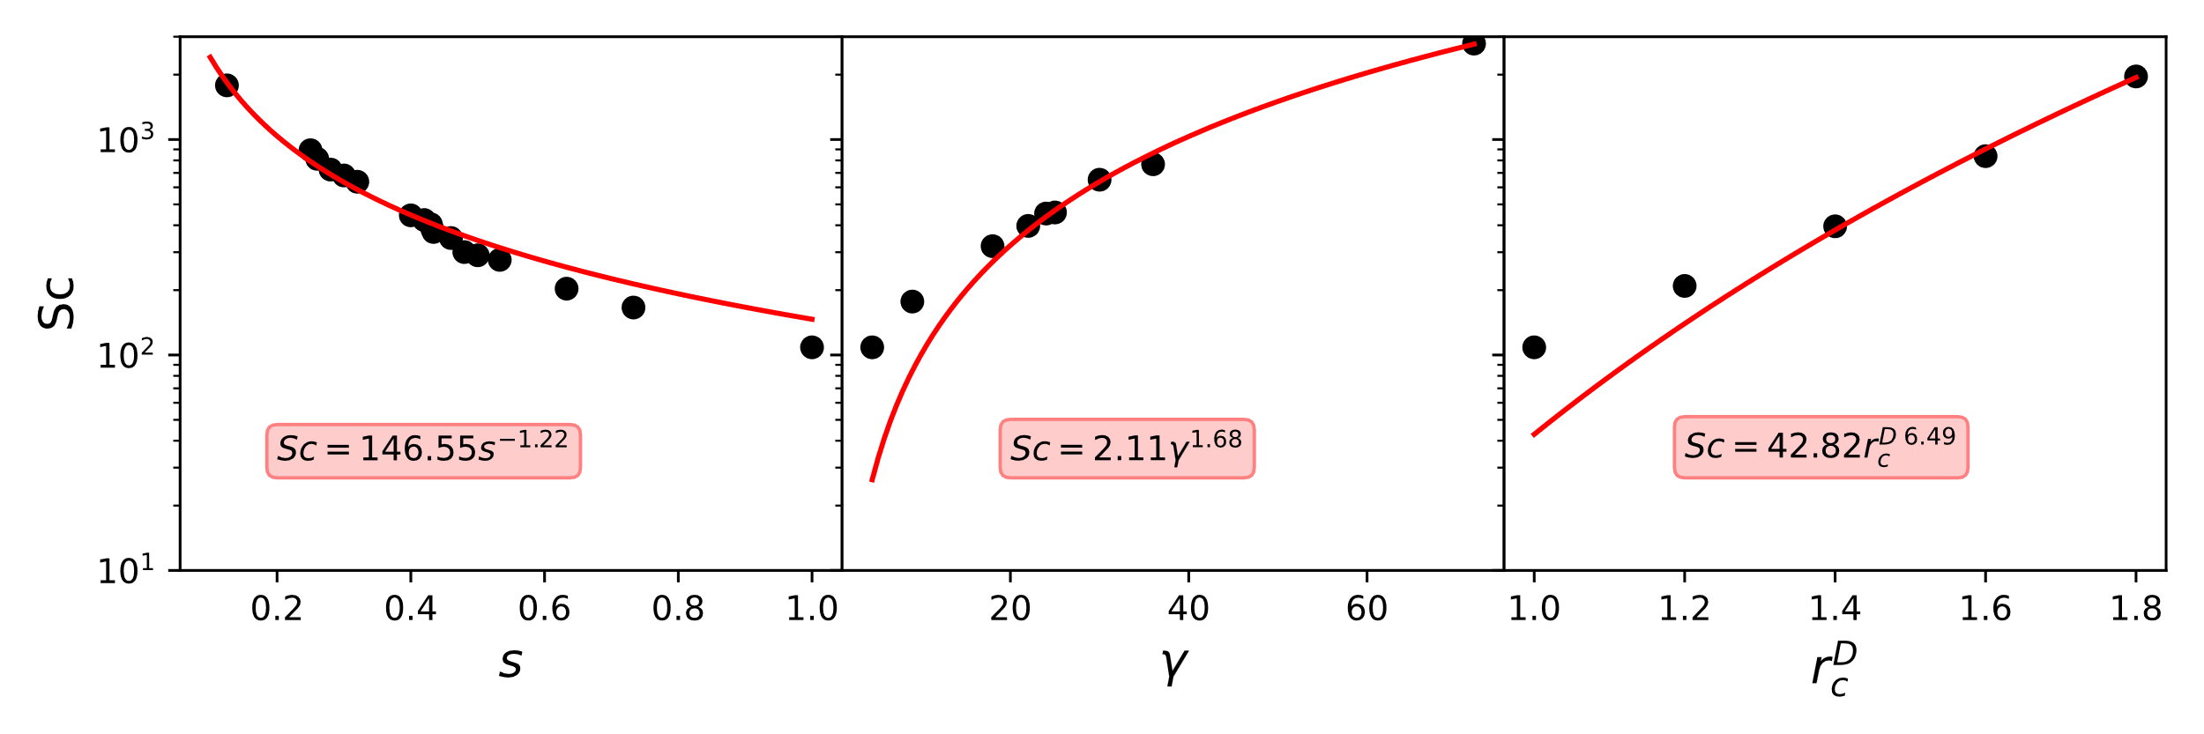
Figure 3. The Schmidt number as a function of (left) dissipative parameter γ, (center) GWF exponent s and (right) dissipative cutoff radius r_{c}^{D}. Dependances of the Schmidt number on the DPD parameters were fit to the power-law.
In Table 2, several aspects are worth to highlight. First, the conversion of viscosity and self-diffusion values from DPD units to real units, gives realistic results for liquid water at 25°C. Another important parameter reported in Table 2 is the so-called effective friction coefficient ^{[13]}, defined as follows:
$$\begin{aligned}γ^{eff}=\int_{0}^{r_{c}^{D}}{γw\left(r_{ij}\right)g\left(r_{ij}\right)}4πr^{2}dr_{ij},\#\left(13\right)\end{aligned}$$
where $g\left(r_{ij}\right)$ is the radial distribution function (RDF). The effective friction coefficient is a measure of the overall bead friction and enables us to the effects of $s$, $r_{c}^{D}$, $γ$ and implicitly of $N_{m}$ into one single characteristic quantity$.$ We can see from Table 2 that values of $γ^{eff}$ for the three sets are rather similar. It is interesting that sets of parameters giving the same $γ^{eff}$ give the same dynamical properties without perturbing the RDF which depends only on conservative contribution. In sight of this, we carried out a multi-parametric study aiming to investigate the Sc number scaling with $γ^{eff}$ and to build curves that can help us to determine the proper parameters we should use in order to simulate a fluid with given dynamical properties.

Table 2. The properties of DPD fluid corresponding to the three sets of DPD parameters, calibrated against the Schmidt number of liquid water at 25°C equal to about 370.
 | Set 1 | Set 2 | Set 3
$s$ | 0.434 | 1 | 1
$r_{c}^{D}$ | 1 | 1.38 | 1
$γ$ | 4.5 | 4.5 | 20.2
$$∆t$$ | 0.01 | 0.005 | 0.01
$$N_{m}$$ | 10 | 10 | 10
$$ρ$$ | 3 | 3 | 3
$ν^{DPD}$(G-K) | 5.89 | 5.87 | 5.88
$ν$ (m²/s) | 0.895·10⁻⁶ | 0.892·10⁻⁶ | 0.893·10⁻⁶
$$D^{DPD}$$ | 0.016 | 0.016 | 0.016
$D$ (m²/s) | 2.43·10⁻⁹ | 2.43·10⁻⁹ | 2.43·10⁻⁹
$$Sc$$ | 368.54 | 367.22 | 367.5
$$γ^{eff}$$ | 4.36 | 3.90 | 4.00

4. Conclusions
It can be concluded that, appropriately choosing the simulation parameters for the SACF calculation and adopting the developed method, the viscosity coefficient estimated via the Green-Kubo approach is comparable with that obtained by using reference techniques with the advantage that this method does not suffer of the intrinsic limitations of non-equilibrium methods. This becomes crucial for viscosity prediction in self-assembled non-Newtonian systems. Moreover, the proposed method of treating the noise of the SACF tail can give not only the mean viscosity value, but also the uncertainty of the numerical procedure associated with the viscosity evaluation. In this work, we show that such uncertainty is lower or comparable to the uncertainty of the experimental measurements.
The transverse DPD thermostat, including shear dissipation, can be used to simulate high Sc number fluids. It, in particular, can reproduce the proper momentum and mass transport behavior of liquid water, with at least three different sets of DPD parameters. The Sc number depends on model parameters whose effect can be grouped into the effective friction coefficient.
References
- R.G. Larson, The Structure and Rheology of Complex Fluids, Oxford University Press, 1999.
- R.D. Groot, P.B. Warren, Imperial College Press 107 (1997) 4423–4435
- M. Panoukidou, C. R. Wand, P. Carbone, Soft Matter 17 (2021) 8343-8353
- N. Lauriello, J. Kondracki, A. Buffo, G. Boccardo, M. Bouaifii, M. Lisal, D. Marchisio, Physics of Fluids 33 (2021) 073106
- P.J. Hoogerbrugge, J.M.V.A. Koelman, Europhys. Lett. 19 (1992) 155–160
- P. Español, P. Warren, Reviews in computational chemistry 30 (1995) 191–196
- C. Junghans, M. Praprotnik, K. Kremer, Soft Matter 4 (2007) 156-161
- M.S. Green, Journal of Chemical Physics, 20 (1952) 1281–1295
- R. Kubo, J. Phys. Soc. Jpn. 12 (1957) 570–586
- E. Helfand, Physical Review 119 (1960) 1
- F. Müller-Plathe, Physical Review E. 59 (1999) 5
- G. Jung, F. Schmid, The Journal of Chemical Physics 144 (2016) 204104
- F. Lahmar, B. Rousseau, Polymer 48 (2007) 3584-3592

