**Monitoring and control of a bioreactor for yeast fermenation**

Silvia Lisci1, Massimiliano Grosso, Stefania Tronci1*

*1 Dip. Ingegneria Meccanica, Chimica e dei Materiali, Università di Cagliari, Via Marengo 2, Cagliari, Italy*

*\*Corresponding author E-Mail: stefania.tronci@unica.it*

**1. Introduction**

In recent decades, biotechnological processes have shown significant growth. Although they concern different sectors (pharmaceutical, cosmetic, agro-food, biowaste treatment, etc.), they all have the cultivation of microorganisms as a common factor. Bioreactors are, in effect, the most important unit operations of biotechnological processes and the most difficult to control and monitor, being a complex combination of biological, chemical, and physical phenomena. Among the several biological processes, ethanol production through fermentation is surely one of the most investigated. Bioethanol represents an alternative to fossil fuels. It can be obtained from different sources such as agro-food residues, municipal waste, or dedicated energy crops collectively called “biomass”. Most of the worldwide production of ethanol occurs through fermentation. Although many advances have been made in ethanol fermentation technology in recent years, there are still significant challenges that need further investigations [1]. In this work, the problem of monitoring and control of a fermentation bioreactor has been addressed using a nonlinear estimator to obtain the direct control of product concentration. The proposed solution shows to be more effective than indirect temperature control [2] to reject disturbances affecting inlet composition, temperature and pH.

**2. Methods**

The bioreactor model used in this work is the same proposed in [2] and not reported here for brevity. The model is used as a virtual plant, and it describes the dynamic behaviour of six states, which are biomass concentration ($b$), ethanol concentration ($p$), substrate concentration ($s$), dissolved oxygen concentration ($do$), reactor temperature ($T_{r}$), and jacket temperature ($T_{j}$). Assuming that the substrate and dissolved oxygen concentration are measured online along with temperature, the proposed system is observable. It is thus possible to reconstruct all the states by using a proper estimation algorithm [3].

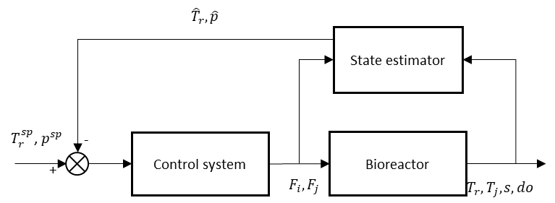

**Figure 1.** Control scheme for the bioreactor.

Because widely used in industry, the Extended Kalman Filter (EKF) has been used to infer ethanol composition in the bioreactor. The estimate is then used in a feedback control loop. According to previous studies [3], the estimator showed to be more robust and efficient if the ethanol concentration is not an innovated state. The dynamics of innovated ${\hat{x}}_{i}=[s,b,do,T_{r},T_{j}]$ and not innovated ${\hat{x}}_{u}=[p]$ products along with the measurement processor are reported in Eq. (1-3).

$\frac{d{\hat{x}}_{i}}{dt}=f_{i}\left({\hat{x}}_{i},{\hat{x}}_{u},u\right)+K\left(y-\hat{y}\right), {\hat{x}}_{i}\left(t_{0}\right)={\hat{x}}_{i,0}$ (1)

$\frac{d{\hat{x}}_{u}}{dt}=f_{u}\left({\hat{x}}_{i},{\hat{x}}_{u},u\right), {\hat{x}}_{u}\left(t_{0}\right)={\hat{x}}_{u,o=0}$ (2)

$K=P\left(t\right)H^{T}R^{-1}$, $\dot{P}\left(t\right)=P\left(t\right)F\left(t\right)+F^{T}\left(t\right)P\left(t\right)+Q\left(t\right)K\left(t\right)H\left(t\right)P\left(t\right), P\left(t_{0}\right)=P_{0}$ (3)

The control configuration is schematically reported in Figure 1. The cooling medium flowrate in the jacket ($F_{j}$) and inlet flowrate ($F_{i}$) are used as manipulated variables to control reactor temperature and product concentration. A PI algorithm is used in the control loops.

**3. Results and discussion**

The performance of the proposed control scheme has been evaluated for different conditions, and results are shown in Figure 2. The following variations have been introduced: decrease of specific growth rate equal to 20% (at time = 750 h), decrease of inlet substrate concentration from 60 to 40 g/l (at time = 1250) and increase of inlet temperature from 25 to 27°C (at time = 2000 h). Noise has also been introduced in the measured outputs. In all the conditions, the controlled system is able to maintain the set-points efficiently.



**Figure 2.** Temperature and biomass concentration (upper panels) manipulated inputs (lower panels). The set-points are indicated with black lines.

**4. Conclusions**

In this work, a state estimation and feedback control have been developed to maintain a bioreactor's desired conditions. Standard PI control algorithm is used to control reactor temperature and product concentration. The latter has been inferred by the available measurements by means of an Extended Kalman Filter. Results show that the proposed methodology can efficiently reject severe disturbances entering the system.

**References**

1. Devi, A., Singh, A., Bajar, S., Pant, D., & Din, Z. U. Ethanol from lignocellulosic biomass: an in-depth analysis of pre-treatment methods, fermentation approaches and detoxification processes. Journal of Environmental Chemical Engineering, 9 (2021) 105798.
2. Nagy, Z. K. Model based control of a yeast fermentation bioreactor using optimally designed artificial neural networks. Chemical engineering journal, 127 (2007) 95-109.
3. Lisci, S., Grosso, M., & Tronci, S. A geometric observer-assisted approach to tailor state estimation in a bioreactor for ethanol production. Processes, 8(4) (2020) 480.