Investigation of the effect of aeration time, storage and heating on the microstructure of oil-continuous foams with X-ray tomography and radiography

Lorenzo Metilli¹, Malte Storm², Shashidhara Marathe³, Aris Lazidis⁴, Stephanie Marty-Terrade⁵, and Elena Simone⁶*
1 Laboratoire Rhéologie et Procédés, Université Grenoble Alpes, Grenoble 38000 (France)
2 Helmholtz-Zentrum hereon, 21502 Geesthacht (Germany)
3 Diamond Light Source Ltd., Harwell Science and Innovation Campus, Didcot OX110DE (UK)
4 Nestlé Product Technology Centre Confectionery, York YO318TA (UK)
5 Nestlé Research, Lausanne 26 1000 (Switzerland)
6 Department of Applied Science and Technology (DISAT), Politecnico di Torino, Torino 10129 (Italy)
*Corresponding author E-Mail: elena.simone@polito.it

1.Introduction
Oil-continuous foams (also called oleofoams) are an emerging type of soft matter, which comprise a continuous liquid oil phase and a dispersed gas phase stabilized by fat crystals through a Pickering mechanism [1,2]. Oleofoams possess untapped potential for application in several manufacturing industries, such as food products with reduced calorific density, and topical delivery systems for active pharmaceutical ingredients. However, there is limited information available on these systems compared to their aqueous counterparts, due to the narrower choice of suitable stabilizers for the air/oil interface. Over the last 5 years research has focused on the relationship between the properties of the stabilizing crystals (size, shape, polymorphism) and the related foamability and stability of the oleofoams [1]. However, due to their opaque and soft nature, investigating the foam microstructure in a non-invasive fashion is challenging [3]. Such knowledge is required to understand the process-structure-function relationship, which in turn is required to prepare oleofoams with fine-tuned properties. In this work, a novel methodology for visualizing the microstructure of oil-continuous foams using synchrotron radiation X-Ray Tomography (SR-XCT) and Radiography (SR-XRR) is presented. A model system featuring cocoa butter and sunflower oil was chosen, due to the prominent role of these natural lipids in food and consumer products. The methodology was subsequently applied to the study of oleofoam microstructure during aeration, storage and heating, as these conditions are relevant for improving their manufacturing process, their shelf life and physical behaviour upon dissolution [4].
2. Methods
Mixtures of cocoa butter (CB) and high oleic sunflower oil (HOSO) were prepared by melting CB at 65°C and adding it to HOSO with a weight concentration of either 15% or 30%. The mixtures were cooled down using a Huber thermostat (Huber, Germany) under shear (DLH overhead stirrer, VELP Scientifica Italy) in a 1L capacity vessel until the formation of a gel (oleogel). The sample temperature was monitored with a Pt-100 thermocouple. Sample “15S” was prepared with 15% CB w/w and a cooling rate of -0.10 °C/min, while sample “30F” was prepared with 30% CB w/w and a cooling rate of -0.75 °C/min. The oleogels were then transferred to a planetary mixer (model 5KPM50, Kitchenaid, USA) and whipped with a constant shear rate (250 rpm). The oleogels were aerated for a total time of 30 minutes, pausing every 5 minutes to measure the amount of incorporated air (overrun). The overrun was calculated by filling a cup of a fixed volume (30 mL) with the foam and measuring its weight. The overrun is then calculated with Equation 1:
$$OR\left(\%\right)=100×\frac{(w_{gel}-w_{foam})}{w_{foam}}$$
Where w_{gel} and w_{foam} are the weight of the unwhipped gel and the oleofoam, respectively. The samples were analysed with SR-XCT after each aeration step. For the stored samples, oleofoams kept at 20°C for 3 and 15 months were analysed as well.
The tomographic analysis was carried out at the I13-2 beamline at Diamond Light Source (DLS) synchrotron (Didcot, UK), using a pink beam source of 27 keV. The 2D projections were acquired with a PCO edge 5.5 CMOS camera (2560 x 2160 pixels). The effective pixel size was 0.8125 µm. A small amount of sample (approximately 1 mm³) was placed on the top of a toothpick glued to the base of the cryocap. The samples were quickly immersed in liquid nitrogen (-196 °C) and installed on the tomography stage. The sample temperature was controlled using a Cryojet device (Cryojet XL, Oxford Instruments, UK) and set to -40 °C during the tomography acquisitions. The exposure time for each projection was set to 100 ms for 1001 projects, with a total time of 5 minutes. Each acquisition was repeated three times per sample.
The oleofoam samples were also subjected to controlled heating, and the changes in microstructure were studied using both SR-XCT and SR-XRR. The heating profile started from 20 °C until the melting temperature of the oleofoams (25 or 27°C) at a heating rate of 2 °C/min. Afterwards, the sample was cooled to 0°C at a rate of 6 °C/min and maintained at 0 °C for 5 minutes. A tomography acquisition was then performed. Radiography images were collected during the temperature ramp every 0.5 s. The radiography images were normalized and used to produce a set of difference images – where the i-th image is subtracted from the i+1-th image – to highlight changes in the microstructure. The difference image stack was further analysed with Principal Component Analysis (PCA) using MATLAB R2021a (Mathworks, USA). The score of the first principal component was plotted against the temperature to detect the onset of structural changes in the oleofoam during heating.
The tomographic images were reconstructed using the savu framework developed at the Diamond Light source; the projections were corrected for dark images and flat-fields images, and a ring-removal algorithm was applied. A Paganin filter was applied to further enhance the contrast between the bubbles and the continuous phase. The reconstructed volumes were then processed using a custom ImageJ routine (National Institute of Health, USA), which includes median filtering, Otsu thresholding, and segmentation based on the 3D Euclidean distance map. Bubbles were counted using the BoneJ plugin, and their volume and surface area measured. BoneJ was also used to measure the thickness of the continuous phase.
3. Results and discussion
Result showed that both type of oleofoams (15S and 30F) displayed an average bubbles size of 20 µm, with a mean sphericity of 0.88. These values remained similar from 5 until 30 minutes of aeration, suggesting that an equilibrium size and shape distribution was reached at the beginning the process (Figure 1). The main difference between the two samples was seen in the overrun and the oleogel thickness. In particular, sample 15S reached a higher overrun (180%) and a thinner oleogel thickness (11 ± 6 µm) in less time, compared to sample 30F which could reach only 130% overrun and retained a significant volume of unwhipped oleogel domains, resulting in a larger oleogel thickness (20 ± 13 µm) after 30 minutes of whipping.
Sample stored for 3 months displayed a decrease in the amount of bubbles (hence the overrun), and an increase in the oleogel thickness. This change was more significant for 15S samples; after 15 months, only sample 30F retained a sufficiently aerated structure, however displaying a further decrease in overrun and a slightly larger bubble size distribution owing to occurrence of Ostwald ripening (Figure 2). Concurrently, growth of the CB crystals could be seen in the continuous phase.
Heating the oleofoams resulted in an increase in the volume-weighted bubble size, due to the melting of the stabilizing fat crystals and the resulting bubble coalescence. The average size increased by 130% for sample 15S and by 109% for sample 30F. At the same time, the bubble sphericity increased from 0.88 to 0.95 (Figure 3). By employing SR-XRR, it was possible to visualize in real time the coalescence of the air bubbles, which occurred over the span of few seconds. Furthermore, the PCA analysis of the radiography images showed that the destabilisation of the oleofoams due to heating could be promptly arrested by lowering the temperature below the melting point of the fat crystals
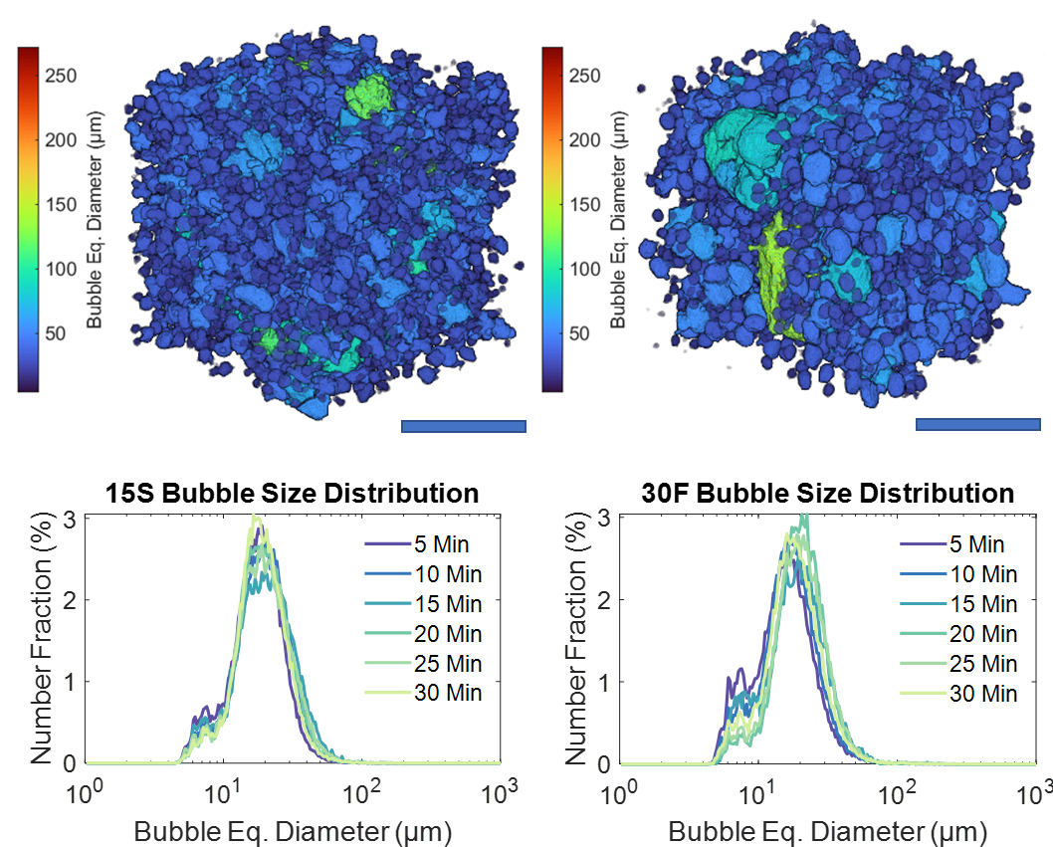
Figure 1. 3D renderings of two Volumes of Interest of a 15S (left) and a 30F sample (right) after 30 minutes of aeration. Scale bar is 250 µm. The bubble size distribution evolution during the aeration is plotted on the lower part of the figure.
Figure 2. 3D renderings of representative Volumes of Interest for each of the aged oleofoam samples: 15S 3 months (a), 30F 3 months (b), 15S 15 months (c), and 30F 15 months (d). The scale bar is 250 μm.

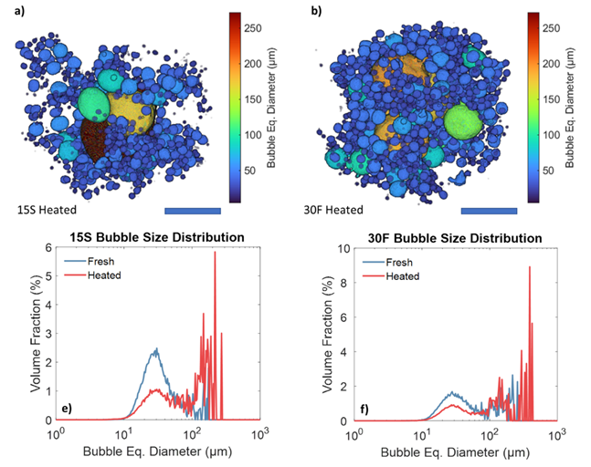
Figure 3. 3D renderings of samples 15S (a) and 30F (b) after being heated. The scale bar for the 3D renderings is 250 μm. Volume-weighed size distributions of sample 15S heated (e) and 30F heated (f) compared with their respective fresh samples.
4. Conclusions
In this work, the three-dimensional native microstructure of fat-stabilized oleofoams was investigated for the first time, both in static and dynamic experiments, using X-ray tomography and radiography. The aeration of oleofoams proceeded with a gradual increase in volume, concomitant with a decrease in the continuous phase thickness. Low-cocoa butter samples displayed a higher overrun (170%) and a lower oleogel thickness (10 μm), reaching an overrun equilibrium value after 15 min of whipping. High-cocoa butter samples, on the other hand, incorporated less air (125% overrun) and featured a coarse final microstructure, retaining fragments of unwhipped oleogel. The air bubble size distribution, centred at 20 μm, was not affected by the amount of solid fat or by the whipping time, suggesting that the shear induced during aeration produced stabilizing crystals with similar properties, regardless of the sample composition and the duration of whipping.
Oleofoam samples showed significant structural changes during storage, with the oleogel phase increasing its thickness, while the overrun decreased significantly for both samples analysed. The higher concentration of solid fat in the sample contributed to slowing down the disproportionation of the air bubbles, with sample 30F retaining a similar size distribution profile after 3 months. After prolonged storage conditions, however, only samples with 30% w/w CB maintained an aerated structure. Therefore, higher amounts of stabilizing crystals were beneficial to retaining the overrun and counteracting phase separation.
Heating the oleofoam samples to their melting point resulted in an increase in bubble sphericity, bubble coalescence, oleogel thickness, and a reduction of the total number of air bubbles. Sample 15S was more prone to coalescence than sample 30F, potentially due to the lower amount of stabilizing crystals. The increase in the bubble size followed by melting of the crystals both at the interface and in the bulk support the hypothesis that bulk contribution to stability in oleofoams is fundamental to prevent gas diffusion. The dynamic changes in the oleofoam microstructure were captured for the first time with XRR, showing clear evidence of bubble coalescence during heating. This body of work, owing to the non-invasive, three-dimensional approach to the study of oleofoams, contains significant information on the physical behaviour of these emerging materials, in relation to relevant processes such as their aeration, storage conditions that will contribute to their understanding, and their use in material formulation.
References
[1] Binks BP, Vishal B. Particle-stabilized oil foams. Adv Colloid Interface Sci 2021;291:102404. doi:10.1016/j.cis.2021.102404.
[2] Fameau AL, Binks BP. Aqueous and Oil Foams Stabilized by Surfactant Crystals: New Concepts and Perspectives. Langmuir 2021;37:4411–8. doi:10.1021/acs.langmuir.1c00410.
[3] Metilli L, Storm M, Bodey AJ, Wanelik K, Tyler AII, Lazidis A, et al. Investigating the microstructure of soft, microporous matter with synchrotron X-ray tomography. Mater Charact 2021;180:111408. doi:10.1016/j.matchar.2021.111408.
[4] Metilli L, Storm M, Marathe S, Lazidis A, Marty-Terrade S, Simone E. Application of X-ray Microcomputed Tomography for the Static and Dynamic Characterization of the Microstructure of Oleofoams. Langmuir 2022;38:1638–50. doi:10.1021/acs.langmuir.1c03318.

