Biodegradability evaluation of waste-derived Polyhydroxyalkanoates

Laura Lorini¹*, Marco Santini¹, Sara Alfano¹, Francesco Valentino², Andrea Martinelli¹, Marianna Villano¹, Mauro Majone¹

1 Department of Chemistry, La Sapienza University of Rome, Rome, 00185, Italy; 2 Department of Environmental Sciences, Informatics and Statistics, Ca’ Foscari University of Venice, Venice, 30172, Italy
*laura.lorini@uniroma1.it

1.Introduction
Biobased and biodegradable plastics are currently object of high interest within the biorefinery and circular economy approach. In this view, waste valorization and energy recovery can be realized through composting and anaerobic digestion of these materials since they are generally identified as biodegradable and compostable and then collected with the Organic Fraction of Municipal Solid Waste (OFMSW). Indeed, biodegradable bioplastics can be subjected to biological decomposition both in aerobic and anaerobic conditions, for the consequent production of carbon dioxide or methane. However, to be addressed to composting and anaerobic digestion treatments, either biodegradable and compostable plastics must meet the EU standards for SUP and packaging. Among biodegradable and biobased plastics, polyhydroxyalkanoates (PHA) are high added-value materials that can be recovered from waste activated sludge and different fermentable organic waste. They are biodegradable polyesters produced as intracellular carbon source by numerous microbes and have thermoplastic properties comparable to fossil-based plastics. The present study regards the evaluation of the Bio-Methane potential (BMP) of several PHA-based materials produced from mixed microbial culture and fermented mixture of OFMSW and sludge as substrate, within a pilot platform based in Treviso (Italy). PHA was produced from a feedstock composed by a mixture of the liquid slurry coming from squeezed OFMSW and the thickened sewage sludge from the treatment of municipal wastewater. The productive process is extensively described in a previous study [1]. Extraction with a mixture of aqueous-phase inorganic reagents was performed following a reserved protocol optimized by Biotrend S.A.. At the end of the extraction, the polymer was oven-dried obtaining a white powder (RU powder). In the framework of RES URBIS project, PHA purified by Biotrend was sent to SABIOMATERIALS for obtaining a melt-compounded pellet by mixing PHA with biodegradable additives (RU pellet). Finally, the pellet was sent to MiPlast, to produce blended PHA-PBS films by blown extrusion (Blend PHA-PBS). In this study, the powder and the pellet of RES URBIS PHA were melted and pressed (at a working T slightly below the melting point) to obtain films (RU film powder and RU film pellet, respectively). All these above-mentioned materials were tested for BMP in comparison with a commercial PHBV (HV 3%w/w) (Tianan powder) and thermal and chemical properties were determined before and after the biodegradation tests.
2. Methods
For the experimental set up, 14 serum bottles were filled with the 70 mL of mesophilic methanogenic sludge, 40 mL of mineral medium and 15mL of a 0.86 M NaHCO₃ solution as buffer. In order to maintain the Inoculum/Substrate ratio = 2:1 (g VSS/g material), about 175 mg of PHA material was added. The tests were carried out in duplicate for each material and for the blanks. From the headspace, 50 µL of gas phase were sampled with a gas syringe and directly injected into the gas chromatograph equipped with heat conductivity detector (TCD) for the determination of methane. Liquid samples were taken to monitor the volatile fatty acids (VFAs) concentration and the pH. VFAs analysis of filtered sample was conducted on GC equipped with flame ionization detector (FID). The materials were analyzed for viscosity average molecular weight (Mv) determination, differential scanning calorimetry (DSC) and thermogravimetric analysis (TGA), following the procedures reported elsewhere [2].
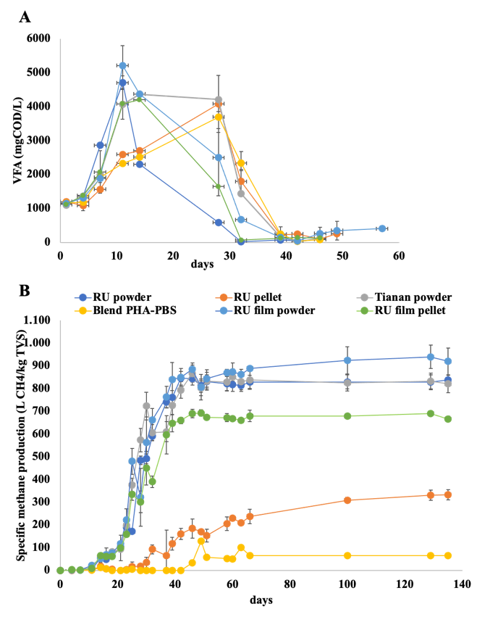
3. Results and discussion
VFA concentration monitored for each material is reported in figure 1A for the first 60 days of BMP test. After an initial peak caused by the fermentation of PHA materials, the concentrations of acetic and propionic acid started to decrease, until zero from day 40 in all the bottles. This effect corresponded to the beginning of methane production, as it can be observed in Figure 1B, confirming the activity of the acetoclastic methanogens. Considering the kinetics of biodegradation and the produced methane, the highest conversion was obtained from both the PHBV powders (RU powder and Tianan) and from RU film powder, as a consequence of the high specific surface area. As regards RU pellet and Blend PHA-PBS, a significantly lower level of conversion into methane was obtained, as shown by the trends. Overall, considering the specific methane production (expressed as L_{CH4}/kgTVS), a complete conversion to methane of PHA raw materials, including those produced from organic waste, can be confirmed [3]. Monomeric composition (i.e. HV content) of the whole RES URBIS set was in the range of 9 – 14 %w/w and the M_{v} of RU powder (207.4 kDa) and pellet (159.2 kDa) was lower than that one of Tianan (322.4 kDa). Melting temperatures (T_{m}) and temperatures at the highest rate of degradation (T_{d}^{max}) were determined by DSC and TGA analysis, respectively, for all the tested samples and also for RU pellet and Blend PHA-PBS residues. Indeed, since these latter were not easily biodegraded, it was possible to collect the residues at the end of the test. As an evaluation of the preliminary characterization of the recovered materials, it can be considered that they resulted macroscopically unchanged, as their properties, if compared to the original materials (158 – 167 °C and 263 – 288 °C, T_{m} and T_{d}^{max} ranges).
Figure 1. (A) VFA concentration; (B) specific methane production
4. Conclusions
As a main result, the biodegradability of PHA raw materials has been confirmed in anaerobic conditions, suggesting the possibility to dispose PHA wastes together with the OFMSW for anaerobic digestion and compost applications. On the other hand, further investigation are required, since the presence of additives and plasticizers, necessary for plastic processing and depending from the application requested, affect the biodegradability. In this view, further characterization of the residual solid materials and tests conducted in different conditions (e.g. thermophilic anaerobic BMP tests) will be carried out.
References
[1] Valentino F, Moretto G, Lorini L, Bolzonella D, Pavan P, Majone M, Ind. Eng. Chem. Res. (2019)
[2] Lorini L, Martinelli A, Capuani G, Frison N, Reis M, Sommer Ferreira B, Villano M, Majone M, Valentino F, Front. Bioeng. Biotechnol. 9(2021) 1–13.
[3] Battista F, Frison N, Bolzonella D, Environ. Technol. Innov. 22 (2021)101393.

Acknowledgements
The financial support from the H2020 EU project RES URBIS (GA 730349) is gratefully acknowledged.

