3D Bioprinting for the production of a perfusable vascularized model of a cancer niche

Federico Maggiotto^{1,2}, Lorenzo Bova^{1,2}, Elisa Cimetta^{1,2}*
1 University of Padua, Department of Industrial Engineering (DII) - Via Marzolo 9, 35131 Padova, Italy;
2 Fondazione Istituto di Ricerca Pediatrica Città della Speranza (IRP) - Corso Stati Uniti 4, 35127 Padova, Italy.
*Corresponding author E-Mail: elisa.cimetta@unipd.it

1.Introduction
The use of tumor models is increasingly advancing in the world of research. In particular, with the advent of three-dimensional (3D) cell cultures, new possibilities for investigation have opened up, making it possible to study tumor behavior in a more realistic environment that closely resembles cell physiology. However, one major limitation of 3D cell cultures is the size of the construct itself. Studies have shown that the limit of oxygen and nutrient diffusion in living tissues is about 100-200 µm - of course depending on the type of tissue analyzed [1]. Therefore, if the size of the 3D model exceeds this limit, it is necessary to employ techniques to simulate the behavior of a vascular network. We here propose to develop 3D models of cancers with a proper vascularization ensuring correct and uniform distribution of nutrients, especially in the bulk of the structure. Moreover, to represent in a more realistic way such a vascular channel, a method of endothelialization is here proposed, aimed at recreating endothelial coating of the walls of the channel [2].
3D cell cultures are mainly realized by exploiting 3D bioprinting techniques, through which structures are built by depositing biomaterials following precise instructions provided by the operator. Among the different possibilities available on the market today, we here used an extrusion 3D bioprinter (BioX; Cellink), which allows to sequentially extrude up to three different biomaterials, controlling their temperature throughout the process. Specifically, the structures are printed layer-by-layer, alternating - when necessary - the different biomaterials involved, thereby requiring each layer to act as a support for the following ones. The choice of materials and the geometry of the construct therefore play a key role in achieving the desired result, leading not only to proper cell attachment and proliferation but also providing the opportunity for their differentiation.
The creation of vascularized structures can be realized by exploiting the technique of sacrificial bioprinting, according to which two different materials are used: a matrix within which the cells are encapsulated and a sacrificial material that will be removed, leaving an empty channel in its place [3-4]. Several materials were tested in this study, identifying gelatin methacrylate (GelMA) and Pluronic F-127 (PLU) as the best candidates to be used as matrix and sacrificial ink, respectively [2].
2. Methods
Hydrogels are the most common choice as bioinks, so the first step of the work is the choice of the ideal materials. For our project, to create a structure that contains a vascular network exploiting sacrificial bioprinting, it is necessary to use two different hydrogels: one that acts as a matrix and one that can be easily removed – for example exploiting its thermoreversibility - to leave empty channels inside the other one.
The hydrogel chosen as matrix is an 8% w/v methacrylate gelatin (GelMA) which is biocompatible, biodegradable and photo-crosslinkable in the presence of a crosslinking agent, such as Irgacure 2959. GelMA is a semi-synthetic hydrogel composed of gelatin and methacrylic anhydride: gelatin alone can form physical gels only at specific temperatures and concentrations; the addition of methacrylic anhydride has therefore the purpose of functionalizing the lysines of gelatin to chemically modify the polymer and support photo-crosslinking.
The sacrificial ink, Pluronic F-127 (PLU), is a synthetic copolymer that exhibits opposite thermoreversibility to GelMA: it liquefies at temperatures below 15°C while it gels at higher temperatures. In the world of bioprinting this material is known for its excellent printability - especially at high concentrations (40 % w/v) - and it’s often used as a sacrificial material.
Hydrogels are synthesized in the laboratory from raw materials: GelMA is made from gelatin and methacrylic anhydride through a reaction at controlled pH and temperature [5], while Pluronic F-127 is prepared by mixing the desired amount - to obtain the optimal concentrations - in a biocompatible solvent, such as 1xPBS (Phosphate-Buffer Saline) or water.
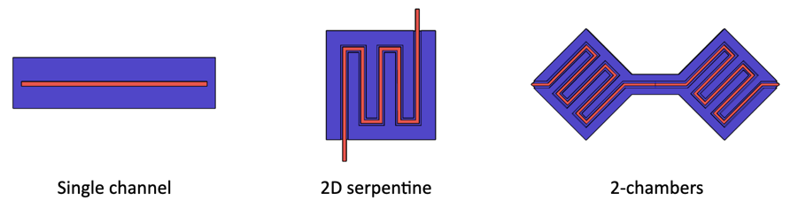
The focus then shifts on the design of a structure that can be fabricated using 3D bioprinting and that is suitable and efficient for the intended purpose. Using AutoCAD® software, we designed several structures each aimed at simulating different scenarios: a single channel, a serpentine, and a two-chamber structure that can accommodate multiple cell lines (Figure 1). To ensure efficient delivery of nutrients to all cells within the hydrogel, a vascular network was proposed consisting of a channel that crosses the entire structure covering as much surface area as possible.
Figure 1. Different structure designs; in blue the matrix (GelMA), in red the sacrificial ink (PLU).
Once the desired structure is bioprinted, the PLU is liquefied by placing the entire construct at 4°C for 5 minutes, after which it is removed by injecting cold 1xPBS from one end of the channel.
The final aim is then to connect the structure to a hydraulic circuit in such a way as to ensure the transport of nutrients and removal of waste in a continuous way. To do this, a perfusion circuit is used in which the nutrients are continuously transported at a fixed flow rate by means of a peristaltic pump: the "fresh" medium is taken from a reservoir, injected into the structure by means of needles, collected at the outlet and returned to the reservoir.
3. Results and discussion
The method used to create the structures is multi-material bioprinting: the scaffolds are created layer-after-layer, alternating the printing of the different materials. Alternatively, the casting/bioprinting method can be employed, according to which a first layer of GelMA is cast into a mold, the PLU is bioprinted on top of it and finally the structure is completed with an additional layer of GelMA. The two methods were shown to be equivalently valid, leading to similar results. Figure 2 shows images of the different structures obtained through the casting/bioprinting method.
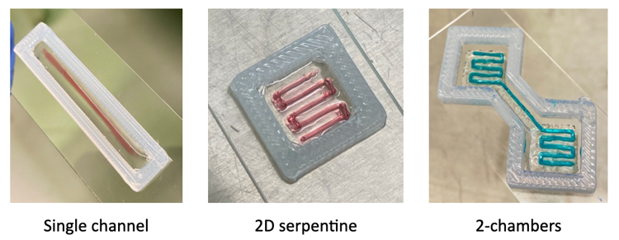
Figure 2. Bioprinted structures. The structures are contained in a 3D bioprinted silicone mold (SE-1700) to aid in needle placement at the ends of the channel.
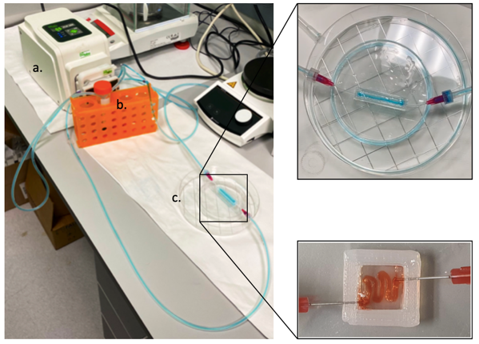
The perfusion circuit is made up from a peristaltic pump through which two hoses are guided: one that transports the nutrients from a reservoir to the inlet of the vascular channel and the other that collects them after they have passed through the channel and returns them to the reservoir (Figure 3).
Figure 3. Perfusion circuit: a) peristaltic pump (Dülabo PLP 800); b) reservoir; c) vascularized structure.
The biological tests that have been performed are mainly two: endothelialization and perfusion.
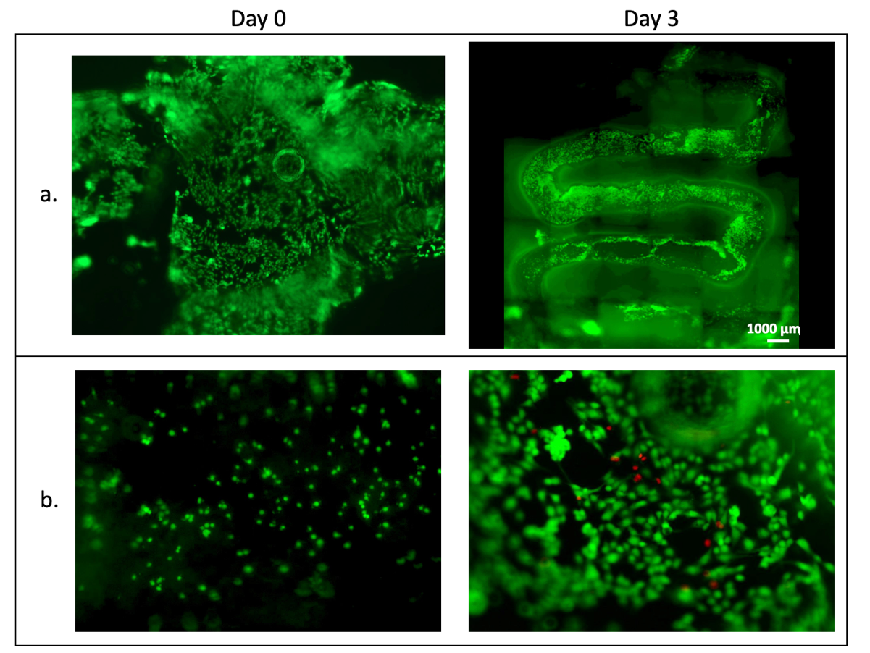
The first are aimed at simulating the formation of a capillary, using endothelial cells (HUVECs) and mesenchymal stem cells (MSCs) to coat the surface of the vascular channel in a monolayer (Figure 4). To achieve this, once the vascularized structure is created and the PLU is removed, HUVECs and MSCs are injected inside the channel. After that, to ensure complete coverage of the channel, the structure is rotated at regular intervals and finally connected to the perfusion circuit.
Figure 4. Endothelialization trials: HUVECs stained with a green cell-tracker inside the vascular canal at day 0 and day 3 after seeding. a) Representation of the entire channel; b) detail of cell morphology: it can be observed that at day 3 HUVECs tend to elongate and form a mono-layer on the surface of the channel.
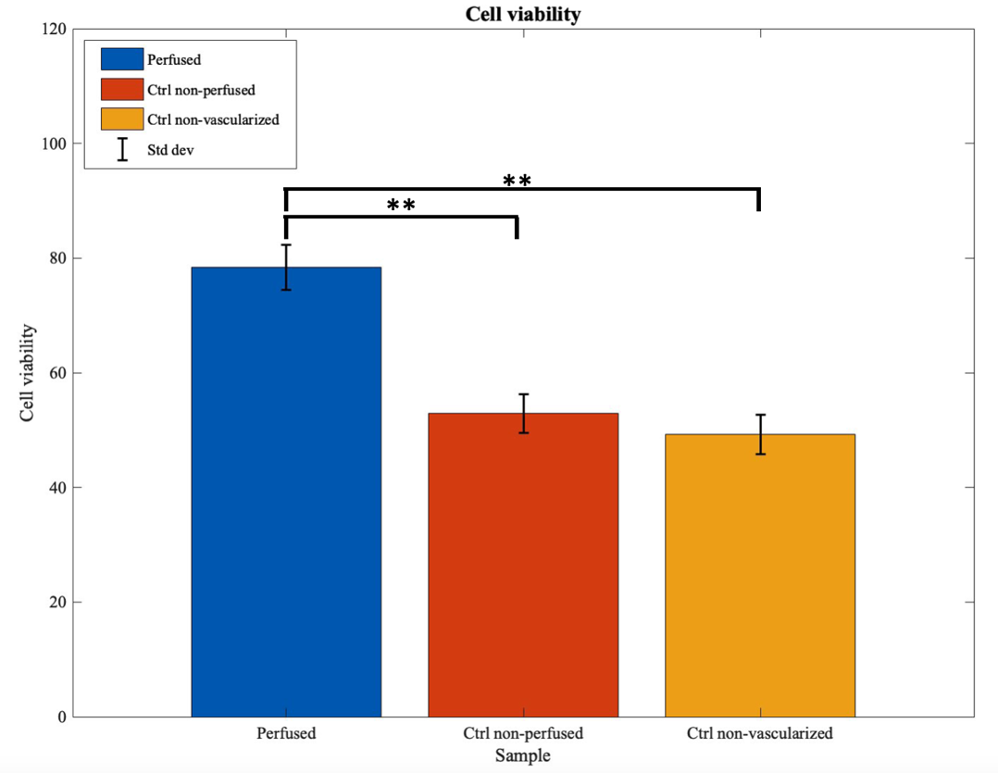
Perfusion tests are aimed at validating the effectiveness of the vascular system. To do so, Neuroblastoma cells (SK-N-AS) are encapsulated in GelMA just prior to bioprinting step. After that, once the PLU is removed, the structure is connected to the perfusion loop to assess cell viability. A comparison of cell viability at day 7 for perfused, static vascularized, and non-vascularized structures can be seen in Figure 5.
Figure 5. Perfusion trials: Live/Dead assay on SK-N-AS at day 7, comparing vascularized perfused construct (blue), vascularized non-perfused construct (red) and non-vascularized construct (yellow). The results show that perfusion significantly promotes cell viability. **p-value<0.01.
4. Conclusions
This work aims to create a 3D model of the tumor microenvironment by employing advanced 3D bioprinting techniques such as sacrificial bioprinting. The results show excellent success of vascularized structures, validated by different cellular assays. Due to the versatility and repeatability of the process, this model can be used to conduct more in-depth studies of the tumor microenvironment.
References
- Carmeliet, P., Jain, R. Angiogenesis in cancer and other diseases. Nature 407, 249–257 (2000).
- Kolesky et al. Three-dimensional bioprinting of thick vascularized tissues, PNAS, March 22, 2016, vol. 113.
- Shen Ji et al. 3D bioprinting of complex channels within cell-laden hydrogels, Acta Biomaterialia, Volume 95, 2019, Pages 214-224, ISSN 1742-7061
- Liliang Ouyang et al. Void-Free 3D Bioprinting for In Situ Endothelialization and Miscrofluidic Perfusion, Adv. Funct. Mater. 2020, 30, 1908349
- Shirahama H, Lee BH, Tan LP, Cho NJ. Precise Tuning of Facile One-Pot Gelatin Methacryloyl (GelMA) Synthesis. Sci Rep. 2016

