From Reaction Safety Modelling towards COVID-19 Pandemic Risk Early Detection

Chiara Vianello¹, Fernanda Strozzi², Paolo Mocellin¹, Bruno Fabiano³,
Flavio Manenti⁴, Giuseppe Maschio¹*
1 Università degli Studi di Padova, Dipartimento di Ingegneria Industriale. Via Marzolo 9, 35131, Padova, Italy
2 Università Carlo Cattaneo e LIUC. Corso Matteotti 22, 21053, Castellanza (Varese), Italy
3 Università di Genova, Dipartimento di Ingegneria Civile, Chimica e Ambientale. Via Montallegro 1, 15145, Genova, Italy
4 Politecnico di Milano. CMIC Dept. “Giulio Natta”, Piazza Leonardo da Vinci 32, 20133, Milano, Italy
* Corresponding author Giuseppe Maschio: giuseppe.maschio@unipd.it

1. Introduction
The ongoing COVID-19 epidemic highlights the need for effective tools to predict the onset of infection outbreaks at their early stages. The tracing of confirmed cases and the prediction of the local dynamics of contagion through early indicators are crucial measures to a successful fight against emerging infectious diseases (EID).
The proposed framework is model-free and applies Early Warning Detection Systems (EWDS) techniques to detect changes in the territorial spread of infections in the very early stages of onset. This study uses publicly available raw data on the spread of SARS-CoV-2, mainly sourced from the Italian Civil Protection Department database.
Two distinct EWDS approaches, the Hub-Jones (H&J) and Strozzi-Zaldivar (S&Z), are adapted and applied to the current SARS-CoV-2 outbreak. They promptly generate warning signals and detect the onset of an epidemic at early surveillance stages even if working on the limited daily available, open-source data.
The EWDS S&Z criterion is theoretically validated based on the epidemiological SIR.
Discussed EWDS successfully analyze self-accelerating systems, like the SARS-CoV-2 scenario, to identify an epidemic spread by calculating onset parameters precociously. This approach can also facilitate early clustering detection, further supporting common fight strategies against the spread of EIDs. Overall, we are presenting an effective tool based on solid scientific and methodological foundations to be used to complement medical actions to contrast the spread of infections such as COVID-19.
2. Methods
This paper proposes a contribution to analysing and interpreting real data on the spread of SARS-CoV-2.
This study is based on the processing of publicly available raw data of which the main source is the database of the Italian Civil Protection Department [1] [2].
The proposed methodology is inspired by the previous experience developed in chemical engineering for the early analysis of the onset of runaway reactions in chemical processes that have been the cause in the past of industrial accidents such as that of Seveso and Bhopal, only to name a few. The approach used is devoid of mathematical models for describing the phenomenon and applies Early Warning Detection Systems (EWDS) techniques to detect changes in the territorial spread of infections in the very early stages of onset.
The study discusses the applicability and adaptability of two EWDS criteria to the pandemic in order to monitor viral spread: the approaches used are those of Hub-Jones (H&J) [3] and Strozzi-Zaldivar (S&Z) [4].
They can process the SARS-CoV-2 data available, in real-time and open-source at the different stages of the development of the pandemic, to promptly generate warning signals and detect the onset or resumption of a potential epidemic and monitor the effects of contrast measures adopted such as social distancing and the classification in coloured zones of our regions [5].
The Hub & Jones criterion states that the runaway occurs when the first and second mathematical derivatives of a system variable s (usually the temperature, T) concerning time t are simultaneously positive.
In a typical reaction system, when the temperature of a reactor increases such that dT⁄dt> 0, the runaway occurs if the second condition is also met.
The boundary between stable and unstable behaviour (runaway) is represented by the temperature trajectory concerning the time when the value of d²T / dt is greater than zero while the reactor temperature is increasing dT / dt> 0
The Strozzi & Zaldivar criterion is based on chaos theory.The method was born from the study of the sensitivity to initial conditions of complex chaotic systems through the Lyapunov exponents (Benettin et al., 1980), i.e. the average increase in the lengths of the axes of an ellipsoid in the state space defined using a single variable of the system (the temperature T (t) in the case of chemical reactors).

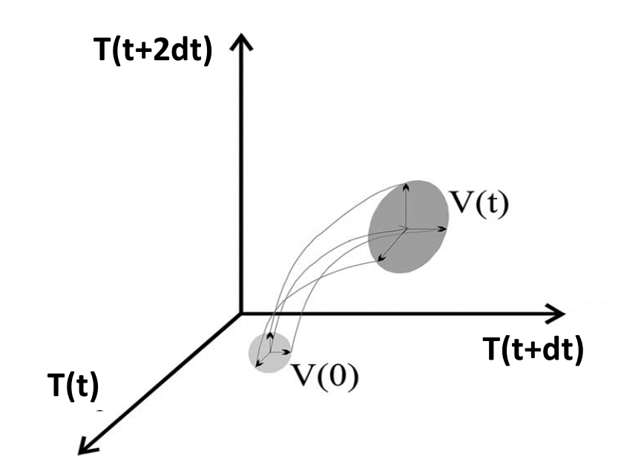

Figure 2. S&Z methodology

The increase in volume is measured by the divergence that allows you to quickly detect a runaway reaction in order to intervene in advance thus putting the system in safety. Furthermore, the EWDS S&Z criterion is theoretically validated based on the epidemiological SIR [7].
The EWDS discussed are suitable for analyzing self-accelerating systems, such as the SARS-CoV-2 scenario, to identify an epidemic spread early through onset parameters.This innovative approach can promote cluster detection and identify the early spread of emerging infectious diseases to support common control strategies.
This method and the related results represent a proactive tool based on solid scientific and methodological foundations that can be used as a complementary system of medical and social distancing actions to combat the viral spread of COVID-19.
3. Results and discussion
The characteristics of the Covid-19 epidemic, combined with the high population density and intense movements on the territory in the North Italian area, has required and still requires an intense scientific and technological effort to support the control and prevention of the virus spread.
An effective fight against similar future scenarios must be a rapid, integrated, and proactive intervention based on the ability to aggregate large datasets from different sources by tracing confirmed cases and predicting the local dynamics of contagion through early indicators.
These elements are part of a “quick learn” strategy, where rapid interpretation of evolving data is crucial to identify the best actions to prevent and contain infection outbreaks, thus enabling Governments to implement timely mitigating strategies. Additionally, the rapid enforcement of preventive measures may avoid resorting to drastic and prolonged lockdowns, which carry dramatic financial implications [6].
To support this strategy, we proved that EWDS algorithms developed and tested on the basis of ongoing epidemic dynamics, can be validly used to monitor the evolution of EIDs. This approach can be useful even if an EID is latent for medium to long periods in a specified area, giving early warnings to detect the onset of new outbreaks or the disease spread resumption.
Both discussed and adopted EWDS systems allow robust monitoring of the development status of the epidemic, and to predict early on-set peaks even in case of overlapping outbreaks. The main advantage of the EWDS is the fact of being Model Free, thus simply requiring series of data and not consolidated mathematical models, thus greatly reducing the sources of error and increasing their versatility.
The results of the two methodologies show that the H&J method can predict well in advance the set point of the exponential growth of the epidemic. The S&Z method relying on the divergence, highlights in advance the impact of the effects due to the mitigation decrees. The measures adopted in March in Italy influenced the trend of the divergence, by decreasing it. On the contrary, when the epidemic restarts the divergence again increases becoming higher than zero and it can be used as an early warning system.
The results achieved with the combination of the two developed EWDS systems, can represent an early alerting tool for tracking the epidemic. This combined approach can robustly support decision makers to best define switches between phases (tightening and/or untightening of restriction measures), also differentiated in the national territory, and it can mainly be used as an early warning tool for future epidemic outbreaks to be rapidly detected, confined and recovered.

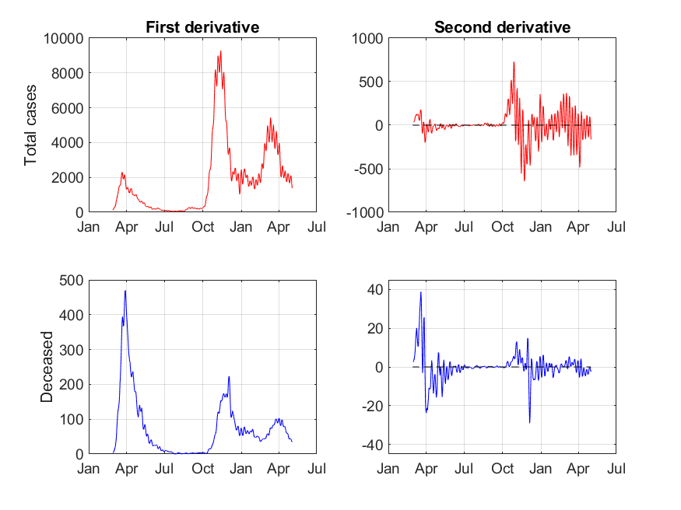 | 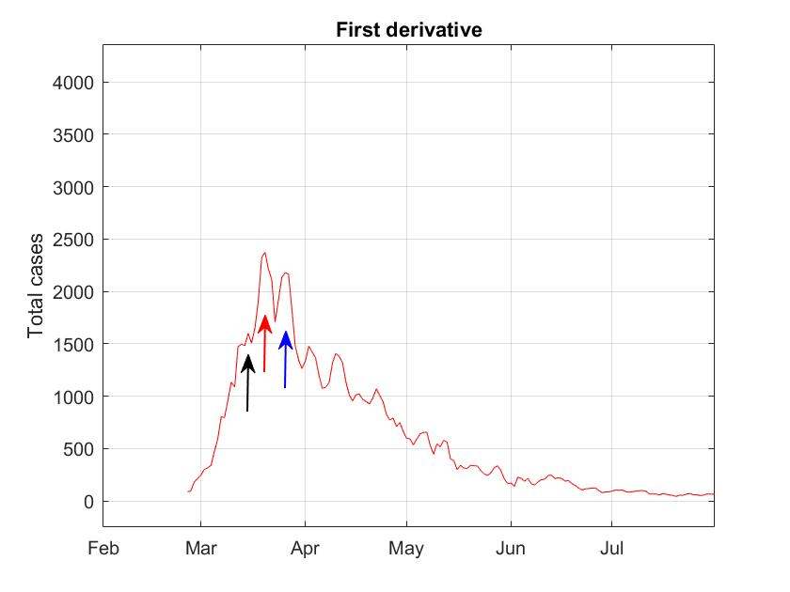
Figure 2. H&J criterion, first and second derivatives calculated from raw data for Lombardy
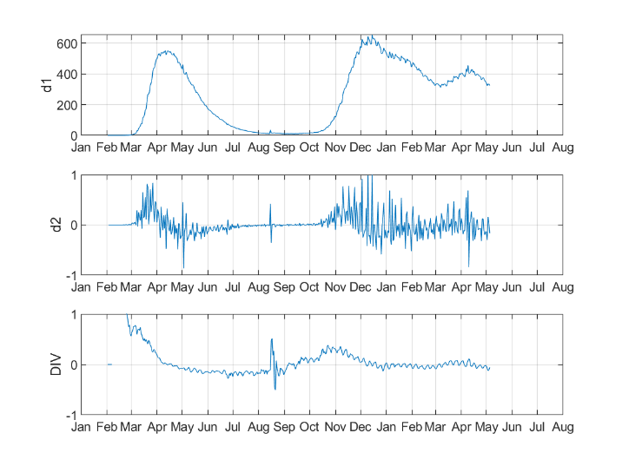
Vaccinations start
Figure 3. S&Z criterion, divergence during the whole evolution of the contagion

In perspective, the EWDS criteria may also be coupled with the monitoring of other relevant data that will be identified by decision makers on the basis of the fundamental scientific contribution of the medical community. Even considering the limitations of the combined approach, as commented by Thomas “the knowledge about the main modes of the epidemic’s behaviour and the orders of magnitude of the numbers of people affected under the various options can regarded as good enough to guide policy decisions”.
The proposed framework therefore lends itself easily to being extended and applied to an increasingly evolved, exhaustive and accurate context of available information.In this way, upon proper refinement and possible connection with advanced epidemiological data, a predictive tool based on solid scientific and methodological foundations will be made available to decision makers which, coupled with medical and epidemiological studies suitable for understanding the mechanisms of replication and spread of the virus, can provide an integrated method for contrasting its spread.

References
- Johns Hopkins Resource Center, COVID-19 Map, Johns Hopkins Coronavirus Resour. Cent, 2020.
[2] Dipartimento della Protezione Civile. COVID-19 Monitoring Italy Database (2020). https://github.com/pcm-dpc/COVID-19
[3] L. Hub, J.D. Jones. Early on-line detection of exothermic reactions Plant/Operations Prog., 5 (1986), pp. 221-224, 10.1002/prsb.720050408
[4] F. Strozzi, J.M. Zaldívar, A.E. Kronberg, K.R. Westerterp. On-Line runaway detection in batch reactors using chaos theory techniques. AIChE J, 45 (1999), pp. 2429-2443.
[5] World Health Organization, WHO Coronavirus Disease (COVID-19) Dashboard, World Heal. Organ., 2020.
[6] Vianello et als., A perspective on early detection systems models for COVID-19 spreading in Biochemical and Biophysical Research Communications 2020 DOI: 10.1016/j.bbrc.2020.12.010
[7] S. Zhao, H. Chen. Modeling the epidemic dynamics and control of COVID-19 outbreak in China. Quant. Biol. (2020), 10.1007/s40484-020-0199-0
[8] K. Sasaki. COVID-19 Dynamics with SIR Model (2020). https://www.lewuathe.com/covid-19-dynamics-with-sir-model.html

