**Experimental Study of Sorption-Enhanced Methanation in a Lab-Scale Fluidized Bed System**

Fiorella Massa1, Antonio Coppola2, Fabrizio Scala1,2*

*1 DICMaPI, Università degli Studi di Napoli Federico II, 80125 Napoli, Italy;*

*2 STEMS, Consiglio Nazionale delle Ricerche, 80125 Napoli, Italy*

*\*Corresponding author E-Mail: fabrizio.scala@unina.it*

**1.Introduction**

Climate change has become one of the most important issues of our time, but the demand for energy is still increasing worldwide. Many efforts are being made to replace fossil resources by renewable energy. One of the main drawbacks of renewable sources is their discontinuity: to overcome that, energy storage systems are needed. Chemical storage has been proposed among the suitable options and, in particular, there is an increasing interest towards the catalytic and biological production of renewable methane. Methane is an important energy carrier that benefits from an already developed infrastructure in many countries and a quite large public acceptance. Methanation of CO2 is known as a Power-to-Gas technology (converting surplus electric energy into a gaseous fuel): the process can be a biogas upgrading or a CCU (Carbon Capture and Utilization) process using CO2 streams captured from industrial plants [1-3]. In both cases “renewable” hydrogen from water electrolysis [4] reacts with CO2 to produce the so called Synthetic or Substitute Natural Gas. Among the paths to “renewable” methane production also methanation of syngas from biomass gasification should be mentioned [5,6]. Catalytic methanation of CO2 and/or CO (discovered by Sabatier and Senderens in 1902 [7]) occurs exothermically with a net reduction of gaseous moles:

$${CO}_{2}+{4H}_{2}⇌{CH}_{4}+{2H}_{2}O -164kJ {mol}^{-1} \left(@298K\right) (1)$$

$${CO + 3H}_{2}⇌{CH}_{4}+H_{2}O -206kJ {mol}^{-1} \left(@298K\right) (2)$$

Commercial methanation processes are typically applied in ammonia synthesis plants to remove carbon monoxide, and rely on a cascade of adiabatic catalytic fixed bed reactors operated at temperatures between 250 and 600°C with intermediate cooling steps and recycles, and at high operational pressure [5]. Among the typical metals that catalyze methanation (Ru, Ni, Co, Fe, and Mo), Ni is the most used for commercial applications due to the good activity and selectivity and the low price, compared to other metals [8]. Unfortunately, commercial Ni-based catalysts are subject to different deactivation mechanisms (chemical, thermal and mechanical) [9]. In particular, the main chemical deactivation of Ni catalysts is represented by carbon (coke) deposition, produced by the Boudouard reaction, on the catalyst surface [10].

In the last years, several research projects were directed to innovate traditional methanation, typically considering processes operated at high pressure to improve methane production. However, the possibility of suppling reactants at lower pressures would be rather appealing to decrease the energy duty for compression work. With this respect, the application of the Le Chatelier principle to shift the reaction equilibrium towards the products formation has been recently proposed: sorption-enhanced methanation with in-situ H2O removal using a suitable sorbent material could be applied to overcome the thermodynamic limits at low pressure [11,12]. These studies were carried out in lab-scale cyclically operated fixed beds and demonstrated that the SEM process has the potential for high-grade methane production at low pressure using commercial materials, with the consequence of a relevant energy saving for the entire process. The feasibility and the possible positive effects of sorption-enhanced conditions have also been tested in different chemical looping systems, such as the sorption-enhanced steam reforming of ethanol [13-16]. Considering the reactor design, fixed beds have the advantage of a compact design, but they imply transient operation and difficult heat management, especially at the industrial scale. In order to overcome such issues, fluidized bed reactors have been suggested as a possible alternative since they are known to be favorable for large‐scale steady operation of highly exothermic reactions. Moreover, the use of a fluidized bed reactor would be advantageous in a SEM process due to the ability of these reactors to easily transfer solid sorbent materials during steady operation [6]. On the basis of this consideration, a novel configuration for SEM, based on the technology of dual interconnected fluidized beds was investigated. This scheme has the advantage of a steady operation of the plant, thus avoiding the unsteady cyclic operation used for sorbent regeneration in fixed bed SEM concepts. The behavior of CaO particles as a steam sorbent during hydration-dehydration cycles was previously studied [17], since calcium oxide reacts with H2O in the temperature range of interest for methanation:

$$CaO + H_{2}O= Ca{\left(OH\right)}_{2} -65kJ {mol}^{-1} \left(@298K\right) (3)$$

In addition, CaO is an eco-friendly, abundant and low-cost material.

However, if CO2 is present in the system, the following reaction also takes place:

$CaO + CO_{2} → CaCO_{3}$ $-178kJ {mol}^{-1} \left(@298K\right) (4)$

The carbonation reaction, which is irreversible in the temperature range of interest, competes with hydration and could decrease the performance of CaO during CO2 SEM. In this work, for the first time, the catalytic methanation with simultaneous CaO hydration was tested under different conditions in a fluidized bed system. The focus of the activity was the proof of concept of the enhancement effect with respect to traditional methanation, and the characterization of the possible detrimental effect of the carbonation reaction on the process.

**2. Methods**

## 2.1. Catalyst and sorbent preparation

The chosen material to catalyze methanation was a Nickel-based catalyst supported on alumina. As for the support, a commercial material was used: a spherical-shaped γ-alumina with an average size of 600 μm, specifically purchased for fluidized bed application, having a significant attrition resistance (provided by Sasol). The active phase was obtained by a precursor salt, the Nickel nitrate exahydrate Ni(NO3)26H2O provided by Alfa Aesar. The preparation method, widely reported in the literature for this type of catalysts [18], was the incipient wetness impregnation technique: the volume of the aqueous solution prepared was exactly the volume needed to fill the porous structure. In this amount of water, the precursor was dissolved in order to obtain a 10%wt of Nickel after two cycles of impregnation-dehydration. The impregnation stage lasted 2 hours, followed by dehydration, carried out by means of a heating plate at 95 °C. The impregnated spheres were calcined to obtain Nickel oxide in the active phase; air calcination was carried out in a fluidized reactor for 1 h at 500 °C, as commonly suggested by other studies [18-20]. The final active phase (Ni) for methanation was obtained after reduction, carried out in a stream of H2 (4%) and N2 for 1 h at 600 °C in a lab-scale fluidized bed reactor.

CaO was used as the H2O sorbent, and was prepared in a laboratory-scale fluidized bed reactor heated to 850 °C and fluidized at a velocity of 0.5 m/s. For each preparation process, 20 g of fresh limestone, sieved in the size range 400-600 μm, was introduced in the reactor when the set-point temperature was reached. Complete calcination was achieved in about 10 min.

## 2.2. Experimental setup

The experimental apparatus used for the tests consisted of a system called Twin Beds (TB) [21], reported in Figure 1: two identical interconnected reactors, East Bed (EB) and West Bed (WB). Each reactor is composed of 3 sections: the wind-box, 0.66 m high, filled with metal elements and acting as a pre-heater/pre-mixer, the 1 m high fluidization column and, in the upper part, a system of a three-way valve that can be connected to the analyzers. This apparatus was conceived with the aim of studying looping processes: it enables the pneumatic transport of granular material in about 5 seconds between the two reactive environments by means of a connecting tube (ID 10 mm) immersed in both reactors. The fluidization column and the wind-box are composed by a tubular steel element (AISI 316) with an internal diameter of 40 mm.



**Figure 1.** Twin bed apparatus.

Between the two sections, connected by a flange, a perforated plate is located to uniformly distribute the gas inside the reactor. A hopper is placed on the top of each reactor to carry out the bed loading. The electrical heating system consists of two semi-cylindrical furnaces on each reactor (Watlow, Ceramic Fiber Heaters) with a heating length of 457 mm and a power per semi-cylinder of 2100 Watts. A PID controller (Watlow, EZ-Zone ST) is connected to each bed via a K-type thermocouple (Cr-Al) inserted 40 mm above the distribution plate. During the methanation tests, the output concentrations of the species were measured by a mobile analyzer (MRU VARIO LUXX) able to detect CH4, CO, CO2 by means of a NDIR sensor and H2 via a TCD sensor. The pneumatic transport of the solids between the reactors was carried out generating an overpressure by means of a system of valves that enables and modulates the flow of the material. Specifically, as for the transport duct, three valves are present on it: two ball valves close to each reactor, which modulate the flow through the duct and a centrally located three-way valve connected to a discharge duct, which allows to direct the material either between the two reactors or towards the discharge vessel. Above each reactor, another valve allows the outlet gas to be sent to the analyzer system and the vent.

## 2.3. Experimental procedure

The methanation/hydration cycles were performed in the EB reactor, while the dehydration of the sorbent in the WB. Before each SEM test, traditional methanation was carried out to set the basis for comparison of the performance of SEM. To perform conventional methanation in the EB reactor, once the temperature was reached, the reduced catalyst was loaded into the reactor, already fluidized with a bed of silica sand in the size 800-900 micron. The presence of silica sand was necessary to keep temperature variations to a minimum and to assure the segregation of both sorbent and catalyst to the top of the bed (in order to perform smooth solids transfer between the reactors [17]). After catalyst loading, the mixture H2/CO2 in the desired ratio and diluted in N2 (H2 lower than 5%vol), was fed to the EB. Two different mixtures of H2 and CO2 were investigated, corresponding to two different values of α[1], the typical parameter used to characterize methanation feeding: α = 2 and α = 3. The latter value corresponds to stoichiometric feeding, while the former one corresponds to a sub-stoichiometric feeding with respect to H2. The choice to work in sub-stoichiometric conditions is linked to the attempt to compensate for the subtraction of CO2 due to CaO carbonation, trying to obtain an almost stoichiometric ratio between H2 and CO2 in the reactive environment.

The first traditional methanation and the subsequent cycles of methanation/hydration lasted 10 min, a sufficient time to achieve sorbent saturation. Once the first methanation stage was over, the sorbent material was introduced into the reactor and four complete cycles of SEM/regeneration were carried out for each test, plus a last fifth SEM in the East Bed reactor, after which the bed material was discharged and separated by means of sieving. As for the regeneration steps, they were carried out in N2, lasting 5 minutes at a fixed temperature of 450 °C. Table 1 summarizes the operating conditions investigated for the SEM tests with the selected sorbent. The amount of catalyst used was selected in order to ensure an optimal solid transfer between the twin beds in the cycles. However, such mass was not sufficient to reach chemical equilibrium at the temperatures of interest. This was also due to the extremely diluted conditions and to the gas by-pass, due to the bubbles, typically occurring in fluidized bed reactors.

**Table 1.** Conditions adopted in the SEM tests.

|  |  |
| --- | --- |
| SORBENT MASS (g) | 10 |
| SORBENT SIZE (mm) | 0.5 |
| CATALYST MASS (g) | 10 |
| CATALYST SIZE (mm) | 0.6 |
| FLUIDIZATION VELOCITY (m/s) | 0.5 |
| SEM TEMPERATURE (°C) | 300-350 |
| α = (H2-CO2)/CO2 (-) | 2-3 |

**3. Results and discussion**

Figure 2 (a-b) reports the methanation test results in terms of the ratio between the molar flows (mol/h) of CH4 at the outlet and that of H2 fed to the fluidized bed, for a fixed bed temperature of 300°C and at different feed ratios (α = 2 and α = 3, a and b respectively), as a function of time. The figure reports results for all the cycles constituting a complete SEM test. The curves relative to traditional methanation (always performed before each SEM test) are indicated with MET while the other ones are relative to the 5 SEM cycles. Considering the qualitative trend of the curves along the cycles, three distinct behaviours can be identified. In particular: 1) the first curve corresponding to traditional methanation; 2) the trend characterizing the first cycle under SEM conditions; and, finally, 3) the trend for the other four SEM cycles after the first one.

During traditional methanation (black line) the production of CH4 shows an increasing trend with an initial transient behaviour before reaching a stable value after about 240 s. During the first SEM cycle (grey line) a similar trend is observed, but exhibiting a distinct slowing down in reaching the asymptotic value with respect to conventional methanation. This behaviour can be explained by considering that fresh CaO immediately starts to irreversibly carbonate, subtracting CO2 reactant from the methanation reaction. Carbonation then rapidly slows down as a CaCO3 shell is gradually formed around the sorbent particles. Finally, the “enhanced-behaviour” trend is already visible in the second SEM cycle, and even more evident in the subsequent three cycles. This trend involves the achievement of a maximum in the CH4 outlet molar flow within approximately the first few minutes (around 90 s) of the cycle during which the produced steam was captured by CaO. To quantify this effect, the integral amount of CH4 produced, with respect to the H2 fed, was calculated and it is reported in Table 2, for the two α values. In particular, the CH4 moles were calculated at two characteristic times: one corresponding to the peak of the “enhanced-behavior” (t90), and the other at t210, corresponding to complete saturation of the sorbent and stabilization of the curves to the asymptotic value. For both times considered, the percentage variation in the produced methane with respect to the “MET” case, is also reported in brackets. By comparing the outlet methane corresponding to the different gas feed ratios, the largest CH4 amount was found for α = 3, i.e. for the stoichiometric case (H2/CO2=4). This may be due to the effect of a higher H2 concentration on kinetics.

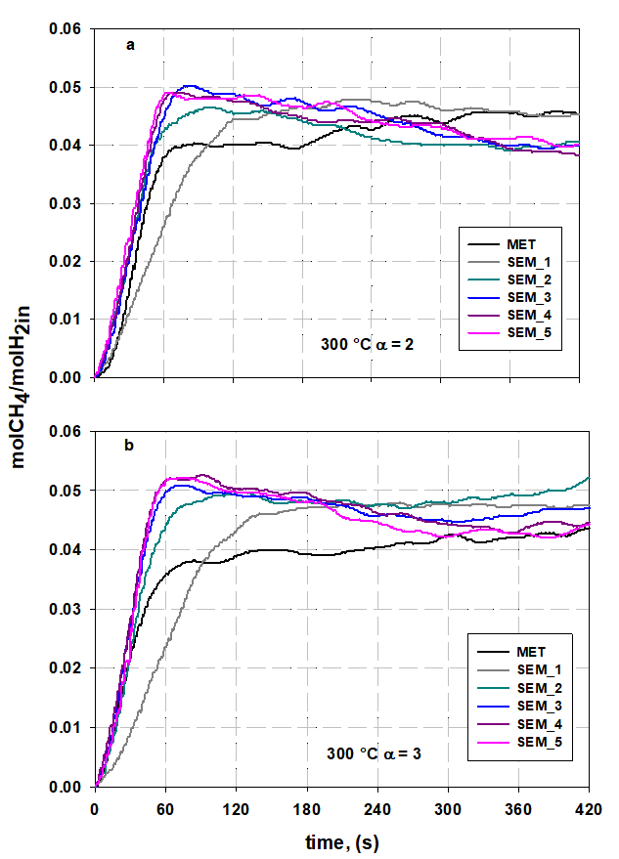

**Figure 2. Molar flow ratio between outlet CH4 and inlet H2 as a function of time at 300°C, at α=2 (a) and α=3 (b).**

For both α considered, the effect of H2O sorption was evident in all the cycles except in the first one, when CaO carbonation clearly prevailed over hydration. In fact, during the first SEM cycle, a dramatic decrease in the CH4 produced, if considering t90, took place: -23% and -34% for α = 2 and α = 3, respectively. Feeding a CO2 excess (α = 2) with respect to the stoichiometric value was able to partly compensate the negative effect of carbonation in the first cycle. Noteworthy, along the cycles, the sorbent tended to rapidly saturate with respect to carbonation while concurrently the hydration effect became stronger with a higher amount of CH4 produced. As far as the last cycles are concerned, the SEM effect for α = 2 produced an enhancement amounting to around 20% (calculated at t210). This value is about 30% lower than the increase corresponding to the peak value (t90), where the maximum CH4 productivity occurred. For a stoichiometric feed (α = 3), this enhancement was even higher, with an average value over the last three cycles equal to about 30%.

**Table 2. Ratio of total CH4 produced to H2 fed in each cycle at 300°C, and relative percentage variation with respect to standard methanation (MET).**

|  |  |  |  |  |  |  |  |  |  |  |  |  |
| --- | --- | --- | --- | --- | --- | --- | --- | --- | --- | --- | --- | --- |
|  | **nCH4out/nH2in** | | | | | | | | | | | |
|  | **MET** | | **SEM_1** | | **SEM_2** | | **SEM_3** | | **SEM_4** | | **SEM_5** | |
| **t90** | **t210** | **t90** | **t210** | **t90** | **t210** | **t90** | **t210** | **t90** | **t210** | **t90** | **t210** |
| **α = 2** | 0.0237 | 0.0331 | 0.0182  (-23%) | 0.0333  (0.34%) | 0.0285  (20%) | 0.038  (14.6%) | 0.0295  (24.6%) | 0.04  (20.4%) | 0.03  (29.5%) | 0.0396  (19.4%) | 0.0317  (34%) | 0.0408  (23%) |
| **α = 3** | 0.0252 | 0.0332 | 0.0165  (-34%) | 0.0327  (-1.4%) | 0.03  (18.6%) | 0.04  (22.3%) | 0.0336  (33.3%) | 0.0423  (27.5%) | 0.035  (39%) | 0.0435  (31.3%) | 0.0339  (34.5%) | 0.0425  28.3%) |

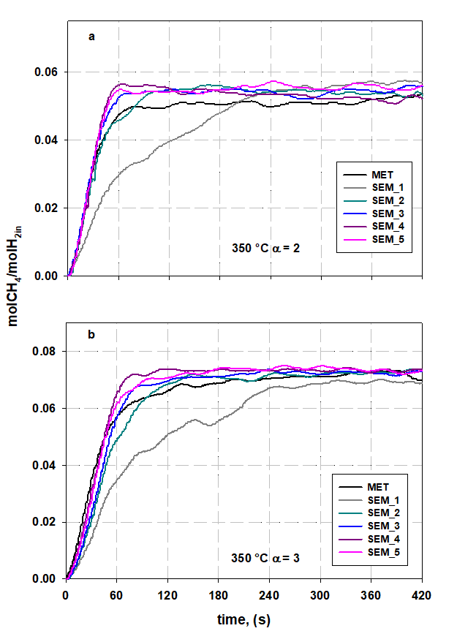

**Figure 3. Mole flow ratio between outlet CH4 and inlet H2 as a function of time at 350°C, at α=2 (a) and α=3 (b).**

Considering the other methanation temperature investigated, 350°C, the results are reported in similar graphs (Figure 3 a-b), and the integral amount of CH4 produced, with respect to the H2 fed, is reported in Table 3, for the two α values. It can be observed, for both gas feed ratios, that the qualitative trend of the curves along the cycles is similar but with some differences from those obtained at 300°C. At 350°C the SEM curves do not show a pronounced maximum in the first part of the cycle due to the water sorption effect, but tend to reach more smoothly the asymptotic value. Moreover, in the first SEM cycle the sorbent reaction with CO2 needed more time to be completed with respect to 300°C.

At 350 °C, as expected, more methane was produced during each cycle with respect to the 300°C case: this is due to the fact that the system did not reach equilibrium and the kinetic effects prevailed. For example, if considering the total amount of CH4 produced at α = 3 in the last two cycles, it amounted to 0.0074 moles for 350°C compared to 0.0057 moles at 300°C.

The increase in CH4 productivity in the last cycles was lower than that found in the same cycles at 300°C, for both α values considered, reaching the maximum enhancement, around 10%, for α = 2. Apart from a stronger effect of the carbonation reaction, this result is most likely linked to the effect of temperature on the thermodynamic equilibrium limit on the hydration reaction of CaO, which worsens by increasing temperature in this range.

On the whole, these results are closely related to the effect of the operating conditions on the kinetics and thermodynamics of both the carbonation and hydration reactions of CaO, calling for a more in-depth analysis.

**Table 3. Ratio of total CH4 produced to H2 fed in each cycle at 350°C, and relative percentage variation with respect to standard methanation (MET).**

|  |  |  |  |  |  |  |  |  |  |  |  |  |
| --- | --- | --- | --- | --- | --- | --- | --- | --- | --- | --- | --- | --- |
|  | **nCH4out/nH2in** | | | | | | | | | | | |
|  | **MET** | | **SEM_1** | | **SEM_2** | | **SEM_3** | | **SEM_4** | | **SEM_5** | |
| **t90** | **t210** | **t90** | **t210** | **t90** | **t210** | **t90** | **t210** | **t90** | **t210** | **t90** | **t210** |
| **α = 2** | 0.0339 | 0.0434 | 0.0209  (-38.5%) | 0.0337  (-22.3%) | 0.035  (2.7%) | 0.0464  (7%) | 0.0364  (7.3%) | 0.0468  (7.8%) | 0.0389  (14.7%) | 0.0479  (10.4%) | 0.0387  (14%) | 0.0477  (10%) |
| **α = 3** | 0.0397 | 0.0555 | 0.0238  (-39.9%) | 0.0406  (-26.8%) | 0.0345  (-12.9%) | 0.0545  (-1.8%) | 0.0383  (-3.2%) | 0.0567  (2.1%) | 0.0443  (11.8%) | 0.0608  (9.6%) | 0.041  (3.4%) | 0.0588  (5.9%) |

**4. Conclusions**

In this work, the CO2 sorption-enhanced methanation process using CaO as sorbent was investigated in a novel configuration consisting of two interconnected fluidized beds. The performance was evaluated at different temperatures compatible with both methanation and chemical sorption of H2O (300°C and 350°C). In addition to a stoichiometric feed (H2/CO2=4), the effect of an over-stoichiometric feed in terms of CO2 (H2/CO2=3) was also considered to partly counteract the influence of the undesired CaO carbonation on the SEM performance. The results were analysed in terms of the amount of produced methane (with respect to the H2 fed), compared to the traditional methanation case, during 5 SEM cycles. For both temperatures considered, the effect of the fresh CaO fed to the system, which immediately tends to carbonate, was dramatic, leading to a significant decrease in the methane productivity with respect to the conventional case during the first SEM cycle. However, when CO2 was fed in excess with respect to the stoichiometric value, this negative effect seemed to be partly compensated.

On the other hand, in the subsequent SEM cycles the negative effect of carbonation tended to vanish and a clear enhancement of the methane productivity was observed. The enhancement of the produced methane during the last cycles, with respect to traditional methanation, was around 20-30% and 8-10% at 300°C and 350°C, respectively. The highest increase was found at 300°C for both feed conditions: the best performance occurred for a stoichiometric gas feed for which the average increase was around 30%. It is worth noting that if considering a shorter time with respect to the entire cycle, i.e. a time corresponding to the peak methane productivity, the CH4 percentage enhancement was even higher and reached on average a value around 37% over the last two cycles.

**Acknowledgements**

The experimental support of Ms. Michela Vignola is gratefully acknowledged.

**References**

[1] Cuéllar-Franca R. M, Azapagic A., Carbon capture, storage and utilisation technologies: A critical analysis and comparison of their life cycle environmental impacts, J. CO2 Util*.* 9 (2015) p. 82–102.

[2] de Boer H. S, Grond L, Moll H, Benders R, The application of power-to-gas, pumped hydro storage and compressed air energy storage in an electricity system at different wind power penetration levels, Energy 72 (2014) p. 360–70.

[3] Pleßmann G, Erdmann M, Hlusiak M, Breyer C, Global energy storage demand for a 100% renewable electricity supply, Energy Procedia 46 (2014) p. 22–31.

[5] Smestad G. P, Steinfeld A, Review: photochemical and thermochemical production of solar fuels from H2O and CO2 using metal oxide catalysts, Ind. Eng. Chem. Res. 51 (2012) p. 11828−11840.

[6] Götz M, Lefebvre J, Mörs F, McDaniel Koch A, Graf F, Bajohr S, Renewable Power-to-Gas: A technological and economic review, Renew. Energy 85 (2016) p. 1371–1390.

[7] Sabatier P, Senderens J-B, New methane synthesis, *J*. Chem. Soc*.* 82 (1902) p. 333-337.

[8] Rönsch S, Schneider J, Matthischke S, Schlüter M, Review on methanation – From fundamentals to current projects, Fuel 166 (2016) p. 276–296.

[9] Mills G. A, Steffgen F.W, Catalytic methanation, Catal. Rev. 8 (1974) p. 159–210.

[10] Bartholomew C. H, Mechanisms of catalyst deactivation, Appl. Catal. A 212 (2001) p. 17–60.

[11] Seemann M.C, Schildhauer T.J, Biollaz S.M.A, Stucki S, Wokaun A, The regenerative effect of catalyst fluidization under methanation conditions, Appl. Catal. A 313 (2006) p. 14–21.

[12] Borgschulte A, Gallandat N, Probst B, Suter R, Callini E, Ferri D, Arroyo Y, Erni R, Geerlings H, Züttel A, Sorption enhanced CO2 methanation, Phys. Chem. Chem. Phys. 15 (2013) p. 9620-9625.

[13] Walspurger S, Elzinga G.D, Dijkstra J.W, Saric M, Haije W.G, Sorption enhanced methanation for substitute natural gas production: Experimental results and thermodynamic considerations, Chem. Eng. J. 242 (2014) p. 379–386.

[14] Dou B, Zhang H, Cui G, Wang Z, Jiang B, Wang K, Chen H, Xu Y, Hydrogen production and reduction of Ni-based oxygen carriers during chemical looping steam reforming of ethanol in a fixed-bed reactor, Int. J. Hydrogen Energy 42 (2017) p. 26217–30.

[15] Dou B, Zhang H, Cui G, Wang Z, Jiang B, Wang K, Chen H, Xu Y, Hydrogen production by sorption-enhanced chemical looping steam reforming of ethanol in an alternating fixed-bed reactor: Sorbent to catalyst ratio dependencies”, Energy Convers. Manag. 155 (2017) p. 243–52.

[16] Müller S, Fuchs J, Schmid J. C, Benedikt F, Hofbauer H, Experimental development of sorption enhanced reforming by the use of an advanced gasification test plant, Int. J. Hydrogen Energy42 (2017) p. 29694–707.

[17] Coppola A, Massa F, Salatino P, Scala F, Fluidized bed CaO hydration-dehydration cycles for application to sorption-enhanced methanation, Combustion Science and Technology 191 (2019) p. 1724–1733.

[18] Lechkar A, Barroso Bogeat A, Blanco G, Pintado J.M, Soussi el Begrani M, Methanation of carbon dioxide over ceria-praseodymia promoted Ni-alumina catalysts. Influence of metal loading, promoter composition and alumina modifier, Fuel 234 (2018) p. 1401–1413.

[19] Rahmani S, Rezaei , Meshkani, F, Preparation of promoted nickel catalysts supported on mesoporous nanocrystalline gamma alumina for carbon dioxide methanation reaction, Journal of Industrial and Engineering Chemistry 20 (2014) p. 4176–4182.

[20] Abate S, Mebrahtu C, Giglio E, Deorsola F, Bensaid S, Perathoner S, Pirone R, Centi G, Catalytic Performance of γ-Al2O3–ZrO2–TiO2–CeO2 Composite Oxide Supported Ni-Based Catalysts for CO2 Methanation, Industrial & Engineering Chemistry Research 55 (2016) p. 4451–4460.

[21] Coppola A, Scala F, Gargiulo L, Salatino P, A twin-bed test reactor for characterization of calcium looping sorbents, Powder Technology 316 (2017) p.585–591.

1. α=(H2-CO2)/(CO+CO2) where H2,CO2 and CO are the respective species molar flows in the feeding.