Thermodynamic characterization of Liquid-Vapor Equilibria of Propionic Acid-Water at atmospheric pressure
Leone Mazzeo^{1,2}*, Vincenzo Piemonte
1 Department of Engineering, University Campus Biomedico of Rome, Via Alvaro del Portillo, 21, 00128 Rome, Italy;
2 Department of Chemical Engineering Materials & Environment, Sapienza University of Rome, Via Eudossiana, 18, 00184 Rome, Italy;
*Corresponding author E-Mail: l.mazzeo@unicampus.it
1.Introduction
Propionic acid is a Volatile Fatty Acid (VFA) which global market is projected to reach the size of US$1.8 Billion by 2027 [1]. Such molecule finds its main application as a food preservative which account for nearly 78% of its total consumption. Propionic acid it is also employed in the food industry (as aroma additive, food additive and flavoring) and in the pharmaceutical industry (for pharmaceuticals and solvents formulation). The price of Propionic Acid was estimate to be 2000-2500 €/ton [2]. Although the main production of Propionic Acid occurs by means of ethylene carbonylation, oxidation of propanal and direct oxidation of hydrocarbons [3], nowadays increasing attention is given to the production of such molecule by means of Anaerobic Digestion [4]. As a matter of fact, currently it was investigated the potential of AD as an environmentally friendly alternative for the production of bulk chemicals such as Volatile Fatty Acids (VFAs) [5]. In this context rises the necessity to further investigate on the possible recovery of Propionic Acid from a fermentation broth which is basically a mixture of water and different types of VFA. This works sets a first step on this path studying the Vapor-liquid equilibrium of the mixture Propionic acid-water at 1 atm. Such mixture was already investigated in the past by other works [6–8], however none of them adopted the Non-Random Two-Liquid model for the description of the activity coefficient of the liquid phase. The aim of his work is then to increase the literature data for the liquid vapor equilibrium at 1 atm for the binary system Propionic Acid-Water and to evaluate the goodness of NRTL model in describing the liquid phase deviations from ideality.
2. Material and Methods
2.1. Experimental
Analytical grade Propionic acid (C₃H₆O₂) reagent was purchased from Sigma Aldrich (United States) and used without any further purification together with distilled water. The Refractive Indexes (RI) of both components were compared with literature data as shown in Table 1.
Table 1. Refractive index of pure compounds at 25°C.
Compound | RI measured | RI literature
Propionic Acid | 1.3843 ± 0.0005 | 1.3837 [9]
Water | 1.3340 ± 0.0005 | 1.3330 [10]
The experimental runs were carried out in a modified Gillespie vapor recirculation still (for further information see the work of Malanowski [11]) already used in other works [12]. Details of the apparatus are reported elsewhere [13]. The condenser of the still was open to the atmosphere in order to keep the system at atmospheric pressure. The equilibrium temperature was measured by means of an Hg thermometer with an accuracy of ± 0.1 °C. Isobaric liquid-vapor equilibrium data were collected once no changes in the measured temperature were observed. Such condition was reached after 30 – 45 minutes from the beginning of each test. The liquid samples at equilibrium (liquid phase and the condensed vapor phase) were analyzed using a Bawch and Lomb Abbe-3L precision refractometer.
2.2. Modeling
The classical condition for vapor-liquid equilibrium, valid for each component $i$, is reported below in Equation 1:
$$Py_{i}φ_{i}=P_{s,i}\left(T\right)γ_{i}x_{i}φ_{i,s}^{°}ν_{L,i}$$ | (1)
where $φ_{i}$ and $φ_{i,s}^{°}$ are the fugacity coefficients of the component $i$ in the mixture at the system pressure $P$ and pure at the vapour tension $P_{s,i}\left(T\right)$ calculated at the equilibrium temperature $T$ respectively; $γ_{i}$ is the liquid activity coefficient, $ν_{L,i}$ is the Poynting coefficient and $y_{i}$, $x_{i}$ are the compositions of the vapour and liquid phase respectively at equilibrium. In this work it was possible to neglect the Poynting effect due to the small difference between the vapour tension and the pressure of the system together with the small value of the specific molar volumes of the pure compounds. It is well known that carboxylic acids such as propionic acid have strong intermolecular interactions due to hydrogen bonds formation which leads to their tendency to form dimers in the vapour phase [8]. For this reason, the vapour phase wasn’t considered ideal even if the experiments were conducted at 1 atm and hence $φ_{i}≠1$. According to this consideration, a calculation of liquid activity coefficients neglecting the non-ideality of the vapor phase may lead to inconsistent thermodynamic data. The chemical theory of vapor imperfections (fully explained in the work of Nothnagel et al. [14]) was commonly adopted for the description of the vapor phase non ideality for strong associating components up to pressures of 5 – 8 atm [9]. In this work the fugacity coefficient was calculated supposing the propionic acid ($A_{1}$) to react in the vapor phase forming dimers ($A_{2}$) with the following chemical reaction stoichiometry
$$2A_{1}⇌ A_{2}$$ | (2)
while water was considered an inert. The chemical equilibrium is characterized by an equilibrium constant defined below in Equation 3:
$$K\left(T\right)=\frac{f_{A_{2}}}{f_{A_{1}}^{2}}=\frac{z_{A_{2}}}{z_{A_{1}}^{2}}\frac{1}{P}\frac{ξ_{A_{2}}}{ξ_{A_{1}}^{2}}$$ | (3)
where $f_{A_{2}}$ is the fugacity of the dimer, $f_{A_{1}}$ is the fugacity of the monomer, and where $z_{A_{i}}$ stands for the true mole fraction and $ξ_{A_{i}}$ for the true fugacity coefficient. The latter can be easily calculated applying the definition of fugacity coefficient by choosing an Equation of State (EOS). In this work the following EOS was selected:
$$P=\frac{n_{T}RT}{V-n_{T}b_{m}}$$ | (4)
where $n_{T}$ is the total amount of moles and $n_{T}b_{m}$ is the is the excluded volume due to the finite size of the molecules (it is usually assumed that $b_{A_{1}}≡ b_{A_{2}}$). Defining the fraction of moles dimerized $α$ it is possible to express Equation 3 as a function of $α$ and the measured mole fraction of the carboxylic acid ($y_{A}$) in presence of an inert as shown in Equation 5. The true mole fractions can be then calculated using Equation 6 - 7where ($z_{I}$) indicates the true mole fraction of the inert compound.
$$K\left(T\right)=\left[\frac{\left(1-y_{A}\right)α}{2y_{A}{\left(1-α\right)}^{2}}+\frac{\left(1-α/2\right)α}{2{\left(1-α\right)}^{2}}\right]\frac{1}{P}$$ | (5)
$$z_{A_{1}}=\frac{y_{A}\left(1-α\right)}{\left(1-y_{A}\right)+y_{A}\left(1-\frac{α}{2}\right)}$$ | (6)
$$z_{I}=\frac{\left(1-y_{A}\right)}{\left(1-y_{A}\right)+y_{A}\left(1-\frac{α}{2}\right)}$$ | (7)
The fugacity coefficients were then calculated with Equation 8
$$φ_{i}=\frac{z_{i}}{y_{i}}ξ_{i}=\frac{z_{i}}{y_{i}}exp⁡\left(\frac{b_{i}P}{RT}\right)$$ | (8)
The Non-Random Two-Liquid Model (NRTL) was instead used to evaluate the liquid activity coefficients. The equations of the NRTL model for a binary system are reported below:
$$\ln{γ_{1}=x_{2}^{2}}\left[τ_{21}{\left(\frac{G_{21}}{x_{1}+G_{21}x_{2}}\right)}^{2}+τ_{12}\frac{G_{12}}{{\left(x_{2}+G_{12}x_{1}\right)}^{2}}\right]$$  $$\ln{γ_{2}=x_{1}^{2}}\left[τ_{12}{\left(\frac{G_{12}}{x_{2}+G_{12}x_{1}}\right)}^{2}+τ_{21}\frac{G_{21}}{{\left(x_{1}+G_{21}x_{2}\right)}^{2}}\right]$$  $$τ_{12}={∆g}_{12}/RT{ τ}_{21}={∆g}_{21}/RT$$  $$G_{12}=\exp\left(-α_{12}τ_{12}\right) { G}_{21}=exp⁡(-α_{12}τ_{21})$$ | (9)
The NTRL model was reduced to a two parameter model by fixing the non-randomness parameter $α_{12}=0.48$ and estimating only the parameters ${∆g}_{12}$ and ${∆g}_{21}$. Even though both liquid and vapor composition were determined experimentally, only T-x data were used for regression and estimation of ${∆g}_{12}$and ${∆g}_{21}$. In fact, by adding Equation 1 for each component it is easy to verify that
$$P=\frac{P_{s,1}\left(T\right)γ_{1}x_{1}φ_{1,s}^{°}}{φ_{1}}+\frac{P_{s,2}\left(T\right)γ_{2}x_{2}φ_{2,s}^{°}}{φ_{2}}$$ | (10)
Using NRTL equations for the calculation of the activity coefficients, for each set of T-x data it is possible to estimate pressure of the system by means of Equation 10. The estimated values of the two parameters of the NRTL model are the ones that minimize the following objective function:
$$∅=\sum_{i=1}^{N}{\frac{1}{N}{\left(P-P_{i,calc}\right)}^{2}}$$ | (10)
where N represents the number of experimental data collected. Obviously this is an iterative method since the calculation of the fugacity coefficients $φ_{i}$ can be accomplished only by knowing the vapour mole fractions at equilibrium. For this reason, as a first attempt the estimation is performed assuming $φ_{i}=1$, while the vapour mole fractions obtained from the first regression can be used to evaluate the values of the fugacity coefficients that were inserted in the second iteration. The iteration continued until the values of the objective function $∅$ from an two consecutive iterations were $\left|∅_{j-1}-∅_{j}\right|<ε$ sufficiently small. This procedure (developed by J.A. Barker) was chosen since it intrinsically respects the conditions of thermodynamic consistency. Once finished the regression, the vapour mole fractions obtained were correlated with the experimental ones verifying simultaneously the consistency of the experimental data and the goodness of the model estimation. A schematic block of the algorithm used for the parameter estimation was given in Figure 1.
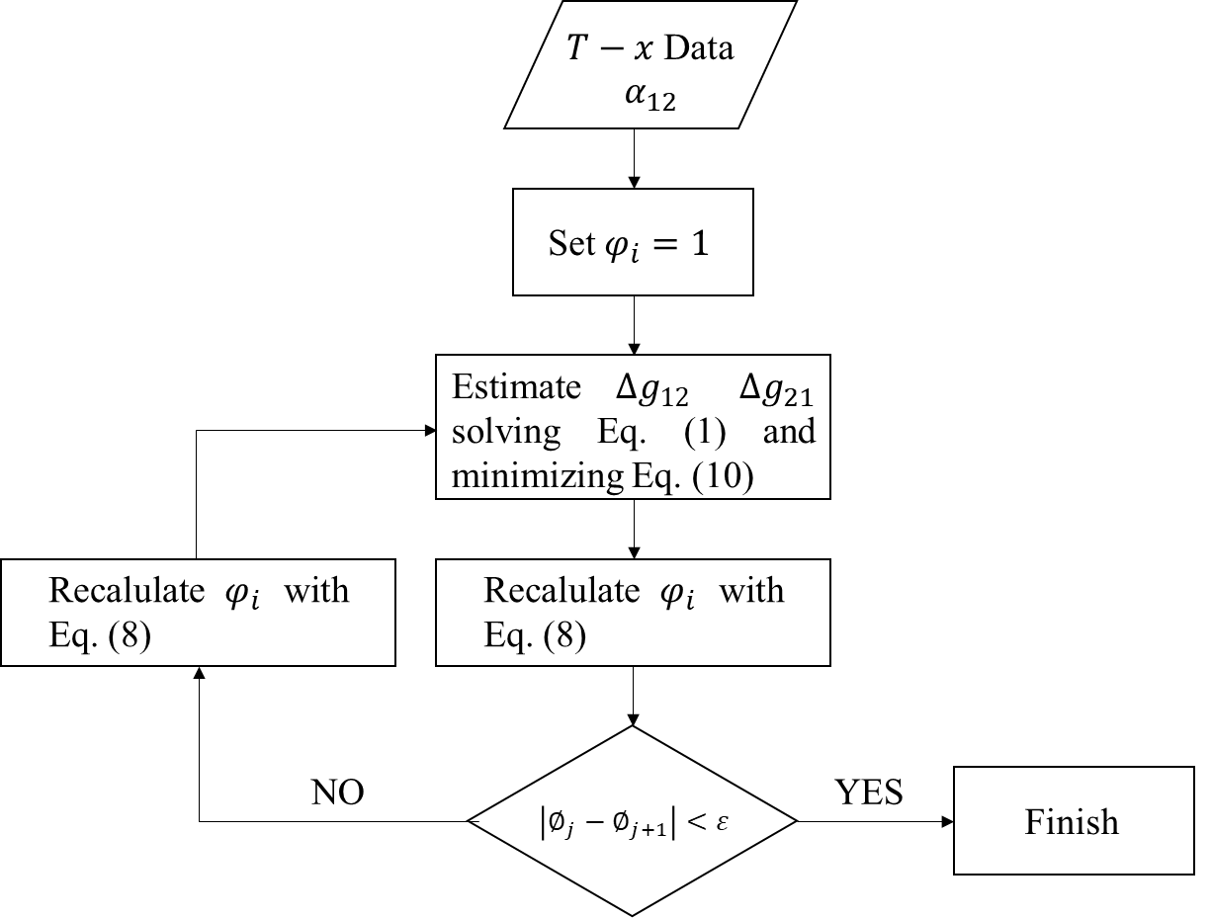
Figure 1. Algorithm for the estimation of NRTL ${∆g}_{12}$ and ${∆g}_{21}$parameters.
3. Results and discussion
Liquid-vapor equilibrium data were reported in Table 2 and in Figure 1. Although the presence of minimum boiling azeotrope was observed, it was not possible to obtain a precise estimation of the azeotropic composition due to the “flatness” of the equilibrium curve in that region between 100.0 °C and 100.2 °C (see Figure 2).
Table 2. Vapor-liquid equilibrium data for Propionic Acid (1) – water (2) at 1 atm.
T, °C | $$x_{1}$$ | $$y_{1}$$
100.2 | 0 | 0
100.0 | 0.106 | 0.081
99.9 | 0.030 | 0.034
99.9 | 0.063 | 0.059
100.2 | 0.147 | 0.094
100.3 | 0.203 | 0.113
101.1 | 0.250 | 0.127
102.0 | 0.420 | 0.165
103.8 | 0.497 | 0.216
104.1 | 0.543 | 0.216
107.2 | 0.650 | 0.301
121.3 | 0.874 | 0.593
125.1 | 0.921 | 0.682
141.2 | 1 | 1

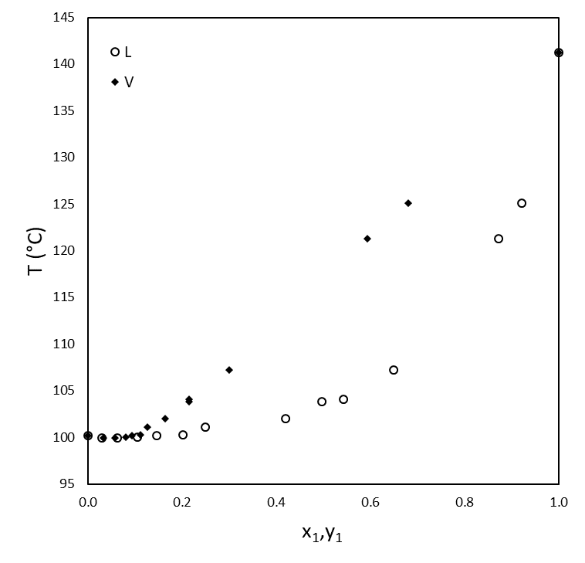
Figure 2. Propionic Acid-water Liquid-vapor equilibrium curve at 1 atm.
The expression for the calculation of the equilibrium constant of dimerization for propionic acid was taken by Tsonopoulos and Prausnitz [15] and reported in Equation 11:
$$\log_{10}{K(T)}= -10.13+\frac{3075}{T} ({mm}^{-1}Hg)$$ | (11)
The relation used for the evaluation of the vapour tension of pure compounds was the one reported on Perry's Chemical Engineers' Handbook [10] and has the following expression:
$$\ln{P_{s,i}(T)}= C1+\frac{C2}{T}+C3\ln{(T)}+C4{ T}^{C5} (Pa)$$ | (12)
In both Equation 11 and 12 temperatures must be used in K. In Table 3 was given the value of the molecular excluded volume as well as the constants used in Equation 12 for each compound.
Table 3. Propionic Acid and water parameters.
Property | Symbol (UM) | Propionic Acid | Water | Reference
Molecular excluded volume | $b$ (cm³/mol) | 170.2 | 49.5 | [14]
Vapour tension constants | C1 | 54.552 | 73.649
 | C2 | -7149.4 | -7258.2 | [10]
 | C3 | -4.2769 | -7.3037
 | C4 | 1.1843·10⁻¹⁸ | 4.1653·10⁻⁶
 | C5 | 6 | 2

In figure 3 a) were reported the liquid activity coefficient values obtained by experimental data implementing the chemical theory for vapor imperfections, while in Figure 3 b) was given the Gibbs excess function ($∆g^{E}$) respect to the molar liquid composition of propionic acid: it is noticeable the positive deviation from ideality which leads to $∆g^{E}>0$ and $γ_{i}$>1.
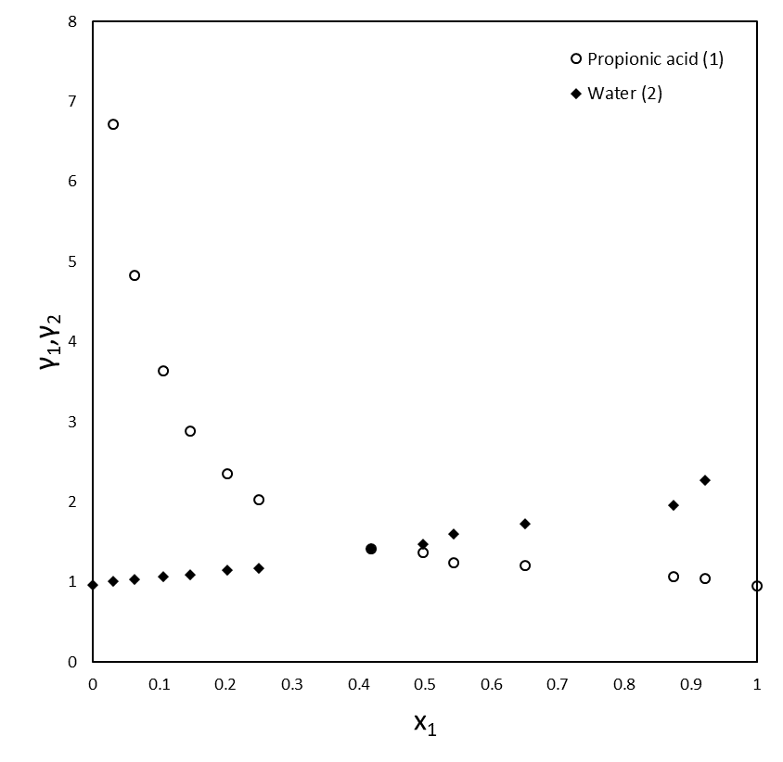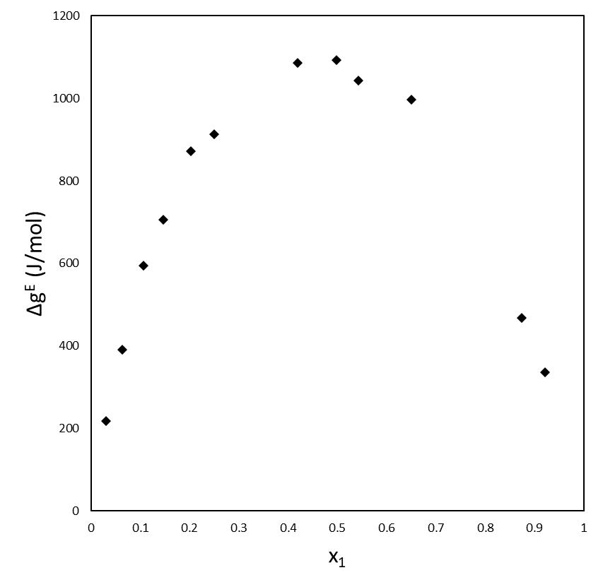
b)
a)
Figure 3. Propionic Acid-water liquid activity coefficients a) and Gibbs excess function ($∆g^{E}$) b).

Figure 4 shows the correlation between the calculated mole fraction of propionic acid in the vapour phase after performing the regression ($y_{1,cal}$) with the experimental one ($y_{1,exp}$). The goodness of the estimation is verified from the value R²=0.9954 which indicates an extremely high correlation between the vapour mole fractions predicted by the model and the experimental ones. The NRTL values obtained are: ${∆g}_{12}=446$ J/mol and ${∆g}_{21}$=6399 J/mol.
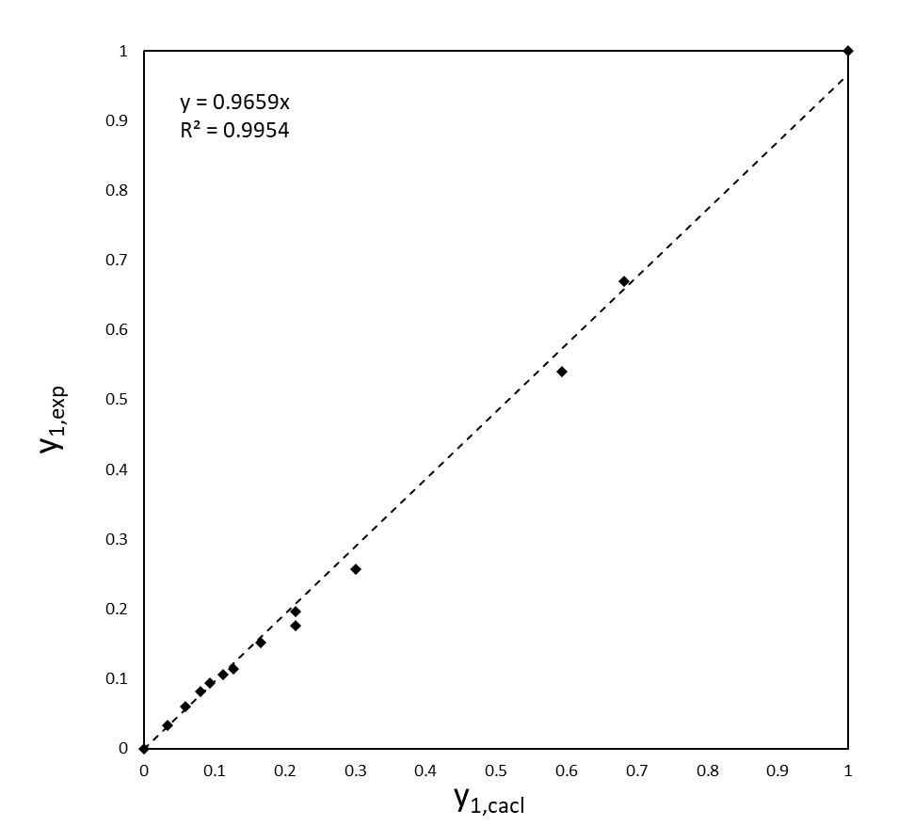
Figure 4. Correlation between the vapor mole fractions predicted by the model ($y_{1,cal}$) respect to the ones evaluated experimentally ($y_{1,exp}$).
4. Conclusions
In this work the atmospheric Liquid-Vapor equilibrium between the binary system Propionic Acid-water was investigated. The chemical theory for vapor imperfections was adopted for the evaluation of the fugacity coefficients considering the dimerization of propionic acid and water as an inert in the vapor phase. Although were collected experimental data also regarding the composition of the vapor phase at equilibrium, it was chosen to utilize such data to verify the goodness of the regression. The system showed a positive deviation from ideality $∆g^{E}>0$ and the presence of an azeotrope between the range of 100.0 °C and 100.2 °C. It was verified that the NRTL well represents the liquid phase non-ideality. Further studies should be conducted at different pressures and introducing others Volatile Fatty Acids (VFAs) in order to evaluate the selective separability of VFAs from water mixtures.
References
[1] Research and markets, Propionic Acid - Global Market Trajectory & Analytics, 2021. https://doi.org/ID: 5030547.
[2] M. Atasoy, I. Owusu-Agyeman, E. Plaza, Z. Cetecioglu, Bio-based volatile fatty acid production and recovery from waste streams: Current status and future challenges, Bioresour. Technol. 268 (2018) 773–786. https://doi.org/10.1016/j.biortech.2018.07.042.
[3] P.M. Brooks, Propionic acid derivatives, Curr. Ther. (Seaforth). 22 (1981) 109–115. https://doi.org/10.1007/978-3-662-02384-6_18.
[4] A. Gallipoli, A. Gianico, S. Crognale, S. Rossetti, L. Mazzeo, V. Piemonte, M. Masi, C.M. Braguglia, 3-routes platform for recovery of high value products, energy and bio-fertilizer from urban biowaste: The revenue project, Detritus. 15 (2021) 24–30. https://doi.org/10.31025/2611-4135/2021.15092.
[5] K. Wang, J. Yin, D. Shen, N. Li, Anaerobic digestion of food waste for volatile fatty acids (VFAs) production with different types of inoculum: Effect of pH, Bioresour. Technol. 161 (2014) 395–401. https://doi.org/10.1016/j.biortech.2014.03.088.
[6] B.P. Dakshinamurty, G.J. Rao, C.V. Rao, VAPOUR-LIQUID EQUILIBRIA IN THE SYSTEM WATER-PROPIONIC ACID, (1961) 226–228.
[7] L.A. Román-Ramírez, F. García-Sánchez, R.C.D. Santos, G.A. Leeke, Vapour-liquid equilibrium of propanoic acid+water at 423.2, 453.2 and 483.2K from 1.87 to 19.38bar. Experimental and modelling with PR, CPA, PC-SAFT and PCP-SAFT, Fluid Phase Equilib. 388 (2015) 151–159. https://doi.org/10.1016/j.fluid.2015.01.004.
[8] T. Ito, F. Yoshida, Vapor-Liquid Equilibria of Water-Lower Fatty Acid Systems: Water-Formic Acid, Water Acetic Acid and Water-Propionic Acid, J. Chem. Eng. Data. 8 (1963) 315–320. https://doi.org/10.1021/je60018a012.
[9] A. Tamir, J. Wisniak, Vapor Equilibrium in Associating Systems (Water-Formic Acid-Propionic Acid), Ind. Eng. Chem. Fundam. 15 (1976) 274–280. https://doi.org/10.1021/i160060a009.
[10] P.E. Liley, G.H. Thomson, D.G. Friend, T.E. Daubert, E.C.N.-D.-0020 Buck, Data: Physical and chemical data, in: Perry’s Chem. Eng. Handb., 1997: pp. 2-1-2-204 ST-Data: Physical and chemical data. t:%5CScholar E-library%5CDatabases%5CDataBase-0020.pdf LB - Chemical and Physical data.
[11] S. Malanowski, Experimental methods for vapour-liquid equilibria. Part I. Circulation methods, Fluid Phase Equilib. 8 (1982) 197–219. https://doi.org/10.1016/0378-3812(82)80035-6.
[12] A. Chlanesef, L. Marrelll, I. Chimica, U. Roma, Isobaric Vapor-Liquid Equilibria of the Ethylbenzene-p-Xylene System, (1985) 424–427.
[13] A. Carli, S. Di Cave, E. Sebastiani, Thermodynamic characterization of vapour-liquid equilibria of mixtures acetic acid-dimethylacetamide and water-dimethylacetamide, Chem. Eng. Sci. 27 (1972) 993–1001. https://doi.org/10.1016/0009-2509(72)80014-9.
[14] K.H. Nothnαgel, D.S. Abrams, J.M. Prausnitz, Generalized Correlation for Fugacity Coefficients in Mixtures at Moderate Pressures. Application of Chemical Theory of Vapor imperfections, Ind. Eng. Chem. Process Des. Dev. 12 (1973) 25–35. https://doi.org/10.1021/i260045a006.
[15] C. Tsonopoulos, J.M. Prausnitz, Fugacity coefficients in vapor-phase mixtures of water and carboxylic acids, Chem. Eng. J. 1 (1970) 273–278. https://doi.org/10.1016/0300-9467(70)85014-6.

