Modeling Flux Reduction in Multiphase Gas Barrier Materials Trough 3D CFD Approach
Lorenzo Merlonghi^{1,3}, Marco Giacinti Baschetti^{1,3}, Maria Grazia de Angelis^{1,2,3}
(1) Department of Civil, Chemical, Environmental and Material Engineering, (DICAM), Alma Mater
Studiorum – Università di Bologna, via Terracini 28, 40131 Bologna, Italy
(2) Institute for Materials and Processes, School of Engineering, University of Edinburgh, Sanderson
Building, Robert Stevenson Road, EH9 3FB, Scotland, UK.
(3) Dutch Polymer Institute (DPI), P.O. Box 902, 5600 AX Eindhoven, the Netherlands.
*Corresponding author E-Mail: lorenzo.merlonghi2@unibo.it

1. Introduction
Semicrystalline polymers (SCP) and polymer matrix composites (PMC) are widely used for gas barrier applications, because crystalline and filler domains act as obstacles for small diffusing gaseous species. The main geometrical parameters that affect transport properties of such multiphase materials are volume fraction (VF) and aspect ratio (AR) of the dispersed particles. Analytical models like Maxwell [1] and Maxwell-Wagner-Sillars (MWS) [2] can be used to predict flux reduction in multiphase materials for simple geometries such as spheres and spheroids, while other methods based on finite elements or volumes methods (FEM, FVM) can be used to reproduce more complex geometries. In this preliminary work, a computational fluid dynamics (CFD) approach is proposed to investigate how particles morphology and size distribution (SD) affect overall transport coefficients of the homogenized material, with respect to the continuous matrix.
2. Methods
The study was based on the analysis of the permeation behavior of gases through a representative volume element (RVE) of the material of interest, obtained by inserting spherical inclusions in a cubic matrix with periodic or symmetric boundaries. Three levels of complexity were used to reproduce the geometry, changing impermeable phase VF, as well as AR, here defined as the ratio between the higher and the lower characteristic dimensions of oblate particles, and SD. For ARs higher than one, impermeable oblate spheroids were aligned perpendicular to the flux direction, reproducing an efficient gas barrier system. Initially, ordered spheroids with the same size were used to represent impermeable domains, then random distributed arrays in terms of size and positioning was generated. Finally, specific SDs of real LDPE samples [3] was reproduced to be more representative as possible of a real material microstructure. Once the microstructure was generated it was fed to a CFD tool for the solution of the transport problem. In particular, ANSYS Fluent 2020 R2 was used to mesh the geometry, set the correct boundary conditions, and solve a steady state pure diffusion problem. To do so, a fixed gradient was fixed between two faces of the cubic RVE, leaving other four as symmetric or coupled periodic boundaries, depending on the model used. Then, the elliptic partial differential equation was solved, setting a Neumann condition of null flux on the interface between amorphous matrix and impermeable phase. At the end, the constant flux was computed in the direction of the gradient and compared with the one obtained by solving the same problem using both the analytical and the numerical method by CFD analysis, in case of a pure amorphous matrix, in order to check the consistency. Finally, the ratio between the two fluxes, defined as flux reduction, is calculated and compared to analytical expressions available in the literature [1,2]. The size of the RVE was maximized in order to obtain the same result at least three times on three significant digits, by fixing RV, AR and SD, and also minimized in order to reduce computational time.
3. Results and discussion
In figure 1, the results for regular random and distributed spheres are compared with analytical models, showing better matching in diluted conditions, as expected. Random and ordered spherical arrays gives the same result of Maxwell [1], while real spherical distributions can give slightly different results. On the other hand, it was found that for oblate inclusions, MWS [2] gives better results for lower ARs and VFs. Moreover, increasing AR for regular and random arrays result in a lower effect on the flux reduction for the second configuration, due to the presence of diffusion shortcuts generated by the random algorithm.
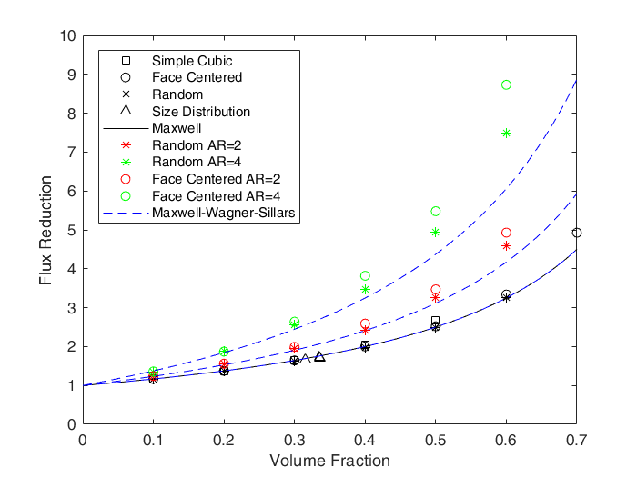
Figure 1. CFD results for spherical inclusions organized in different arrays compared with [1],[2].
4. Conclusions
In conclusion, this CFD approach was useful to understand the difference in terms of flux reduction, due to the presence of an impermeable phase in a continuous matrix, comparing ordered, random and distributed arrays. It was shown that all CFD results are consistent with analytical models available in the literature [1,2] and it was found that a real multiphase material can be easily reproduced using a specific size distribution, to have a more realistic prediction. In future works, this approach will be extended to different morphologies, like ellipsoids or fibers, and will be also improved inserting an interphase between the two main phases, when expected in real materials.
References
- C. Maxwell, Treatise on Electricity and Magnetism, Oxford Univ. Press, 1873; Vol. 1.
- R.W. Sillars, The Properties of a dielectric containing semi conducting particles of various shapes, Institution of Electrical Engineers, in: Proceedings of the Wireless Section of the Institution 12, 1937, pp. 139–155.
- Leyva-Porras, C.; Balderrama-Aguilar, A.; EstradaÁvila, Y.; Espelosín-Gómez, I.; Mendoza-Duarte, M.; Piñón Balderrama, C.; Saavedra-Leos, M.Z.; Estrada-Moreno, I. Injection Molding of Low-Density Polyethylene (LDPE) as a Model Polymer: Effect of Molding Parameters on the Microstructure and Crystallinity. Polymers 2021, 13, 3597.
Acknowledgment: This research forms part of the research program of DPI, project 844 | Modelling and Design of Multiphase Polymeric Materials for High-Performance Applications Across Multiple Scales (MuMPol).

